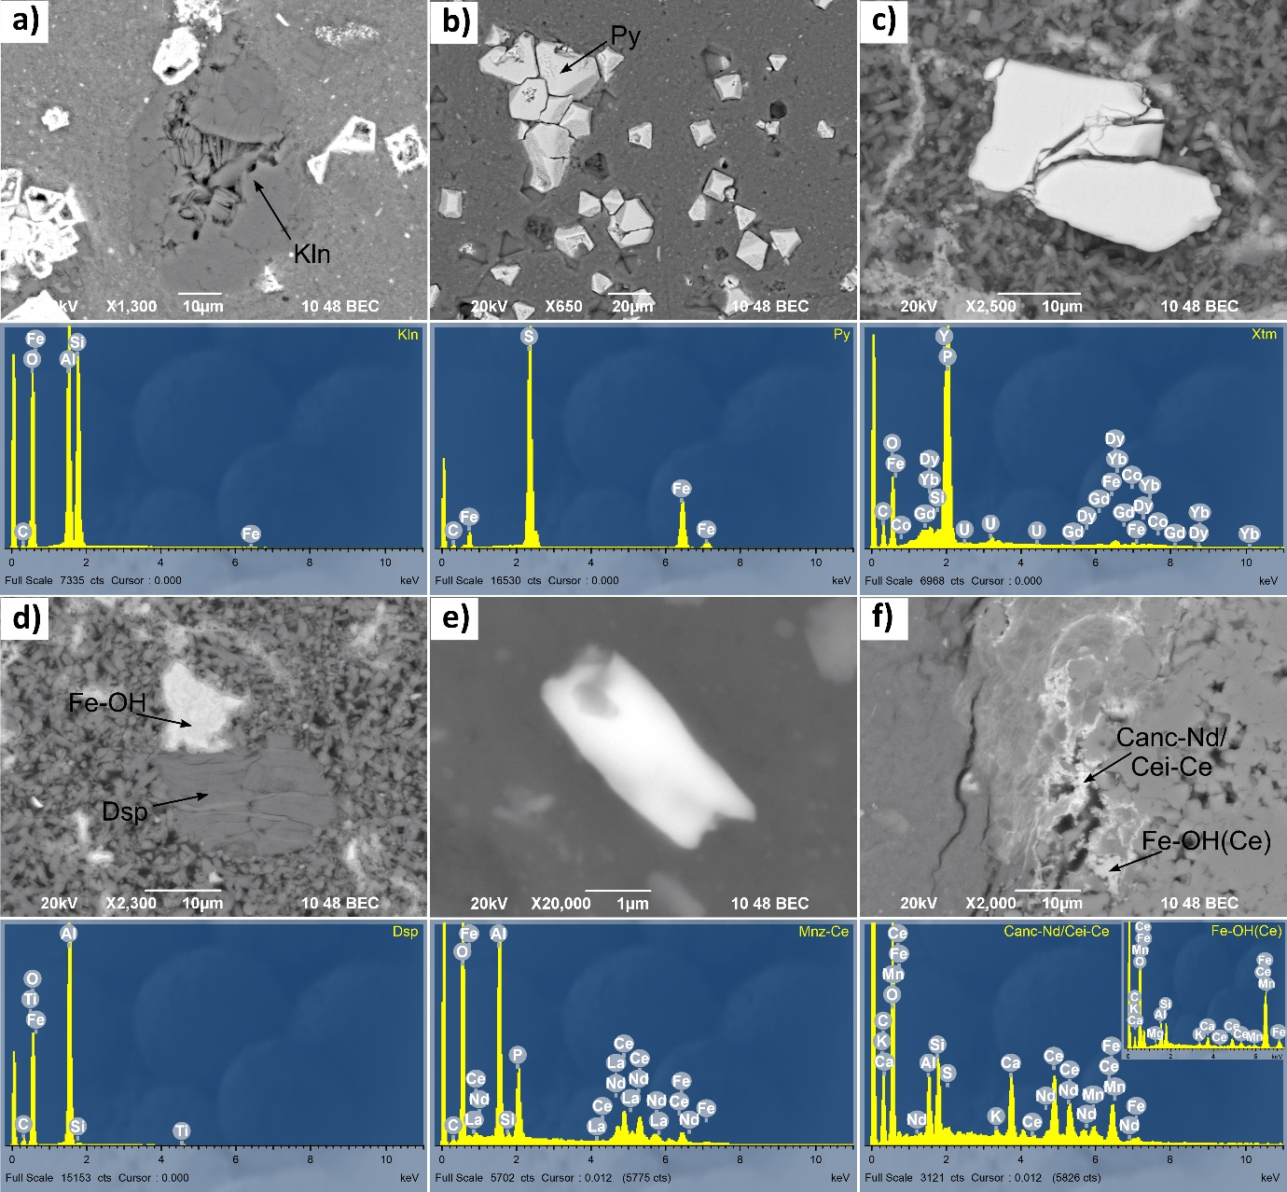
Figure S1: SEM (BSE) images and EDS spectra of phases in bauxite samples: (a) kaolinite (Kln) (Kb 01); (b) pyrite (Py) (Kb 01); (c) xenotime (Xtm) (Kb 03); (d) diaspore (Dsp) (Kb 03) and Fe-oxyhydroxide (Fe-OH); (e) monazite (Ce) (Mnz-Ce) in ooide (Hr 03); (f) calcioancylite (Nd) or cerianite (Ce) without Th (Canc-Nd/Cei-Ce) and Fe-oxyhydroxide (Ce) (Fe-OH(Ce)) (Lo 01). The samples are coated with carbon.

Figure S2: SEM (BSE) images and EDS spectra of phases in bauxite samples: (a) lanthanite (Ce) (Ltn-Ce) (Lo 01); (b) xenotime (Xtm) (Lo 01); (c) Fe-oxyhydroxide with variable Fe content (Fe-OH sp.1, Fe-OH sp.2) (Lo 07); (d) cerianite (Ce) without Th (Cei-Ce) and rutile/anatase (Rt/Ant) (Pod 02). The samples are coated with carbon.
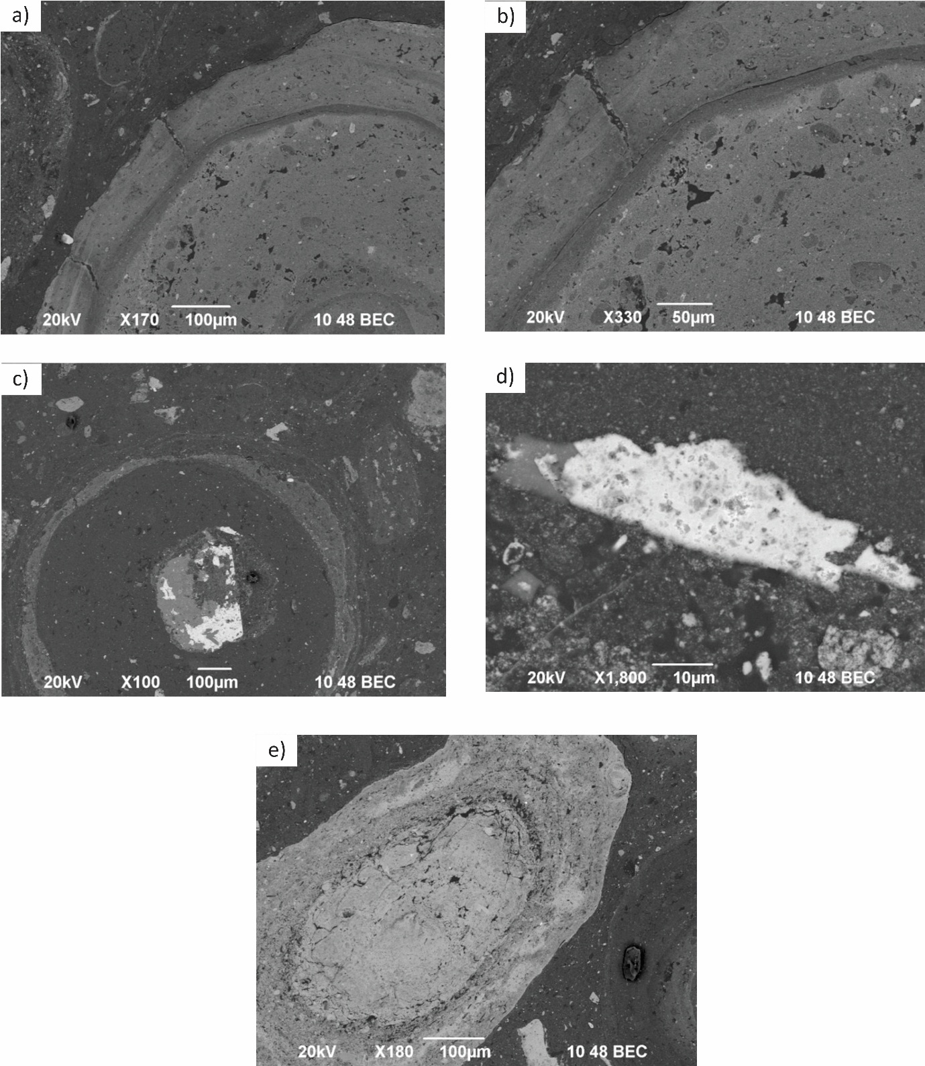Figure S3: SEM (BSE) imeges of different ooides in sample Pod 02 from T₃²⁺³ bauxites. Image (b) represents a close up of image (a) showing structure of the outter rim of an ooide with CeO (small white rim). Image (d) represents a close up of image (c) representing the core structure of an ooide composed of chalcopyrite/nukundamite.
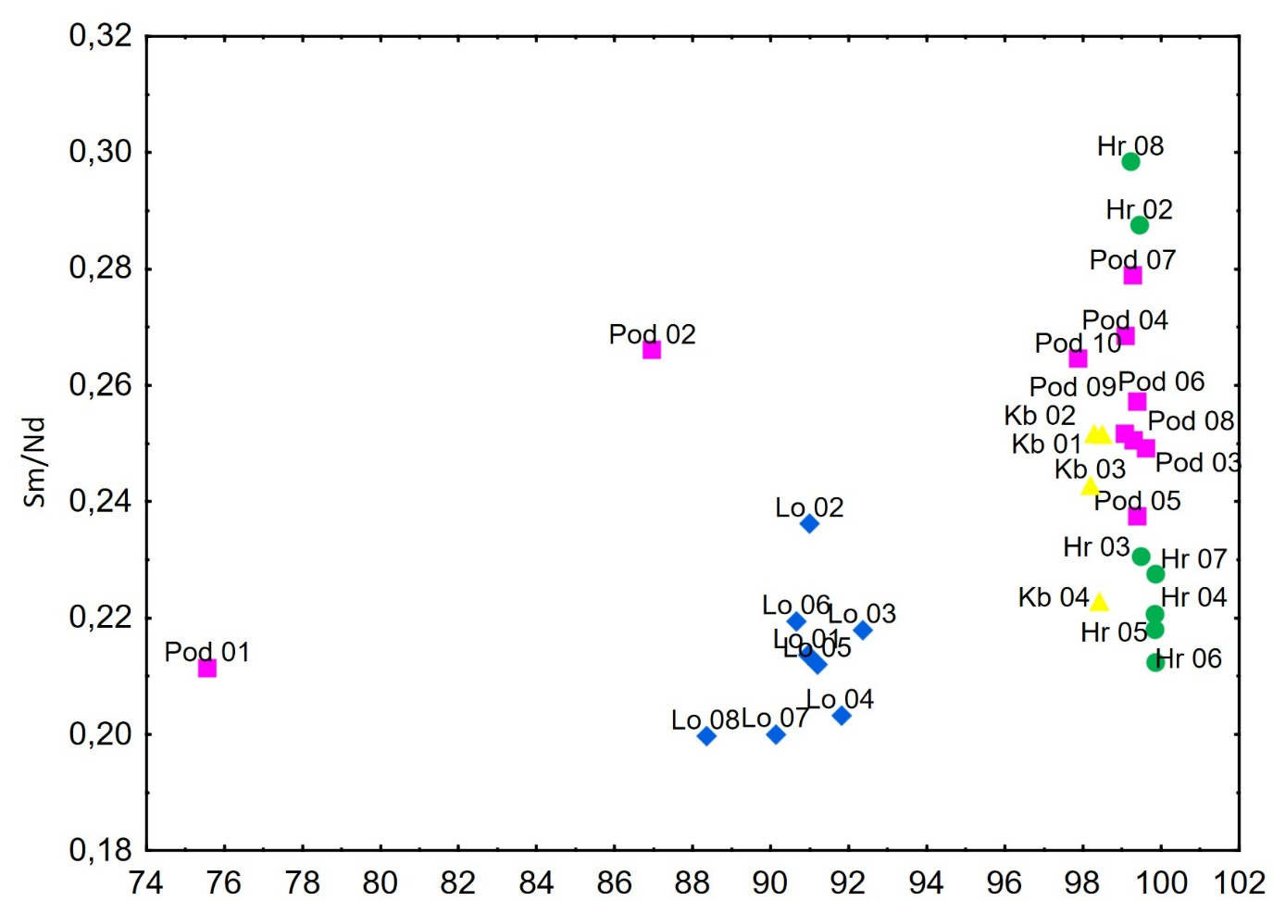
Figure S4: Sm/Nd vs CIA diagram of investigated bauxites by Babechuk et al., 2014.
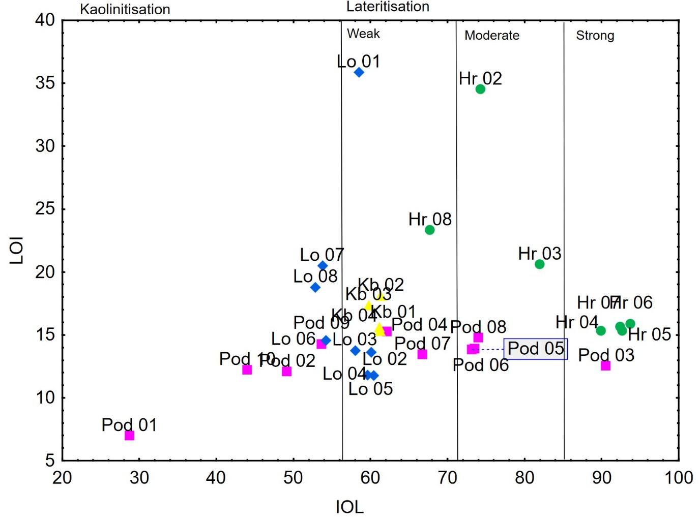
Figure S5: LOI vs IOL diagram of investigated d bauxites by Babechuk et al., 2014.
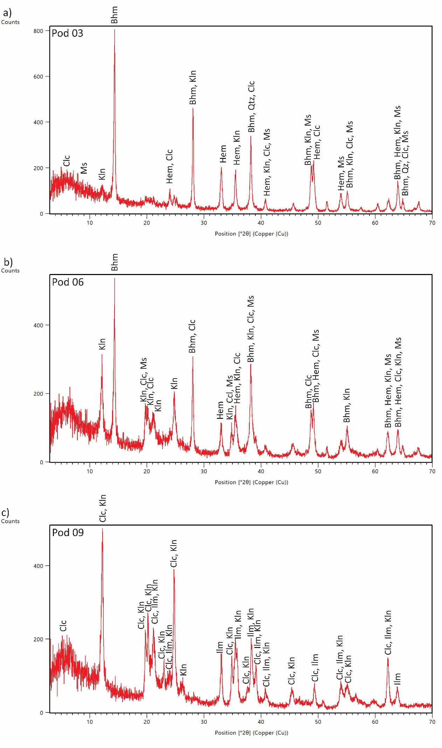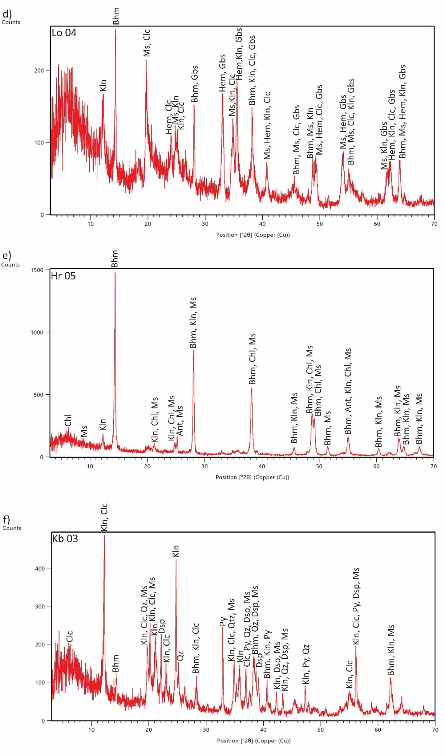
Figure S6: Mineral composition of sample a) Pod 03, b) Pod 06, c) Pod 09, d) Lo 04, e), Hr 05 and f) Kb 03. Abbriviations: Ant – anatase, Bhm – Bohemite, Chl – chlorite, Clc – Chlinoclore, Gbs – gibbsite, Hem – hematite, Ilm – ilmenite, Kln – kaolinite, Ms – muscovite, Qz – quartz.
Table S1: Chemical composition of investigated bauxites – trace elements in mg/kg.

Sample | As | Ba | Co | Cr | Cs | Cu | Ga | Hf | Mo | Nb | Ni | Pb
Pod 01 | 5.9 | 770.0 | 13.0 | 40.0 | 23.1 | 20.0 | 23.0 | 4.0 | 1.0 | 12.0 | 50.0 | 68.0
Pod 02 | 9.9 | 161.5 | 100.0 | 48.0 | 6.9 | 170.0 | 37.5 | 15.0 | 1.0 | 25.0 | 90.0 | 77.0
Pod 03 | 31.6 | 34.5 | 16.0 | 161.0 | 1.3 | 5.0 | 58.0 | 22.0 | 2.0 | 48.5 | 125.0 | 124.0
Pod 04 | 3.3 | 51.0 | 20.0 | 94.0 | 3.7 | 10.0 | 39.0 | 18.0 | 1.0 | 36.0 | 130.0 | 22.0
Pod 05 | 15.2 | 57.0 | 17.0 | 94.0 | 3.9 | 5.0 | 47.0 | 15.0 | 1.0 | 36.0 | 120.0 | 88.0
Pod 06 | 15.9 | 82.0 | 16.0 | 107.0 | 3.7 | 5.0 | 48.0 | 18.0 | 1.0 | 39.0 | 120.0 | 79.0
Pod 07 | 22.1 | 69.0 | 20.0 | 91.0 | 4.1 | 20.0 | 41.0 | 19.0 | 3.0 | 34.0 | 140.0 | 88.0
Pod 08 | 18.0 | 68.0 | 10.0 | 121.0 | 3.2 | 10.0 | 47.0 | 16.0 | 1.0 | 38.0 | 110.0 | 83.0
Pod 09 | 21.8 | 46.0 | 23.5 | 65.0 | 4.6 | 10.0 | 28.0 | 13.0 | 1.0 | 27.5 | 110.0 | 110.5
Pod 10 | 13.1 | 66.0 | 7.0 | 35.0 | 2.9 | 5.0 | 33.0 | 13.0 | 1.0 | 28.0 | 50.0 | 75.0
Lo 01 | 14.6 | 37.0 | 80.0 | 90.0 | 3.1 | 20.0 | 9.0 | 0.5 | 5.0 | 6.0 | 90.0 | 24.0
Lo 02 | 28.6 | 158.0 | 24.0 | 262.0 | 14.0 | 30.0 | 35.0 | 5.0 | 14.0 | 17.0 | 110.0 | 63.0
Lo 03 | 10.6 | 193.0 | 31.0 | 256.0 | 17.1 | 20.0 | 42.0 | 6.0 | 2.0 | 24.0 | 160.0 | 59.0
Lo 04 | 6.7 | 212.0 | 22.0 | 237.5 | 16.5 | 15.0 | 39.0 | 5.5 | 2.0 | 27.0 | 150.0 | 43.0
Lo 05 | 6.3 | 226.0 | 26.0 | 226.0 | 16.6 | 20.0 | 38.0 | 7.0 | 2.0 | 27.0 | 140.0 | 42.0
Lo 06 | 5.7 | 217.0 | 44.0 | 236.0 | 16.7 | 50.0 | 39.0 | 7.0 | 3.0 | 28.0 | 150.0 | 44.0
Hr 01 | 6.1 | 157.0 | 35.0 | 167.0 | 11.8 | 20.0 | 28.0 | 4.0 | 1.0 | 25.0 | 90.0 | 41.0
Hr 02 | 19.4 | 191.0 | 17.0 | 184.0 | 13.6 | 20.0 | 31.0 | 6.0 | 4.0 | 23.0 | 110.0 | 53.0
Hr 03 | 9.5 | 2.0 | 0.5 | 18.0 | 0.3 | 10.0 | 1.0 | 0.5 | 3.0 | 0.5 | 30.0 | 2.5
Hr 04 | 25.7 | 4.0 | 10.0 | 132.0 | 0.3 | 20.0 | 12.0 | 4.0 | 11.0 | 13.0 | 110.0 | 18.0
Hr 05 | 60.1 | 18.0 | 31.0 | 328.0 | 1.4 | 10.0 | 43.0 | 12.0 | 51.0 | 41.0 | 400.0 | 74.0
Hr 06 | 49.0 | 11.0 | 24.0 | 439.0 | 0.3 | 5.0 | 56.0 | 17.0 | 51.0 | 52.0 | 330.0 | 85.0
Hr 07 | 46.8 | 9.0 | 30.0 | 502.0 | 0.3 | 5.0 | 61.5 | 19.0 | 42.5 | 54.5 | 330.0 | 86.0
Hr 08 | 58.4 | 8.0 | 33.0 | 431.0 | 0.3 | 20.0 | 57.0 | 16.0 | 34.0 | 50.0 | 320.0 | 66.0
Lo 07 | 44.2 | 10.0 | 21.0 | 440.0 | 0.3 | 20.0 | 59.0 | 16.0 | 13.0 | 53.0 | 320.0 | 48.0
Lo 08 | 239.0 | 20.0 | 20.0 | 193.0 | 0.7 | 40.0 | 26.0 | 7.0 | 8.0 | 22.0 | 420.0 | 70.0
Kb 01 | 83.2 | 46.0 | 86.0 | 136.0 | 1.7 | 110.0 | 28.0 | 9.0 | 4.0 | 29.0 | 190.0 | 94.0
Kb 02 | 70.0 | 41.0 | 34.0 | 130.0 | 1.8 | 80.0 | 31.0 | 13.0 | 3.0 | 33.0 | 130.0 | 48.0
Kb 03 | 72.9 | 41.0 | 16.0 | 131.0 | 2.0 | 60.0 | 34.0 | 12.0 | 3.0 | 34.0 | 90.0 | 51.0
Kb 04 | 62.2 | 47.0 | 79.0 | 139.0 | 2.0 | 90.0 | 29.0 | 12.0 | 3.0 | 33.0 | 180.0 | 85.0

Table S1 continuation: Chemical composition of investigated bauxites – trace elements in mg/kg.
Sample | Rb | Sb | Sc | Sn | Sr | S | Ta | Th | Tl | U | V | W | Zn | Zr
Pod 01 | 140.0 | 2.4 | 16.0 | 7.0 | 58.0 | 0.0 | 1.1 | 15.2 | 1.3 | 2.2 | 90.0 | 12.0 | 133.0 | 178.0
Pod 02 | 36.5 | 1.8 | 25.5 | 16.0 | 40.0 | 0.0 | 2.5 | 53.9 | 0.3 | 2.3 | 49.5 | 5.5 | 215.0 | 490.5
Pod 03 | 3.0 | 4.9 | 55.5 | 19.0 | 30.0 | 0.0 | 2.8 | 69.6 | 0.1 | 3.4 | 134.0 | 18.5 | 19.5 | 723.0
Pod 04 | 8.0 | 1.0 | 48.0 | 16.0 | 14.0 | 0.0 | 3.2 | 60.6 | 0.1 | 4.9 | 88.0 | 16.0 | 41.5 | 605.0
Pod 05 | 6.0 | 3.1 | 48.0 | 16.0 | 21.0 | 0.0 | 2.9 | 54.6 | 0.1 | 3.8 | 91.0 | 6.0 | 37.0 | 602.0
Pod 06 | 6.0 | 2.9 | 50.0 | 17.0 | 25.0 | 0.0 | 3.1 | 59.4 | 0.1 | 4.0 | 95.0 | 7.0 | 35.0 | 628.0
Pod 07 | 7.0 | 3.4 | 46.0 | 14.0 | 58.0 | 0.0 | 2.9 | 55.3 | 0.1 | 3.8 | 86.0 | 27.0 | 27.0 | 552.0
Pod 08 | 8.0 | 2.2 | 47.0 | 18.0 | 50.0 | 0.0 | 2.9 | 57.5 | 0.1 | 3.9 | 89.0 | 7.0 | 27.0 | 650.0
Pod 09 | 6.0 | 2.9 | 39.0 | 12.0 | 53.0 | 0.0 | 2.5 | 41.0 | 0.1 | 4.1 | 66.0 | 7.5 | 22.5 | 431.0
Pod 10 | 11.0 | 3.0 | 24.0 | 10.0 | 22.0 | 0.0 | 2.3 | 49.2 | 0.1 | 7.4 | 66.0 | 12.0 | 21.0 | 482.0
Lo 01 | 29.0 | 0.4 | 20.0 | 1.0 | 80.0 | 0.1 | 0.3 | 12.0 | 0.6 | 3.5 | 46.0 | 2.0 | 318.0 | 51.0
Lo 02 | 108.0 | 2.0 | 33.0 | 6.0 | 43.0 | 0.0 | 1.4 | 27.1 | 1.0 | 8.6 | 180.0 | 4.0 | 286.0 | 212.0
Lo 03 | 126.0 | 2.0 | 40.0 | 7.0 | 57.0 | 0.0 | 2.0 | 34.3 | 1.2 | 4.2 | 177.0 | 5.0 | 381.0 | 291.0
Lo 04 | 129.0 | 1.5 | 40.0 | 7.5 | 64.5 | 0.0 | 2.2 | 31.2 | 1.2 | 3.3 | 177.0 | 5.5 | 293.0 | 321.5
Lo 05 | 138.0 | 2.1 | 39.0 | 7.0 | 63.0 | 0.0 | 2.1 | 32.1 | 1.2 | 3.3 | 170.0 | 10.0 | 305.0 | 315.0
Lo 06 | 139.0 | 1.2 | 35.0 | 7.0 | 71.0 | 0.2 | 2.3 | 30.7 | 1.3 | 4.1 | 171.0 | 8.0 | 299.0 | 322.0
Hr 01 | 104.0 | 0.9 | 27.0 | 4.0 | 93.0 | 1.2 | 1.7 | 20.5 | 0.9 | 3.5 | 126.0 | 4.0 | 198.0 | 233.0
Hr 02 | 122.0 | 1.7 | 26.0 | 5.0 | 77.0 | 3.9 | 1.8 | 22.5 | 1.0 | 6.8 | 147.0 | 6.0 | 215.0 | 271.0
Hr 03 | 1.0 | 1.5 | 6.0 | 0.5 | 124.0 | 0.0 | 0.1 | 1.9 | 0.1 | 0.6 | 46.0 | 0.5 | 5.0 | 12.0
Hr 04 | 1.0 | 3.0 | 17.0 | 3.0 | 108.0 | 0.0 | 0.9 | 15.3 | 0.1 | 3.1 | 212.0 | 3.0 | 10.0 | 132.0
Hr 05 | 8.0 | 7.3 | 35.0 | 11.0 | 81.0 | 0.0 | 2.8 | 41.7 | 0.4 | 11.3 | 479.0 | 8.0 | 38.0 | 394.0
Hr 06 | 1.0 | 6.3 | 39.0 | 14.0 | 91.0 | 0.0 | 1.6 | 60.4 | 0.1 | 15.9 | 508.0 | 13.0 | 31.0 | 577.0
Hr 07 | 1.0 | 6.5 | 38.0 | 13.5 | 98.5 | 0.0 | 1.0 | 66.7 | 0.1 | 16.2 | 698.5 | 17.0 | 22.5 | 585.5
Hr 08 | 1.0 | 7.3 | 33.0 | 11.0 | 93.0 | 1.2 | 0.8 | 56.9 | 0.2 | 11.0 | 658.0 | 16.0 | 21.0 | 570.0
Lo 07 | 1.0 | 6.6 | 34.0 | 11.0 | 66.0 | 0.0 | 1.0 | 60.3 | 0.1 | 7.5 | 489.0 | 22.0 | 32.0 | 569.0
Lo 08 | 5.0 | 26.6 | 33.0 | 5.0 | 168.0 | 0.0 | 1.5 | 26.8 | 0.3 | 3.5 | 1028.0 | 4.0 | 89.0 | 239.0
Kb 01 | 8.0 | 3.8 | 35.0 | 6.0 | 906.0 | 1.6 | 2.3 | 35.0 | 1.1 | 9.1 | 157.0 | 6.0 | 503.0 | 394.0
Kb 02 | 9.0 | 3.7 | 26.0 | 5.0 | 878.0 | 7.5 | 2.5 | 35.8 | 0.9 | 8.6 | 158.0 | 11.0 | 207.0 | 414.0
Kb 03 | 10.0 | 3.6 | 27.0 | 6.0 | 918.0 | 5.2 | 2.7 | 37.5 | 0.9 | 9.3 | 160.0 | 8.0 | 173.0 | 424.0
Kb 04 | 9.0 | 3.3 | 31.0 | 7.0 | 853.0 | 1.6 | 2.6 | 31.7 | 1.4 | 9.8 | 157.0 | 8.0 | 540.0 | 411.0

Table S3: : Chemical composition of investigated bauxites – REE in mg/kg, Ce/Ce* and Eu/Eu* anomalies.
Sample | Y | Ce | Eu | La | Nd | Pr | Dy | Er | Gd | Ho | Lu | Sm | Tb | Tm | Yb | Eu/Eu* |  | Ce/Ce*
Pod 01 | 101 | 117 | 1.71 | 93.8 | 62 | 18.7 | 12.6 | 8.3 | 10.7 | 2.7 | 1.1 | 13.1 | 2 | 1.19 | 6.2 | 0.5 | 0.6
Pod 02 | 154 | 262 | 4.66 | 160 | 145.5 | 38.05 | 24.7 | 13.85 | 28.55 | 4.9 | 1.83 | 38.7 | 4.25 | 1.94 | 11.8 | 0.48 | 0.73
Pod 03 | 201.5 | 335 | 5.295 | 162 | 137.5 | 37.25 | 29.75 | 19 | 29.6 | 6.3 | 2.79 | 34.25 | 4.85 | 2.75 | 15.85 | 0.54 | 0.96
Pod 04 | 156 | 225 | 1.8 | 96.1 | 57 | 17.2 | 20.3 | 15.1 | 14 | 4.8 | 2.41 | 15.3 | 2.9 | 2.29 | 14.6 | 0.44 | 1.2
Pod 05 | 212 | 255 | 4.83 | 141 | 134 | 35.2 | 28.9 | 18.3 | 28 | 6.1 | 2.55 | 31.8 | 4.6 | 2.61 | 14 | 0.53 | 0.79
Pod 06 | 215 | 262 | 5.49 | 156 | 147 | 39.8 | 31.1 | 19.1 | 31 | 6.4 | 2.74 | 37.8 | 5.1 | 2.77 | 15 | 0.54 | 0.71
Pod 07 | 201 | 310 | 3.87 | 116 | 104 | 27.9 | 25 | 16 | 22.7 | 5.4 | 2.28 | 29 | 4 | 2.33 | 14.1 | 0.53 | 1.12
Pod 08 | 181 | 284 | 4.42 | 112 | 117 | 31.7 | 27.1 | 17.3 | 25.7 | 5.7 | 2.54 | 29.3 | 4.3 | 2.5 | 13.8 | 0.53 | 1.05
Pod 09 | 258 | 292 | 4.04 | 162.5 | 107.5 | 30.4 | 28.8 | 18.45 | 24.85 | 6.3 | 2.39 | 27.05 | 4.35 | 2.575 | 14.25 | 0.53 | 0.87
Pod 10 | 107 | 197 | 2.21 | 83.3 | 69.2 | 19.9 | 16.7 | 10.8 | 13.9 | 3.5 | 1.62 | 18.3 | 2.5 | 1.61 | 9.9 | 0.48 | 1.03
Lo 01 | 425 | 354 | 13.6 | 638 | 374 | 89.6 | 43.5 | 20.4 | 64.6 | 8.1 | 1.94 | 79.9 | 8.9 | 2.38 | 11.4 | 0.65 | 0.31
Lo 02 | 357 | 103 | 3.49 | 203 | 88.9 | 24.1 | 21.1 | 14.3 | 19.8 | 5.1 | 1.78 | 21 | 3.3 | 1.97 | 10.7 | 0.6 | 0.31
Lo 03 | 165 | 198 | 3.87 | 256 | 123 | 34 | 15.1 | 9.9 | 17.9 | 3.3 | 1.38 | 26.8 | 2.7 | 1.39 | 8.4 | 0.62 | 0.46
Lo 04 | 157.5 | 169 | 4.355 | 245 | 108 | 30.85 | 19.05 | 12.1 | 18.45 | 4.05 | 1.675 | 21.95 | 2.9 | 1.72 | 9.95 | 0.72 | 0.42
Lo 05 | 158 | 173 | 4.04 | 224 | 96.7 | 28.1 | 18.8 | 12.2 | 17.2 | 4 | 1.64 | 20.5 | 2.9 | 1.73 | 9.3 | 0.72 | 0.51
Lo 06 | 150 | 155 | 2.99 | 173 | 77 | 22.5 | 15.1 | 10.6 | 14.3 | 3.5 | 1.48 | 16.9 | 2.3 | 1.52 | 8.3 | 0.65 | 0.56
Lo 07 | 180 | 152 | 4.12 | 178 | 114 | 29.1 | 18.3 | 10.8 | 20.2 | 3.8 | 1.39 | 22.8 | 2.8 | 1.46 | 6.8 | 0.63 | 0.49
Lo 08 | 155 | 129 | 2.4 | 134 | 72.6 | 20.7 | 12.7 | 8.7 | 12.3 | 2.9 | 1.23 | 14.5 | 1.9 | 1.23 | 6.7 | 0.59 | 0.58
Hr 01 | 9 | 27 | 0.38 | 15.6 | 9 | 2.57 | 1.1 | 0.6 | 1.5 | 0.2 | 0.08 | 2.4 | 0.2 | 0.09 | 0.6 | 3.06 | 0.23
Hr 02 | 17 | 47 | 0.64 | 24.4 | 16 | 4.51 | 2.6 | 1.6 | 2.7 | 0.5 | 0.25 | 4.6 | 0.4 | 0.23 | 2 | 0.67 | 0.99
Hr 03 | 39 | 84 | 1.34 | 43.6 | 34.7 | 9.9 | 6.6 | 4.4 | 6 | 1.4 | 0.78 | 8 | 1 | 0.68 | 4.1 | 0.64 | 0.98
Hr 04 | 49 | 104 | 1.39 | 51.9 | 41.7 | 12.4 | 7.6 | 5.2 | 6.5 | 1.7 | 0.95 | 9.2 | 1.1 | 0.87 | 5.9 | 0.6 | 0.91
Hr 05 | 46.5 | 128 | 1.405 | 58.95 | 45.65 | 13.8 | 7.85 | 5.5 | 6.45 | 1.7 | 0.97 | 9.95 | 1.2 | 0.855 | 6.3 | 0.61 | 0.97
Hr 06 | 42 | 103 | 1.22 | 46.9 | 40.5 | 11.8 | 7 | 4.8 | 5.7 | 1.5 | 0.86 | 8.6 | 1 | 0.75 | 3.1 | 0.59 | 0.94
Hr 07 | 47 | 92 | 1.23 | 42.6 | 35.6 | 10.4 | 8 | 5.5 | 6.1 | 1.7 | 0.97 | 8.1 | 1.2 | 0.84 | 5.8 | 0.58 | 0.93
Hr 08 | 40 | 87 | 1.78 | 45.1 | 38.2 | 10.4 | 6.7 | 3.8 | 7.2 | 1.3 | 0.56 | 11.4 | 1.1 | 0.55 | 3.8 | 0.7 | 0.88
Kb 01 | 94 | 253 | 4.77 | 174 | 128 | 34.8 | 15.4 | 9.4 | 19.5 | 3 | 1.39 | 32.2 | 2.7 | 1.37 | 9.1 | 0.67 | 0.68
Kb 02 | 89 | 221 | 4.47 | 159 | 122 | 32.6 | 13.7 | 8.3 | 18.5 | 2.8 | 1.3 | 30.7 | 2.4 | 1.26 | 8.9 | 0.66 | 0.65
Kb 03 | 91 | 225 | 4.85 | 165 | 131 | 35.4 | 14.7 | 9.1 | 19 | 2.9 | 1.41 | 31.8 | 2.6 | 1.37 | 8.3 | 0.68 | 0.64
Kb 04 | 96 | 206 | 4.76 | 152 | 127 | 34.3 | 15.9 | 9.9 | 19.6 | 3.2 | 1.49 | 28.3 | 2.7 | 1.43 | 8.4 | 0.67 | 0.66

