SUPPLEMENTARY MATERIAL
TITLE: Geomorphological and hydrological controls on shallow karst depressions (dayas) on a planar carbonate platform: the Nullarbor Plain, Australia

AUTHORS: Matej Jelovčan¹, Uroš Stepišnik², Andrej Šmuc³, Primož Miklavc³, Matej Dolenec³, Matej Lipar⁴
¹Karst Research Institute, Research Centre of the Slovenian Academy of Sciences and Arts; Postojna, 6230, Slovenia.
²Department of Geography, University of Ljubljana; Ljubljana, 1000, Slovenia.
³Department of Geology, Faculty of Natural Sciences and Engineering, University of Ljubljana; Ljubljana, 1000, Slovenia.
⁴Anton Melik Geographical Institute, Research Centre of the Slovenian Academy of Sciences and Arts; Ljubljana, 1000, Slovenia.

Table 1: Monthly and daily evaporation rates for the Nullarbor region.
 | Evaporation rate
 | Monthly (mm/month) | Daily (mm/day) | Daily (m/day)
March | 250–300 | 8.1–9.7 | 0.0081–0.0097
April | 175–200 | 5.8–6.7 | 0.0058–0.0067
May | 125–150 | 4.0–4.8 | 0.004–0.0048
June | 100–125 | 3.3–4.2 | 0.0033–0.0042
July | 100–125 | 3.3–4.2 | 0.0033–0.0042
August | 125–150 | 4.0–4.8 | 0.004–0.0048

Table 2: Calculations of change in water volume and theoretical evaporation loss for daya 1.
DAYA 1
29.3.2024–8.4.2024 | GIS-derived values for March:  Water level = 143.67 m  Water surface area = 228,243 m²  Water volume = 154,604.8 m³ | GIS-derived values for April:  Water level = 143.63 m  Water surface area = 196,837 m²  Water volume = 133,995.3 m³
29.3.2024–8.4.2024 | Volume difference between March and April dates (10 days) = 154,604.8 m³ - 133,995.3 m³ = 20,609.5 m³
29.3.2024–8.4.2024 | Theoretical evaporation:  V = E × S  March daily value: 0.0081–0.0097 m × 228,243 m² = 1848.7–2214.0 m³/day  April daily value: 0.0058–0.0067 m × 228,243 m² = 1323.8–1529.2 m³/day  2 days × 1848.7–2214 + 8 days × 1323.8–1529.2 = 14,287.8–16,661.6 m³  Over 10 days, the theoretical evaporation would range between 14,287.8–16,661.6 m³.
8.4.2024–8.5.2024 | GIS-derived values for April:  Water level = 143.63 m  Water surface area = 196,837 m²  Water volume = 133,995.3 m³ | GIS-derived values for May:  Water level = 143.21 m  Water surface area = 105,791 m²  Water volume = 25,597.0 m³
8.4.2024–8.5.2024 | Volume difference between April and May dates (30 days) = 133,995.3 m³ - 25,597.0 m³ = 108,398.3 m³
8.4.2024–8.5.2024 | Theoretical evaporation:  V = E × S  April daily value: 0.0058–0.0067 m × 196,837 m² = 1141.7–1318.8 m³/day  May daily value: 0.004–0.0048 m × 196,837 m² = 787.3–944.8 m³/day  22 days × 1141.7–1318.8 + 8 days × 787.3–944.8 = 25,117.4–29,013.6 + 6298.4–7558.4 = 31,415.8–36,572.0 m³  Over 30 days, the theoretical evaporation would range between 31,415.8–36,572.0 m³.

8.5.2024–22.6.2024 | GIS-derived values for May:  Water level = 143.21 m  Water surface area = 106,533 m²  Water volume = 25,597.0 m³ | GIS-derived values for June:  Water level = /  Water surface area = 0 m²  Water volume = 0 m³
8.5.2024–22.6.2024 | Volume difference between May and June dates (45 days) = 25,597.0 m³ – 0 m³ = 25,597.0 m³
8.5.2024–22.6.2024 | Theoretical evaporation:  V = E × S  May daily value: 0.004–0.0048 m × 106,533 m² = 426.1–511.6 m³/day  June daily value: 0.0033–0.0042 m × 106,533 m² = 351.6–447.4 m³/day  23 days × 426.1–511.6 + 22 days × 351.6–447.4 = 9800.3–11,766.8 + 7735.2–9842.8 = 17,535.5–21,609.6 m³  Over 45 days, the theoretical evaporation would range between 17,535.5–21,609.6 m³.
V = volume; E = evaporation rate; S = surface area

Table 3: Calculations of change in water volume and theoretical evaporation loss for daya 2.
DAYA 2
29.3.2024–8.4.2024 | GIS-derived values for March:  Water level = 134.94 m  Water surface area = 187,960 m²  Water volume = 151,570.4 m³ | GIS-derived values for April:  Water level = 134.85 m  Water surface area = 169,536 m²  Water volume = 130,075.9 m³
29.3.2024–8.4.2024 | Volume difference between March and April dates (10 days) = 151,570.4 m³ – 130,075.9 m³ = 21,494.5 m³
29.3.2024–8.4.2024 | Theoretical evaporation:  V = E × S  March daily value: 0.0081–0.0097 m × 187,960 m² = 1522.5–1823.2 m³/day  April daily value: 0.0058–0.0067 m × 187,960 m² = 1090.2–1259.3 m³/day  2 days × 1522.5–1823.2 + 8 days × 1090.2–1259.3 = 3045–3646.4 + 8721.6–10,074.4 = 11,766.6–13,720.8 m³  Over 10 days, the theoretical evaporation would range between 11,766.6–13,720.8 m³.
8.4.2024–8.5.2024 | GIS-derived values for April:  Water level = 134.85 m  Water surface area = 169,536 m²  Water volume = 130,075.9 m³ | GIS-derived values for May:  Water level = /  Water surface area = 0 m²  Water volume = 0 m³
8.4.2024–8.5.2024 | Volume difference between April and May dates (30 days) = 130,075.9 m³ - 0 m³ = 130,075.9 m³
8.4.2024–8.5.2024 | Theoretical evaporation:  V = E × S  April daily value: 0.0058–0.0067 m × 169,536 m² = 938.3–1135.9 m³/day  May daily value: 0.004–0.0048 m × 169,536 m² = 678.1–813.8 m³/day  22 days × 938.3–1135.9 + 8 days × 678.1–813.8 = 20,642.6–24,989.8 + 5242.8–6510.4 = 25,885.4–31,500.2 m³  Over 30 days, the theoretical evaporation would range between 25,885.4–31,500.2 m³.

Figure 1: Visuals and calculations for daya 2.
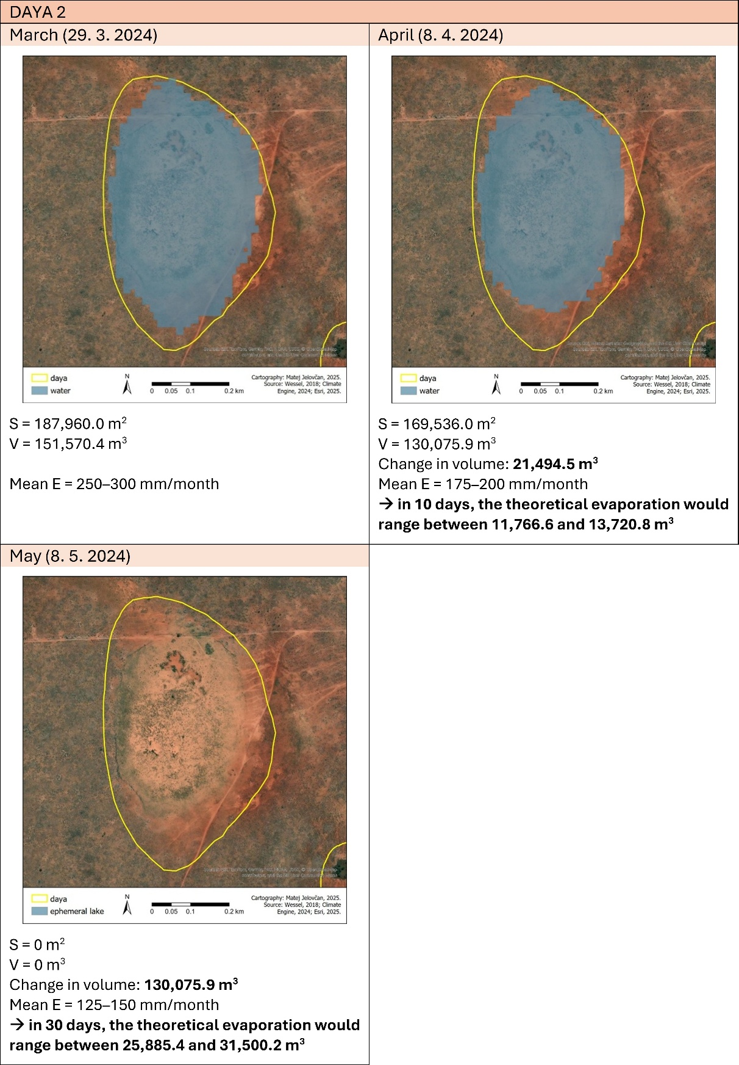

Table 4: Calculations of change in water volume and theoretical evaporation loss for daya 3.
DAYA 3
29.3.2024–8.4.2024 | GIS-derived values for March:  Water level = 140.34 m  Water surface area = 176,791 m²  Water volume = 204,847.5 m³ | GIS-derived values for April:  Water level = 140.10 m  Water surface area = 145,671 m²  Water volume = 161,321.4 m³
29.3.2024–8.4.2024 | Volume difference between March and April dates (10 days) = 204,847.5 m³ – 161,321.4 m³ = 43,526.1 m³
29.3.2024–8.4.2024 | Theoretical evaporation:  V = E × S  March daily value: 0.0081–0.0097 m × 176,791 m² = 1432.0–1714.9 m³/day  April daily value: 0.0058–0.0067 m × 176,791 m² = 1025.4–1184.5 m³/day  2 days × 1432.0–1714.9 + 8 days × 1025.4–1184.5 = 2864.0–3429.8 + 8203.2–9476.0 = 11,067.2–12,905.8 m³  Over 10 days, the theoretical evaporation would range between 11,067.2–12,905.8 m³.
8.4.2024–8.5.2024 | GIS-derived values for April:  Water level = 140.10 m  Water surface area = 145,671 m²  Water volume = 161,321.4 m³ | GIS-derived values for May:  Water level = 139.72 m  Water surface area = 116,365 m²  Water volume = 103,593.0 m³
8.4.2024–8.5.2024 | Volume difference between April and May dates (30 days) = 161,321.4 m³ – 103,593.0 m³ = 57,728.4 m³
8.4.2024–8.5.2024 | Theoretical evaporation:  V = E × S  April daily value: 0.0058–0.0067 m × 145,671 m² = 844.9–976.0 m³/day  May daily value: 0.004–0.0048 m × 145,671 m² = 582.7–699.2 m³/day  22 days x 844.9–976.0 + 8 days x 582.7–699.2 = 18,587.8–21,472.0 + 4661.6–5593.6 = 23,249.4–27,065.6 m³  Over 30 days, the theoretical evaporation would range between 23,249.4–27,065.6 m³.
8.5.2024–22.6.2024 | GIS-derived values for May:  Water level = 139.72 m  Water surface area = 116,365 m²  Water volume = 103,593.0 m³ | GIS-derived values for June:  Water level = 139.36 m  Water surface area = 82,859 m²  Water volume = 55,020.5 m³
8.5.2024–22.6.2024 | Volume difference between May and June dates (45 days) = 103,593.0 m³ – 55,020.5 m³ = 48,572.5 m³
8.5.2024–22.6.2024 | Theoretical evaporation:  V = E × S  May daily value: 0.004–0.0048 m × 116,365 m² = 465.5–558.6 m³/day  June daily value: 0.0033–0.0042 m × 116,365 m² = 384.0–488.7 m³/day  23 days x 465.5–558.6 + 22 days x 384–488.7 = 10,706.5–12,847.8 + 8448.0–10,751.4 = 19,154.5–23,599.2 m³  Over 45 days, the theoretical evaporation would range between 19,154.5–23,599.2 m³.
22.6.2024–22.7.2024 | GIS-derived values for June:  Water level = 139.36 m  Water surface area = 82,859 m²  Water volume = 55,020.5 m³ | GIS-derived values for July:  Water level = /  Water surface area = 0 m²  Water volume = 0 m³
22.6.2024–22.7.2024 | Volume difference between June and July dates (35 days) = 55,020.5 m³ – 0 m³ = 55,020.5 m³
22.6.2024–22.7.2024 | Theoretical evaporation:  V = E × S  June daily value: 0.0033–0.0042 m × 82,859 m² = 273.4–348.0 m³/day  July daily value: 0.0033–0.0042 m × 82,859 m² = 273.4–348.0 m³/day  35 x 273.4–348.0 = 9569.0–12,180.0 m³  Over 35 days, the theoretical evaporation would range between 9569.0–12,180.0 m³.

Figure 2: Visuals and calculations for daya 3.


