Utilisation of biomass and waste-derived ashes in the extrusion of fired clay bricks: mechanical properties, microstructure and leaching behaviour

Lea Žibret¹, Majda Pavlin¹, Vilma Ducman^{1,*}

¹ Laboratory for Cements, Mortars and Ceramics, The Department of Materials, Slovenian National Building and Civil Engineering Institute (ZAG), Dimičeva ulica 12, 1000 Ljubljana, Slovenia

* Corresponding author
Supplementary materials

Supplement 1: Raw materials: (a) ashes and (b) clay. Photos F1, B1, F3, B3, F4 and B4 have been previously published in Materials Vol. 16 Iss. 15 (2023) by S. Tominc and V. Ducman [42].
(a)
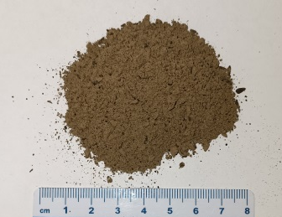 | 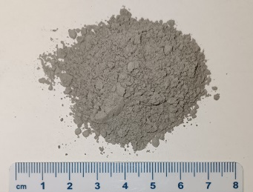 | 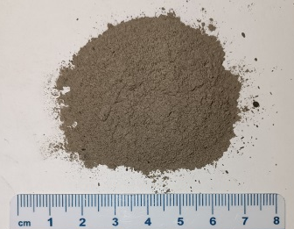 | 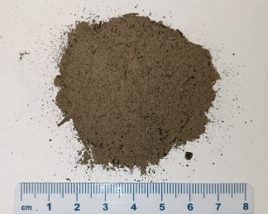
F1 | F2 | F3 | F4
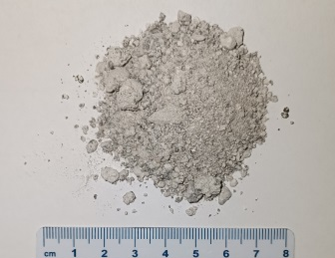 | 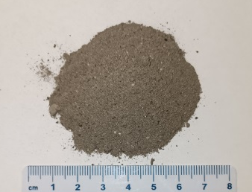 | 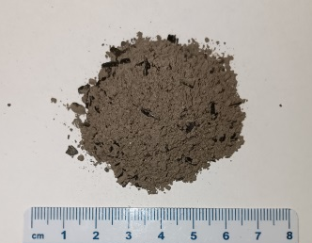 | 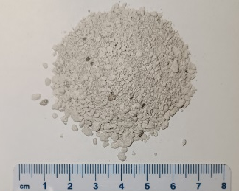
B1 | B2 | B3 | B4
(b)
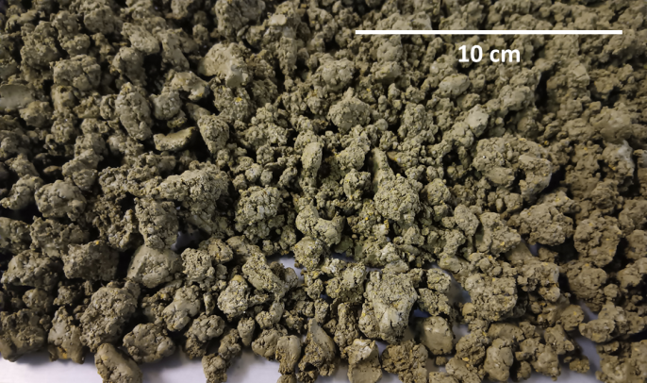
Supplement 2: XRD pattern and major phases of the fired brick specimens with various mass % (ma%) of the ash F1: A-0 = 0 ma%; A-2 = 5 ma%; A-1 = 10 ma%; A-3 = 15 ma%.
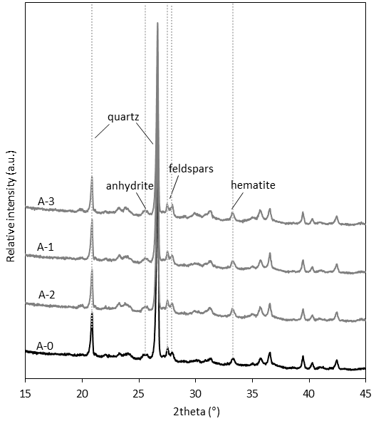

Supplement3: XRD pattern and major phases of the fired brick specimens with 10 mass% of various ashes: (a) F1 (A-1) and B1 (A-5); (b) F2 (A-14) and B2 (A-8); (c) F3 (A-12) and B3 (A-10); (d) F4 (A-18) and B-4 (A-15*). * The maximum ash content, which allowed proper shaping was 5 ma% (A-15).
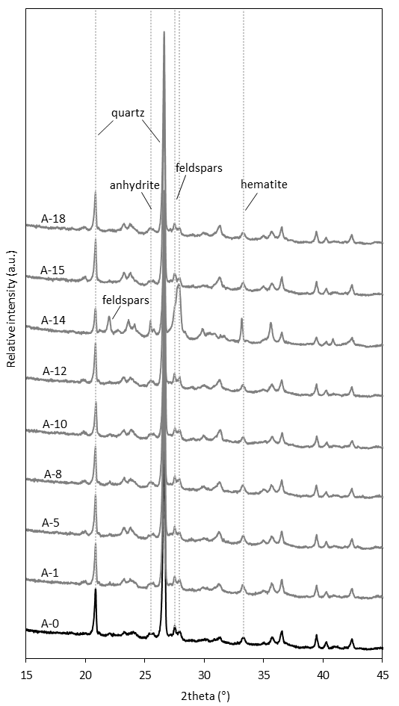

Supplement 4: The model of crack development under the influence of vacuum extrusion (sample A-5). 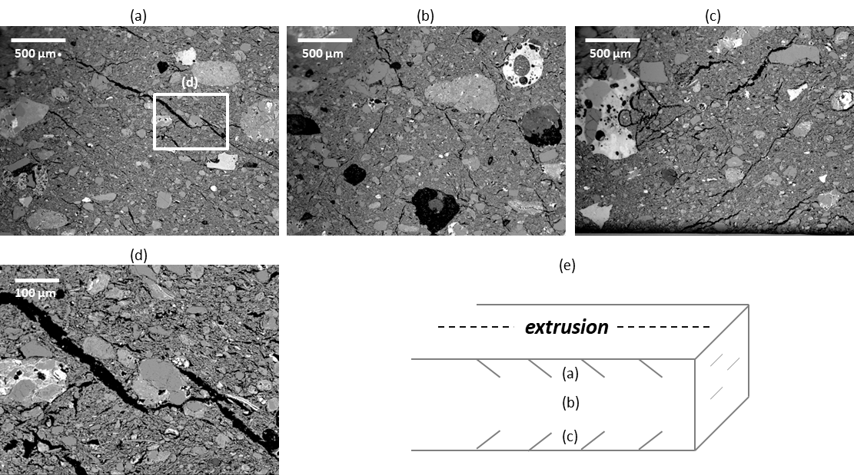

Supplement 5: (a-d) Elongated calcite grain in sample A-8 that turned into lime during firing and caused cracks: SEM/BSE images (a-c) and EDXS element maps of the main elements (d).
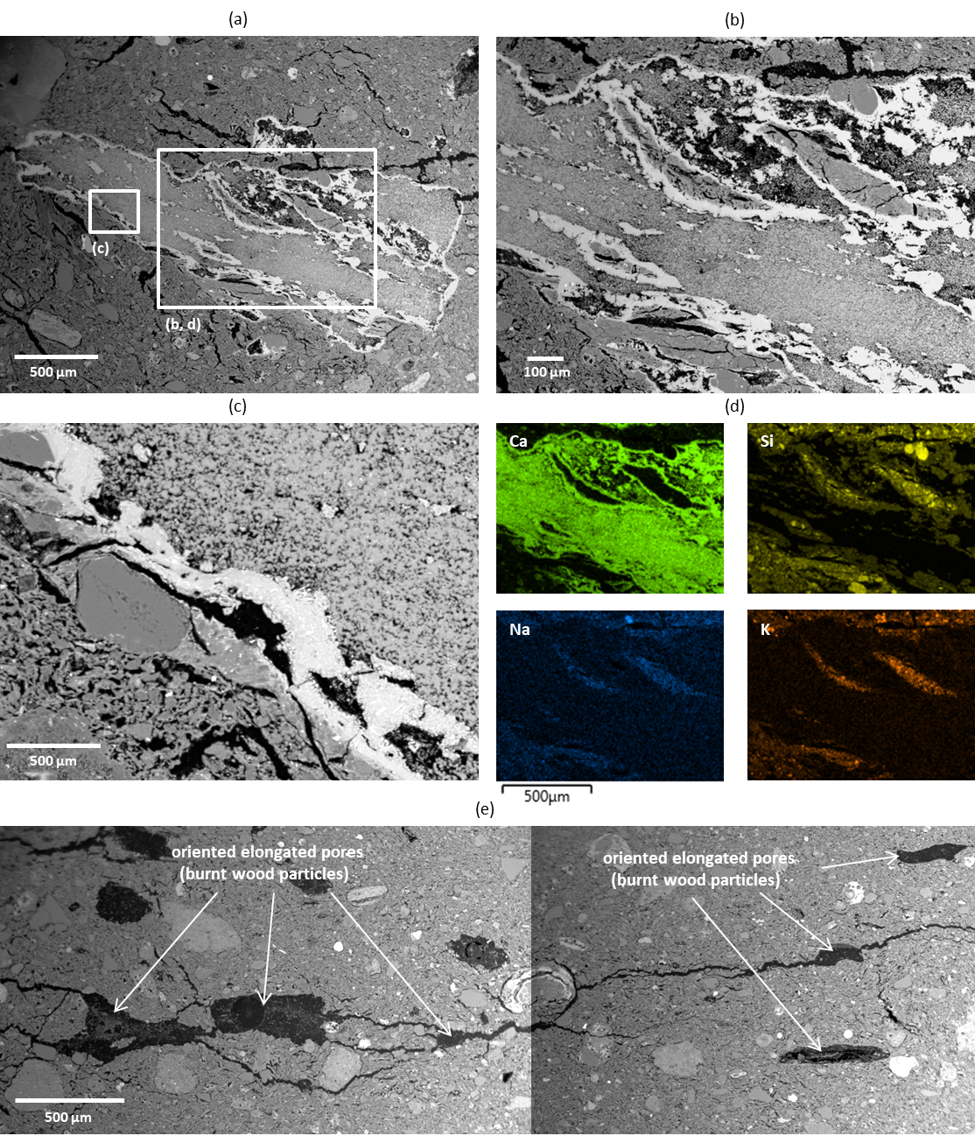

Supplement 6: Development of horizontal firing cracks in brick sample with wood ash (A-12).

Supplement 7: Clasts with calcite and quartz grains in sample A-15: SEM/BSE images (a) and EDXS element maps of the main elements (b). Calcite turned into lime during firing and caused cracks, which near clasts had subparallel orientation. In bricks with PS FA cracks were isolated (c) while in bricks with PS BA cracks appeared in larger zones (d).


