This is the Author-Accepted Version of the paper: B. Podgornik. 2026. Materials role and challenges of green transition. In Razvoj industrijskega inženiringa: priložnosti, potenciali in izzivi za zeleni prehod z uporabo umetne inteligence = Development of industrial engineering: opportunities, potentials and challenges for green transition through the use of artificial intelligence : zbornik recenziranih prispevkov 10. mednarodne znanstvene konference = proceedings of reviewed papers of 10th International Scientific Conference : Novo mesto, 14. maj 2026, p. 33-39.

Vloga materialov in pasti zelenega prehoda

Materials role and challenges of green transition

Bojan Podgornik^{1,2}

¹ Fakulteta za industrijski inženiring, Novo mesto, Slovenija, ²Inštitut za kovinske materiale in tehnologije, Ljubljana, Slovenija
E-naslovi: bojan.podgornik@imt.si

Povzetek: Prehod v podnebno nevtralno družbo je pogosto predstavljen kot transformacija energetskega sistema, vendar v resnici pomeni širšo preobrazbo industrijskih procesov in rabe materialov. Prispevek obravnava vlogo materialov in industrije pri zelenem prehodu ter poudarja ključne medsebojne povezave in sistemske omejitve. Čeprav obnovljivi viri energije, elektrifikacija in vodik predstavljajo pomembne poti za zmanjševanje emisij toplogrednih plinov, njihova široka uvedba povečuje potrebe po materialih, poglablja odvisnost od dobavnih verig in odpira vprašanja celotnega okoljskega odtisa. Posebna pozornost je namenjena energetsko intenzivnim industrijam ter kritičnim surovinam, ki so ključne za nizkoogljične tehnologije. Analiza kaže, da številne rešitve sicer zmanjšujejo neposredne emisije, vendar lahko hkrati povzročajo nove okoljske in družbene obremenitve vzdolž globalnih verig vrednosti. Zato je za doseganje resnične podnebne nevtralnosti nujen celosten pristop, ki vključuje analizo življenjskega cikla, načela krožnega gospodarstva in odgovorno upravljanje z materiali. Rezultati poudarjajo ključno vlogo materialov in inženirstva materialov pri zagotavljanju trajnostnega in dolgoročno vzdržnega zelenega prehoda.

Ključne besede: zeleni prehod, materiali, obnovljivi viri energije, reciklaža, trajnost

Razvrstitev: Znanstveni prispevek

Abstract: The transition towards climate neutrality is often framed as a shift in energy systems; however, it fundamentally represents a broader transformation of industrial processes and material use. This paper critically examines the role of materials and industry in enabling the green transition, highlighting key interdependencies and systemic constraints. While renewable energy, electrification and hydrogen technologies offer viable pathways for reducing greenhouse gas emissions, their large-scale deployment is associated with increased material demand, supply chain dependencies and significant life-cycle impacts. Particular attention is given to energy-intensive industries and the growing importance of critical raw materials required for low-carbon technologies. The analysis demonstrates that many proposed solutions, although effective at reducing operational emissions, introduce new environmental and resource challenges across global value chains. Therefore, achieving true climate neutrality requires a holistic, life-cycle-based approach that integrates decarbonization, circular economy principles and responsible material management. The findings emphasize that materials science and engineering play a central role in balancing performance, sustainability and resource availability, and are essential for ensuring a resilient and truly sustainable green transition.

Keywords: green transition, materials, renewable energy, recycling, sustainability

Article Classification: Scientific Paper

INTRODUCTION

Climate change represents one of the most pressing challenges of modern society, driven primarily by anthropogenic greenhouse gas (GHG) emissions associated with energy production, industrial activities, transport and material use. In response, Europe has adopted an ambitious objective to become the first climate-neutral continent by 2050, aiming to balance GHG emissions with natural and technological carbon removal processes [1]. Achieving climate neutrality requires not only substantial emission reductions, but also compensation of unavoidable emissions through carbon sinks such as forests, soils and oceans. However, the transition to a climate-neutral society extends far beyond emission reduction alone. It represents a systemic transformation of energy systems, industrial production, mobility patterns and resource management.

From a global perspective, greenhouse gas emissions are dominated by energy-related activities, which account for approximately three-quarters of total emissions (Fig. 1), with electricity and heat production, industry and transport representing the largest contributing sectors [2]. Despite significant progress within the European Union, where emissions have been reduced by nearly 30% over the past decades while maintaining economic growth, climate change remains a global challenge [3]. The European Union today contributes less than 10% of global GHG emissions, whereas regions such as Asia account for the dominant share due to rapid industrialization and economic expansion [3]. This imbalance introduces the critical issue of carbon leakage, where emission-intensive production is relocated to regions with less stringent environmental regulations. While such shifts may reduce emissions within Europe, they often fail to reduce global emissions and may even increase them when considering embedded emissions in imported goods [4]. Therefore, the effectiveness of the green transition must be evaluated from a global life-cycle perspective, taking into account emissions across entire value chains. A comprehensive approach to climate neutrality must integrate decarbonization of energy systems, transformation of industrial processes and sustainable resource management. Only by addressing these interdependencies can the green transition deliver meaningful and lasting reductions in global environmental impact.

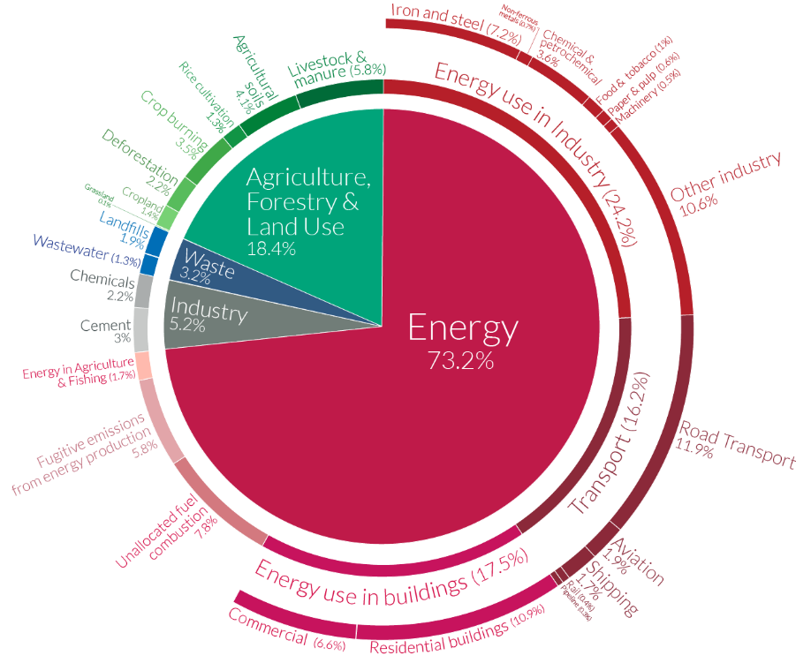
Figure 1: Global GHG emissions in 2020 by sectors [10]

This paper adopts a structured analytical approach based on a critical review and synthesis of scientific literature, policy reports and industrial data sources. The analysis focuses on identifying key interdependencies between energy systems, material use and industrial processes, with particular emphasis on life-cycle perspectives and resource constraints. The study is qualitative in nature and aims to provide a system-level assessment of the challenges associated with the green transition.

ROLE OF INDUSTRY IN DECARBURIZATION

Industry plays a central role in the transition towards climate neutrality, accounting for approximately 20% of greenhouse gas (GHG) emissions in Europe and an even larger share globally when indirect energy-related emissions are considered [2]. Decarbonizing industrial systems is therefore essential, yet particularly challenging due to the inherent complexity of production processes, high energy demand and long lifetimes of industrial assets. A fundamental pillar of industrial decarbonization is the transition towards a circular economy, aimed at reducing dependence on primary raw materials and minimizing waste generation. This includes extending product lifetimes, improving reparability and increasing the use of recycled materials. However, despite its recognized importance, circularity remains limited in practice, with only around 12% of secondary materials currently reintroduced into the EU economy [5]. This highlights a substantial untapped potential for reducing both resource consumption and associated emissions. At the same time, the green transition is inherently material-intensive. Clean energy technologies, electrification and hydrogen systems require large quantities of strategic and critical raw materials such as lithium, nickel, copper, aluminum and rare-earth elements [6]. Their extraction and processing are highly energy-intensive and often associated with significant environmental impacts. Consequently, industrial decarbonization cannot be achieved without simultaneous decarbonization of energy supply, as nearly 70% of industrial energy consumption globally still relies on fossil fuels [7].

The greatest challenge lies within energy-intensive industries (EIIs), including steel, cement, aluminum and chemical sectors. These industries account for the majority of industrial emissions (Fig. 1) due to their reliance on high-temperature processes and, in some cases, unavoidable process-related emissions. Steel and cement production alone each contribute approximately 7% of global CO₂ emissions [7]. In such sectors, conventional efficiency improvements are insufficient, and transformative technological changes are required. Several technological pathways are currently being developed to address these challenges. In steel production, the shift from blast furnace routes to electric arc furnaces (EAF), particularly when combined with recycled feedstock and renewable electricity, can reduce emissions by up to 75% [8]. Further reductions are expected through the development of hydrogen-based direct reduction processes (DRI-H₂), which have the potential to nearly eliminate process emissions. Similarly, aluminum production can achieve substantial emission reductions through recycling, as secondary aluminum requires up to 95% less energy compared to primary production without compromising material properties [9].

Despite these advantages, increasing the share of secondary production faces multiple barriers, including insufficient collection systems, limited availability of high-quality scrap and inefficient material separation technologies. In parallel, industrial side-streams represent a largely underutilized resource. Significant amounts of potentially valuable materials are still treated as waste due to technical, economic and regulatory constraints, including inconsistent quality, lack of standardization and underdeveloped value chains [10].

In addition to technological and material challenges, industrial decarbonization in Europe is strongly influenced by global economic dynamics. Stringent environmental regulations increase production costs and may incentivize relocation of emission-intensive industries to regions with less strict climate policies, leading to carbon leakage [4]. To address this, the European Union has introduced the Carbon Border Adjustment Mechanism (CBAM), aimed at ensuring that imported products reflect their embedded carbon emissions and that domestic decarbonization efforts are not undermined. Overall, the industrial sector represents both one of the largest challenges and one of the most critical enablers of the green transition. Achieving substantial emission reductions requires a combination of material efficiency, circular economy practices, low-carbon energy supply and breakthrough process innovations. Without a successful transformation of industrial systems, climate neutrality targets cannot be achieved, nor can a sustainable and secure supply of materials for the green transition be ensured.

ENERGY TRANSITION

The decarbonization of the energy system is the cornerstone of the green transition, as energy production and use account for approximately three-quarters of global greenhouse gas (GHG) emissions and a comparable share within the European Union [2,11]. Despite decades of policy efforts and technological progress, the global and European energy systems remain strongly dependent on fossil fuels. In the EU, oil, natural gas and coal still dominate the energy mix, while renewables and nuclear energy represent a significantly smaller share. Globally, the situation is even more pronounced, with fossil fuels accounting for more than 80% of primary energy consumption in most regions [12]. This structural dependency represents a fundamental barrier to rapid decarbonization.

The transition towards renewable energy sources (RES), including solar, wind and hydropower, is therefore essential. In recent years, renewables have experienced significant growth, driven by decreasing costs and supportive policy frameworks. However, their integration into the energy system is associated with several systemic challenges. First, renewable energy sources are inherently variable and dependent on weather conditions, leading to intermittency in electricity generation. This requires substantial investments in grid infrastructure, energy storage and system flexibility to ensure stable and reliable energy supply. Second, the scale of renewable deployment required to meet climate targets is unprecedented. Achieving climate neutrality by 2050 will require a massive expansion of renewable generation capacity, including large-scale offshore wind and solar installations. At the same time, electrification of transport, heating and industrial processes will significantly increase electricity demand, further amplifying the need for clean energy production. This creates a dual challenge: decarbonizing existing energy supply while simultaneously expanding it.

A critical but often overlooked aspect of the energy transition is its material intensity. Renewable energy technologies require substantially larger quantities of raw materials compared to conventional fossil-based systems (Fig. 2). Wind turbines, solar panels, batteries and grid infrastructure depend on metals such as copper, aluminum, lithium and rare-earth elements, the supply of which is geographically concentrated and limited [13,14]. This introduces new dependencies and risks. In this context, hydrogen is increasingly recognized as a key energy carrier capable of complementing electrification and enabling decarbonization of sectors that are difficult to electrify directly. These include high-temperature industrial processes, long-distance transport, shipping and aviation. Green hydrogen, produced via water electrolysis using renewable electricity, offers the potential for near-zero emissions energy use. However, its large-scale deployment is constrained by several factors. First, hydrogen production is highly energy-intensive. Producing green hydrogen requires significantly more electricity compared to direct electrification pathways, making its efficiency relatively low [15]. Second, the carbon footprint of hydrogen strongly depends on the electricity mix. If produced using fossil-based electricity, hydrogen may have equal or even higher emissions than conventional fuels, undermining its environmental benefits [16]. Third, hydrogen storage and transport present additional technical challenges due to its low volumetric energy density, requiring either high-pressure compression or liquefaction at extremely low temperatures, both of which are energy demanding [17]. Furthermore, hydrogen technologies rely on critical materials such as nickel, platinum and iridium, which are associated with supply risks and high costs [18]. This adds another layer of complexity to the energy transition, linking energy system transformation directly to material availability and sustainability.

Overall, the energy transition is not merely a technological shift from fossil fuels to renewables, but a complex systemic transformation involving energy, materials, infrastructure and global supply chains. While renewable energy and hydrogen provide viable pathways toward decarbonization, their large-scale implementation is constrained by physical, material and economic limitations. Addressing these challenges requires an integrated approach that combines expansion of renewable energy, improvements in energy efficiency, development of energy storage solutions and responsible management of material resources.

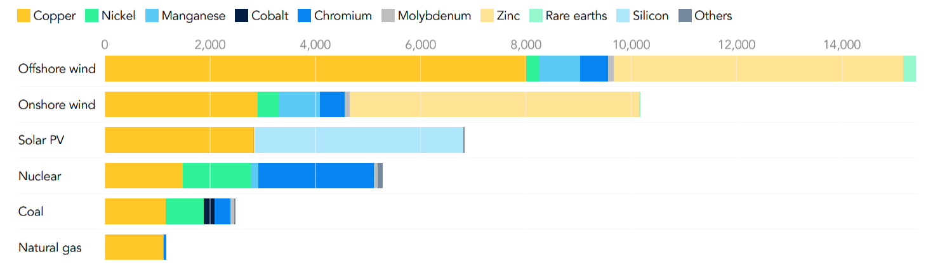
Figure 2: Minerals required in kilograms per MW of electrical generation from different energy source [19]

MATERIALS AS ENABLERS OF THE GREEN TRANSITION

While the green transition is often framed in terms of decarbonization and the deployment of renewable energy technologies, it is fundamentally a materials transition. The shift from a fossil-based energy system to one based on renewable electricity, electrification and hydrogen fundamentally changes the material basis of the economy, increasing both the quantity and complexity of materials required [19]. Consequently, materials are not merely passive components of green technologies, but critical enablers that determine their performance, scalability and sustainability. A defining feature of low-carbon technologies is their significantly higher material intensity compared to conventional systems. For example, electric vehicles require several times more mineral inputs than internal combustion engine vehicles, while renewable power generation technologies, particularly wind and solar demand substantially larger quantities of metals such as copper, aluminum and rare-earth elements [19]. Over the past two decades, the average material requirement per unit of installed renewable capacity has increased markedly (Fig. 2), reflecting the transition towards more complex and resource-intensive technologies. This increasing demand is particularly pronounced for a group of strategic and critical raw materials, including lithium, nickel, cobalt, manganese, graphite and rare-earth elements. These materials are essential for key components such as batteries, permanent magnets, photovoltaic cells and hydrogen technologies [13]. Their functional properties, such as high energy density, magnetic performance or catalytic activity are often difficult to substitute, making them indispensable for the deployment of clean technologies.

However, the supply of these materials is characterized by strong geographical concentration and limited diversification (Fig. 3). For instance, the production and processing of rare-earth elements is dominated by a small number of countries, while significant shares of lithium and cobalt resources are located in regions with environmental, social and governance challenges [14]. This creates supply risks, price volatility and geopolitical dependencies, particularly for regions such as Europe, which have limited domestic extraction and processing capacities. In addition to supply risks, the environmental footprint associated with raw material extraction and processing presents a critical challenge. Mining and refining of critical materials are energy-intensive processes that can lead to significant greenhouse gas emissions, land degradation, water consumption and biodiversity loss. In some cases, the environmental impact of material production represents a substantial share of the total life-cycle impact of green technologies, potentially offsetting part of their environmental benefits if not properly managed. These challenges highlight the importance of adopting a life-cycle perspective when evaluating the sustainability of green technologies. The environmental performance of a technology cannot be assessed solely based on its operational emissions, but must also include upstream impacts related to material extraction, processing and manufacturing, as well as end-of-life management and recycling.

In this context, circular economy strategies play a central role in mitigating material-related constraints. Increasing the use of secondary raw materials through recycling can significantly reduce both energy consumption and emissions. Despite evident advantages, current recycling rates for many critical materials remain low, particularly due to technical challenges, insufficient collection systems and the complex composition of modern products. Another important but underutilized opportunity lies in the valorization of industrial side-streams. Many industrial processes generate by-products that contain valuable materials, yet these streams are often treated as waste due to lack of appropriate technologies, standards and market structures [10]. Developing efficient pathways for their utilization could significantly reduce the demand for primary raw materials and improve overall resource efficiency.
Beyond improving material efficiency and circularity, reducing dependence on critical raw materials also requires innovation in materials design. This includes the development of alternative materials with lower criticality, improved recyclability and reduced environmental impact. Examples include cobalt-free battery chemistries, reduced rare-earth permanent magnets and alternative catalysts for hydrogen technologies [18]. However, such substitutions often involve trade-offs in performance, cost or scalability, requiring careful optimization.

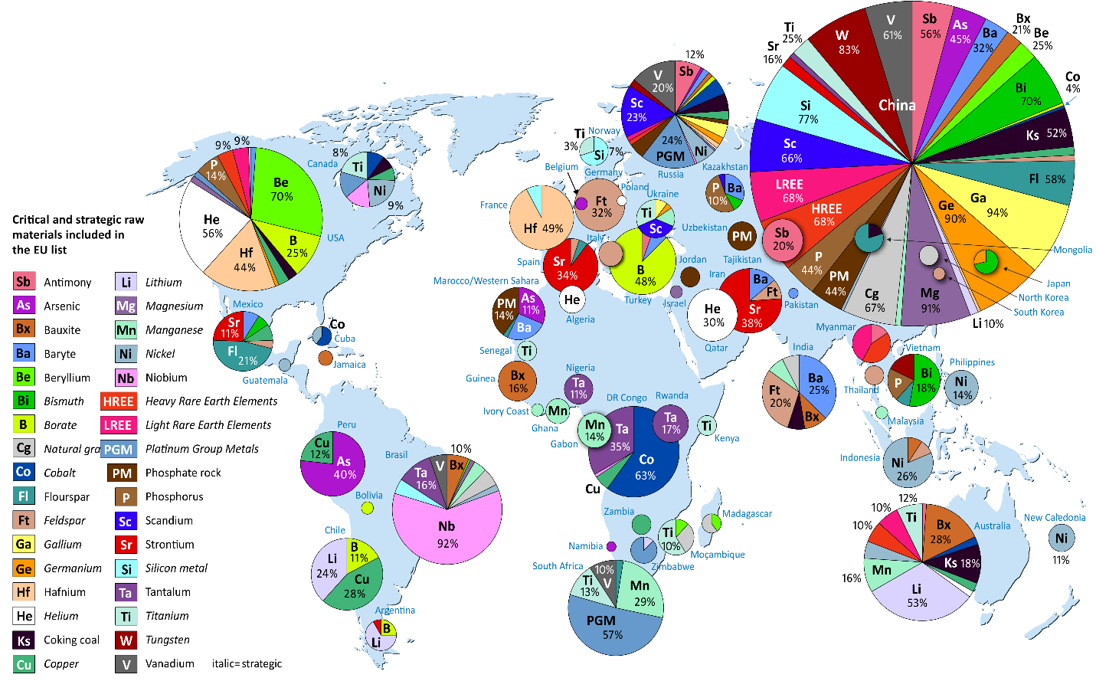
Figure 3: Global distribution of critical and strategic raw materials [6]

The rapid growth in demand for materials driven by the green transition raises fundamental questions about long-term resource availability. Projections indicate that demand for key materials such as lithium, nickel and rare-earth elements could increase several-fold by 2040, depending on the pace of decarbonization [20]. At the same time, mining capacity, processing infrastructure and recycling systems may not scale at the same rate, creating potential bottlenecks that could slow down the transition. For Europe, these challenges are particularly pronounced. The region is highly dependent on imports for most critical raw materials and currently lacks sufficient mining, refining and recycling capacity to ensure supply security [13]. This has led to the development of strategic initiatives aimed at strengthening domestic capabilities, diversifying supply chains and increasing material circularity. However, achieving these goals will require substantial investments, regulatory support and technological innovation.

Overall, the success of the green transition is intrinsically linked to the availability, sustainability and efficient use of materials. While renewable energy technologies and electrification pathways offer clear opportunities for reducing operational emissions, their large-scale deployment introduces new environmental and resource challenges. Addressing these challenges requires an integrated approach that combines responsible sourcing, improved material efficiency, circular economy strategies and innovation in materials science and engineering. In this context, materials science emerges as a key discipline in enabling the green transition, providing solutions that balance performance, sustainability and resource constraints. Without a fundamental shift in how materials are sourced, used and managed, the transition to a climate-neutral society may face significant limitations in both scalability and long-term sustainability.

TECHNOLOGY SPECIFIC LIMITATIONS

Although low-carbon technologies are essential for achieving climate neutrality, none of them are without limitations. Their large-scale deployment introduces technical, material, environmental and systemic challenges that must be critically addressed to ensure a truly sustainable transition. A central example is electric mobility, widely regarded as a key solution for decarbonizing transport. While battery electric vehicles (BEVs) can significantly reduce tailpipe emissions, their overall environmental performance strongly depends on the electricity mix used for charging. When powered by fossil-based electricity, life-cycle emissions of BEVs may approach or even exceed those of efficient internal combustion engine vehicles [20]. Furthermore, battery production is highly material-intensive, requiring large quantities of lithium, cobalt, nickel and other critical materials, the extraction of which is associated with environmental degradation, high energy consumption and social concerns [21]. End-of-life management presents an additional challenge, as recycling of lithium-ion batteries remains complex, energy-intensive and economically demanding [22]. Combined with growing demand for batteries, these factors raise concerns regarding long-term resource availability and sustainability. It needs to be taken into account that the number of new electric cars registered in the EU increased from only 600 in 2010 to over 2 million in 2022, but still being far away from the EU target of having 30 million zero-emission cars in operation on European roads by 2030. Globally, electric vehicles sales in 2022 exceeded 10 million cars. However, this still represents less than 2% of the global passenger cars fleet, not yet following the overall growth and 95% of electric vehicles being restricted to China, Europe and North America, as shown in Figure 4 [23]. By 2050 the global vehicle fleet is set to double!
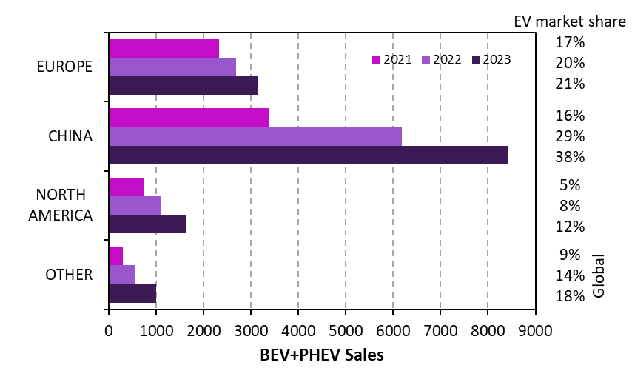
Figure 4: Electric cars sales and market share [23]

Solar energy, often perceived as one of the cleanest energy sources, also involves significant upstream environmental impacts. The production of photovoltaic (PV) panels requires energy-intensive processes and the use of hazardous chemicals, including fluorinated gases and other toxic substances [24]. Although operational emissions are low, it may take several years for a solar panel to offset emissions generated during its production. In addition, relatively low conversion efficiencies and gradual performance degradation over time necessitate large-scale installations, which can lead to land use conflicts, habitat disruption and local climate effects such as the photovoltaic heat island phenomenon [25]. End-of-life management of PV panels represents another growing concern, as recycling infrastructure remains limited and significant volumes of waste are expected in the coming decades [26].

Wind energy faces a different set of challenges. While wind turbines produce low operational emissions, their manufacturing relies on both critical and non-critical materials with substantial environmental footprints. Rare-earth elements used in permanent magnets are associated with environmentally intensive mining and processing, as well as supply risks due to geographic concentration [27]. At the same time, the bulk of turbine mass consists of steel and concrete, whose production is highly energy-intensive and contributes significantly to overall emissions. End-of-life issues are particularly pronounced for turbine blades, which are difficult to recycle due to their composite structure, leading to increasing volumes of waste and reliance on landfill or downcycling solutions. Additional concerns include land use, visual impact, noise and potential local climate effects associated with large wind farms [28].

Hydrogen technologies, often highlighted as a key solution for decarbonizing hard-to-abate sectors, are similarly constrained by efficiency and infrastructure challenges. The environmental benefits of hydrogen depend critically on its production pathway. While green hydrogen produced via electrolysis using renewable electricity offers low emissions, it requires significantly higher energy input compared to direct electrification [15]. If produced using fossil-based electricity, hydrogen may have a higher carbon footprint than conventional fuels [16]. Storage and transport further complicate its deployment, as hydrogen has low volumetric energy density, requiring compression or liquefaction, both of which are energy-intensive processes [17]. In addition, hydrogen technologies rely on scarce and costly materials such as platinum and iridium, creating further supply constraints [18].

Across all these technologies, a common pattern emerges. Their environmental performance cannot be evaluated solely based on operational emissions, but must consider full life-cycle impacts, including material extraction, production, use and end-of-life phases. Moreover, large-scale deployment amplifies challenges related to material demand, infrastructure requirements and system integration. These limitations do not undermine the importance of low-carbon technologies, but rather emphasize the need for a balanced and system-oriented approach. Sustainable transition requires not only technological innovation, but also improvements in material efficiency, circularity, infrastructure development and responsible resource management. Without addressing these interconnected constraints, the green transition risks shifting environmental burdens rather than reducing them.

CONCLUSIONS

The transition to climate neutrality is not merely an energy transition, but a fundamental transformation of the industrial and material backbone of modern society. While renewable energy, electrification and hydrogen are essential for reducing emissions, their large-scale deployment reveals a critical reality: decarbonization is inherently resource- and material-intensive. When assessed from a full life-cycle perspective, many low-carbon technologies do not eliminate environmental impact, but redistribute it across global supply chains, often beyond Europe’s borders.

Achieving a truly sustainable transition therefore requires a systemic approach that integrates energy, materials and industrial processes. Circular economy principles, responsible sourcing and material innovation must become central strategies, not secondary considerations. Ultimately, the success of the green transition will not depend only on how effectively we replace fossil fuels, but on how intelligently we manage materials and technological complexity. In this context, materials science and engineering are not supporting elements, but decisive enablers of a sustainable future.

REFERENCES

[1] European Green Deal, European Council, https://www.consilium.europa.eu/en/policies/green-deal/; accessed 20.04.2026
[2] RITCHIE, H. Sector by sector: where do global greenhouse gas emissions come from?, Our World In Data, 2020, https://ourworldindata.org/ghg-emissions-by-sector; accessed 20.04.2026
[3] RITCHIE, H., ROSADO, P., ROSER, M. Greenhouse gas emissions, Our World in Data, https://ourworldindata.org/greenhouse-gas-emissions; accessed 20.04.2026
[4] LEONARD, M., PISANI-FERRY, J., SHAPIRO, J., TAGLIAPIETRA, S., WOLFF, G. The geopolitics of the European Green Deal, European Council on Foreign Relations, https://ecfr.eu/publication/the-geopolitics-of-the-european-green-deal/; accessed 22.10.2024
[5] The European Green Deal - a roadmap to a sustainable economy, Public Agency Ihobe, 2020, https://www.ihobe.eus/news/the-european-green-deal-a-roadmap-to-a-sustainable-economy; accessed 20.04.2026
[6] Geological Survey of Sweden, Critical and strategic raw material, 2024, https://www.sgu.se/en/mineral-resources/critical-raw-materials/; accessed 20.04.2026.
[7] IEA, Energy Technology Perspectives 2020, 2020, https://www.iea.org/reports/energy-technology-perspectives-2020; accessed 20.04.2026
[8] TOTO, D. Study confirms EAF advantage in carbon emissions, Recycling today, July 2022, https://www.recyclingtoday.com/news/us-steelmaking-75-percent-less-carbon-emission/; accessed 20.04.2026
[9] BEHESHTI, R. Sustainable aluminium and iron production, Ph.D. Thesis, KTH Royal Institute of Technology, Sweden, 2017
[10] LEPPÄNEN, T., KÖPMAN, J., RASILA, O., TERVONEN, P. Categorization of Industrial Side Streams for Reuse Potential Evaluation, International Journal of Management, Knowledge and Learning, Vol. 10 (2021) 253-265.
[11] European Environment Agency, Greenhouse gas emission intensity of electricity generation in Europe, November 2025, https://www.eea.europa.eu/en/analysis/indicators/greenhouse-gas-emission-intensity-of-1; retrieved 20.04.2026
[12] RITCHIE, H., ROSADO, P. Energy Mix, Our World in Data, 2020, https://ourworldindata.org/energy-mix; retrieved 20.04.2026
[13] GROHOL, M., VEEH C., Study on the critical raw materials for the EU 2023 – Final report, Publications Office of the European Union, 2023, doi/10.2873/725585
[14] CARRARA, S. et al. Supply chain analysis and material demand forecast in strategic technologies and sectors in the EU – A foresight study, Publications Office of the European Union, Luxembourg, 2023, doi:10.2760/386650, JRC132889.
[15] GODFREY NNABUIFE, S., HAMZAT, A.K., WHIDBORNE, J., KUANG, B., JENKINS, K.W. Integration of renewable energy sources in tandem with electrolysis: A technology review for green hydrogen production, International Journal of Hydrogen Energy, Vol. 107 (2025) 218-240
[16] WEISS, T., GAMAGE, C., KOCH BLANK, T., LILLIS, G., JARDINE WALL, A. Hydrogen Reality Check: All “Clean Hydrogen” Is Not Equally Clean, RMI, October 2022, https://rmi.org/all-clean-hydrogen-is-not-equally-clean/; accessed 20.04.2026
[17] ESSLER, J. et al. Report on Technology Overview and Barriers to Energy- and Cost-Efficient Large Scale Hydrogen Liquefaction, IDEALHY project (FP7/2007-2013, grant agreement no. 278177), June 2012, https://www.idealhy.eu/; accessed 20.04.2026
[18] EIKENG, E., MAKHSOOS, A., POLLET, B.G. Critical and strategic raw materials for electrolysers, fuel cells, metal hydrides and hydrogen separation technologies, International Journal of Hydrogen Energy, Vol. 71 (2024) 433-464
[20] IEA, The Role of Critical Minerals in Clean Energy Transitions, 2022, https://www.iea.org/reports/the-role-of-critical-minerals-in-clean-energy-transitions, accessed 20.04.2026
[21] European Environment Agency, Progress of EU transport sector towards its environment and climate objectives, https://www.eea.europa.eu/publications/progress-of-eu-transport-sector-1; accessed 20.04.2026
[22] ZHENG, M. The Environmental Impact of Lithium and Cobalt Mining, Earth.org, March 2023, https://earth.org/lithium-and-cobalt-mining/; accessed 20.04.2026
[23] SKEETE, J.-P., WELLS, P., DONG, X., HEIDRICH, O., HARPER, G. Beyond the EVent horizon: Battery waste, recycling, and sustainability in the United Kingdom electric vehicle transition, Energy Research & Social Science, Vol. 69 (2020) 101581
[24] The global electric vehicle market overview in 2025, VIRTA, https://www.virta.global/en/global-electric-vehicle-market; retrieved 20.04.2026
[25] HESS, J.C. Chip Production’s Ecological Footprint: Mapping Climate and Environmental Impact, Interface, June 2024, https://www.interface-eu.org/publications/download/chip-productions-ecological-footprint; accessed 20.04.2026
[26] BARRON-GAFFORD, G.A. et al. The Photovoltaic Heat Island Effect: Larger solar power plants increase local temperatures, Scientific Reports, Vol. 6 (2016) 35070
[27] Weckend, S., Wade, A., Heath, G. End-of-Life Management – Solar Photovoltaic Panels, International Renewable Energy Agency, June 2016, https://www.irena.org/-/media/Files/IRENA/Agency/Publication/2016/IRENA_IEAPVPS_ End-of-Life_Solar_PV_Panels_2016.pdf; accessed 20.04.2026
[28] LI, Jiashuo et al. Critical Rare-Earth Elements Mismatch Global Wind-Power Ambitions, One Earth, Vol. 3 (2020) 116-125
[29] Miller, L.M., Keith, D.W. Climatic Impacts of Wind Power, Joule, Vol. 2 (2018) 2618-2632

