Supporting information (SI) for
In-situ hydroxyapatite mineralization in beech and pine wood: effects of leaching on fire behavior
Matic Sitar ^{a,b}, Sabina Dolenec ^{a,c}, Nataša Knez ª, Miha Hren ª, Boštjan Lesar ^{b}, Andreja Pondelak ^{a,*}
ª Slovenian National Building and Civil Engineering Institute, Dimičeva ulica 12, 1000 Ljubljana, Slovenia
E-mail: (ORCID): matic.sitar@zag.si (0009-0005-3484-3668), sabina.dolenec@zag.si (0000-0003-0483-9623), natasa.knez@zag.si (0000-0002-7080-7358), miha.hren@zag.si (0000-0001-5826-0508), andreja.pondelak@zag.si (0000-0003-1078-389X)
^{b} University of Ljubljana, Biotechnical Faculty, Jamnikarjeva 101, 1000 Ljubljana, Slovenia
Bostjan.Lesar@bf.uni-lj.si (0000-0003-3965-3458)
^{c} University of Ljubljana, Faculty of Natural Sciences and Engineering, Aškerčeva cesta 12, 1000 Ljubljana, Slovenia
*Corresponding author. E-mail address: andreja.pondelak@zag.si (A. Pondelak).
The Supporting information image S1 compares FTIR spectra of synthesised HAp before and after TG analysis compared to purchased HAp.
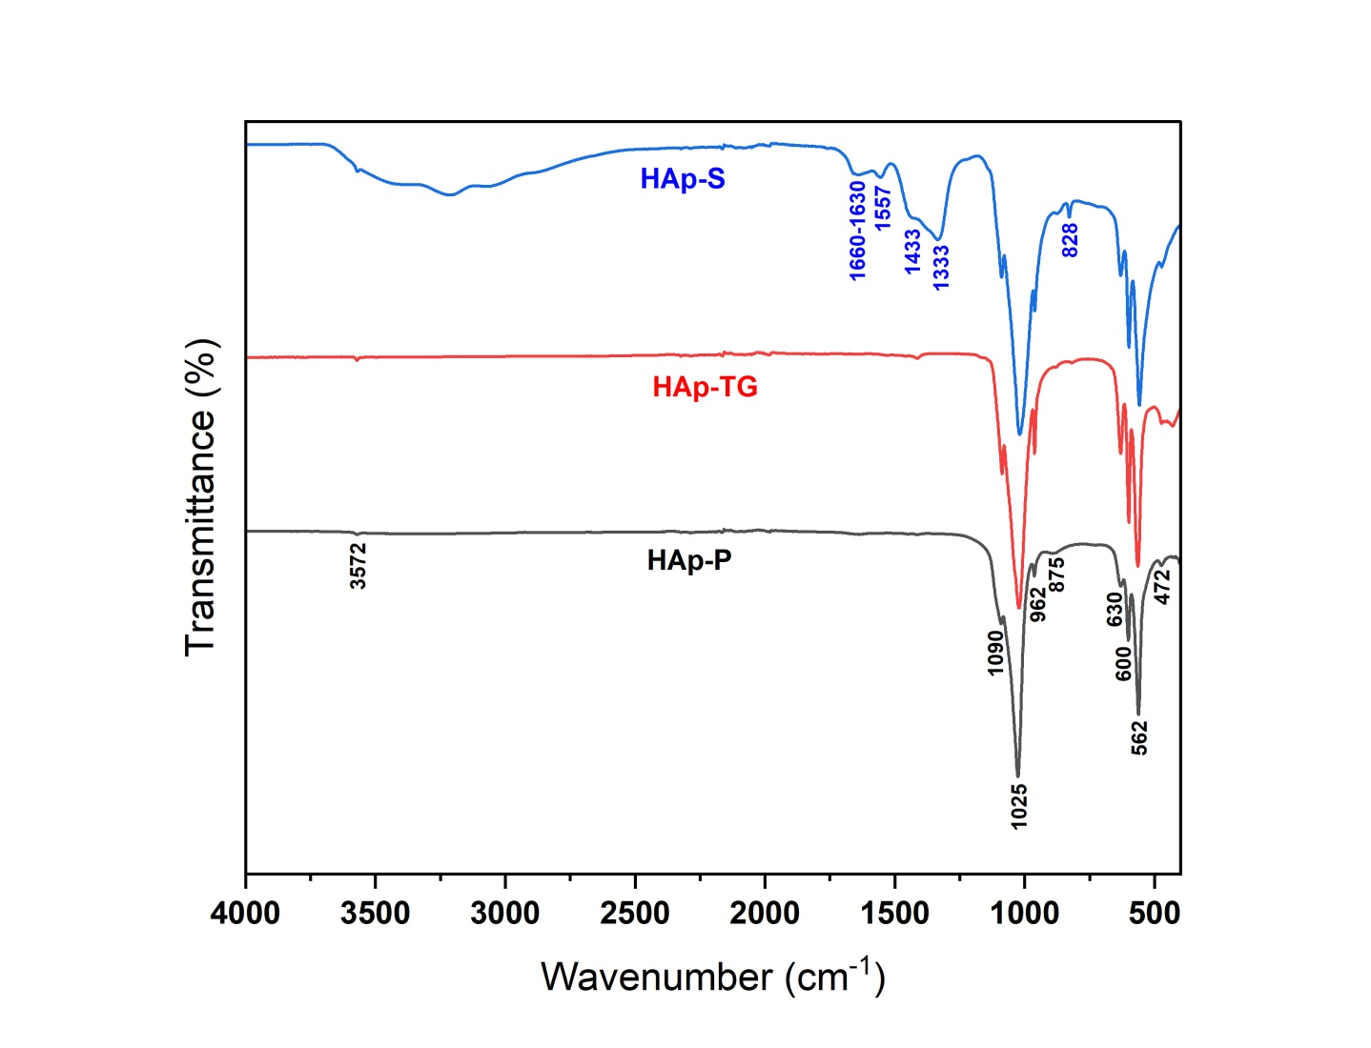
Fig. S1: FTIR spectra of unleached HAp (HAp-S), HAp residue after thermal analysis of the HAp-S sample (HAp-TG) and purchased HAp (HAp-P).

