Digitising Stećci – 3D Documentation and Relief Visualisation of Medieval Tombstones: Supplementary material

Introduction
This text represents the supplementary material part of the paper “The 3D digitisation and visualisation of medieval tombstones (stećci). It contains maps and descriptions of stećci sites mentioned in the main paper and the surface visualizations that were not included in the main paper.

The sites
Milavići
Milavići is a contemporary communal cemetery in the municipality of Bileća. It was a burial site for a larger community during the medieval period, as evidenced by the preservation of 352 stećci tombstones (Bešlagić 1971). Milavići has been part of our research since 2019, focusing on two areas. In Area 1000, four stećci burials were investigated, including removing the tombstones and excavating the graves underneath. Area 2000 is located on the top of the presumed prehistoric burial mound, where, according to local oral tradition, a medieval church was located. The excavation brought to light several medieval burials with or without stećci tombstones and a large building complex with a well-preserved baptismal pool. Further research revealed that the building was much older than initially assumed, dating back to the late Roman period. Milaviči is one of the few sites in the region showing evidence of continuous human activity from prehistoric, Roman, and medieval times.
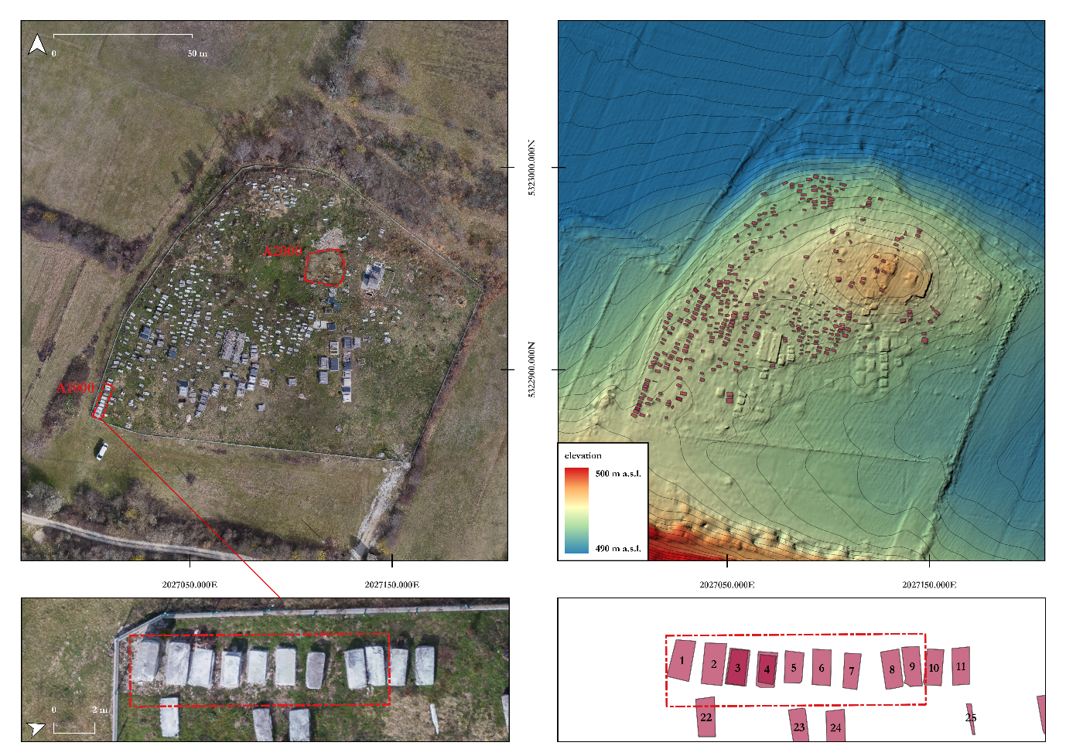
Fig. 1. Map of the Milavići cemetery. Aerial ortophoto of the site with marked excavation areas (left). Airborne LiDAR derived digital elevation model of the site with annotated locations of the stećci tombstones.

Ljuti Do
Ljuti Do cemetery is a medieval and contemporary cemetery by an Orthodox church located on an important east-west communication route. One large prehistoric mound is within the necropolis and several other nearby. Most of the 82 individual stećci can be found in the southwestern part of the necropolis. We fully digitized three tombstones with inscriptions and iconography during the documentation process. All the other tombstones were photographed and measured.
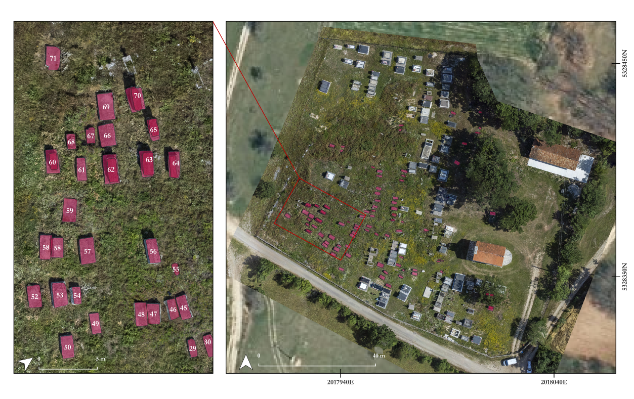
Fig. 2. Map of the cemetery at Ljuti Do. Aerial ortophoto of the cemetery with annotated stećci tombstones (right). A close up of the largest group of tombstones located in the south-western part of the cemetery (left).
Kalac
Kalac cemetery is located by the main road Berkovići-Bileća, near Orahovice village, in the western part of the Fatnica basin. The total number of stećci at this site is unknown, as it was destroyed in the 1970s when the road was constructed. Kalac appears to have been quite a large site, today mostly overgrown by dense vegetation. We digitized two stećci with indications of inscriptions.
Baljci
Baljci or Bunčići (also Grebnice) site is located on a vast plateau north of Bileća, close to the border with Montenegro. It is one of the 28 stećci cemeteries under UNESCO protection, and with 291 tombstones, it represents one of the region's largest stećci cemeteries. Thirty-two stećci have decorations, and seven have inscribed epitaphs in bosančica, a medieval Cyrillic and today's extinct script.

Morine plateau
Morine is a remote highland plateau located at an average altitude of approximately 1500 m. Although the area is mostly uninhabited today, remnants of old pastoral settlements (katuns), prehistoric burial mounds, and stećci gravesites remain scattered throughout the landscape. The region has a rich history of transhumance - the seasonal migration of pastoral communities from the lowlands to the mountain plateaus for summer grazing.
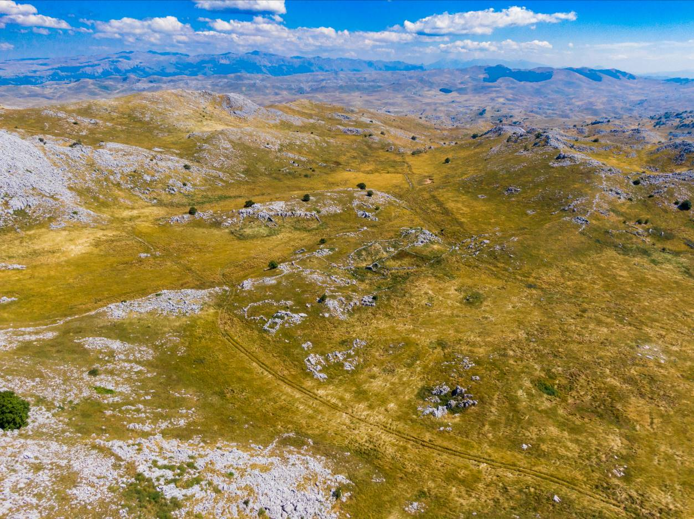
Fig. 3. Aerial view of the Morine plateau.

Busovača
Busovača is a small valley in the south-western part of the Morine plateau, ideal for settlement due to its geographic isolation and two water sources. Though abandoned today, our initial survey uncovered drystone enclosures, small building foundations and two large anthropogenic stone mounds located at the two most accessible entrances to the valley. Carbon dating confirmed that these structures date to the last three centuries. Prehistoric pottery was found near circular stone structures and a small stećci necropolis was discovered on a glacial moraine in the centre of the valley.
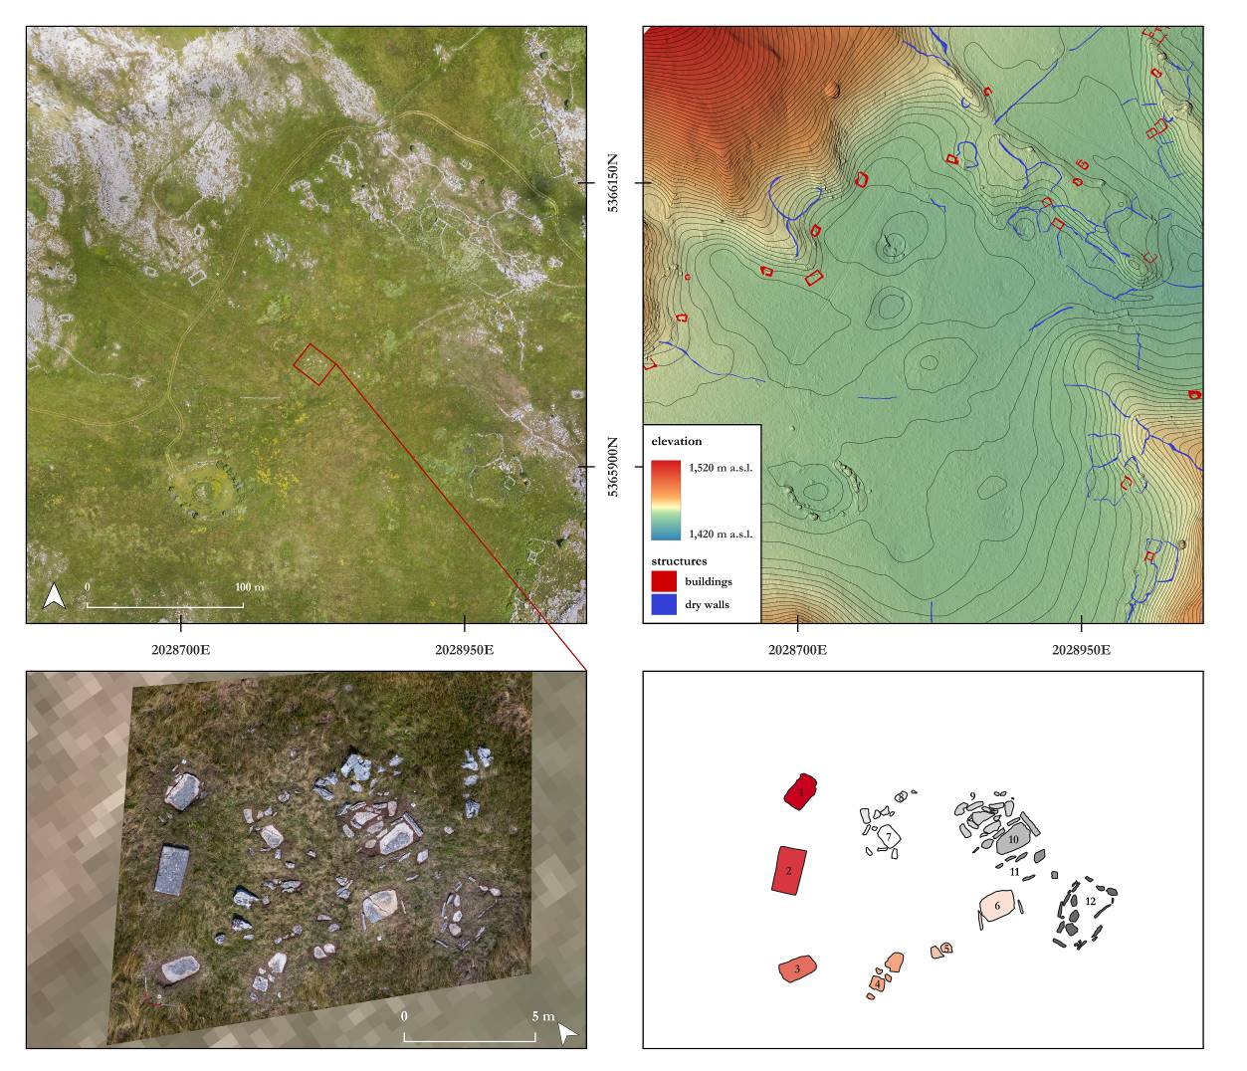
Fig. 4. Map of the Busovača valley. Aerial ortophoto of the valley (upper left). Digital elevation model with the annotated structural remains (upper right). Aerial ortophoto of the stećci burial site located in the central part of the valley (bottom left). Annotated individual graves (bottom right).

Bojčiči Do
Bojčići Do site lays on a mountain pass at 1600m altitude, northwest of the Busovača valley. This remote area is only accessible through a hiking trail. The necropolis with 20 stećci is arranged in two groups, separated by a path. Near the burial site are the remains of a building with drystone foundations situated in a small hollow protected from harsh winds.

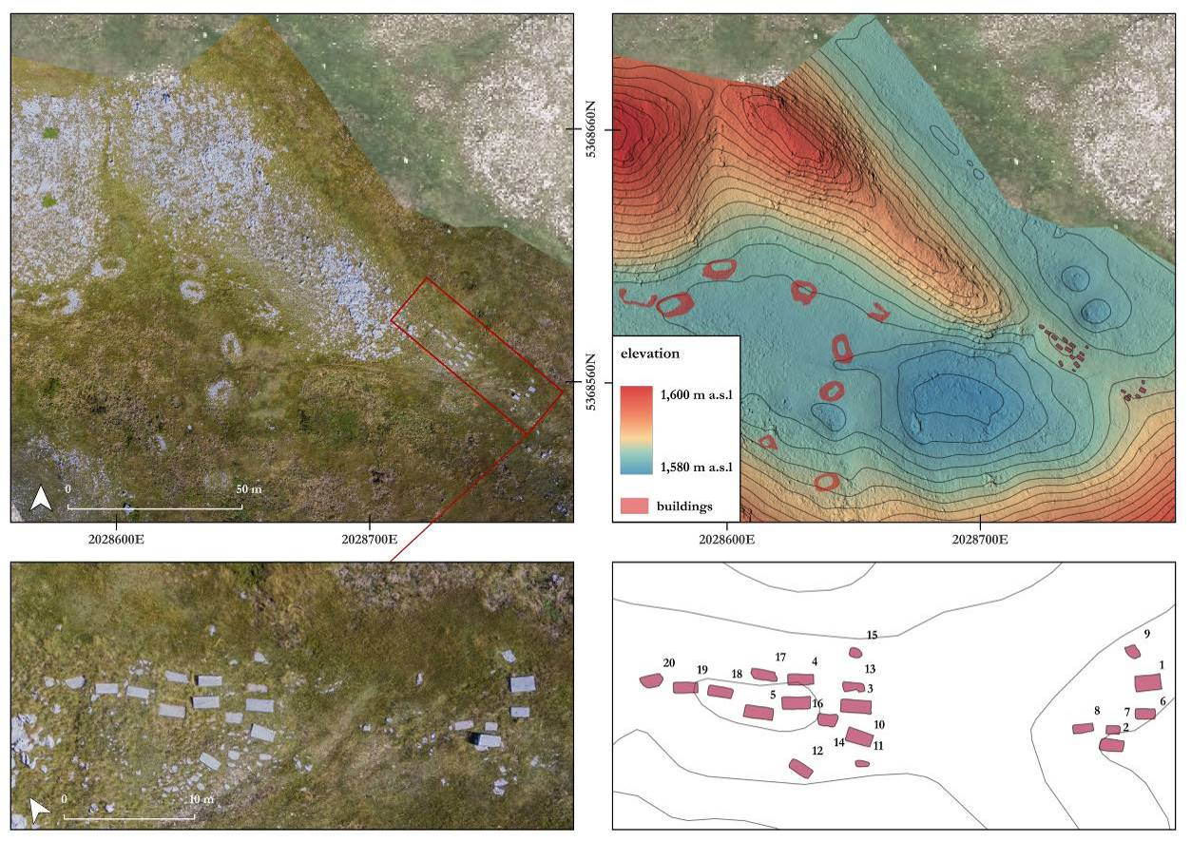
Fig. 5. Map of the Bojčiči Do site. Aerial ortophoto of the stećci cemetery and nearby settlement remains (upper left). Digital elevation model with the annotated stećci tombstones and building remains (upper right). Otrophoto close up the stećci cemetery (bottom left).

The visualisations
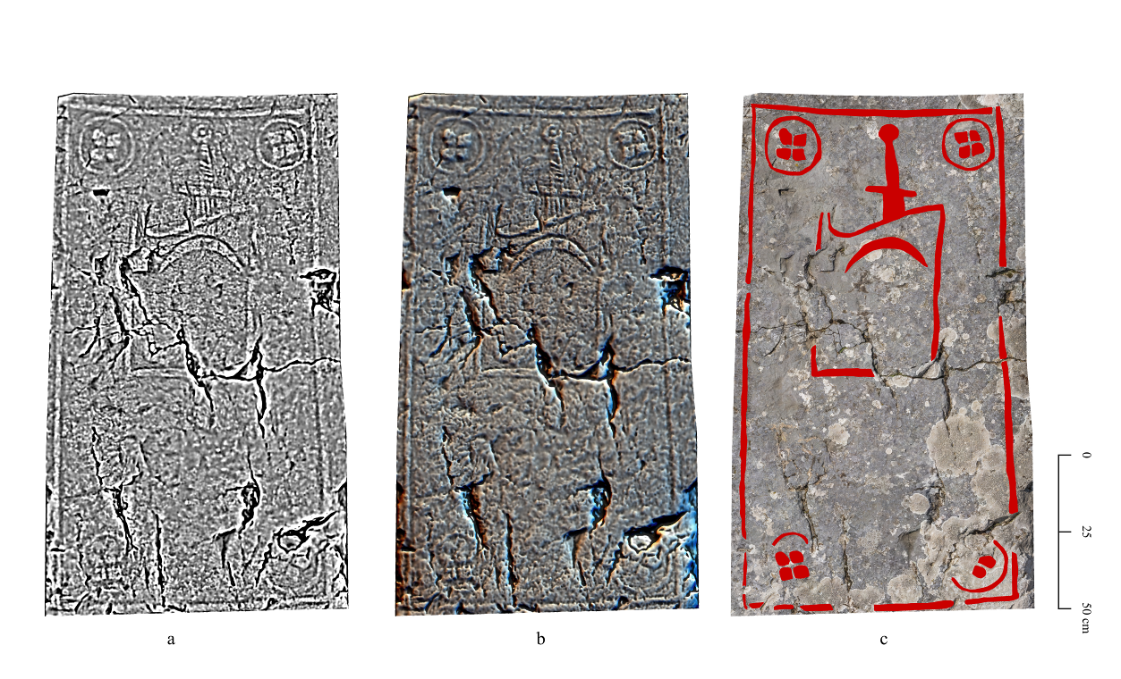
Fig. 6. Top surface of the srećak No. 2 from Busovaća. The iconography includes a shield with an emblem of a crescent moon and a sword behind it. The corners are profiled and decorated with rosette motifs. a) SLRM10. b) SLRM10+ HS D16 H35. c) Annotated features on an ortophoto background.
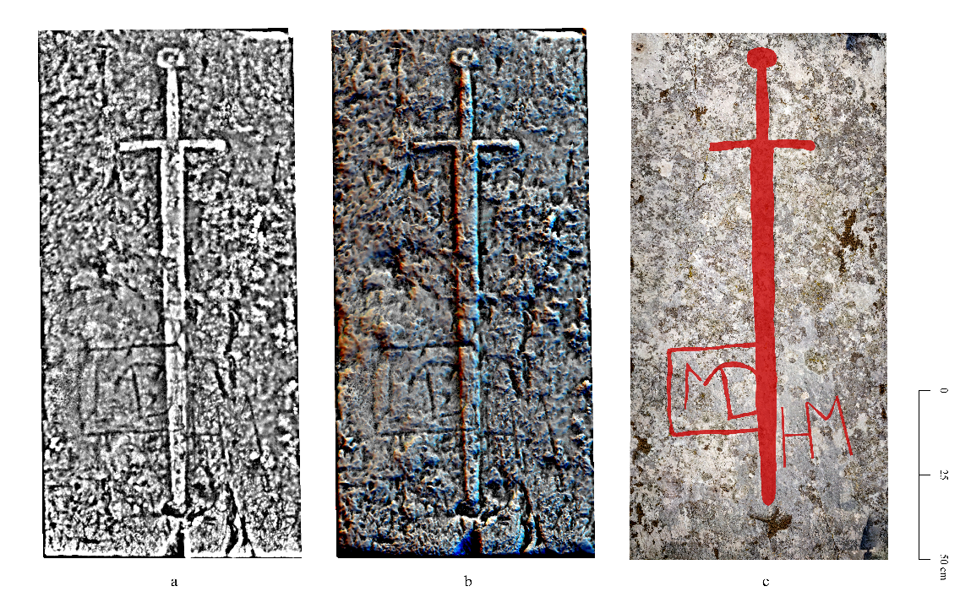
Fig. 7. Top surface of the stećak No. 2 from Bojcići do. The surface is decorated with a sword and the inscription MD HM. a) SLRM25. b) SLRM25+ HS D16 H35. c) Annotated features on an ortophoto background.
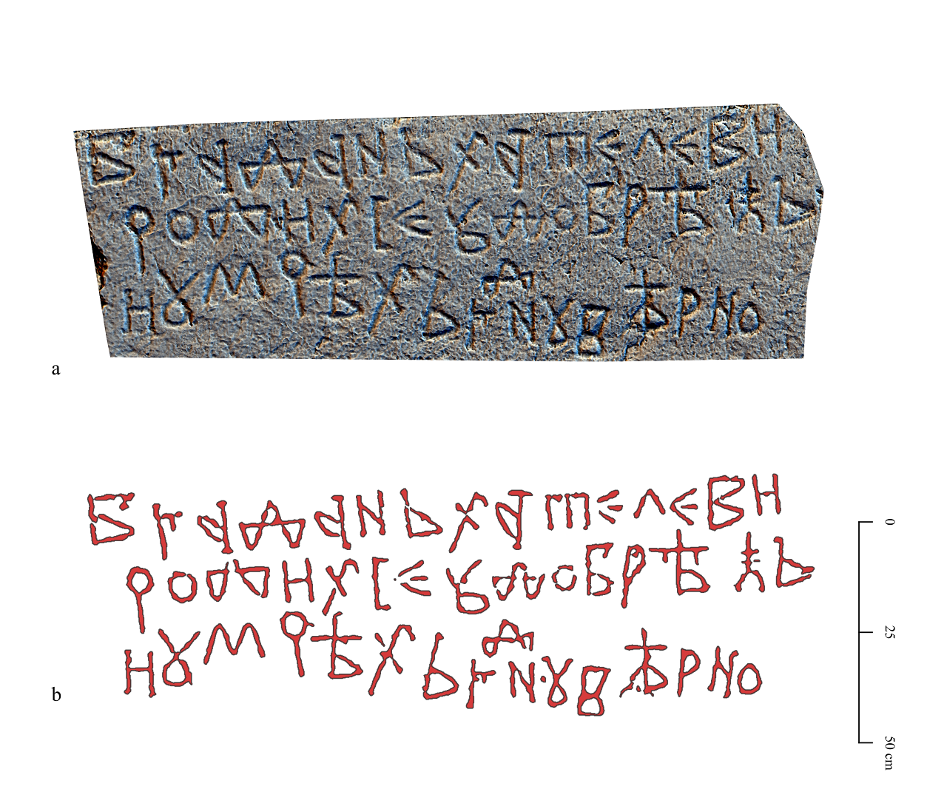
Fig. 8. Stećak No. 56 from Milavići with the inscription of Bogdan Hataljević. a) SLRM25+HS D16 H35. b) Automatically vectorised inscription.
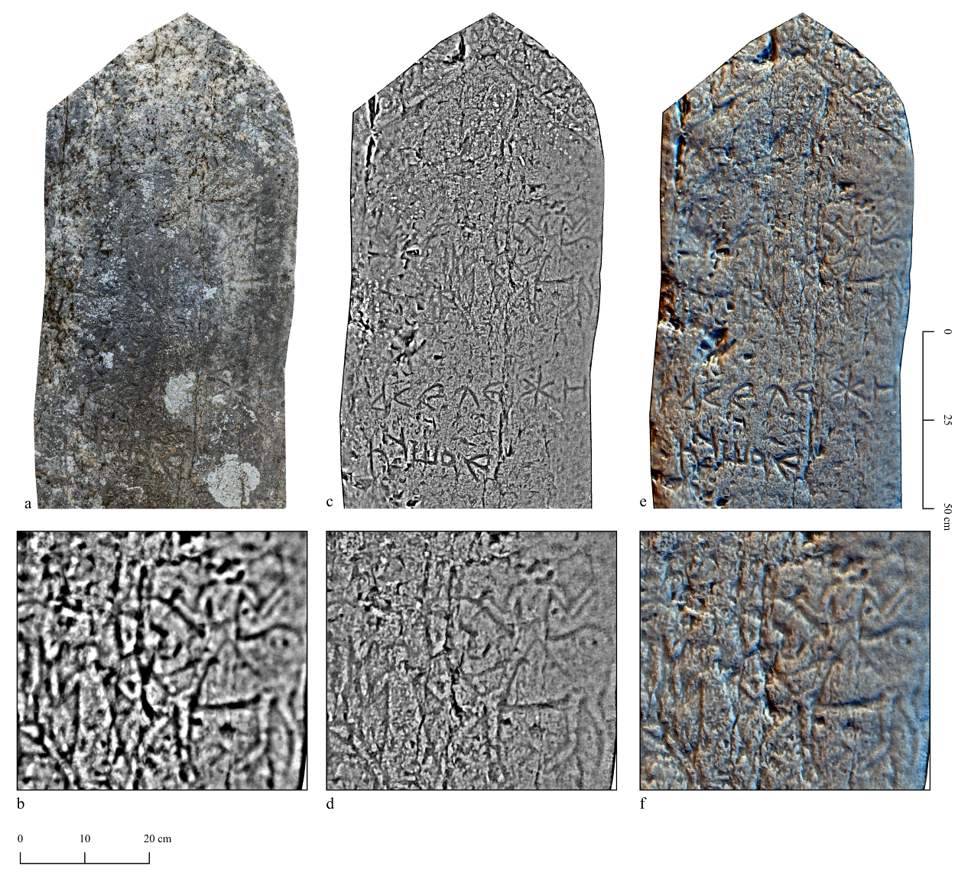
Fig. 9. Stećak No. 1 from Baljci. Decorated with a motif of two riders, flanking a female figure. a) ortophoto. b) SLRM50. c, d) SLRM25. e, f) SLRM25+HS D16 H35.

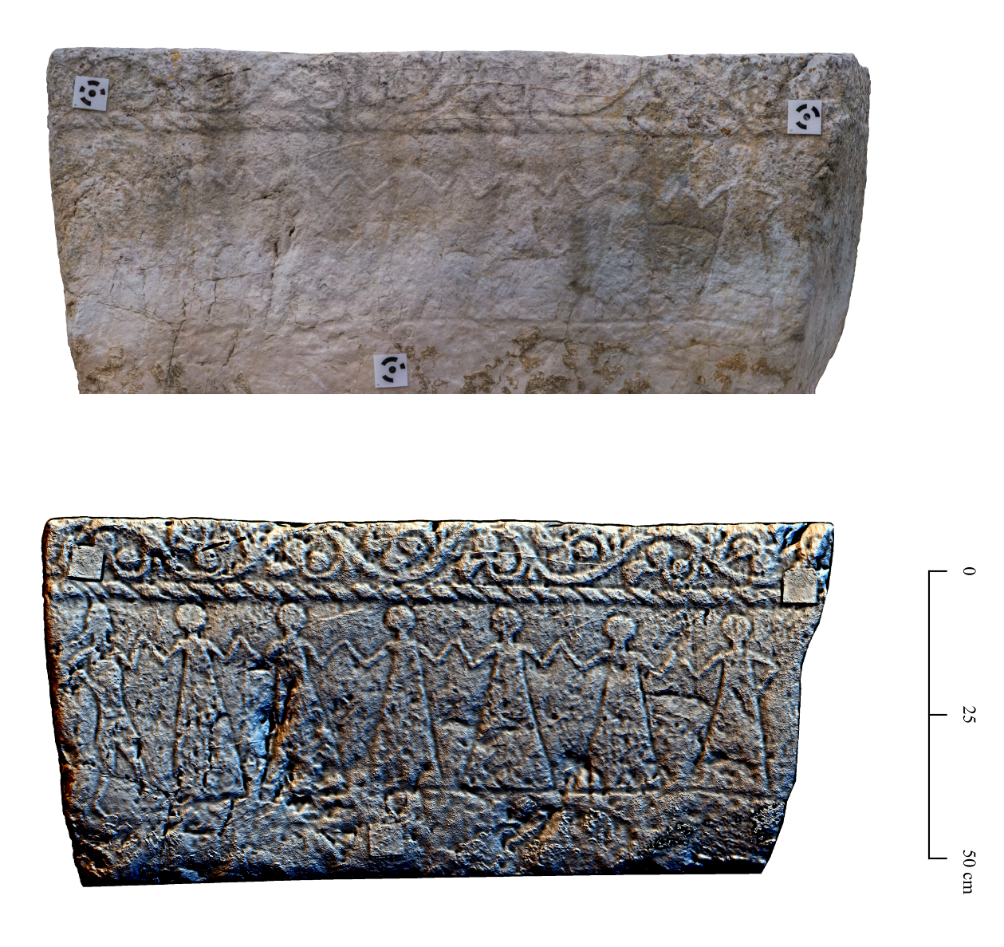
Fig. 10. Stečak No. 4 from Milavići. Ortophoto image of the dancers motif (top). Combined visualisation using SLRM and HSMD (bottom).
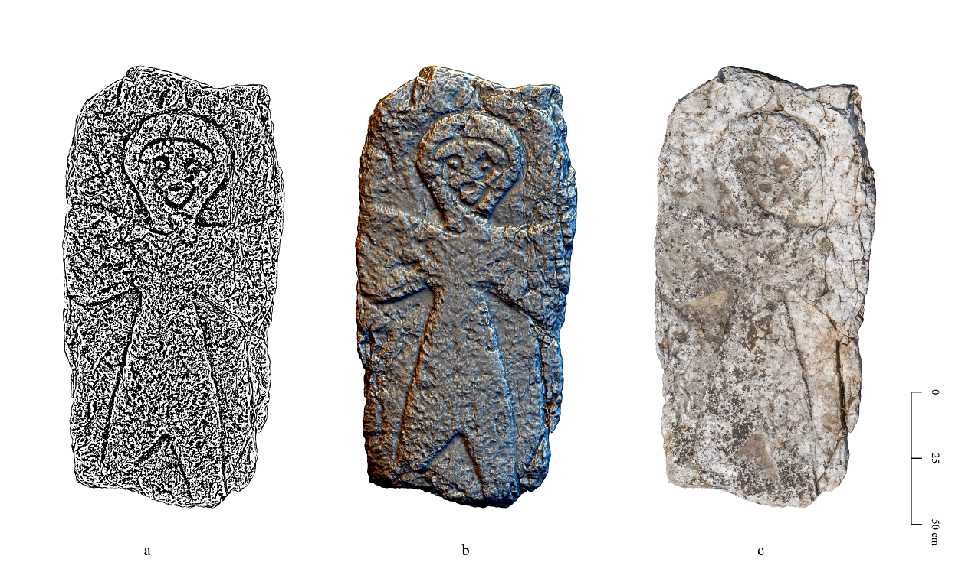
Fig. 11. Stečak No. 423 from Milavići. a) SLRM10 b) SLRM+HSMD c) ortophoto.
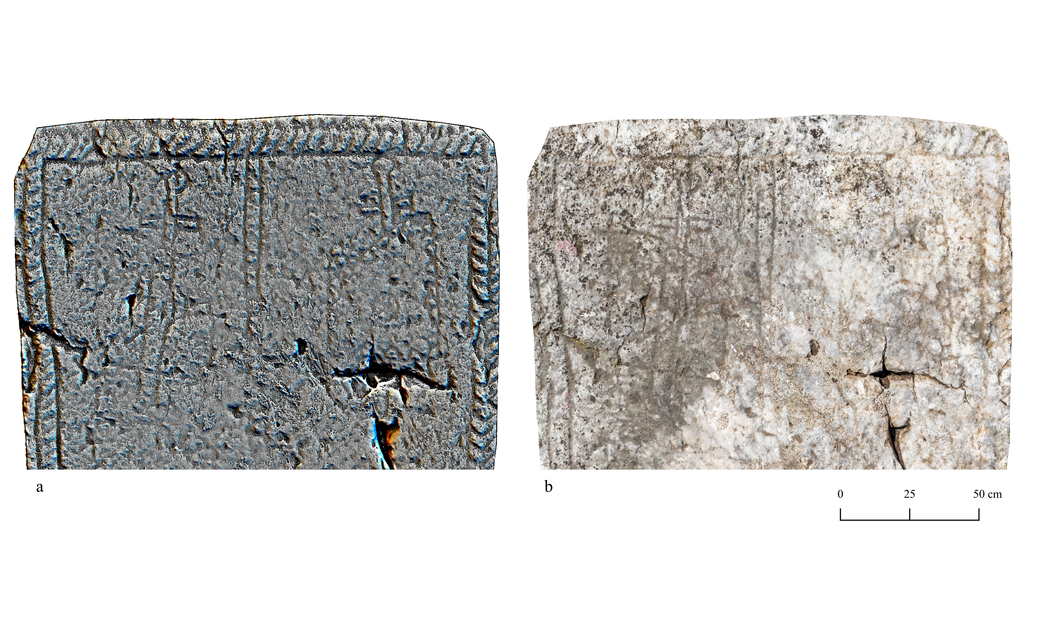
Fig 12. Stečak No. 468 from Milavići. a) SLRM+HSDM c) otophoto.
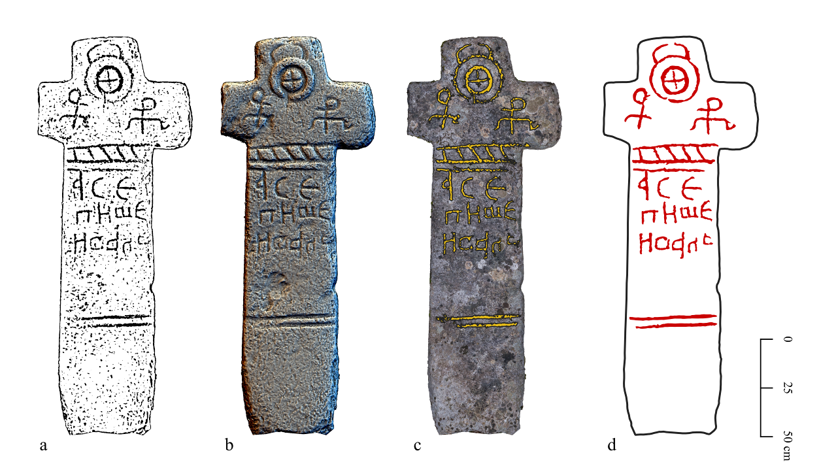
Fig. 13. Stećci No. 2 from Kalac. a) Mask layer based on simple local relief model (R50), b) a combination of simple local relief model (R25) and hillshading from three directions, c) automatic vectorization on an orthophoto background, and d) manual annotation. Transcription: A se piše Ivan/ This is written by Ivan (after Vego 1964, 25, n. 149).

