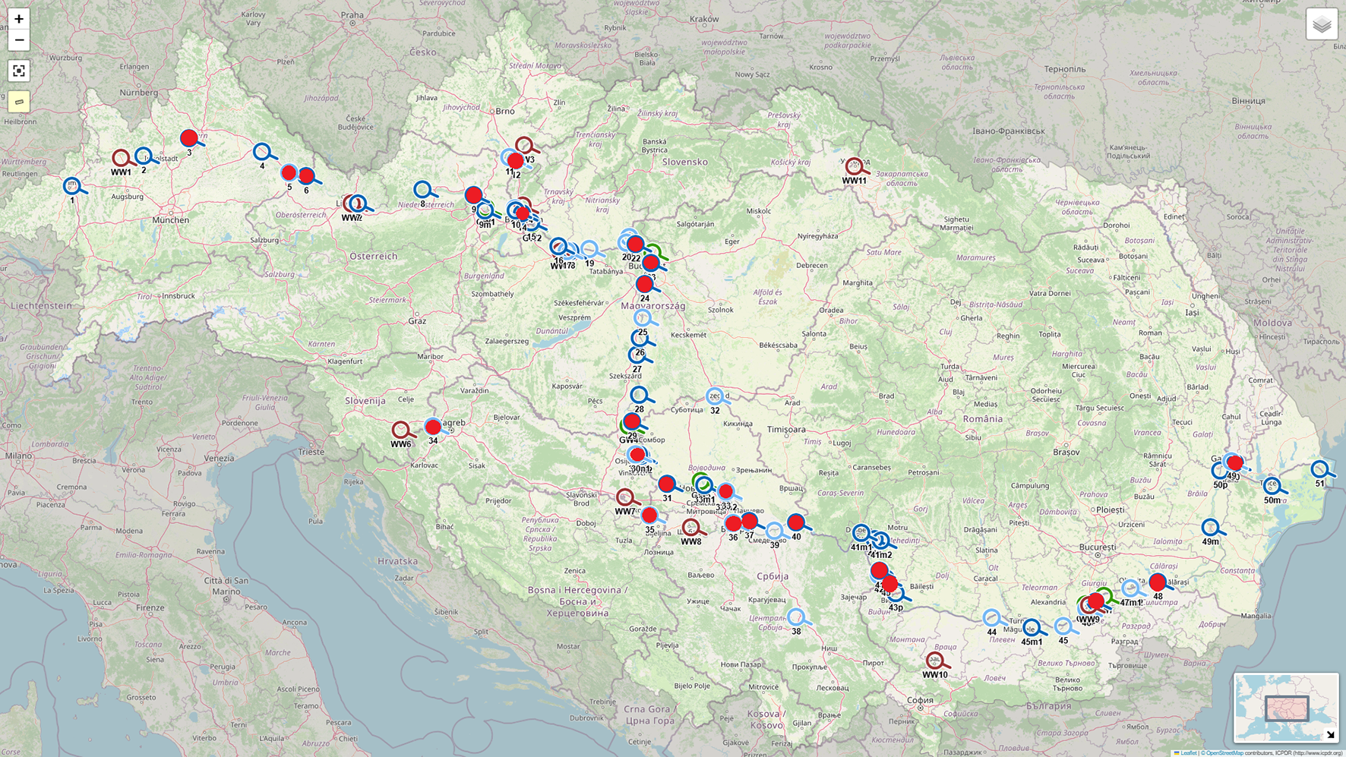
Fig. S1 Sampling sites on the Danube River (18 sites) and at its tributaries (Drava, Tisza, and Sava) (5 sites)
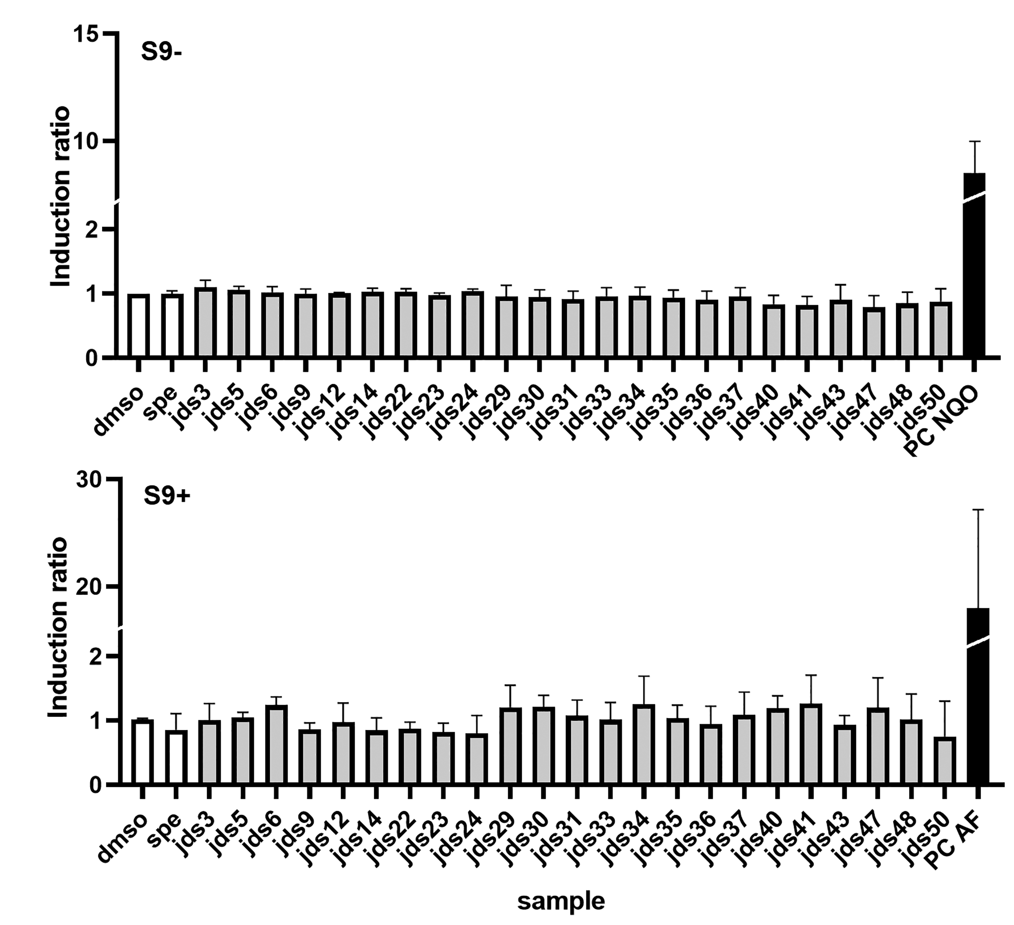
Fig. S2 Effect of samples at REF100 on the induction of SOS/umuC response in Salmonella typhimurium TA1535 pSK1002, without (S9-) and with metabolic activation (S9+); results are presented as mean ± SD. PC – positive control: NQO - 4-nitroquinoline (4-NQO; 0.5 μg/mL) and AF - aflatoxin B1 (10 μg/mL).

