Electronic Supplementary Material for:

Hydration of Belite-Ye’elimite-Ferrite Cement with Addition of Red Mud and Waste Concrete
In the following Tables S1-S2 and Figures S1–S6, the data reported in this study are summarized, as they are already discussed in detail in the paper.

Table S1. Chemical analyses of waste concrete and red mud (wt. %).
 | Waste concrete | Red mud
SiO₂ | 8.95 | 7.80
Al₂O₃ | 1.65 | 23.89
Fe₂O₃ | 0.67 | 31.90
CaO | 42.45 | 12.15
MgO | 7.14 | 0.70
SO₃ | 0.42 | 2.28
Na₂O | 0.27 | 4.36
K₂O | 0.16 | 0.15
TiO₂ | 0.06 | 3.05
L.O.I. | 38.81 | 12.96

Table S2. Amount of raw materials used in the raw meal (wt. %).
 | Limestone | Flysch | Calcined bauxite | Titano-gypsum | Mill scale | Calcite | Waste concrete | Red mud
CNAT | 48.35 | 42.05 | 5.30 | 3.80 | 0.45 | - | - | -
CCON | 25.20 | 35.60 | 5.50 | 3.55 | 0.60 | 1.00 | 28.50 | -
CRMD | 47.10 | 41.30 | 4.60 | 3.50 | - | 1.00 | - | 2.45

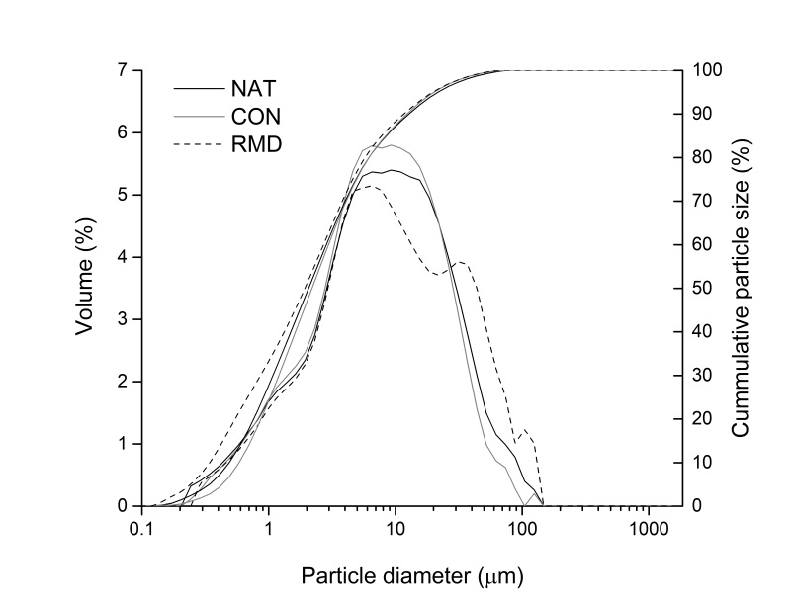
Figure S1. Particle size distributions of cements NAT, CON and RMD.

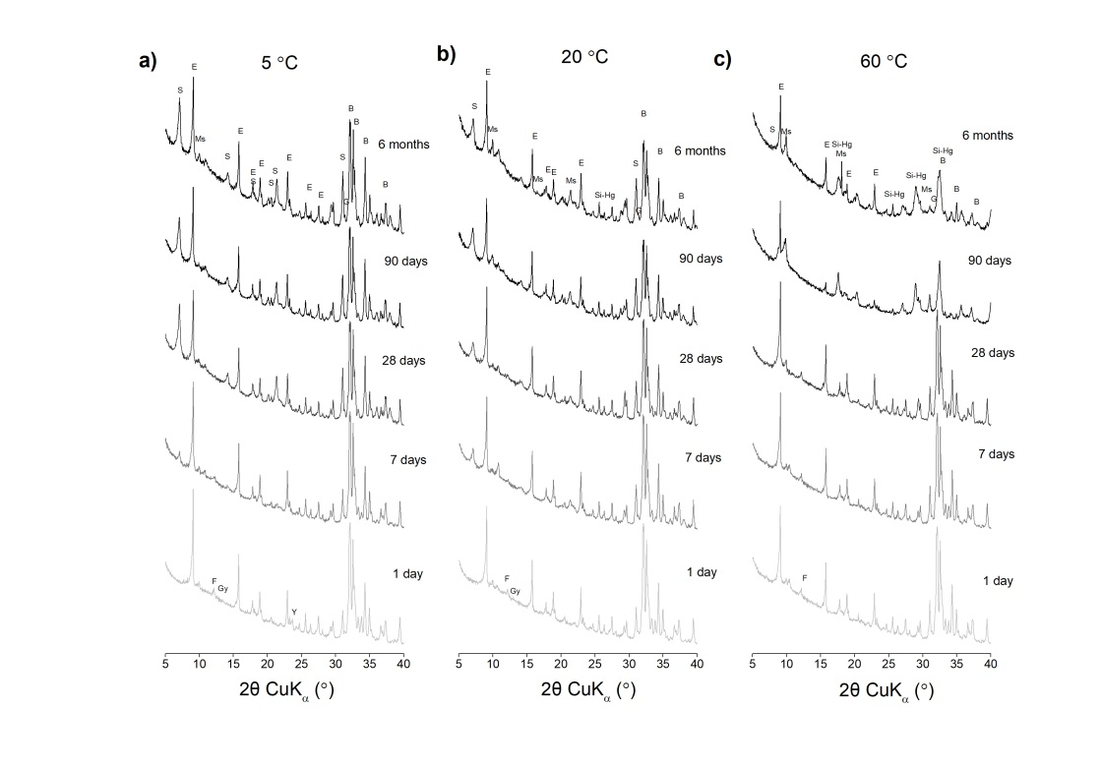
Figure S2. X−ray diffraction patterns of CON mixture at (a) 5 °C, (b) 20 °C and (c) 60 °C at different curing times. B = belite, E = ettringite, F = ferrite, G = gehlenite, Gy = gypsum, Ms = monosulfate , S = strätlingite, Si-Hg = siliceous hydrogarnet, Y = ye'elimite.
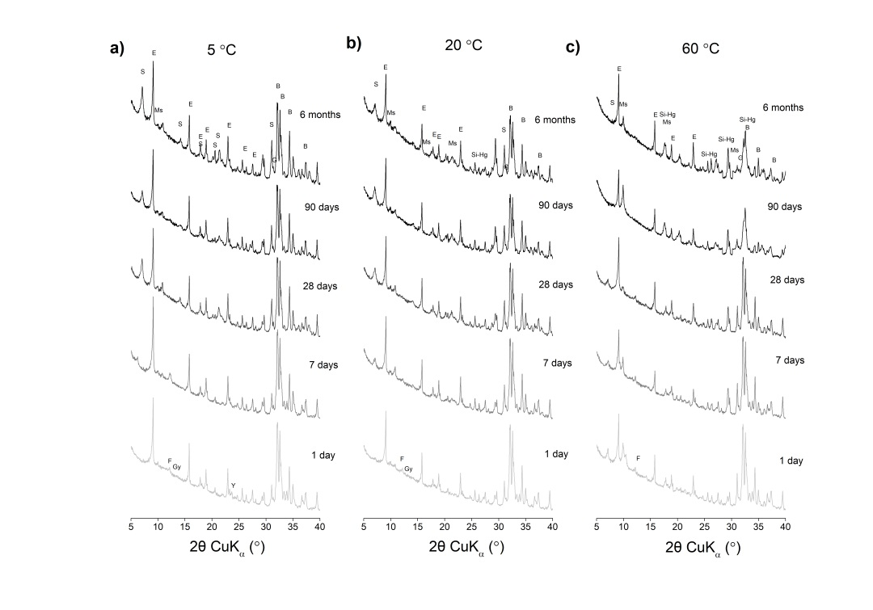
Figure S3. X−ray diffraction patterns of RMD mixture at (a) 5 °C, (b) 20 °C and (c) 60 °C at different curing times. B = belite, E = ettringite, F = ferrite, G = gehlenite, Gy = gypsum, Ms = monosulfate , S = strätlingite, Si-Hg = siliceous hydrogarnet, Y = ye'elimite.
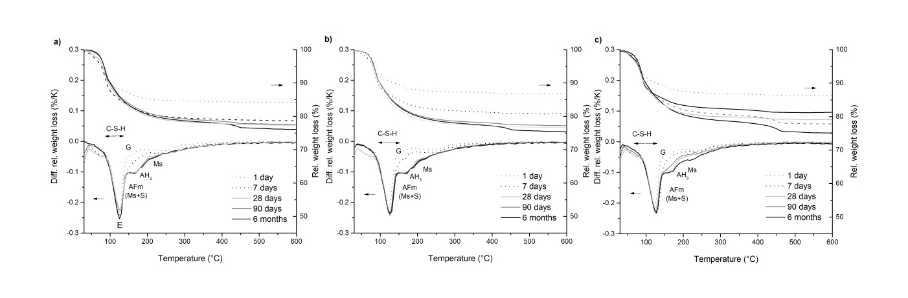
Figure S4. Thermogravimetric analyses of the (a) NAT, (b) CON and (c) RMD cement pastes cured at 5°C at different curing times. AH₃ = aluminium hydroxide, C―S―H = calcium silicate hydrate, E = ettringite, G = gypsum, Ms = monosulfate, S = strätlingite.

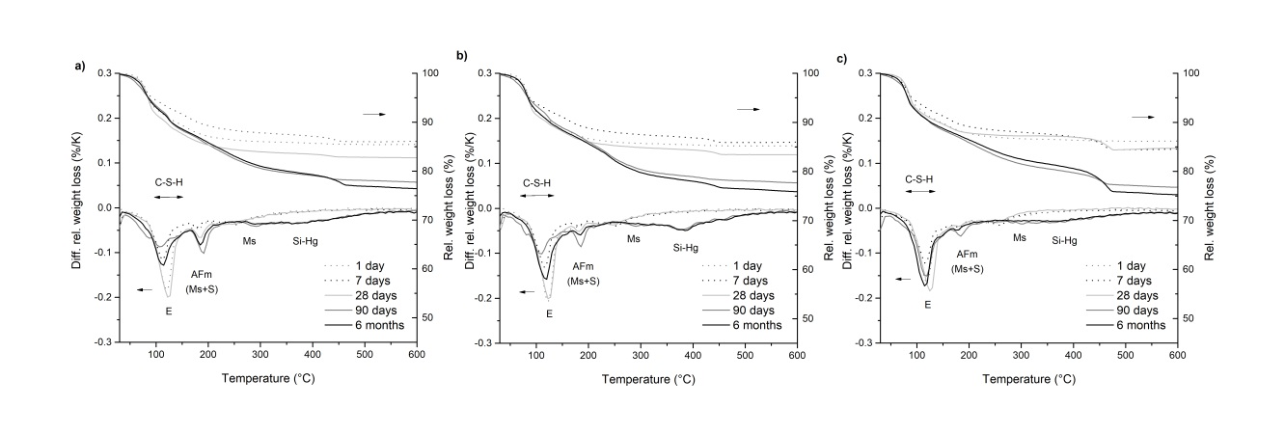
Figure S5. Thermogravimetric analyses of the (a) NAT, (b) CON and (c) RMD cement pastes cured at 60°C at different curing times. C―S―H = calcium silicate hydrate, E = ettringite, Ms = monosulfate, S = strätlingite, Si-Hg = siliceous hydrogarnet.

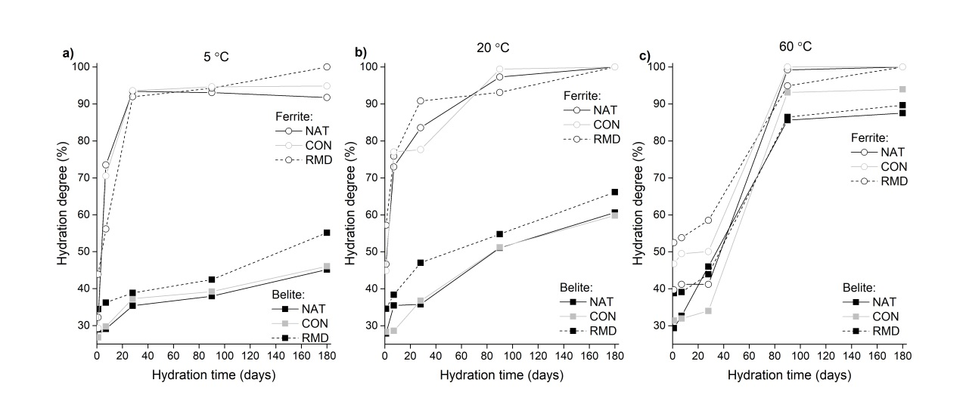
Figure S6. Phase contents of β-belite and ferrite in the NAT, CON and RMD mixtures at (a) 5 °C (b) 20 °C and (c) 60 °C, as determined by quantitative X-ray diffraction. Relative errors are estimated to be ±5 %.

