SUPPORTING INFORMATION

Fabrication and testing of ZnO@C nanoparticle-based Zn anodes for rechargeable alkaline batteries

Elisa Emanuele^{1*}, Maya Kobchenko² , Lucia Mancini², Seyedamin Razaghi¹, Rožle Repič² and Benedetto Bozzini¹

¹Department of Energy, Politecnico di Milano, via Lambuschini 4, 20156 Milano, Italy

² Slovenian National Building and Civil Engineering Institute (ZAG), Dimičeva ulica 12, SI-1000 Ljubljana, Slovenia

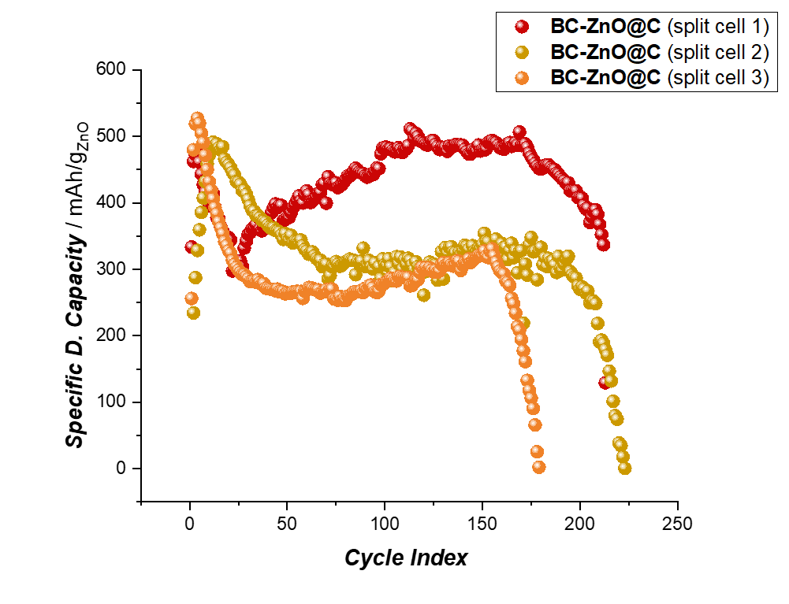
Figure S1: GCD cycling experiments replicates carried out with BC-ZnO@C electrodes in Split cell

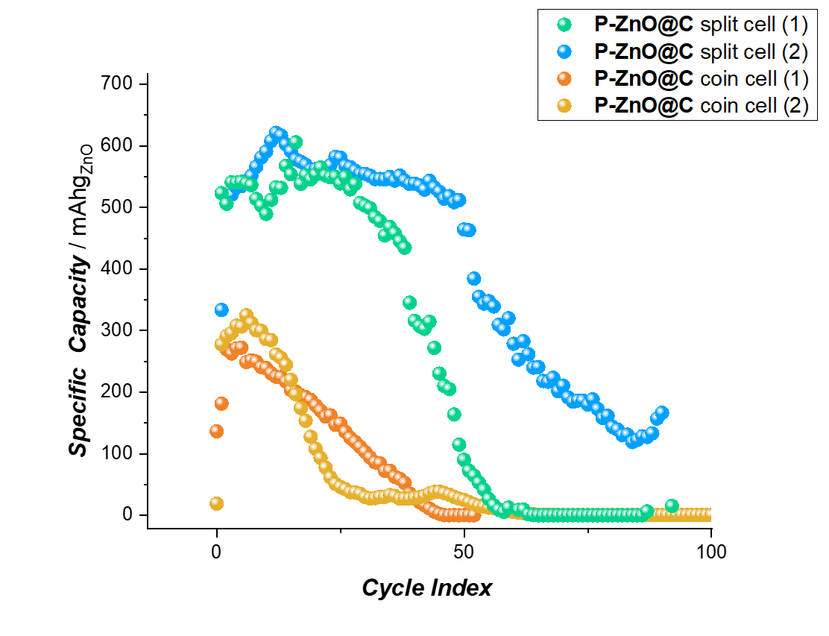
Figure S2: GCD cycling experiments replicates carried out with P-ZnO@C electrodes in Split cell (blue and green) and Coin cell (yellow and orange).

Alternative charging protocols were investigated implementing various potential cut-off limits for the BC-ZnO@C anode in the split cell configuration. Specifically, we tested three different potential cut-off values (1.85, 1.95 and 2V): the results are reported in Figure S3. were evaluated. The voltage cut-off value must be determined on the basis of the particular cell used since it is affected by many cell variables including the composition of the positive electrode, electrolyte concentration, cell impedance, as well as the charge current and cell temperature.
The selection of the voltage cut-off is based on the evolution of side reactions at both electrodes provided by Cvs studied presented in Figure 1 of the main text.
A clear correlation was observed between the charging potential limit and discharge capacity retention. The highest potential cut-off (2V) exhibited superior discharge specific capacity and enhanced stability throughout cycling. This improved performance can be attributed to extended charging duration, resulting in higher %DOC and therefore %DOD.
Notably, all potential cut-off protocols demonstrated significantly lower initial specific capacities compared to the capacity-limited protocol shown in Figure 2 of the main text. The disparity in initial capacity between these approaches, approximately 300-350 mAhg⁻¹, indicating that the time-limited charging protocol offers more effective electrode utilization compared to potential cut-off one. The difference shown can be attributed to the different charging time. Indeed, capacity limited approach reaches higher DOC.

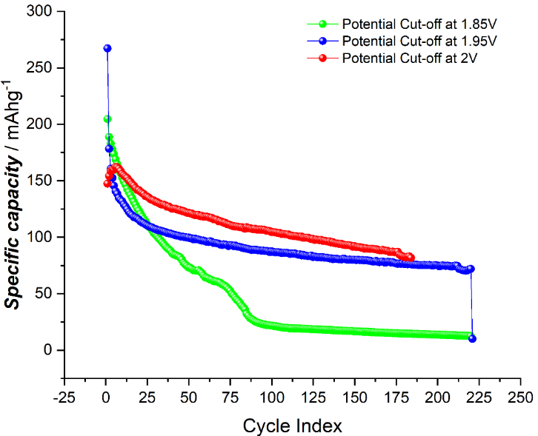

Figure S3: Discharge-specific capacity vs cycle number for the BC-ZnO@C anode in split cell configuration with different potential cut-off values.

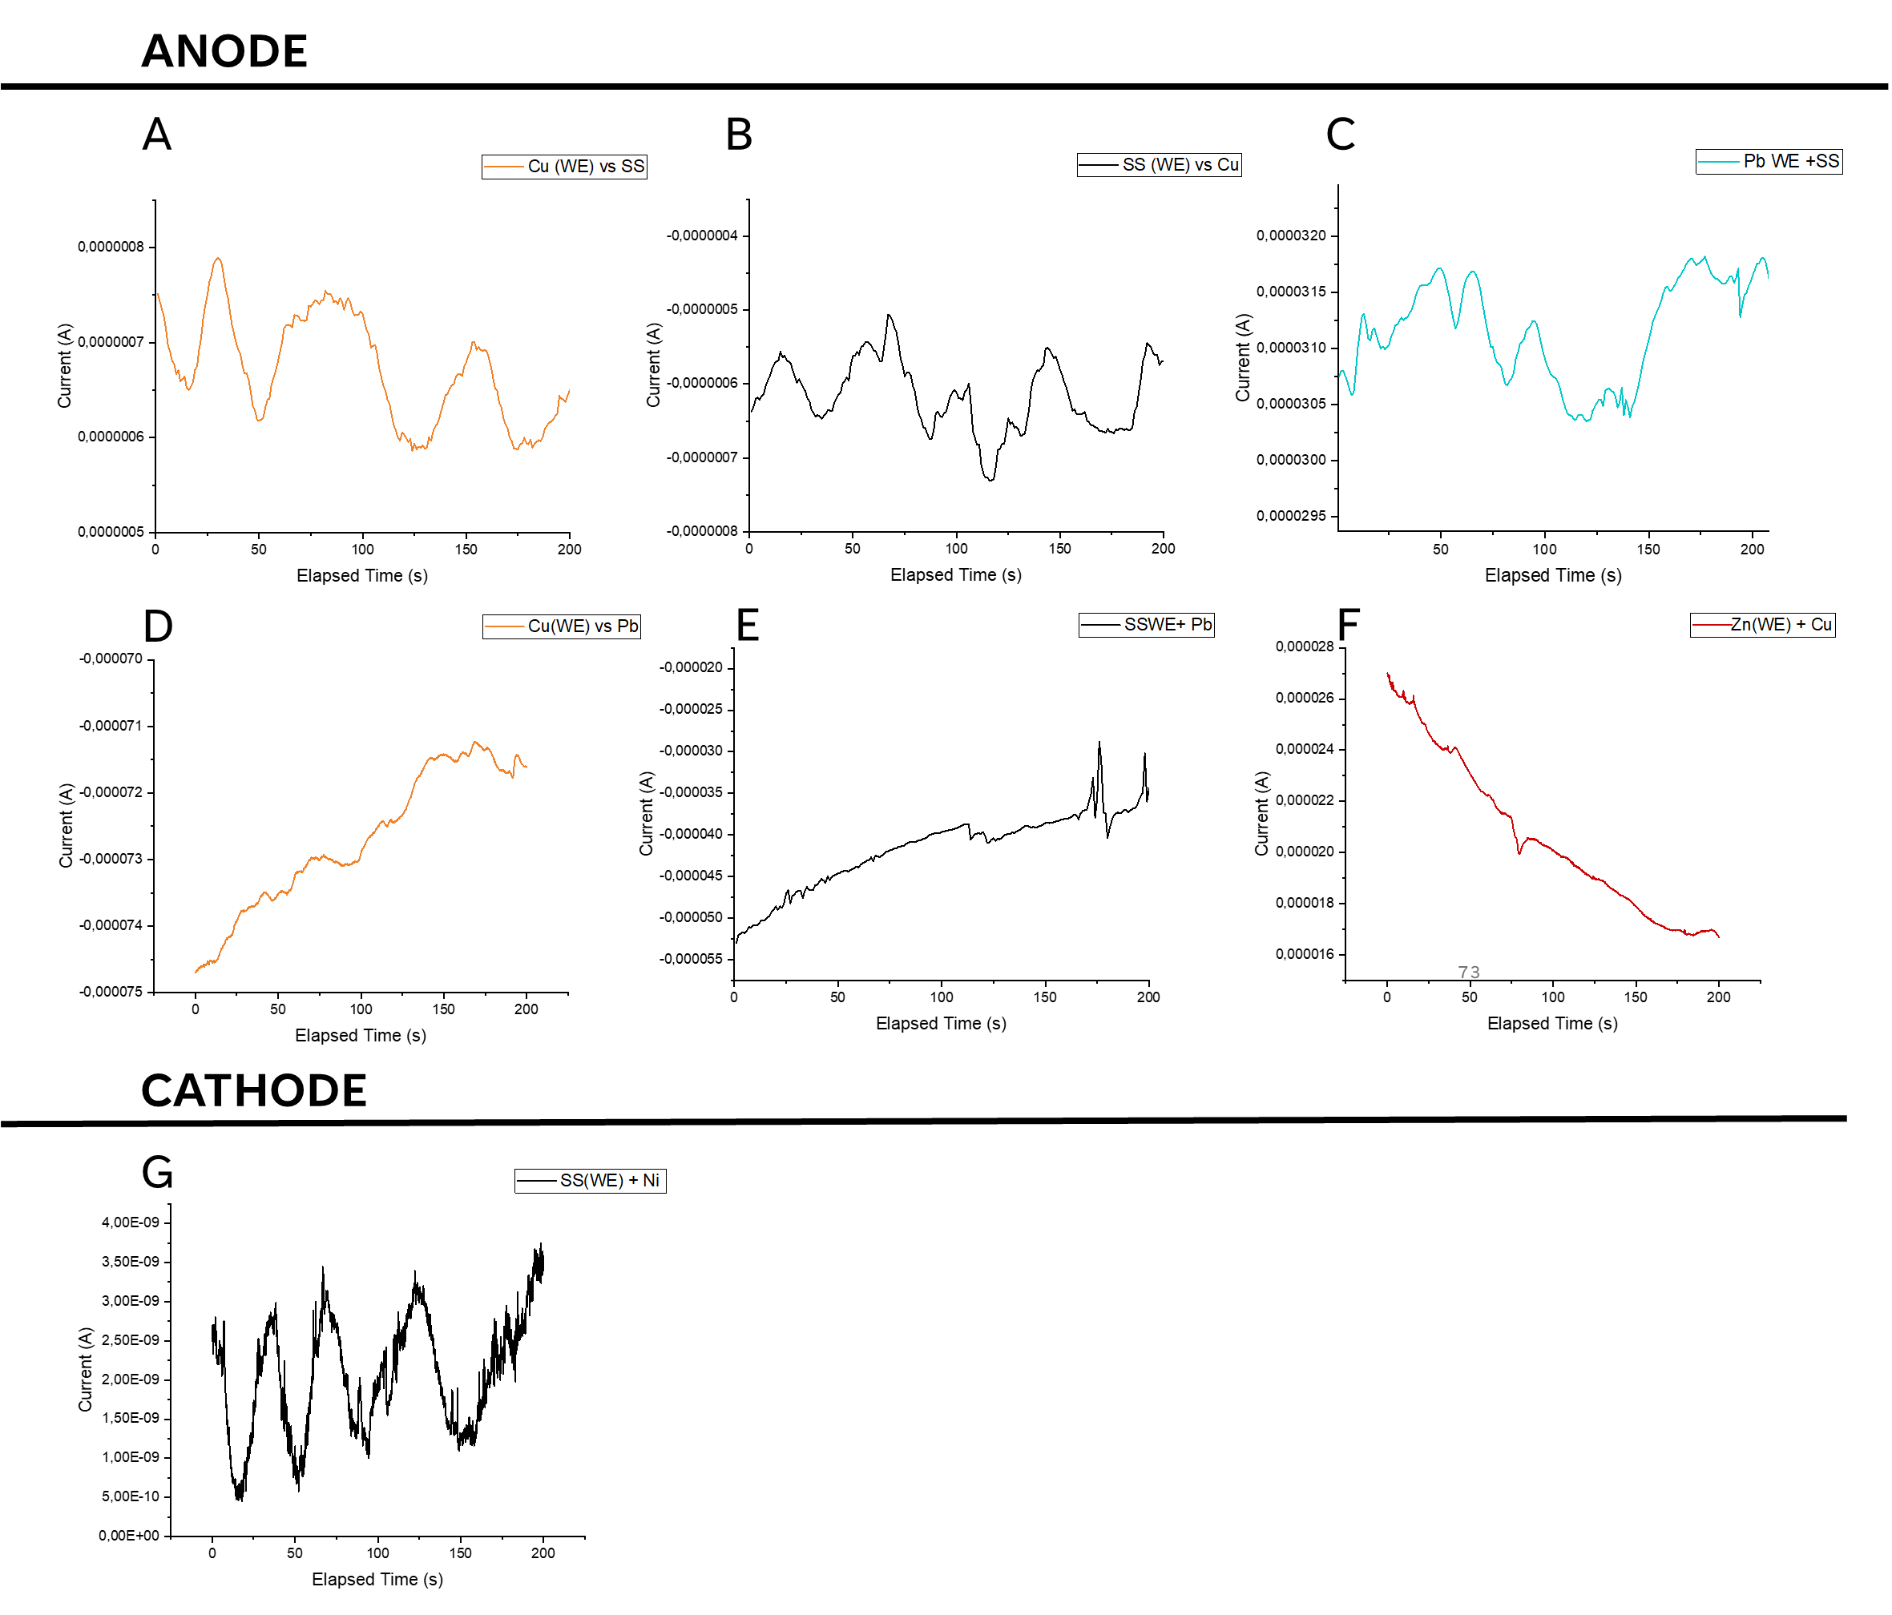
Figure ‎S4: ZRA measurements on Cu foil vs SS (A), vs Cd (B) and vs Pb (D). ZRA measurements on SS vs Cu (C), SS vs Pb (E) AND Pb vs SS (F).

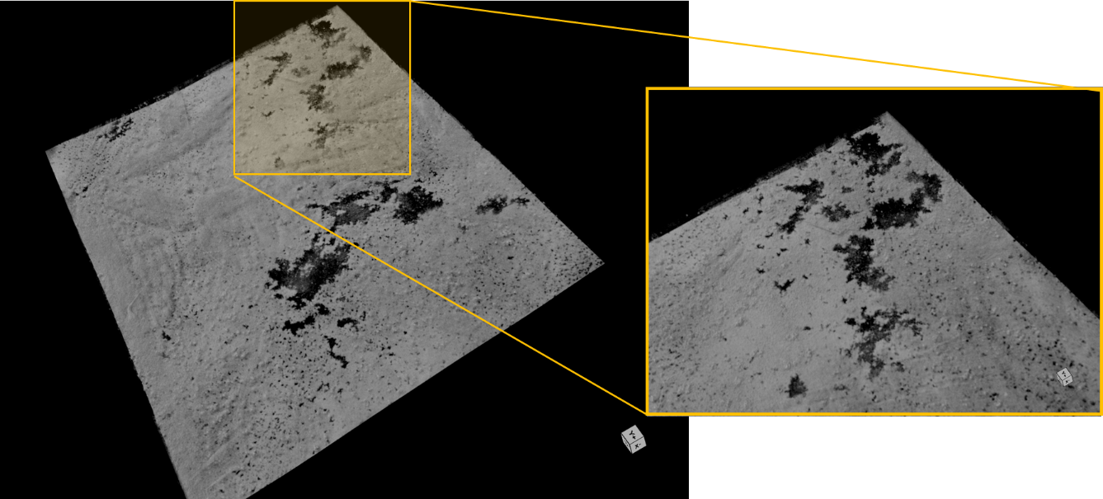

Figure ‎S5: XμCT measurements: 3D renderings of the Copper foil current collector of BC-ZnO@C after GCD cyclings reported in Figure 2 and S1.

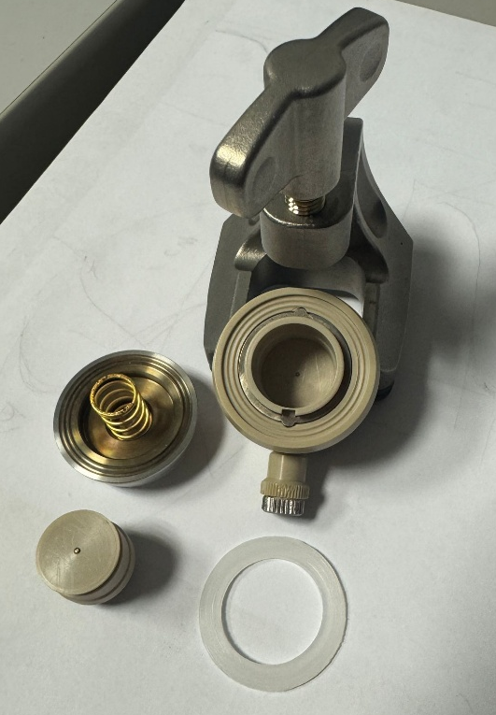
Figure S6: Split Cell electrochemical set-up

Reference | Anode active material | Electrode preparation | Test conditions | Max.Capcity (mAhg⁻¹) | n. cycles
Long (4) | ZnO@C  Coating done with ball milling synthesis | ZnO@C, acetylene black, PTFE (ratio:80:10:10)  Pasted on Cu mesh | 6M KOH saturated with ZnO | 500 | 200
Li (5) | ZnO@C | ZnO@C, acetylene black, SnO, In₂O₃ and PTFE (ratio: 83:10:1:1:5)  Pasted on a tin plated copper sheet | 4 M KOH, 1.6 M K₂BO₃, 0.9 M KF and 0.1 M LiOH, saturated with ZnO (2mL) | 500 | 200
Feng(6) | ZnO@C hydrothermally synthesized | ZnO@C, acetylene black, PTFE (ratio: 85:10:5)  Pasted on Cu mesh | 6 M KOH saturated with ZnO | 500 | 300
Wu(26) | ZnO@C | ZnO@C, carbon black, PVDF (ratio: 80:10:10)  Blade coated on Sn foil | 4 M KOH + 2 M KF + 2 M K₂CO₃ | 400 | 40
Li(7) | ZnO@C | ZnO@C, carbon black, and PVDF (ratio: 80:10:10)  Blade coated on Carbon Cloth | 6 M KOH saturated with ZnO | 600 | 500
Yan(27) | ZnO@C/GO/carbon black composite (lasagna-like) | ZnO@C, graphene oxide, carbon black, and water binder (BTA-520L) (ratio: 8:1:1:1.2);  Drop casted on Sn or Cu foil | 4 M KOH + 2 M KF + 2 M K₂CO₃ | 500 | 150
Chen(35) | ZnO@C clusters (pomegranate-like) | Zn-pome, carbon black, PVDF (ratio: 80:10:10)  Blade coated on Sn foil | 4 M KOH + 2 M KF + 2 M K₂CO₃ | 400 | 50

Table S1: Literature comparison of ZnO@C fabrication and performances

