Supplementary material
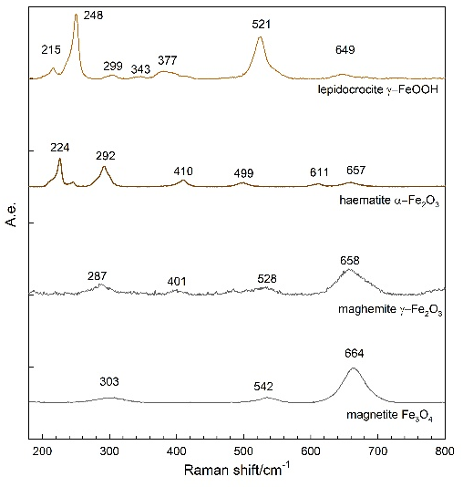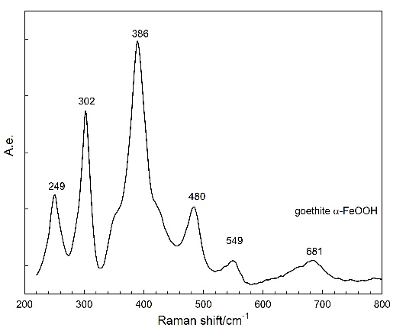
Supplementary Figure 1: Raman reference spectra (a and b)

Supplementary Table 1: Initiation times in days and number of tiding cycles for each electrode
Electrode | Initiation time (days) | Initiation time (cycles)
1 | / | /
2 | / | /
3 | 44.2 | 353
4 | / | /
5 | / | /
6 | / | /
7 | 95.2 | 490
8 | / | /
9 | / | /
10 | / | /
11 | 122 | 490
12 | / | /

