APPENDIX

Table S1: Location names, ID, coordinates and elevation data for the sample sites of Gallotia galloti in Tenerife. The last column shows the year in which the lizards were collected and the skin samples taken.
Location ID | Location Name | Coor (N) | Coor (E) | Elevation (m) | Year of lizard collection
AD | Adeje | 28,15 | -16,79 | 97 | 2021
AR | Area Recreativa El Contador | 28,21 | -16,54 | 1365 | 2021
BE | Benijo Anaga | 28,57 | -16,19 | 116 | 2021 and 2023
BT | Base of Teide | 28,26 | -16,62 | 2308 | 2023
BV | Buenavista del Norte | 28,37 | -16,86 | 83 | 2021
CR | Cruz de Tea | 28,13 | -16,61 | 1045 | 2021
CT | Cono de El Teide | 28,27 | -16,64 | 3650 | 2021 and 2023
EM | El Medano | 28,06 | -16,54 | 121 | 2021 and 2023
EP | El Pris Mirador de Juan Fernández | 28,51 | -16,42 | 163 | 2021 and 2023
GN | La Guancha | 28,38 | -16,66 | 290 | 2023
GR | Granadilla de Abona | 28,12 | -16,57 | 604 | 2023
GU | Puertito de Guimar | 28,29 | -16,39 | 43 | 2023
LG | La Laguna | 28,48 | -16,32 | 580 | 2021 and 2023
LL | San José de Los Llanos | 28,33 | -16,79 | 1088 | 2021
OI | Izaña astronomic observatory | 28,31 | -16,50 | 2331 | 2023
RQ | Recibo quemado Barranco de la Degollada | 28,31 | -16,58 | 1901 | 2021

Table S2: Details of measurements obtained with UV data logger for eight sites.
Location ID | Elevation (m) | Date of UVI data collection | Mean UVI | Max UVI | Min UVI
BT | 2308 | 6.08.2021 | 7,23 | 16,00 | 0,10
BV | 83 | 31.07.2021 | 3,99 | 10,98 | 0,04
CR | 1045 | 2.08.2021 | 5,95 | 13,10 | 0,10
CT | 3650 | 11.08.2021 | 6,34 | 12,90 | 0,10
GR | 604 | 2.08.2021 | 5,94 | 13,20 | 0,10
LL | 1088 | 31.07.2021 | 4,98 | 10,50 | 0,01
OI | 2331 | 28.07.2021 | 8,14 | 18,23 | 0,01
RQ | 1901 | 8.08.2021 | 7,60 | 15,90 | 0,10

Table S3: Principal component analysis (PCA) of scale morphology variables in Gallotia galloti. PCA loadings for scale morphology traits with proportion of variance per component and the cumulative proportion of variance given bellow.
Variable | PC1 | PC2  (Scale density) | PC3 | PC4
Variable | (Scale size) | PC2  (Scale density) | PC3 | PC4
Scale Length | 0.52 | -0.06 | 0.79 | 0.31
Scale Width | 0.52 | 0.33 | -0.54 | 0.57
Scale Area | 0.52 | 0.42 | -0.42 | -0.74
Scale Density | -0.42 | 0.84 | 0.28 | 0.17
Proportion of variance | 0.81 | 0.14 | 0.04 | 0.01
Cummulative Proportion of variance | 0.81 | 0.95 | 0.99 | 1.00

Table S4: Full GLM model built (top row) and predictor reduction process with analysis of deviance results of comparison between the reduced and the stepwise-selected model for each dataset (dorsal, ventral and tail scales vs. PC1 and PC2). The final, the most parsimonious model is shown in bold.
 | full model | HFP2020, mean_UVI, bio2, bio3, bio15, TALOC_July, VLOC_July, SOLR_July, PCTWET_July
Dataset tested | Model name | Predictors included | Residual df | Residula deviance | Deviance | p-value
DORSAL and PC1_adj | Predictors with VIF>5 that were excluded | mean_UVI, bio2, PCTWET_July
 | reduced model | HFP2020, bio3, bio15, TALOC_July, VLOC_July, SOLR_July | 41 | 104.68
 | stepwise-selected model | TALOC_July, VLOC_July, SOLR_July | 44 | 105.30 | -0.62 | 0.840
DORSAL and PC2_adj | Predictors with VIF>5 that were excluded | mean_UVI, bio2, PCTWET_July
 | reduced model | HFP2020, bio3, bio15, TALOC_July, VLOC_July, SOLR_July | 41 | 462.21
 | stepwise-selected model | HFP2020, TALOC_July, VLOC_July, SOLR_July | 43 | 465.03 | -2.81 | 0.838
VENTRAL and PC1_adj | Predictors with VIF>5 that were excluded | mean_UVI, SOLR_July, PCTWET_July
 | reduced model | HFP2020, bio2, bio3, bio15, TALOC_July, VLOC_July | 25 | 97.46
 | stepwise-selected model | HFP2020 | 30 | 99.10 | -1.65 | 0.960
VENTRAL and PC2_adj | Predictors with VIF<5 | mean_UVI, bio2, PCTWET_July
 | reduced model | HFP2020, bio3, bio15, TALOC_July, VLOC_July, SOLR_July | 25 | 76.03
 | stepwise-selected model | HFP2020, bio3 | 29 | 78.08 | -2.04 | 0.776
TAIL and PC1_adj | Predictors with VIF<5 | bio3, TALOC_July, PCTWET_July
 | reduced model | HFP2020, mean_UVI, bio2, bio15, VLOC_July, SOLR_July | 57 | 261.15
 | stepwise-selected model | mean_UVI, SOLR_July | 61 | 265.34 | -4.18 | 0.801
TAIL and PC2_adj | Predictors with VIF<5 | bio3, TALOC_July, PCTWET_July
 | reduced model | HFP2020, mean_UVI, bio2, bio15, VLOC_July, SOLR_July | 57 | 199.55
 | stepwise-selected model | mean_UVI, bio2, bio15, VLOC_July, SOLR_July | 58 | 200.28 | -0.73 | 0.536

Figure S1: ImageJ macro code used to automatically run length and width measurements of a selected area. The code converts the image into 8-bit grayscale and automatically adjusts the thresholds to differentiate the selected object from the background. The background is then converted to white and enables the measurements of the object area and perimeter. A bounding box is used to measure the length and width of the object and finally the results are displayed and saved.

Figure S2: Collinearity plot with elevation and all macro climatic predictors and elevation tested for collinearity. The numbers indicate the collinearity score, the size of the circle shows the strength of collinearity (analogous to the score), and the colour stands for negative (red) or positive (blue) correlations.
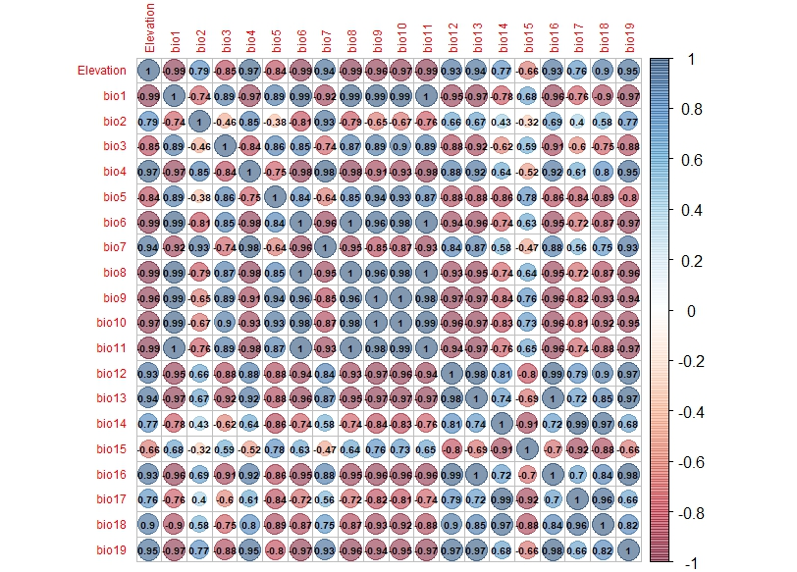

Figure S3: Collinearity plot with all micro climatic predictors tested for collinearity. The numbers indicate the collinearity score, the size of the circle shows the strength of collinearity (analogous to the score), and the colour stands for negative (red) or positive (blue) correlations.
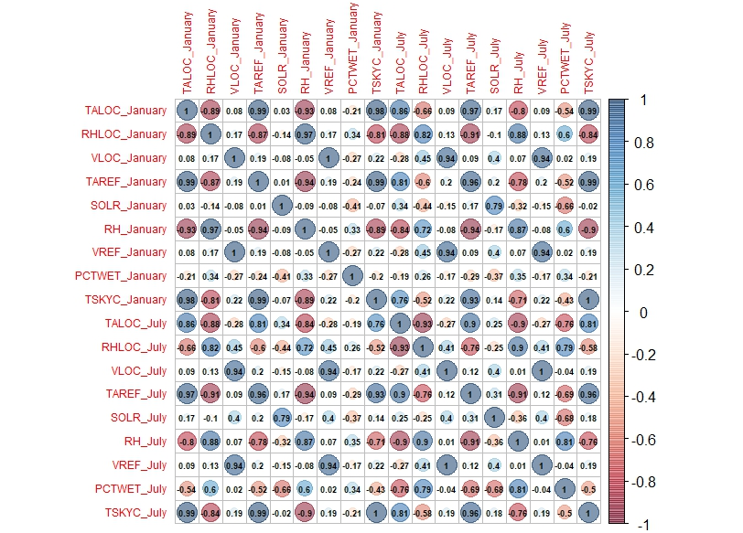

Figure S4: Plotted daily UVI measurements collected with UV data logger for one day at eight different sites. BT - Base of Teide; BV - Buenavista del Norte; CR - Cruz de Tea; CT - Cono de El Teide; GR - Granadilla de Abona; LL – San José de Los Llanos; OI - Izaña astronomic observatory; RQ - Barranco de la Degollada.
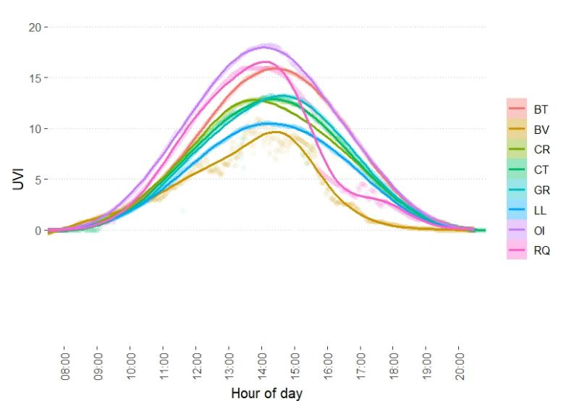

Figure S5: Mean measured UV index (UVI) at 8 sites over the entire altitude range and interpolated UVI values of the remaining 8 sites.


