Supplementary Figures
for
Slippery slopes: Montane isolation and elevational shifts shape the evolution and diversity of Iberolacerta lizards
Christophe Dufresnes, Sven Gippner, Sylvia Hofmann, Spartak Litvinchuk, Anamarija Zagar, Daniel Jablonski, Gilles Pottier, Rodrigo Megía-Palma, Gregorio Sánchez-Montes, Octavio Jiménez Robles, Enrique Ayllón, Pierre-André Crochet, ĺñigo Martínez-Solano

Fig. S1: ddRAD-seq IQ-TREE analysis on representative samples | 2
Fig. S2: TreeMix Optimization plot. | 3
Fig. S3: ML tree of 12S sequences | 4
Fig. S4: ML tree of 16S sequences | 5
Fig. S5: ML tree of COI sequences | 6
Fig. S6: ML tree of cytb sequences | 7
Fig. S7: ML tree of ND4 sequences | 8
Fig. S8: ML tree of CR1 sequences | 9
Fig. S9: ML tree of CR2 sequences | 10
Fig. S10: Cross-entropy of the LEA clustering | 11
Fig. S11: IBD in the four densely sampled species | 12
Fig. S12: Microsatellites vs. ddRADseq Ho in I. bonnali | 13

Fig. S1. ddRAD-seq IQ-TREE analysis on the subset of representative samples.
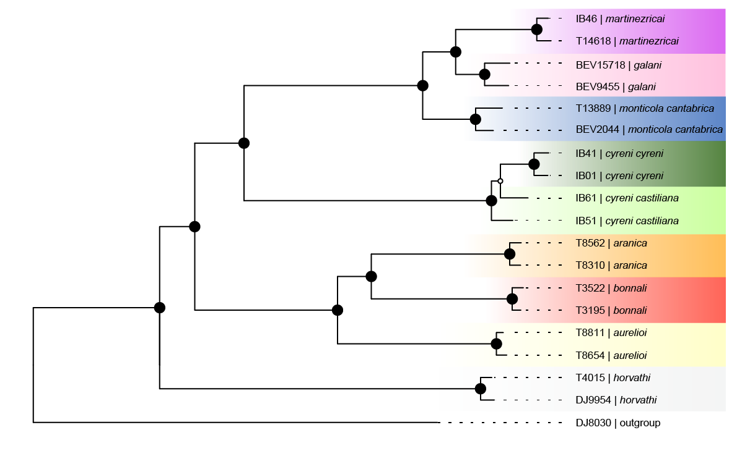

Fig. S2. TreeMix Optimization plot. All four indicators suggest a single migration event.

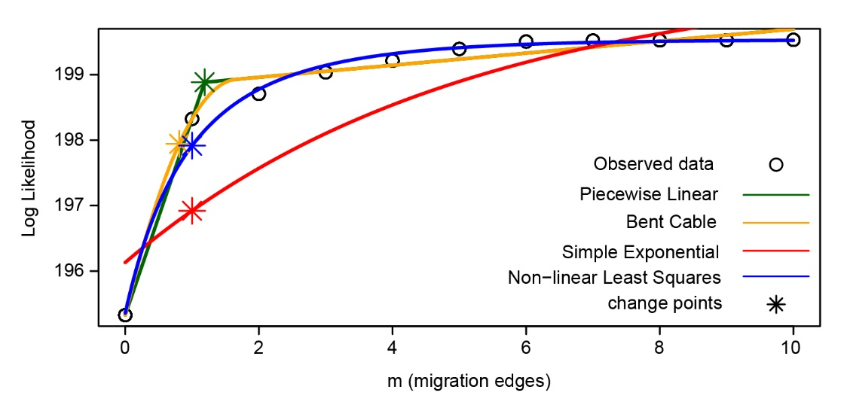
Fig. S3. Unrooted maximum-likelihood tree of Iberolacerta 12S sequences available on GenBank. Colored frames and labels emphasize the main distinguishable lineages.
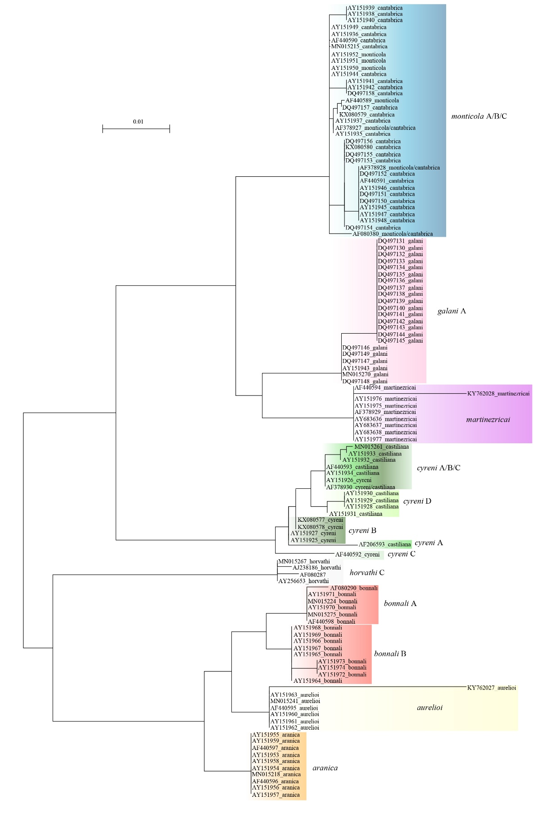
Fig. S4. Unrooted maximum-likelihood tree of Iberolacerta 16S sequences available on GenBank. Colored frames and labels emphasize the main distinguishable lineages.

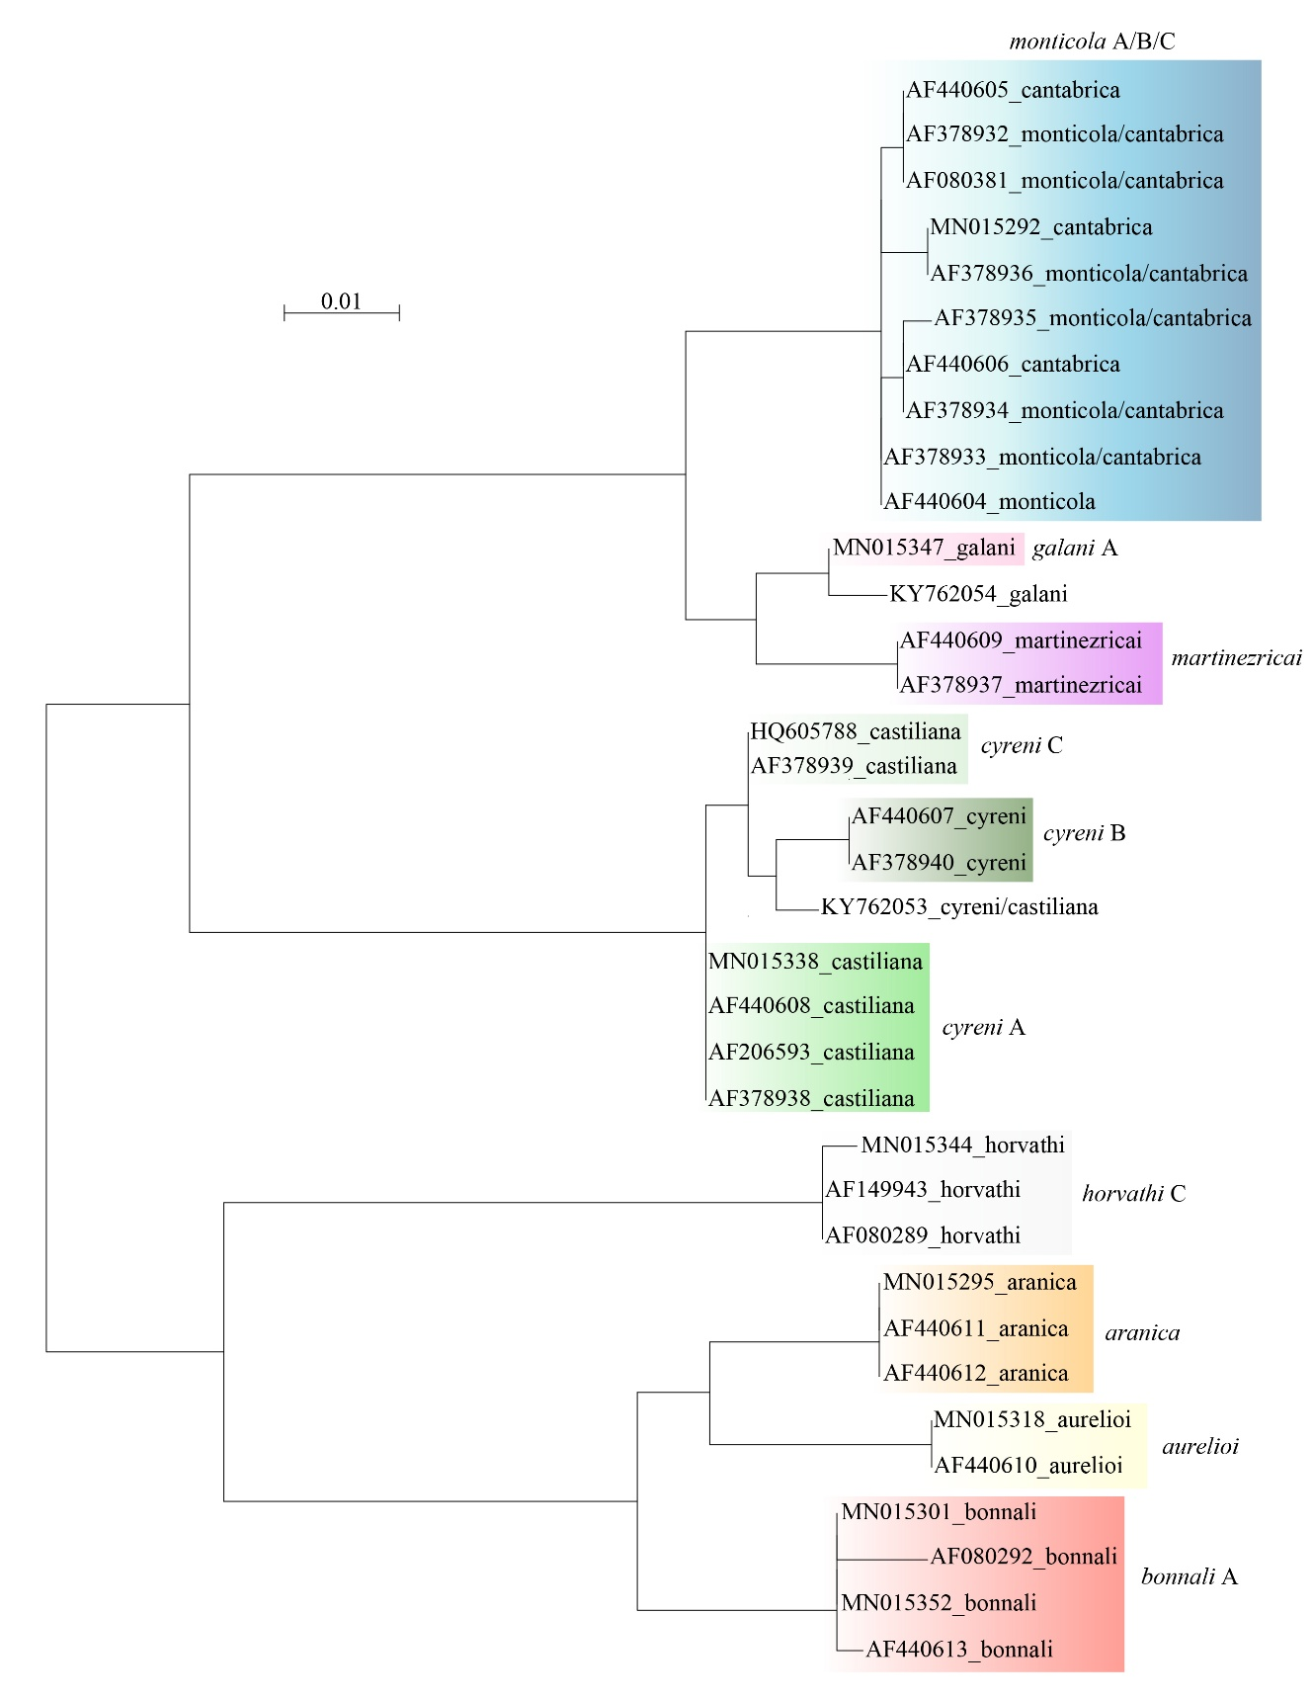

Fig. S5. Unrooted maximum-likelihood tree of Iberolacerta COI sequences available on GenBank. Colored frames and labels emphasize the main distinguishable lineages.

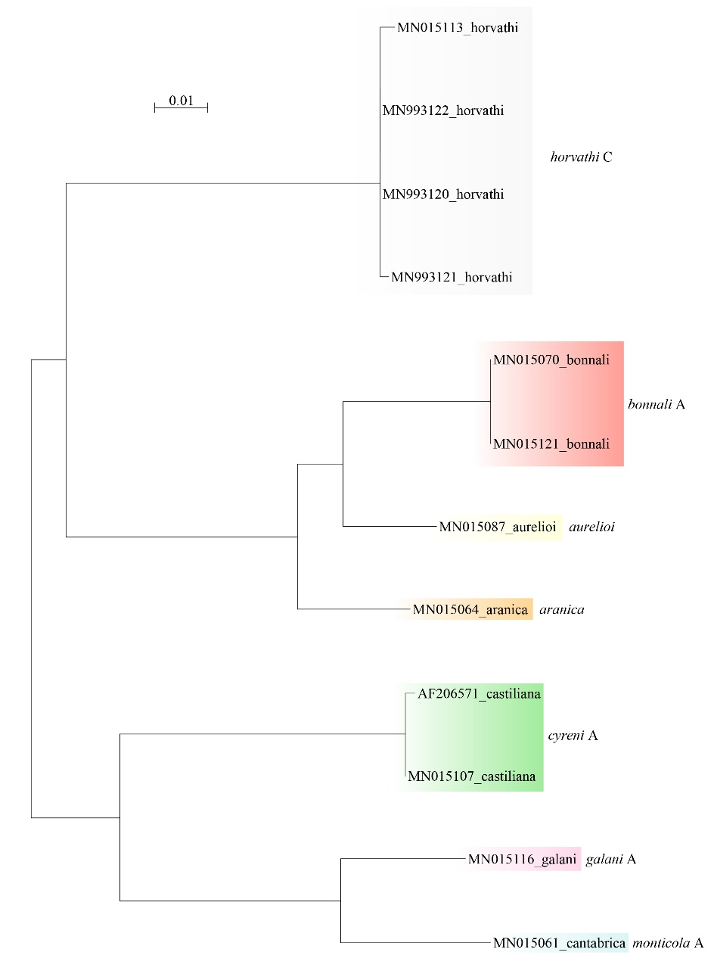
Fig. S6. Unrooted maximum-likelihood tree of Iberolacerta cytb sequences available on GenBank. Colored frames and labels emphasize the main distinguishable lineages.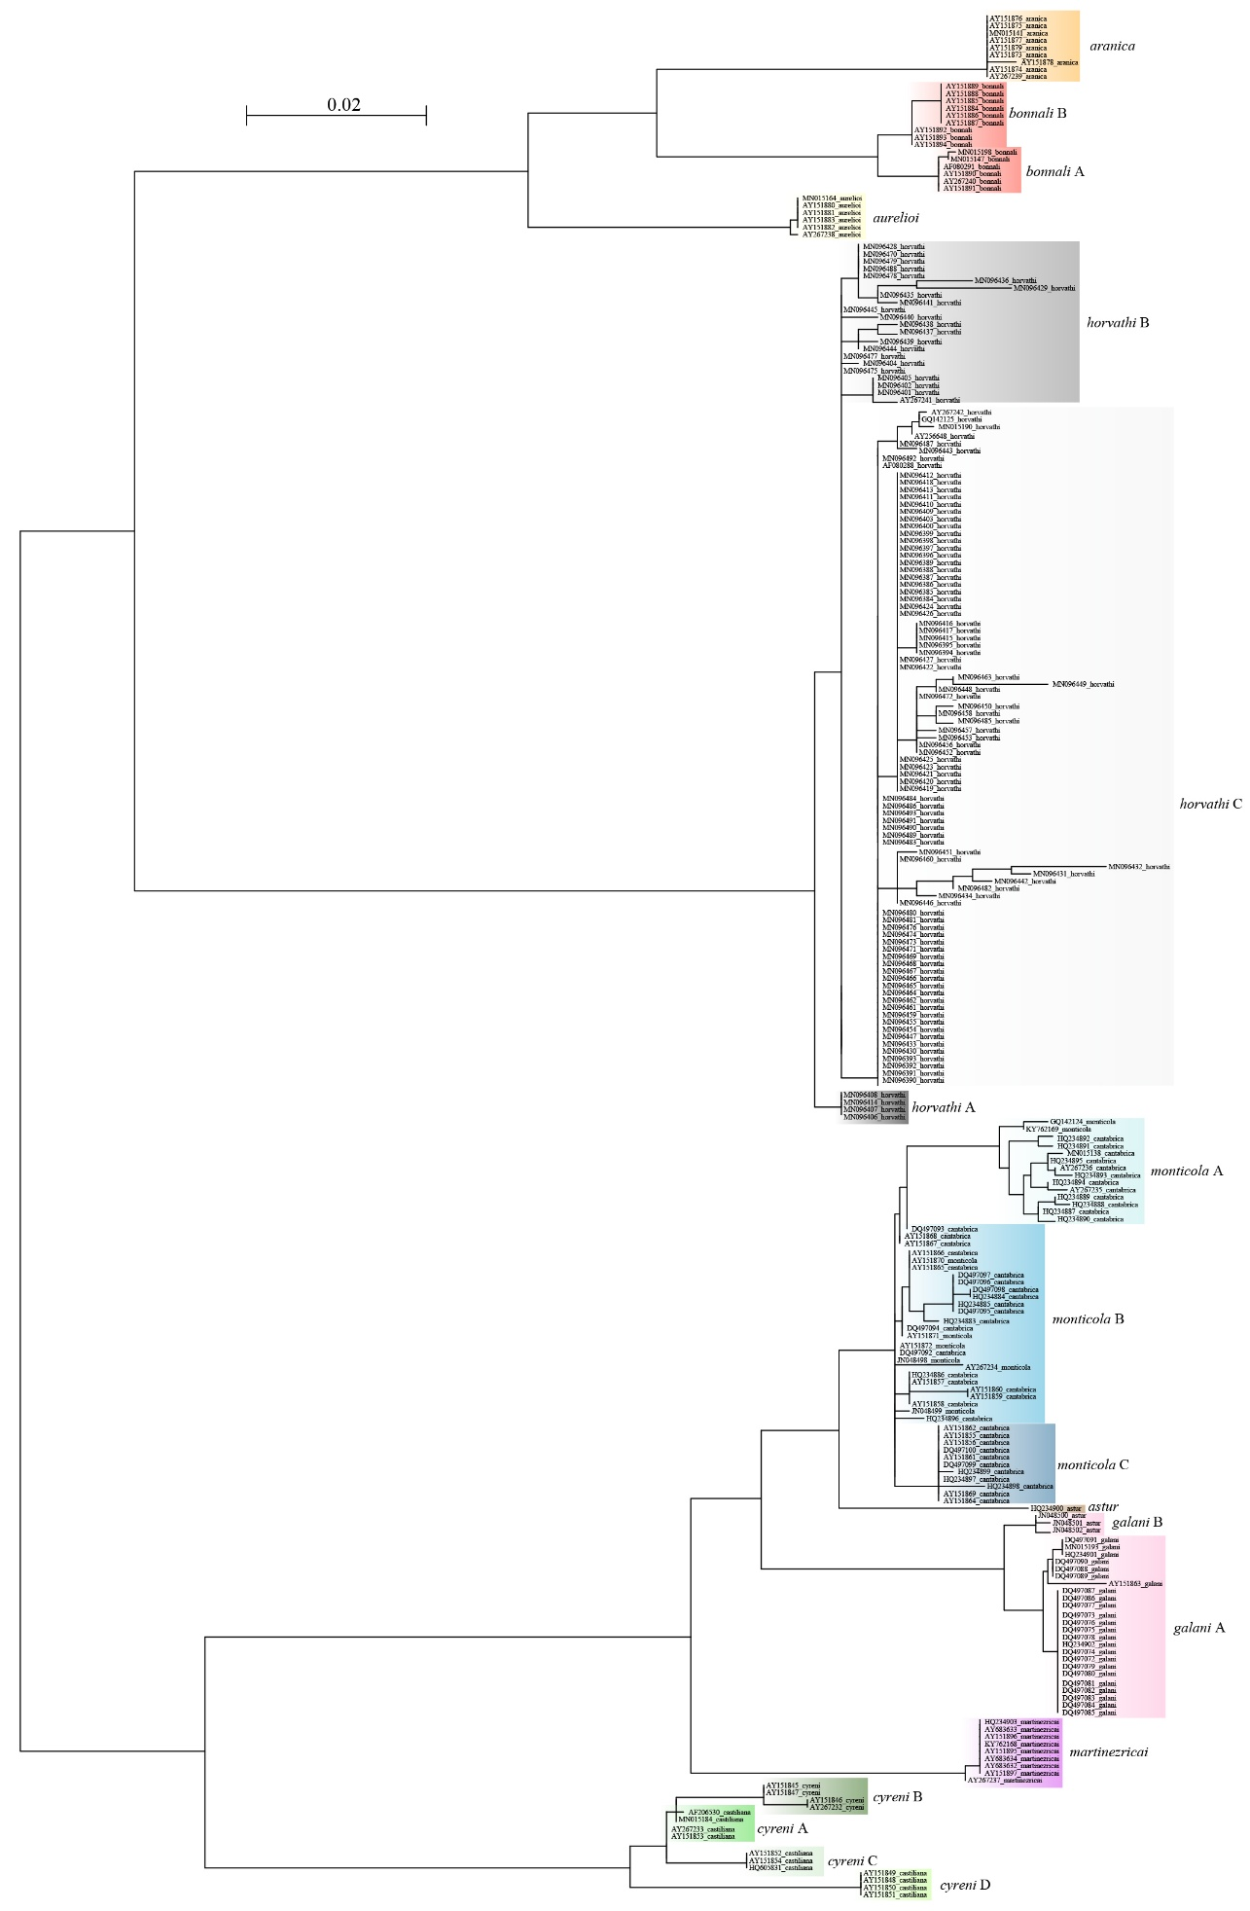
Fig. S7. Unrooted maximum-likelihood tree of Iberolacerta ND4 sequences available on GenBank, as well as new sequences. Colored frames and labels emphasize the main distinguishable lineages.
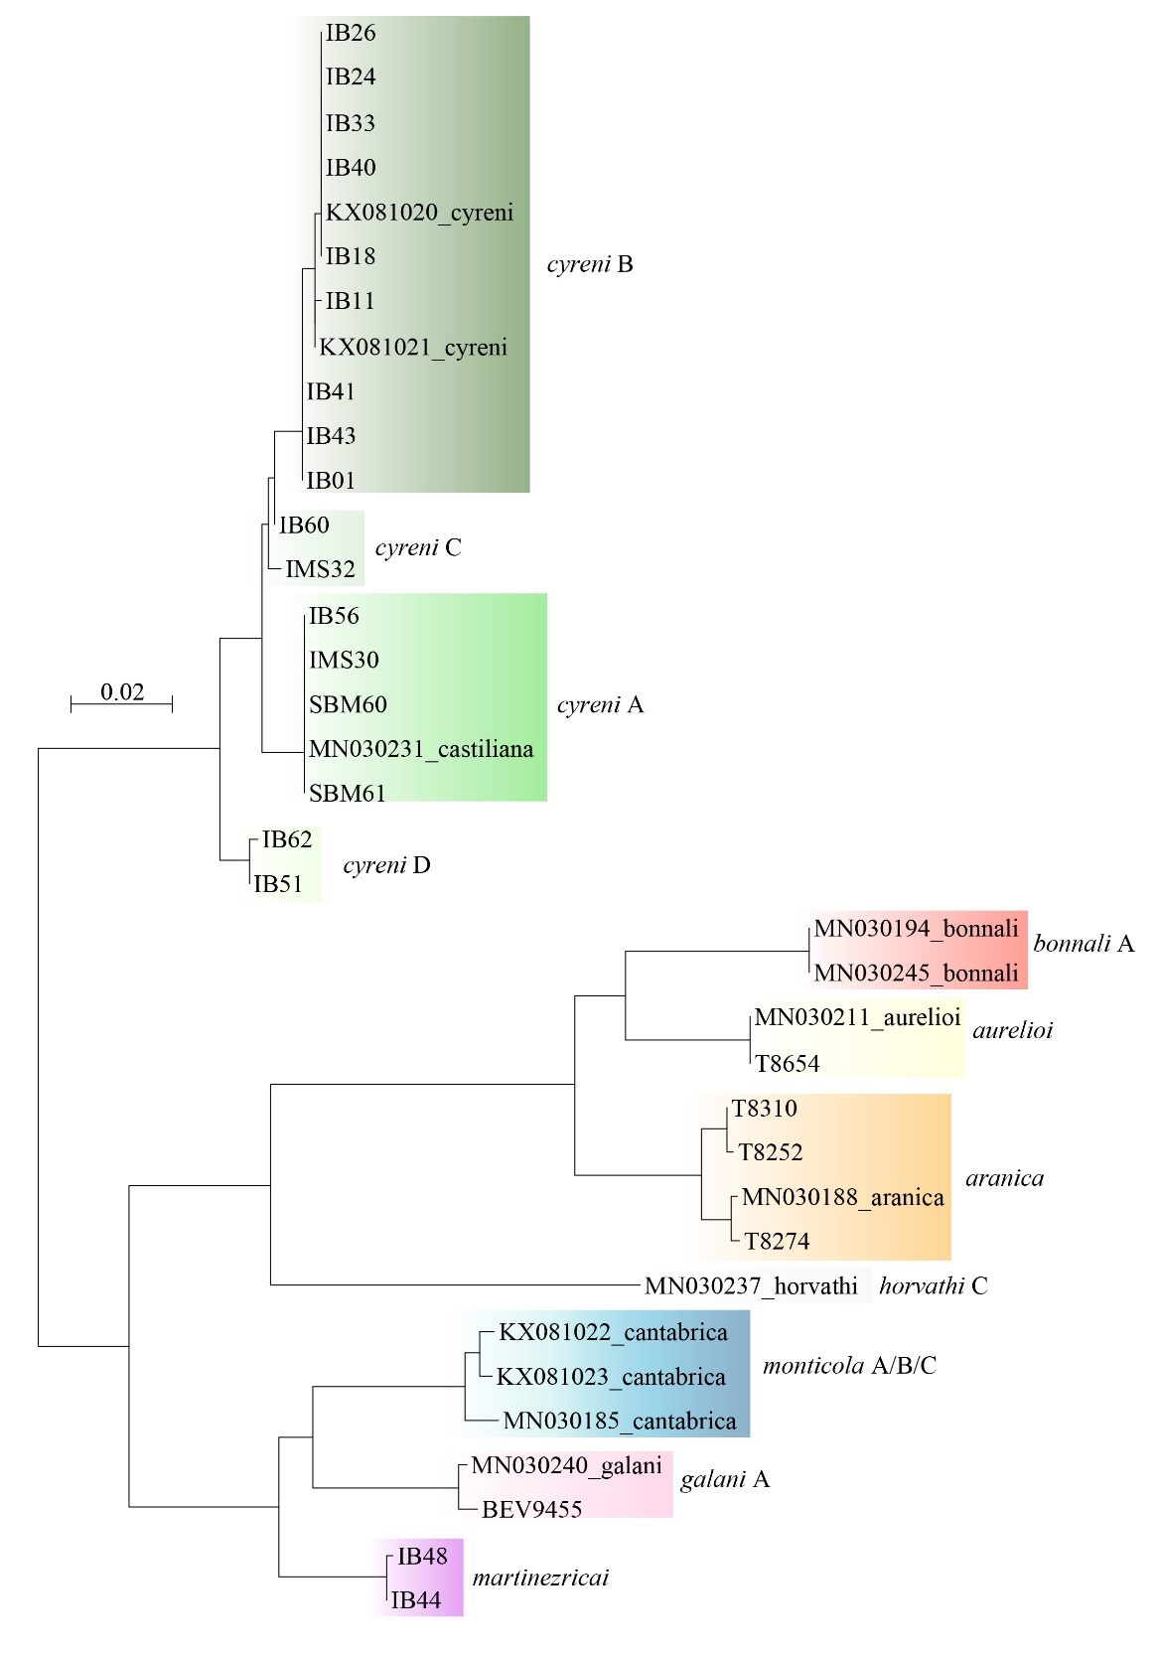
Fig. S8. Unrooted maximum-likelihood tree of Iberolacerta CR1 sequences available on GenBank. Colored frames and labels emphasize the main distinguishable lineages.

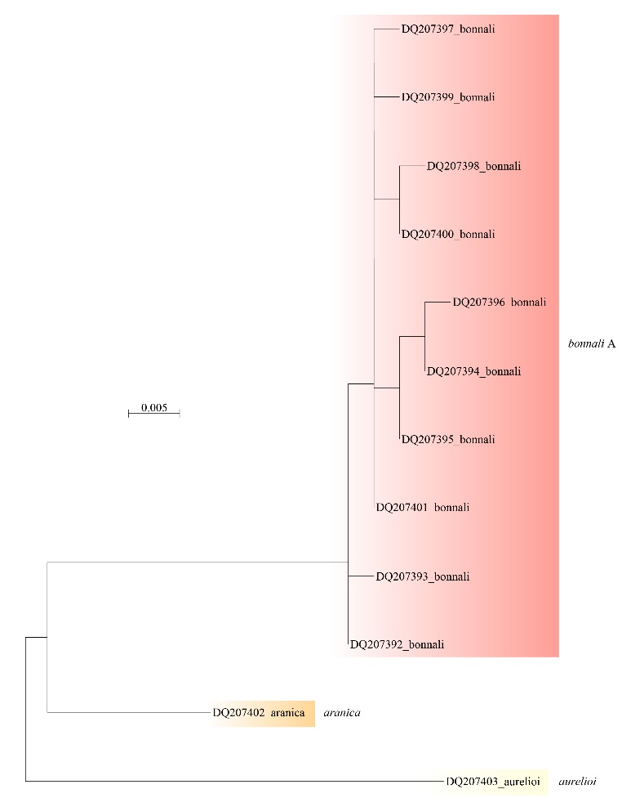

Fig. S9. Unrooted maximum-likelihood tree of Iberolacerta CR2 sequences available on GenBank. Colored frames and labels emphasize the main distinguishable lineages.

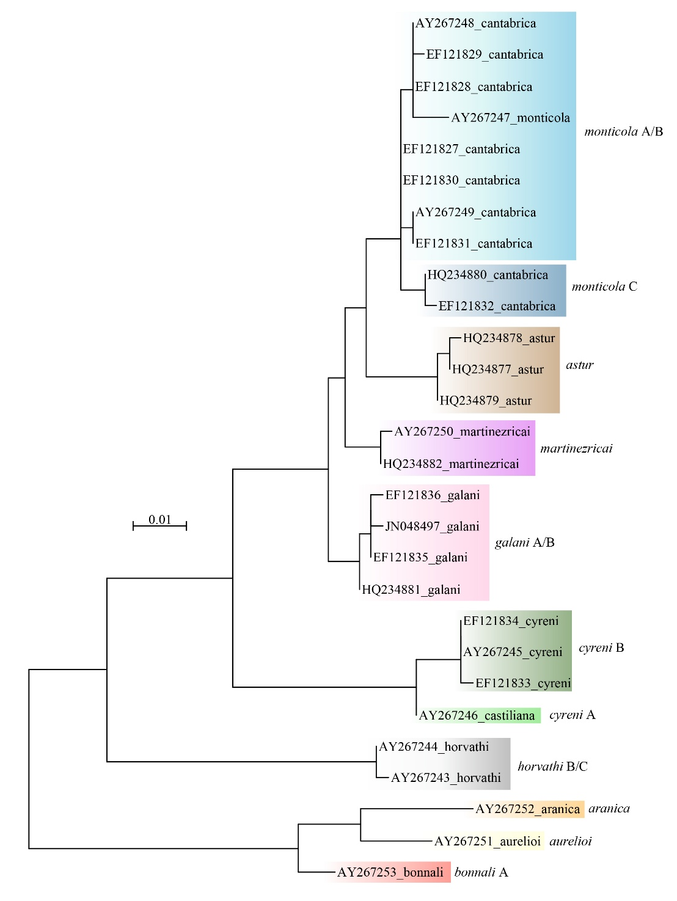

Fig. S10. Variation of cross-entropy across LEA runs with different K values for I. cyreni, I. bonnali, I. aranica and I. aurelioi.
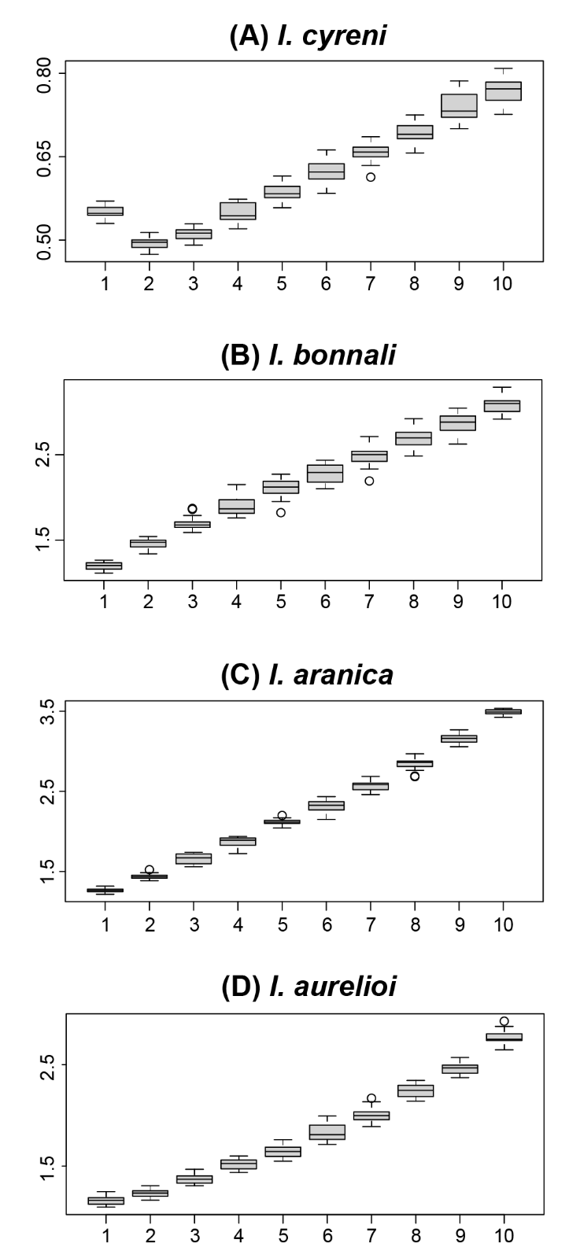
Fig. S11. Isolation by distance among the four densely sampled Iberolacerta species. Relationships (log-log) are all significant (Mantel tests).
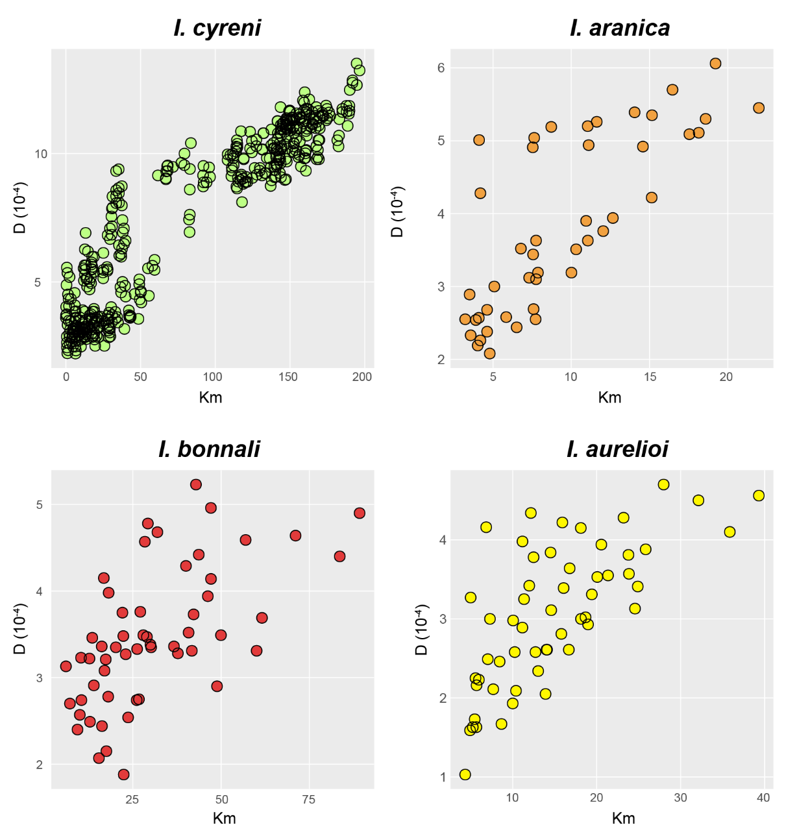

Fig. S12. Relationship between Ho estimates obtained from microsatellites (Ferchaud et al. 2015) and ddRADseq (this study) in 9 populations of I. bonnali analyzed with both types of loci.


