SUPPLEMENTARY DATA
Figure S1: FTIR spectra of the a) A-MEOA, b) A-DEOA and c) A-TEOA samples.

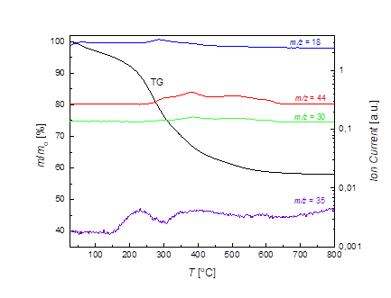
Figure S2: TG-MS curves of A-MEOA-7.5.
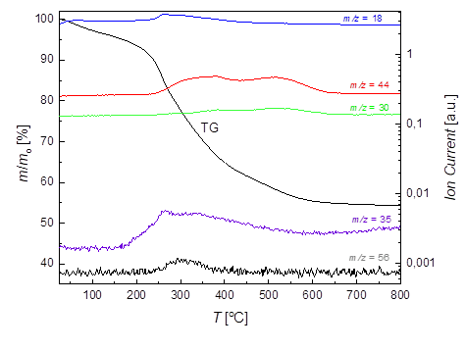
Figure S3: TG-MS curves of A-DEOA-7.5.

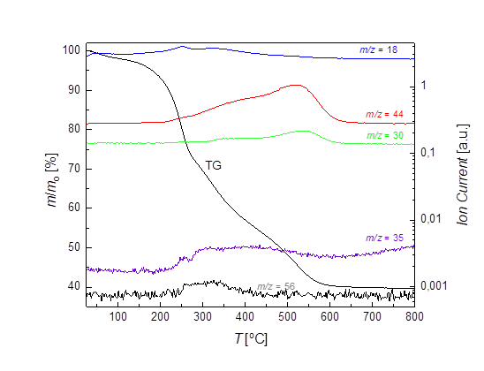
Figure S4: TG-MS curves of A-TEOA-7.5.

