Supplementary material
Carbonation of Lightweight Alkali-Activated Aggregates based on Biomass Fly Ash: Effect on Microstructure and Leaching Behavior
Anže Tesovnik ^{a, b}, Lisbeth M. Ottosen ^{c}, Vilma Ducman ^{a, *}
ª Laboratory for Cements, Mortars and Ceramics, The Department of Materials, Slovenian National Building and Civil Engineering Institute, Dimičeva ulica 12, 1000 Ljubljana, Slovenia
^{b} Jožef Stefan International Postgraduate School, Jamova cesta 39, 1000 Ljubljana, Slovenia
^{c} Department of Environmental and Resource Engineering, Technical University of Denmark, Brovej, 2800 Lyngby, Denmark

* Corresponding author.
E-mail address: vilma.ducman@zag.si (V. Ducman).

Table S1. Mineral phases and amorphous content in BFA, according to XRD data evaluation.
Mineral name | Mineral content [wt%] | ICSD file no. | Chemical formula
Anhydrite | 1.7 | ICSD 98-000-1956 | CaSO₄
Quartz | 15.5 | ICSD 98-015-6196 | SiO₂
Lime | 5.9 | ICSD 98-006-0704 | CaO
Periclase | 6.1 | ICSD 98-006-4928 | MgO
Calcite | 1.4 | ICSD 98-016-4935 | CaCO₃
Akermanite | 3.9 | ICSD 98-002-0391 | Ca_{1.53}Fe_{0.16}Mg_{0.39}Na_{0.51Al0.41}Si₂O₇
Hematite | 0.3 | ICSD 98-005-6372 | Fe₂O₃
Brownmillerite | 13.5 | ICSD 98-009-8824 | Ca₂Fe_{1.796}Al_{0.204}O₅
Magnetite | 5.9 | ICSD 98-005-0273 | Fe_{2.9}O₄
Amorphous content: | 45.8 wt%

Asymmetric stretching vibrations at 1412 cm⁻¹ and symmetric stretching vibrations at 711 cm⁻¹ indicate carbonates (e.g., calcite also indicated by XRD, Figure 2). The broad peak observed at 950 – 1150 cm⁻¹ can be attributed to T–O–Si asymmetric stretching vibrations and Si-O, where T represents Si or Al cations. Together with bending vibrations at 500 cm⁻¹, these vibrations are characteristic of silica- or aluminosilicate-based phases, both crystalline and amorphous. Bending and stretching vibrations at 594 cm⁻¹ can furthermore indicate metal oxide phases (mainly Fe oxides according to XRD and XRF; Table 1, Figure 2). As the BFA was dried at 40 °C before testing, the O–H stretching vibrations in the range of 3200–3600 cm⁻¹ were not detected in the spectrum, indicating the removal of water molecules during the drying process. The peak at 617 cm⁻¹ is associated to SO₄²⁻ from sulfates, such as anhydrite.
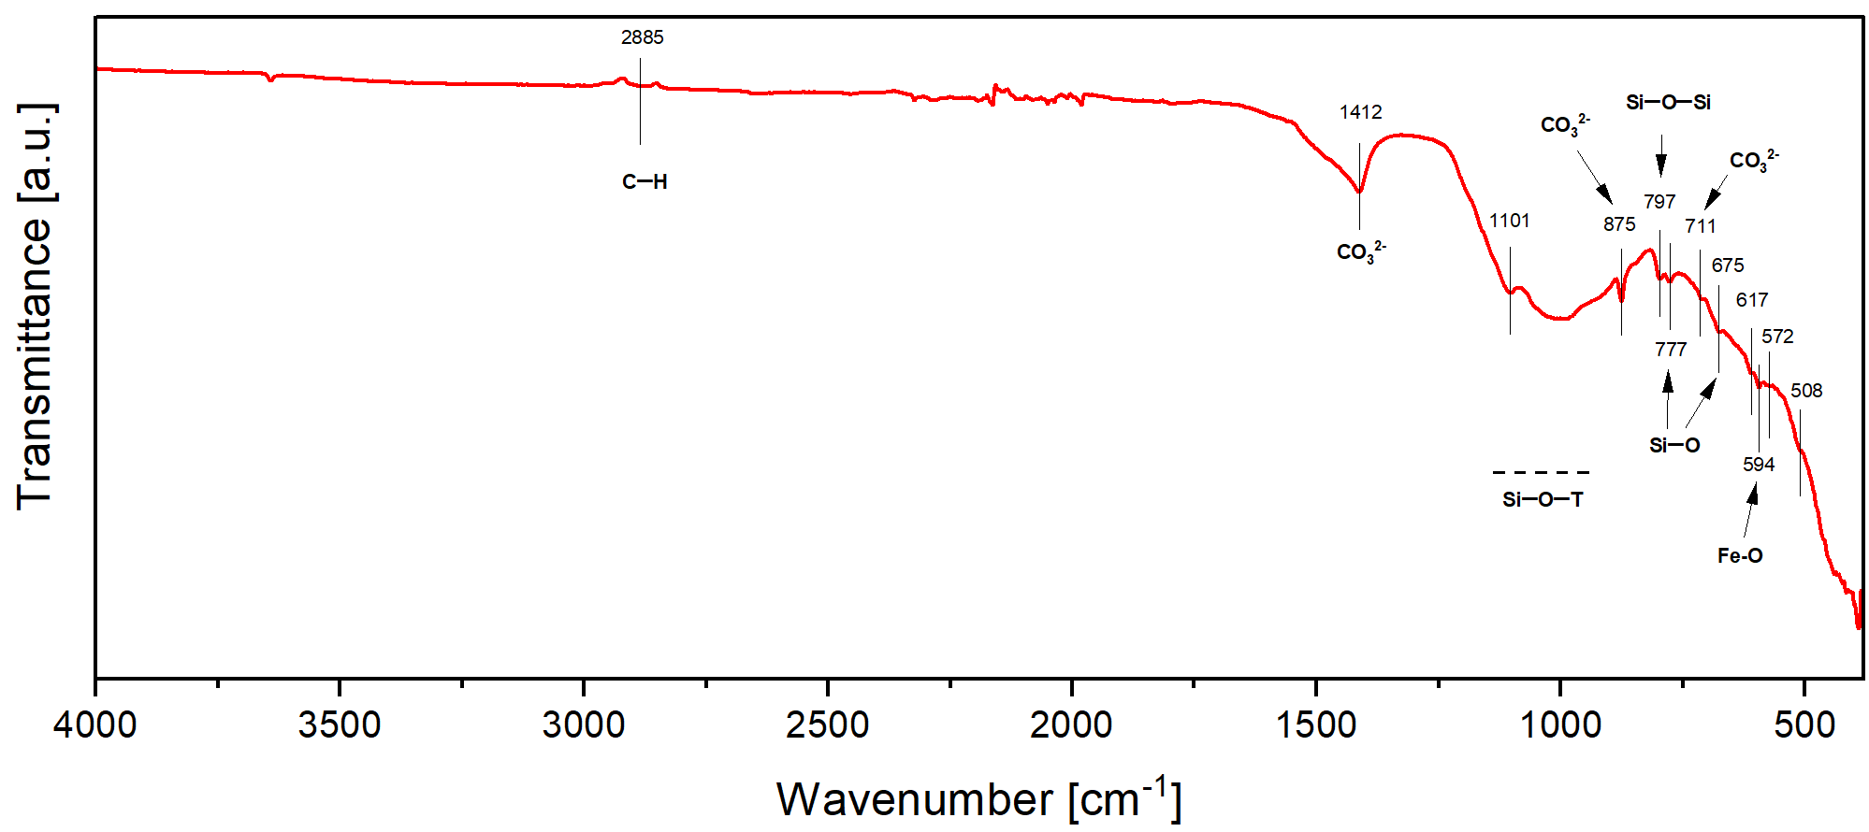
Figure S1. FTIR spectrum of the biomass fly ash (BFA) precursor used in the study.

The theoretical molar ratios of the alkali-activated mixtures (whole active system, amorphous part of precursor and the alkaline solution) for relevant elements from the 1st group of the periodic table (e.g., Na⁺, K⁺) versus Al and Si were calculated and normalized to Al. These ratios were determined using data obtained from XRD and XRF analyses, according to the procedure described in previous work. The mixtures were tailored according to theoretical modeling to achieve a ratio Si/Al=1.9 in M1, while a lower Si/Al ratio of 1.6 was set for M2.
Table S2. Calculated elemental ratios of (Na+K) : Al : Si in the prepared mixtures.
Mixtures | (Na+K) : Al : Si
 | [/]
M1 | 1.3 : 1 : 1.9
M2 | 0.9 : 1 : 1.6
M3 | /

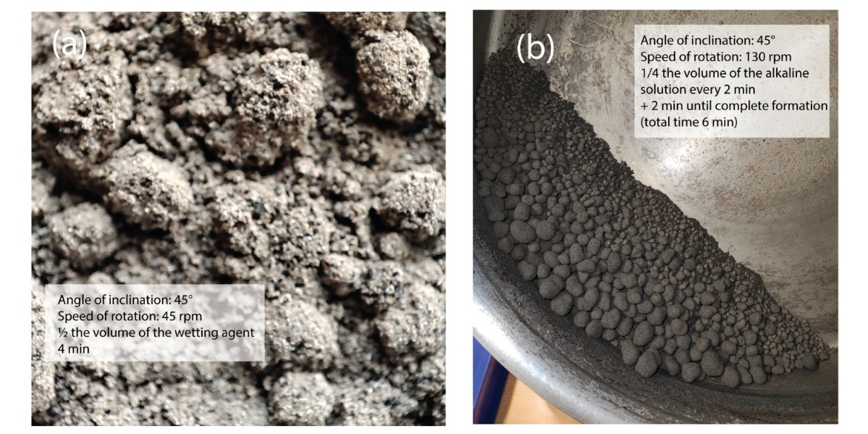
Figure S2. (a) Fotographs showing the nuclei formation on the surface of powder BFA and (b) final view of the produced aggregates after growth to the desired size.

Figure S3. Influence of mix design on the performance of samples cured under different conditions: (a) ambient curing, (b) heat and humidity curing, and (c) carbonation curing.

Differentiating crystalline and amorphous SiO₂ phases in AAM using SEM can be challenging, while EDXS primarily provides only elemental composition and lacks structural information. Crystalline and amorphous SiO₂ show a strong Si signal (emission voltage 1.74 keV). However, with SEM morphology evaluation, quartz (crystalline SiO₂ phase) typically appears as well-defined, angular grains with sharp edges. Due to chemically inert quartz in the AAM, its mineral borders appear as distinct, isolated grains with little variation in composition. In contrast, amorphous silica has an irregular, diffuse, or gel-like appearance. It can be partially reacted in AAM, leading to a mixed composition (e.g., Na, Al incorporation).
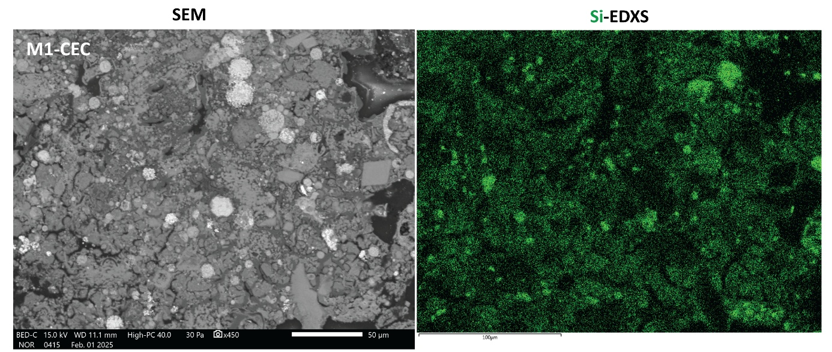
Figure S4. M1-CEC cross-section, whereas, as a result of carbonation, Ca-depleted phases have higher Si content. Some of the residual fully Ca-depleted gel is now amorphous silica, almost completely Si without any other elemental incorporation

