Appendix
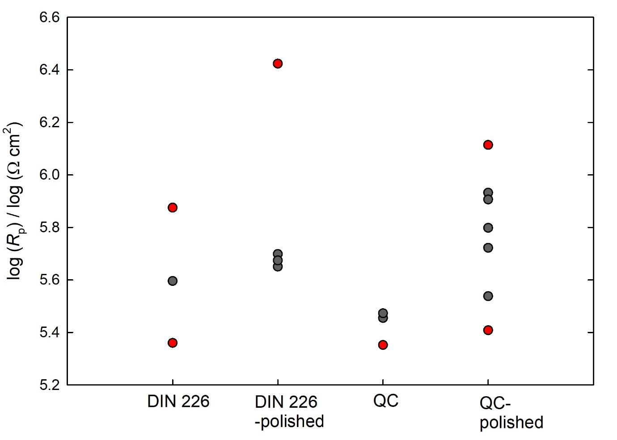
Figure S1: Scatter diagram for all polarization resistance (R_{p}) values, estimated from linear polarization measurements for the two alloys, with usual preparation method and by polishing. Red dots are outlier data.

