Supplementary information
Figure S1: Scheme of the samples processing for histology and synchrotron X-rays analysis.

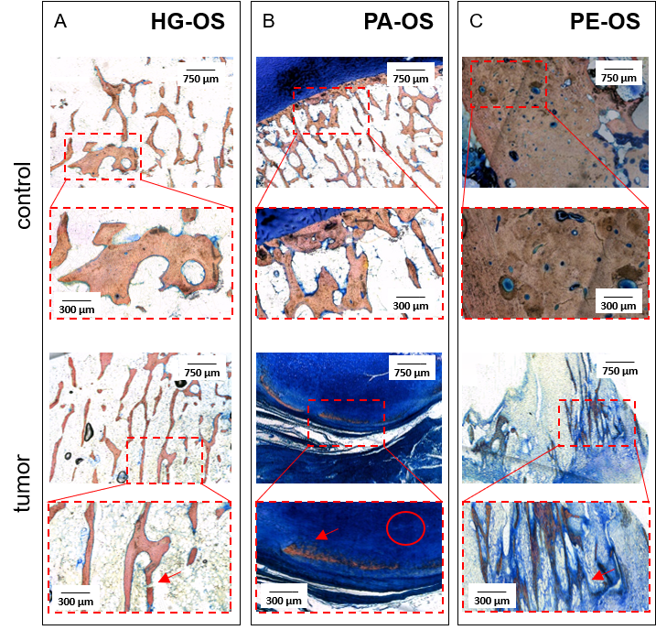
Figure S2: Stevenel’s blue – Van Gieson staining of control and tumor HG-OS (A), PA-OS (B) and PE-OS (C). The red-dashed boxes provide a zoom of a region of interest in the histological section. Red-Orange: specific bone tissue stain. Deep blue: specific connective tissue and collagen fibrils stain. HG-OS bone disruption is indicated by the red arrow in A. In the PA-OS, the presence of densely ossified and lobulated mass and atypical spindle cells between the osseous trabeculae is indicated by the red arrow and the circle in B. The red arrow in C highlights osteoid production by neoplastic cells.
Figure S3: Diffractograms from a control and tumor region containing bone tissue for HG-OS (A and C, respectively), PA-OS (E and G, respectively) and PE-OS (I and M, respectively). Through radial integration, a radial spectrum is derived (lines in B, D, F, H, L, N) showing the main HA diffraction peaks. From the HA reference (red spectra in B, D, F, H, L, N), ’002’ peak can be easily individuated.

Figure S4: Hydroxyapatite Ca K-edge reference spectrum. Letters indicate the main spectral features: absorption peak (C), called white line, a pre-edge (A), a shoulder preceding the white line (B) and oscillation peaks at higher energies (from D to H).

Figure S5: Microscope image of the control and tumoral samples with overlapped XRFM images (scale bar 1 mm). In A) and B) tumor and control PA-OS. In C) and D) tumor and control HG-OS while in E) and F) tumor and control PE-OS.

Figure S6: Integrated intensity maps of the HA distribution of control and tumor HG-OS (A), PA-OS (B) and PE-OS (C). The dimension of the analyzed ROIs is approximately 20 mm².

ID | Gender | Hystotype | Age | Chemotherapy
HG-OS | F | high-grade OS | 14 | YES
PA-OS | F | parosteal OS | 62 | NO
PE-OS | M | periosteal OS | 15 | NO
Table S1: Summary of the clinicopathological features of the patients studied.

