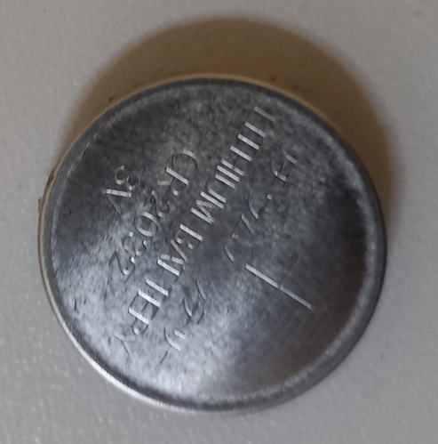 | 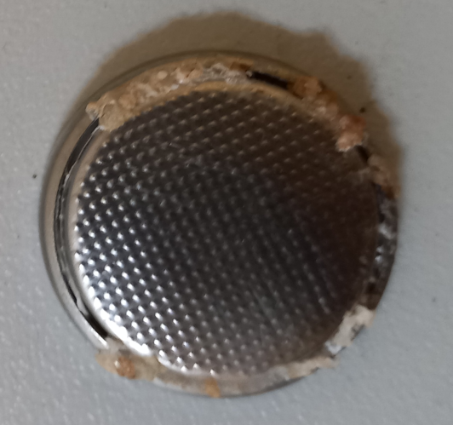
Figure A: Pictures showing the fully charged RAB3 sample after thermal abuse tests performed for 2 hours at 200 °C. An apparent effect of bumping the metallic case is visible on both (back and front) sides of the coin cell. A leak of plastic material, most likely the sealant, was also observed outside the cell (see the right picture).

(a)  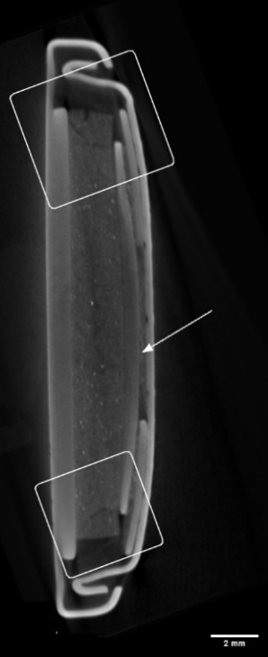 | (b) 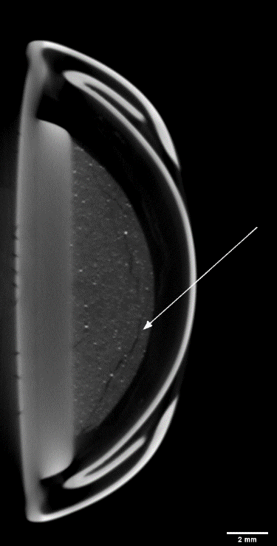 | (c) 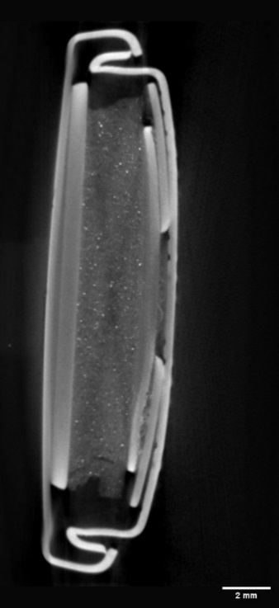 | (d) 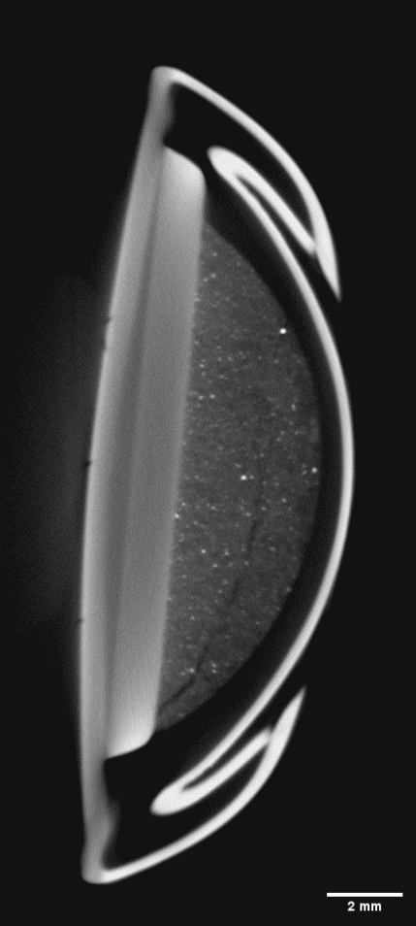
Figure B: Representative virtual sections of the RAB after the thermal abuse test at 200 °C for 2 hours. In (a, c), transversal and (b, d) axial slices are shown in (a, respectively). Tomographic reconstruction was performed with an isotropic voxel size of 20.6 µm.

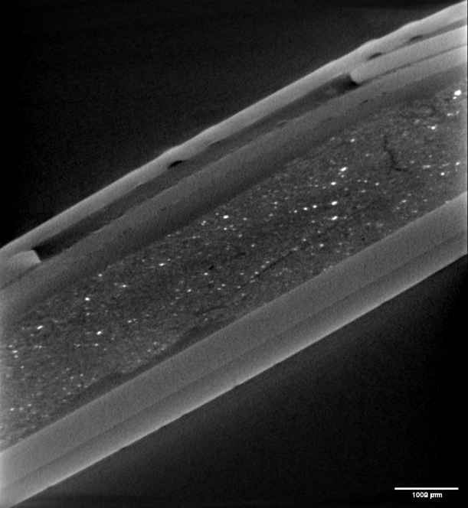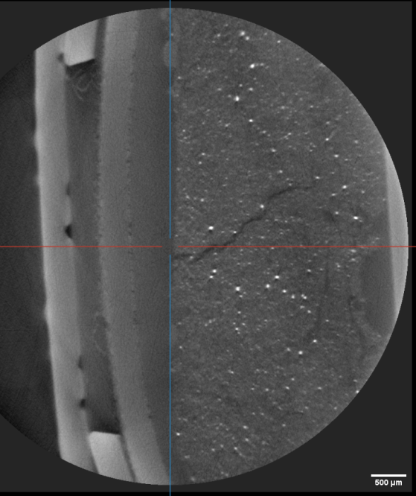
Figure C: Two virtual sections of the fully charged RAB3 sample after abuse tests. The CT reconstruction was done with an isotropic voxel size of 7.95 µm. We can better visualize cracks in the battery's active region and the active material's lack or detachment.

