SUPPLEMENTARY INFORMATION

Microplastics from cigarette filters: comparative effects on selected terrestrial and aquatic invertebrates

Andraž Dolar^{a,b}, Branka Mušič^{c}, Tina Skalar^{d}, Gregor Marolt^{d}, Damjana Drobneª, Andrijana Sever Škapin^{c,e}, Anita Jemec Kokalj^{a,d}
ªUniversity of Ljubljana, Biotechnical Faculty, Department of Biology, Jamnikarjeva 101, SI-1000 Ljubljana, Slovenia
^{b}Rudolf Maister Grammar and Secondary School Kamnik, Novi trg 41, SI-1241 Kamnik, Slovenia
^{c}Slovenian National Building and Civil Engineering Institute; Dimičeva ulica 12; SI-1000 Ljubljana, Slovenia
^{d}University of Ljubljana, Faculty of Chemistry and Chemical Technology, Večna pot 113, SI-1000 Ljubljana, Slovenia
^{e}Faculty of Polymer Technology, Ozare 19, SI-2380 Slovenj Gradec, Slovenia

*Corresponding author:
Anita Jemec Kokalj, anita.jemec@bf.uni-lj.si
University of Ljubljana, Biotechnical Faculty, Department of Biology, Jamnikarjeva 101, SI-1000 Ljubljana, Slovenia

Figure S1


Figure S1. Public reminder against cigarette butt littering (Arrecife, Lanzarote, Spain; photo Anita Jemec Kokalj). The sculpture is made of cigarette butts and represents a vine. The inscription translates to: You reap what you sow.

Figure S2
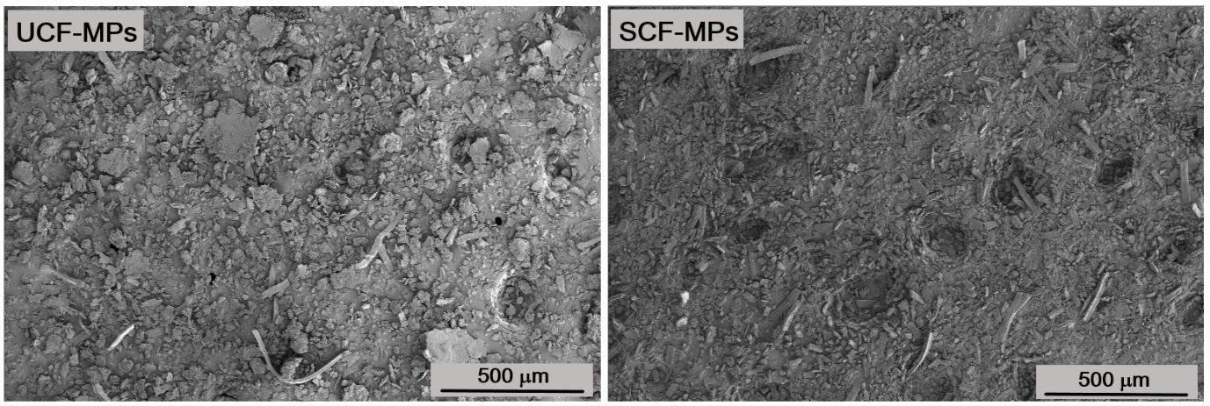
Figure S2. Scanning electron microscopy image of microplastics milled from unsmoked (UCF-MPs) and smoked cigarette filters (SCF-MPs).
Figure S3
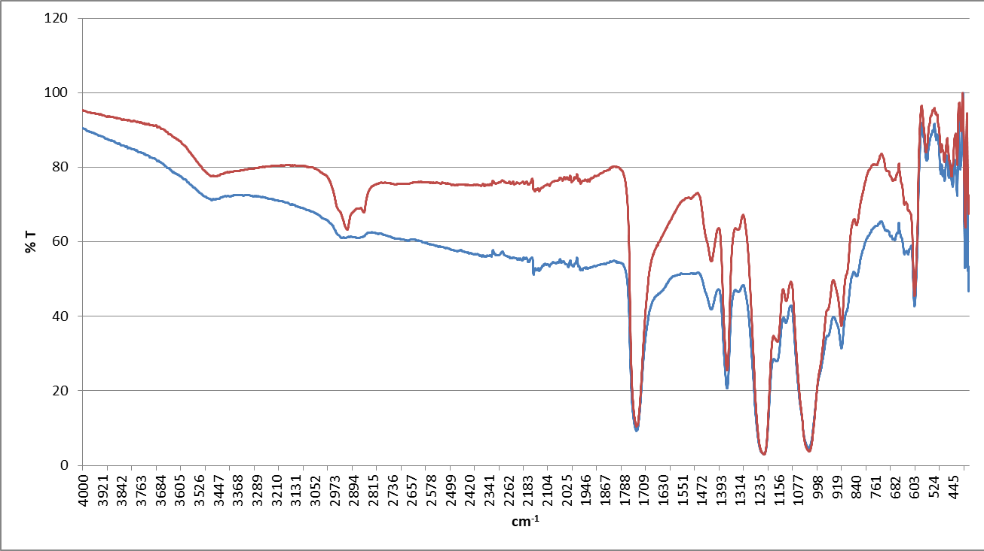
Figure S3. The chemical composition of unsmoked (UCF-MPs; red spectrum) and smoked (SCF-MPs; blue spectrum) cigarette filter microplastics, as determined by Fourier transform infrared spectroscopy (diamond crystal, FTIR Spectrum Two spectrometer; PerkinElmer).

Figure S4

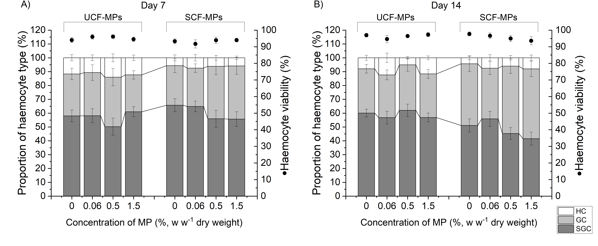
Figure S4: Proportion of the three main haemocyte types SGC (semi-granular cells), GC (granular cells), and HC (hyaline cells) and haemocyte viability in the haemolymph of the isopod Porcellio scaber exposed to microplastics from unsmoked (UCF-MPs) and smoked cigarette filters (SCF-MPs) in Lufa 2.2 soil (0, 0.06, 0.5, 1.5% w w⁻¹ dry weight) for A) 7 days and B) 14 days. The stacked columns and dots represent the mean ± standard error.

Table S1. Concentrations of metals and other selected elements in microplastics from unsmoked (UCF-MPS) and smoked cigarette filters (SCF-MPs). Mean values and standard errors are shown (n=4).
Metal | UCF-MPs (µg/g) | SCF-MPs(µg/g)
⁷Li | < 0.001 µg/g | 0.027 ± 0.018
⁹Be | 0.0037 ± 0.0013 | 0.0037 ± 0.0012
¹¹B | 0.138 ± 0.006 | 0.62 ± 0.09
²³Na | 34.0 ± 0.5 | 21.26 ± 0.11
²⁴Mg | 69.4 ± 1.6 | 60.2 ± 0.6
²⁷Al | 15.7 ± 1.8 | 9.4 ± 0.3
³¹P | 1.4 ± 0.4 | 7.7 ± 0.3
³⁹K | 22.07 ± 0.18 | 900 ± 10
⁴⁴Ca | 49.2 ± 1.6 | 27.1 ± 1.6
⁴⁷Ti | 6.2 ± 0.6 | 5.0 ± 0.4
⁵¹V | 0.0274 ± 0.0017 | 0.0210 ± 0.0019
⁵²Cr | 1.42 ± 0.08 | 0.69 ± 0.05
⁵⁵Mn | 0.32 ± 0.09 | 0.38 ± 0.04
⁵⁶Fe | 20.9 ± 0.5 | 14.1 ± 0.7
⁵⁹Co | 0.019 ± 0.003 | 0.0061 ± 0.0015
⁶⁰Ni | 0.44 ± 0.05 | 0.17 ± 0.02
⁶³Cu | 0.95 ± 0.04 | 0.433 ± 0.006
⁶⁶Zn | 2.31 ± 0.05 | 4.5 ± 0.7
⁶⁹Ga | 0.052 ± 0.015 | 0.043 ± 0.003
⁷⁵As | 0.0026 ± 0.0005 | 0.0366 ± 0.0011
⁷⁸Se | < 0.001 | 0.015 ± 0.008
⁸⁵Rb | 0.0336 ± 0.0004 | 0.715 ± 0.007
⁸⁸Sr | 0.192 ± 0.002 | 0.222 ± 0.005
⁹⁵Mo | 0.126 ± 0.014 | 0.014 ± 0.002
¹⁰⁷Ag | 0.016 ± 0.004 | 0.0011 ± 0.0006
¹¹¹Cd | 0.0018 ± 0.0005 | 0.344 ± 0.006
¹¹⁵In | 0.0005 ± 0.0001 | < 0.001
¹¹⁸Sn | 0.142 ± 0.007 | 0.0185 ± 0.0014
¹²¹Sb | 0.0068 ± 0.0010 | 0.0006 ± 0.0003
¹²⁵Te | < 0.001 | < 0.001
¹³³Cs | 0.0015 ± 0.0001 | 0.0047 ± 0.0001
¹³⁷Ba | 0.26 ± 0.08 | 0.22 ± 0.01
²⁰⁵Tl | 0.0001 ± 0.0001 | 0.0241 ± 0.0002
²⁰⁸Pb | 0.070 ± 0.004 | 0.232 ± 0.004
²⁰⁹Bi | 0.0063 ± 0.0002 | 0.0018 ± 0.0002

Table S2. Gas chromatography with mass spectrometry (GC/MS) analysis of compounds in microplastics from unsmoked (UCF-MPs) and smoked cigarette filters (SCF-MPs).
UCF-MPs
Time (min) | GC compound | Area (A.U.)
10.266 | Triacetin | 16.44
SCF-MPs
Time (min) | GC compounds | Area (A.U.)
3.313 | 1,2-Propanediol | 1.53
6.306 | 2-Cyclopenten-1-one, 3-methyl- | 0.38
6.564 | Phenol | 0.57
7.411 | Phenol, 2-methyl- | 1.20
7.654 | Phenol, 3-methyl- | 2.44
7.788 | Mequinol | 0.92
8.366 | 1-Phenyl-2-ethylnitrile | 0.55
8.452 | Phenol, 2,5-dimethyl- | 0.46
8.899 | Creosol | 0.20
9.852 | 2-ethenyl benzaldehyde | 0.25
10.102 | 2-methoxy-4-vinyl-phenol | 0.52
10.294 | Triacetin | 273.60
10.474 | Nicotine (Pyridine, 3-(1-methyl-2-pyrrolidinyl)-, (S)-) | 32.81
10.844 | Indole, 3-methyl- | 0.39
11.618 | 2H-1,2-Oxazine, tetrahydro-2-methyl-6-(3-pyridinyl)-, (-)- | 1.09
12.133 | 4,4'-Bipyridine | 0.30
13.441 | Cotinine | 0.47
15.138 | n-Hexadecanoic acid | 1.26
16.926 | Butyl citrate | 6.37

Biochemical methods details
Each individual was homogenised for 1 min in 0.8 ml of ice-cold potassium phosphate buffer - PPB (50 mM, pH 7.0), using an UltraTurrax T10 basic homogenizer (speed 5; IKA, Germany). The homogenates were centrifuged for 15 min at 20,817 g at 4 °C (5810 R, Eppendorf, Germany) and supernatants were used for measuring enzyme activities. These were measured in triplicate for each sample.
AChE activities were determined according to Ellman’s method (Ellman et al., 1961) with minor modifications, using a VIS microplate reader (Anthos Zenyth 3000, Great Britain). The reaction mixture per well was: 50 µl of PPB (50 mM, pH 7.0), 50 µl of supernatant, 100 µl of Ellman’s reagent (0.1148 mM DTNB) with acetylthiocholine chloride (ACh-Cl) (1 mM final concentration in the well). Suitable working concentrations of DTNB and ACh-Cl were prepared immediately before use. In blank reactions, the supernatant was replaced by 50 μl of PPB (100 mM, pH 6.5). The reactions were followed spectrophotometrically at 405 nm at 25 °C for 20 min. AChE activity was expressed in nmoles of hydrolysed ACh-Cl/min/mg protein (extinction coefficient, ε405=13,600 M⁻¹ cm⁻¹).
The GST activity was determined as described by Habig et al. (1974), using a VIS microplate reader (Anthos Zenyth 3000, Great Britain). The reaction mixture per well was: 50 µl of supernatant, 50 µl of CDNB (4 mM) and 100 µl of reduced glutathione (GSH) (2 mM). CDNB was dissolved in absolute ethanol to 50 mM, which was afterwards diluted in PPB (100 mM, pH 6.5) to the final concentration of 4 mM. The working solution of GSH was prepared in PPB (100 mM, pH 6.5) immediately before use. The final well concentrations of the CDNB and GSH in the well were both 1 mM. In blank reactions, the supernatant was replaced by 50 μl of PPB (100 mM, pH 6.5). The reaction was followed spectrophotometrically at 340 nm (25 °C for 20 min). The GST activity was expressed in nanomoles of conjugated reduced GSH/min/mg protein (extinction coefficient, ε340= 9,600 M⁻¹ cm⁻¹).
For ETS activity, 250 µL of each sample was mixed with 150 µL of homogenisation buffer (0.1 M KH₂PO₄, 0.1 M NaH₂PO₄, 830 µM MgSO₄, 0.15% (w/v) polyvinylpyrrolidone (PVP) and 0.2% (w/v) triton X-100), vortexed for 90 seconds and centrifuged for 10 minutes at 1000 rcf in 4°C. 50 µL of the mixture was placed in a 96-well microplate with 150 µL of buffer substrate solution (0.1 M KH₂PO₄, 0.1 M NaH₂PO₄, 1.8 mM nicotinamide adenine dinucleotide , 0.28 mM nicotinamide adenine dinucleotide phosphate and 0.27% (w/v) triton X-100) and 100 µL of 3.95 mM 2-[4-Iodophenyl]-3-[4-nitrophenyl]-5-phenyl-tetrazolium chloride. The absorbance of samples was measured at 490 nm, and 25°C for 5 minutes with the Agilent BioTek Synergy LX Multi-Mode Reader. ETS activities were calculated using a molar extinction coefficient of formed formazan (ε490=15 900 M⁻¹ cm⁻¹), transformed into energetic equivalents using the oxy-enthalpic equivalents for an average lipid, protein, and sugar mixture (484 kJ mol O₂⁻¹), and expressed as mJ per mg proteins per hour (Verslycke et al., 2004).
Protein concentrations in supernatants were determined using BCA Protein Assay kits (Pierce, Rockford, USA). After 30 min of incubation in the dark at 37 °C, the color formation was determined at 562 nm using a microplate reader (Dynex Technologies, USA). All samples were measured in triplicate.

References:
Ellman, G.L., Courtney, K.D., Andres, V., Featherstone R.M., 1961. A new rapid colorimetric determination of acetylcholinesterase activity. Biochemical Pharmacology, 7, 88–95.
Habig, W.H., Pabst, M.J., Jakoby, W.B., 1974. Glutathione S-transferases. The first enzymatic step in mercapturic acid formation. Journal of Biological Chemistry 249, 7130-7139.
Verslycke, T., Roast, S.D., Widdows, J., Jones, M.B., Janssen, C.R. 2004. Cellular energy allocation and scope for growth in the estuarine mysid Neomysis integer (Crustacea: Mysidacea) following chlorpyrifos exposure: a method comparison. Journal of Experimental Marine Biology and Ecology 306:1–1

