Supplementary material

The application of digital PCR as a reference measurement procedure to support the accuracy of quality assurance for infectious disease molecular diagnostic testing.

Samreen Falak^{1*}, Denise M O’Sullivan^{2*}, Megan H Cleveland^{3*}, Simon Cowen², Eloise J Busby², Alison S Devonshire², Esmeralda Valiente¹, Gerwyn Jones², Martin Kammel^{4,5,6}, Mojca Milavec⁷, Laura Vierbaum⁴, Ingo Schellenberg⁴, Heinz, Zeichhardt^{4,5}, Andreas Kummrow¹, Peter M Vallone³, Rainer Macdonald¹, Jim F Huggett^{2,8 x}

¹Physikalisch-Technische Bundesanstalt, Germany, ²NML, LGC, London, UK, ³National Institute of Standards and Technology, Gaithersburg, Maryland, USA, ⁴INSTAND e.V., Düsseldorf, Germany, ⁵IQVD GmbH, Institut fuer Qualitaetssicherung in der Virusdiagnostik, Berlin, Germany, ⁶GBD Gesellschaft fuer Biotechnologische Diagnostik mbH, Berlin, Germany, ⁷Department of Biotechnology and Systems Biology, National Institute of biology, Večna pot 121, 1000 Ljubljana, Slovenia ⁸School of Biosciences & Medicine, University of Surrey, Guildford, UK

*Contributed equally
^{X} corresponding author

Contents
1. Supplementary methods 3
External quality assurance panels 3
Supplemental Table 1: Virus Genome Detection of corona virus and SARS-CoV-2 EQA sample properties and distribution 4
Supplemental Table 2: Virus Genome Detection of SARS-CoV-2 additional samples - properties 7
RT digital PCR 8
One-step RT-dPCR methodology (PTB) 8
One-step RT-dPCR methodology (NML) 8
One-step RT-dPCR methodology (NIST) 8
Supplemental Table 3: Primer and probe sequences to the SARS-CoV-2 nucleocapsid (N) gene 9
Analytical assessment of SARS-CoV-2 CDC N2 RT-dPCR assay. 9
2. Supplementary results 11
Supplemental Table 4: Analytical precision of CDC N2 RT-dPCR assay 11
Supplemental Table 5: Results of LOD testing of CDC N2 RT-dPCR assay 11
Supplemental Table 6: Measurement uncertainty* of CDC N2 RT-dPCR assay 12
Supplemental Figure 1: Examples of digital PCR results 12
Supplemental Figure 2: Linearity of CDC N2 RT-dPCR assay. 14
Supplemental Figure 3: Between laboratory variation 15
Supplemental Figure 4: Same material in different rounds 16
Supplemental Table 7: dMIQE checklist for authors, reviewers and editors 17
3. References 24

1. Supplementary methods

External quality assurance panels
In total, six panels for the SARS-CoV-2 molecular external quality assurance (EQA) schemes assessments were prepared and distributed by INSTAND for evaluation of SARS-CoV-2 molecular diagnostic performance between June 2020 to November 2021. Initially, the panel contained a dilution series of the original Wuhan SARS-CoV-2, other human coronaviruses and Middle East respiratory syndrome coronavirus (MERS-CoV) and negative controls. As variants of concern (VOC) arose, samples with these variants, as well as samples with the original Wuhan strain, were included in the panels (Supplemental Table 1).
A variety of SARS-CoV-2 strains and non-SARS coronaviruses were used for different EQA rounds (see Supplemental Table 1). SARS-CoV-2, provided by the National Consultant Laboratory for Coronaviruses at Charité—University Medicine Berlin, Institute of Virology, Berlin, Germany, was propagated under BSL-3 conditions in Vero E6 cells (ATCC CRL-1586). For EQA sample preparation cell culture supernatant was used which was heat inactivated (4 h, 60 °C) or chemically inactivated (treatment with beta-propiolactone). Inactivation of the virus was proven by two blind passages. The EQA samples were prepared by using defined dilution series of the virus-containing cell culture supernatants with cell culture medium (Minimal Essential Medium, PanBio-Tech, Aidenbach, Germany) with the addition of non-essential amino acids (PanBioTech), HEPES buffer (PanBioTech) and gamma-irradiated fetal calf serum (PanBioTech, 10-15% v/v). The diluted cell culture supernatants were aliquoted at 1.1 ml each into 2 ml tubes (Sarstedt, Nuembrecht, Germany) and then lyophilized over a period of 72 hours in an Epsilon 2-10D LSC freeze dryer (Martin Christ Gefriertrocknungsanlagen GmbH, Osterode, Germany). All samples were stored at
<-20°C until shipment at ambient temperature. For further details on sample preparation including inactivation of the cell culture supernatant and sample lyophilization see Vierbaum et al., 2022 [3]. Non-SARS coronaviruses were not inactivated.

Supplemental Table 1: Virus Genome Detection of corona virus and SARS-CoV-2 EQA sample properties and distribution
EQA survey | Sample Number | INSTAND Sample ID | Strain | SARS-CoV-2 | Variant of Concern (VOC) | EQA - dilution | SARS-CoV-2 (copies/mL) RT dPCR value assigned conc. ± expanded uncertainty (95% CI) | Number of EQA participants providing quantitative estimation when qPCR assays that targeted the N gene (Fig.3)
2020 June/July | 1 | 340066 | BetaCoV/ Munich/ChVir984/2020 | positive | non-VOC | 1 : 5 000 000 | (1570 ± 360) | 6
2020 June/July | 2 | 340069 | BetaCoV/ Munich/ChVir984/2020 | positive | non-VOC | 1 : 50 000 | (177000 ± 37000) | 6
2020 June/July |  | 340071 | BetaCoV/ Munich/ChVir984/2020 | positive | non-VOC | 1 : 50 000 000 | (213 ± 77) | 6
2020 June/July | 3 | 340073 | BetaCoV/ Munich/ChVir984/2020 | positive | non-VOC | 1 : 500 000 | (18200 ± 3100) | 6
2020 June/July |  | 340067 | MERS-CoV (inactivated) | negative |  | 1 : 1 000 | Negative
2020 June/July |  | 340068 | HCoV 229E | negative |  | 1 : 1 000 | Negative
2020 June/July |  | 340072 | HCoV NL63 | negative |  | 1 : 1 000 | Negative
2020 June/July |  | 340074 | HCoV OC43 | negative |  | 1 : 1 000 | Negative
2020 June/July |  | 340070 | MRC-5-cell lysates as negative control | negative |  | 1 : 6 | Negative
2020 November | 4 | 340075 | BetaCoV/Berlin/ChVir1670/2020_IsolatBER | positive | non-VOC | 1 : 50 000 | (3.35 ± 1.15) x 10⁵ | 8
2020 November | 5 | 340077* | BetaCoV/Munich/ChVir984/2020 | positive | non-VOC | 1 : 7 500 | (1.33 ± 0.27) x 10⁶ | 8
2020 November | 6 | 340079 | BetaCoV/Baden-Wuerttemberg/1/ChVir1577/2020_IsolatBER | positive | non-VOC | 1 : 50 000 | (2.85 ± 1.36) x 10⁵ | 8
2020 November | 7 | 340080 | BetaCoV/Munich/ChVir984/2020 | positive | non-VOC | 1 : 75 000 | (1.23 ± 0.57) x 10⁵ | 8
2020 November |  | 340076 | MRC-5-cell lysates as negative control | negative |  | 1 : 6 | negative
2020 November |  | 340078 | HCoV 229E | negative |  | 1 : 1 000 | negative
2021 March | 11 | 409001 | BetaCoV/Munich/BavPat9-ChVir1433/2020_IsolatBER | positive | non-VOC | 1 : 1 000 | (2.07 ± 0.55) x 10⁷ | 10
2021 March | 12 | 409002 | BetaCoV/Passau/ChVir21652/2020 | positive | VOC B.1.1.7 (Alpha) | 1 : 2 500 | (1.13 ± 0.19) x 10⁷ | 10
2021 March | 13 | 409003 | BetaCoV/South Africa/ChVir22131/2020 | positive | VOC B.1.351 (Beta) | 1 : 3 500 | (9.80 ± 6.30) x 10⁴ | 10
2021 March | 5 | 409005* | BetaCoV/Munich/ChVir984/2020 | positive | non-VOC | 1: 7 500 | (1.15 ± 0.58) x 10⁶ | 10
2021 March |  | 409004 | MRC-5-cell lysates as negative control | negative |  | 1 : 6 | Negative
2021 June | 17 | 409006 | BetaCoV/Passau/ChVir21652/2020 | positive | VOC B.1.1.7 (Alpha) | 1 : 25000 | (9.16 ± 3.66) x 10⁵ | 3
2021 June | 18 | 409008 | BetaCoV/South Africa/ChVir22131/2020 | positive | VOC B.1.351 (Beta) | 1 : 35000 | (6.71 ± 2.68) x 10⁵ | 3
2021 June | 19 | 409009 | BetaCoV/Munich/ChVir948/2021 | positive | non-VOC | 1 : 500 000 | (1.53 ± 0.73) x 10⁴ | 3
2021 June |  | 409007 | MRC-5-cell lysates as negative control | negative |  | 1 : 6 | Negative
2021 June |  | 409010 | HCoV NL63 | negative |  | 1 : 1.000 | Negative
2021 September | 22 | 409011 | BetaCoV/Munich/ChVir984/2020 | positive | non-VOC | 1 : 100 000 | (1.99 ± 0.42) x 10⁵ | 8
2021 September | 23 | 409012 | hCoV-19/Germany/SH-ChVir25702_4/2021 | positive | VOC B.1.617.2 (Delta) | 1 : 11 000 | (7.85 ± 3.34) x 10⁵ | 8
2021 September | 24 | 409013 | BetaCoV/Munich/ChVir984/2020 | positive | non-VOC | 1 : 75 000 | (1.05 ± 0.24) x 10⁵ | 8
2021 September | 25 | 409014 | hCoV-19/Germany/SH-ChVir25702_4/2021, | positive | VOC B.1.617.2 (Delta) | 1 : 19 000 | (7.41 ± 2.62) x 10⁵ | 8
2021 September | 26 | 409015 | BetaCoV/Munich/BavPat9-ChVir1433/2020 | positive | non-VOC | 1 : 10 000 | (2.06 ± 0.20) x 10⁶ | 8
2021 November | 30 | 409016 | hCoV-19/Germany/SH-ChVir25702_4/2021 | positive | VOC B.1.617.2 (Delta) | 1 : 5 500 | (3.38 ± 1.28) x 10⁶ | 5
2021 November | 31 | 409018 | BetaCoV/Passau/ChVir21652/2020 | positive | VOC B.1.1.7 (Alpha) | 1 : 2 000 | (5.13 ± 1.73) x 10⁵ | 5
2021 November | 32 | 409020 | BetaCoV/Munich/ChVir984/2020 | positive | non-VOC | 1 : 50 000 | (1.79 ± 0.59) x 10⁴ | 5
2021 November |  | 409017 | HCoV 229E | negative |  | 1 : 2 000 | Negative
2021 November |  | 409019 | MRC-5-cell lysates as negative control | negative |  |  | Negative
*Samples 340077 and 409005 are identical with the internal code G20916
All sample materials are cell culture supernatants
Only MRC-5- is a cell lysates

Supplemental Table 2: Virus Genome Detection of SARS-CoV-2 additional samples - properties
Sample Number | Additional samples ID  (not used for the EQA) | Strain | SARS-CoV-2 | Variant of Concern (VOC) | Dilution | SARS-CoV-2 (copies/mL) RT dPCR value assigned conc. ± expanded uncertainty (95% CI)
8 | G21124* | BetaCoV/Munich/ChVir984/2020 | Positive | non-VOC | 1 : 750 | (1.24 ± 0.36) x 10⁷
9 | G21125* | BetaCoV/Munich/ChVir984/2020 | Positive | non-VOC | 1 : 7 500 | (1.23 ± 0.33) x 10⁶
10 | G21126 | BetaCoV/Munich/ChVir984/2020 | Positive | non-VOC | 1 : 75 000 | (1.16 ± 0.42) x 10⁵
14 | G21617 | BetaCoV/Munich/BavPat9-ChVir1433/2020 | Positive | non-VOC | 1 : 100 000 | (2.05 ± 1.17) x 10⁵
15 | G21801 | BetaCoV/Passau/ChVir21652/2020 | Positive | VOC B.1.1.7 (Alpha) | 1 : 250 000 | ((9.78 ± 6.32) x 10⁴
16 | G21849 | BetaCoV/South Africa/ChVir22131/2020 | Positive | VOC B.1.351 (Beta) | 1 : 350 000 | (6.28 ± 4.10) x 10⁴
20 | G22029 | BetaCoV/Berlin/ChVir1670/2020_IsolatBER | Positive | non-VOC | 1 : 1 675 | (8.99 ± 3.26) x 10⁶
21 | G22030 | BetaCoV/Berlin/ChVir1670/2020_IsolatBER | Positive | non-VOC | 1 : 16 750 | (8.95 ± 2.41) x 10⁵
27 | G22733 | BetaCoV/Munich/ChVir984/2020 | Positive | non-VOC | 1 : 2 371 7 | (4.75 ± 1.68) x 10⁶
28 | G22815 | hCoV-19/Germany/SH-ChVir25702_4/2021 | Positive | VOC B.1.617.2 (Delta) | 1 : 250 | (2.80 ± 0.42) x 10⁷
29 | G22828 | hCoV-19/Germany/SH-ChVir25702_4/2021 | Positive | VOC B.1.617.2 (Delta) | 1 : 500 | (1.42 ± 0.18) x 10⁷
* Sample G21124 corresponds to RM1 and sample G21125 corresponds to RM 2 of Vierbaum et al. 2022 [3].

RT digital PCR
Examples of RT dPCR plots is available in Supplemental Figure 2.

One-step RT-dPCR methodology (PTB)
SARS-CoV-2 RNA was quantified using a duplex assay targeting to China N and Sarbeco E gene [1, 2]. The China N probe was labelled with 5’ FAM and Sarbeco E with 5’ HEX and with BHQ1 quenched. Reactions were set up using the One-Step RT-ddPCR Advanced Kit for Probes (Cat no. 1864021, Bio-Rad). 20 µL reactions were prepared to contain 1X Supermix, 20 U/µL reverse transcriptase, 15 mM DTT, primers and probes concentration (400 nM and 200 nM respectively) and nuclease-free water and. 8 µL of RNA templates was added to a 20 µL total reaction volume. The reactions were performed in triplicates using a 96-well plate. Nuclease-free water (NTCs) were used as negative control and for RT negative control, water was used instead of RT. Thermocycling conditions were as follows: Reverse transcription at 50 °C for 15 minutes, 5 minutes at 95 °C, 45 cycles of 95 °C for 30 s, and 55 °C for 30 sec, followed by 98°C for 5 min and a 4 °C hold. The ramp rate for each step was 2°C/s. After thermocycling was completed, the plate was read on the QX200 Droplet Reader, and the data were analyzed using Bio-Rad QuantaSoft version 1.0.596. All thresholds were manually set up to allow the distinction between positive and negative partitions. Only the reactions with more than 10,000 accepted partitions were considered for analysis. A partition volume of 0.850 nL was used to calculate copy number concentration. Data were exported in Microsoft Excel 2010 for further analysis.

One-step RT-dPCR methodology (NML)
SARS-CoV-2 RNA was quantified using the CDC N2 assay (see table S1). The assay probe was labelled with 5’ FAM and quenched with 3’ BHQnova1 (Biosearch). Reactions were set up using the One-Step RT-ddPCR Advanced Kit for Probes (Cat no. 1864021, Bio-Rad). 22 µL reactions were prepared containing 1X Supermix (5.5 µL of 4x), 20 U/µL reverse transcriptase (2.2 µL of 10x), 15 mM DTT (1.1 µL of 300 nM), 900 nM primers and 250 nM probe, 6.6 µL nuclease-free water. RNA templates were denatured by heating to 65°C for 5 minutes before immediate chilling on ice for at least 1 minute. 5.5 µL of denatured RNA template was added per 22 µL prepared reaction volume. Reactions were prepared in triplicate using 96-well plate. Triplicate no template control (NTCs) were prepared using nuclease-free water instead of RNA template. For RT negative controls, RT enzyme was substituted with nuclease-free water. Thermocycling conditions were as follows: Reverse transcription at 47.5°C for 60 minutes, 10 minutes at 95 °C, 40 cycles of 95 °C for 30 s and 55 °C for 60 sec, followed by 98°C for 10 min and a 4 °C hold for at least 1 hour. The ramp rate for each temperature step was 2°C/s, except for a 1°C/s ramp rate used for the final 4°C hold step. After thermocycling was completed, the plate was read on the QX200 Droplet Reader, and the data were analysed using Bio-Rad QuantaSoft version 1.7.4.0917. All thresholds were set using the ‘Autoanalyze - combined wells’ function to classify positive and negative partitions. Only reactions with 10,000 or greater accepted droplets were considered for analysis. Data were exported in Microsoft Excel for Office 365 for further analysis. A partition volume of 0.776 nL was used to calculate copy number concentration.

One-step RT-dPCR methodology (NIST)
SARS-CoV-2 RNA was quantified using the CDC N2 assay (see table S1), the probe was labelled with 5’ FAM and quenched with 3’ MGB-NFQ (Thermofisher, catalog # 4316034). Reactions were set up using the One-Step RT-ddPCR Advanced Kit for Probes (Cat no. 1864021, Bio-Rad). 22 µL reactions were prepared containing 1X Supermix, 20 U/µL reverse transcriptase , 15 mM DTT, 1000 nM primers and 250 nM probe, 0.45 µL nuclease-free water. 10 µL of RNA template was added to a 22 µL total reaction volume. The reactions were performed in triplicates using 96-well plate. Elution buffer from the Qiagen Viral Mini 2.0 Kit (Qiagen, catalog # 52906) was used as the no template control (NTCs). For RT negative control, water was used instead of RT enzyme. Thermocycling conditions were as follows: Reverse transcription at 50°C for 60 minutes, 10 minutes at 95 °C, 60 cycles of 95 °C for 30 s, and 58 °C for 60 sec, followed by 98°C for 10 min and a 4 °C hold. The ramp rate for each step was 2°C/s. After thermocycling was completed, the plate was read on the QX200 Droplet Reader, and the data were analysed using Bio-Rad QuantaSoft version 1.7.4.0917. All thresholds were manually set up to allow the distinction between positive and negative partitions. Only the reactions with more than 8,000 accepted partitions were considered for analysis. A partition volume of 0.7472 nL was used to calculate copy number concentration. Data were exported in Microsoft Excel for Office 365 for further analysis.

Supplemental Table 3: Primer and probe sequences to the SARS-CoV-2 nucleocapsid (N) gene
Assay designation | GenBank accession/locus | Name | 5’ to 3’ * | Amplicon length (bp) | Source
CDC N2 | NC_045512.2: 29164-29230 | Forward | TTA CAA ACA TTG GCC GCA AA | 67 | [1]
CDC N2 | NC_045512.2: 29164-29230 | Reverse | GCG CGA CAT TCC GAA GAA | 67 | [1]
CDC N2 | NC_045512.2: 29164-29230 | Probe | ACA ATT TGC CCC CAG CGC TTC AG | 67 | [1]
China N | NC_045512.2 | Forward | GGGGAACTTCTCCTGCTAGAAT | 99 | [2]
China N | NC_045512.2 | Reverse | CAGACATTTTGCTCTCAAGCTG | 99 | [2]
China N | NC_045512.2 | Probe | TTGCTGCTGCTTGACAGATT | 99 | [2]

Analytical assessment of SARS-CoV-2 CDC N2 RT-dPCR assay.
The linearity, precision, limit of quantification (LOQ) and limit of detection (LOD) of the CDC N2 assay was evaluated by NML based on ISO 20395:2019 and CLSI Guideline EP17-A2 [4,5].
For evaluation of linearity and precision, dilutions of a synthetic RNA material, SARS-CoV-2 Research Grade Test Material fragment 1 (RGTM) 10169 (NIST) [6], were gravimetrically prepared in in ~5 ng/µL FirstChoice® Human T-Cell Leukaemia (Jurkat) Total RNA (Ambion) in RNA Storage Solution (1 mM sodium citrate, pH 6.5) (Thermo Fisher Scientific) from 5E+04 to 3 copies per reaction corresponding to ~ λ of 2 to 0.0001. A Sartorius balance (model A200S) was used for gravimetric dilution, calibrated using a 1-500 mg weight set (Zwibel 21902904). Three RT-dPCR experiments were performed with in triplicate reactions as per the above methods described in supplementary material. Linearity (Supplemental Figure 2) was assessed by linear regression analysis with Graphpad Prism version 9.4.1. Repeatability and intermediate precision (Supplemental Table 4) were calculated by 1-way ANOVA using R version 4.2.2.
To evaluate LOQ and LOD, a SARS-CoV-2 RNA from sample INSTAND 340059 (as previously described), was diluted gravimetrically to the following approximate input concentrations and analysed with n replicates as given in parenthesis: ~8 copies/μL (n = 10), ~6 copies/μL (n = 10), ~1 copies/μL (n=25) and ~0.5 copies/μL (n = 25) with three independent experiments being performed. The LOQ was defined as the dilution where the coefficient of variation (CV) was < 25%, with a copy number concentration of 6 copies/μL (30 copies per reaction) (Supplemental Table 4) being the lowest concentration tested which met this criterion. Limit of detection (LOD) was calculated at a confidence level of 95%, using a logistic regression model with combined data from all three experiments (Supplemental Table 5). A LOD of 1.3 copies/μL input concentration was calculated, which corresponds to 7 copies per reaction (rounded upwards to the nearest whole copy).
Combined measurement uncertainties for a sample analysis composed of three experiments with n = 3 replicates, were calculated based on analytical precision (Supplemental Table 4), partition volume uncertainty (5.2% relative standard uncertainty) and between assay variation (4% relative standard uncertainty) and are shown in Supplemental Table 6. Partition volume uncertainty is based on the SD of four independent measurements of partition volume [7, 8, 9], combined with variation between the ddPCR Supermix for Probes without dUTP and the Advanced One-step RT-ddPCR supermix for Probes.

2. Supplementary results

Supplemental Table 4: Analytical precision of CDC N2 RT-dPCR assay
Sample | Mean concentration (copies/uL input)* | Number of experiments | Number of reactions (total) | Repeatability (%CV) | Intermediate precision (%CV)
NIST RGTM F1 | 10047 | 3 | 10 | 1.2% | 2.8%
NIST RGTM F1 | 1842 | 3 | 11 | 1.8% | 1.8%
NIST RGTM F1 | 357 | 3 | 12 | 3.8% | 3.8%
NIST RGTM F1 | 70 | 3 | 12 | 20% | 22%
NIST RGTM F1 | 13 | 3 | 12 | 16% | 17%
INSTAND #340059 (RNA extract) | 8 | 3 | 30 | 22% | 22%
INSTAND #340059 (RNA extract) | 6 | 3 | 30 | 21% | 21%
NIST RGTM F1 | 2 | 3 | 12 | 35% | 35%
*5 μL added per 20 μL dPCR reaction

Supplemental Table 5: Results of LOD testing of CDC N2 RT-dPCR assay
Sample (RNA extract) | Mean (copies/uL input) | Number of reactions (total) | Number of non-zero reactions
INSTAND #340059 | 8.19 | 30 | 30
INSTAND #340059 | 5.57 | 30 | 30
INSTAND #340059 | 1.35 | 75 | 73
INSTAND #340059 | 0.45 | 75 | 54

Supplemental Table 6: Measurement uncertainty* of CDC N2 RT-dPCR assay
Concentration (copies/uL input) | Relative Standard uncertainty | Relative Expanded uncertainty  (k = 2)
10047 | 6.8% | 14%
1842 | 6.6% | 13%
357 | 6.9% | 14%
70 | 14.1% | 28%
13 | 11.8% | 24%
8 | 14.4% | 29%
6 | 13.9% | 28%
2 | 21.0% | 42%
*Measurement uncertainties reflect the analytical performance of the assay at a single laboratory with purified RNA template compared to Table S1-S2 where measurement uncertainties include pre-analytical and inter-laboratory variation.

Supplemental Figure 1: Examples of digital PCR results
Examples of positive and negative experimental results from the three participating NMI’s, (A) PTB, (B) NML and (C) NIST. (A-C) are the graphical outputs from the QuantaSoft software showing the 1D plot with the reactions on the X-axis in the FAM fluorescence channel/Ch1 with the blue dots representing positive partitions and the grey dots representing negative partitions. On the Y-axis is the fluorescence amplitude. The thresholds to separate the populations of negative and positive partitions are coloured in pink
A
B

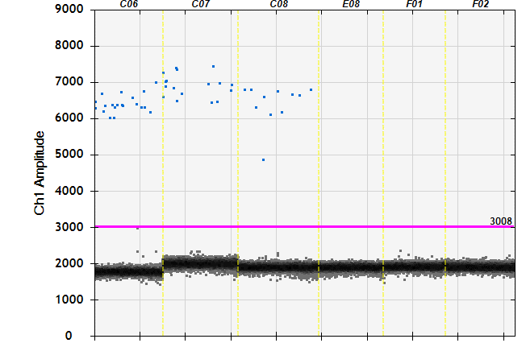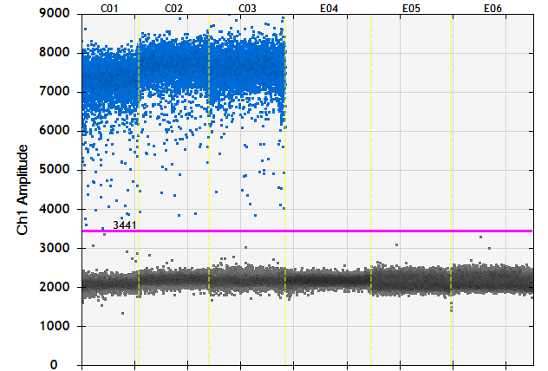
409002 Extraction blank
340066 Extraction blank

C

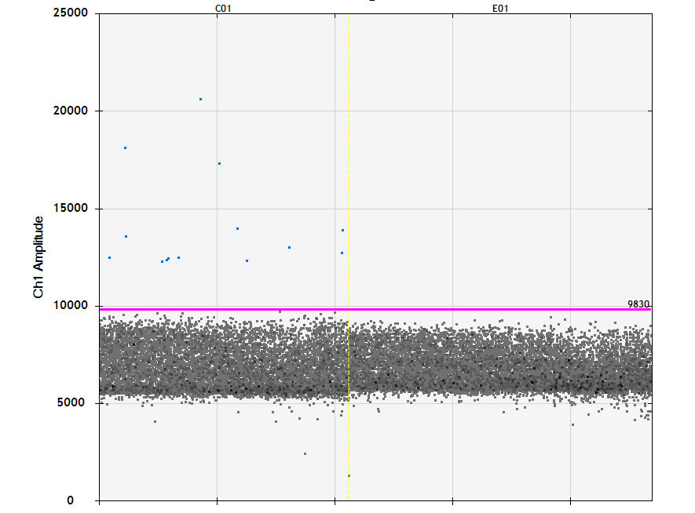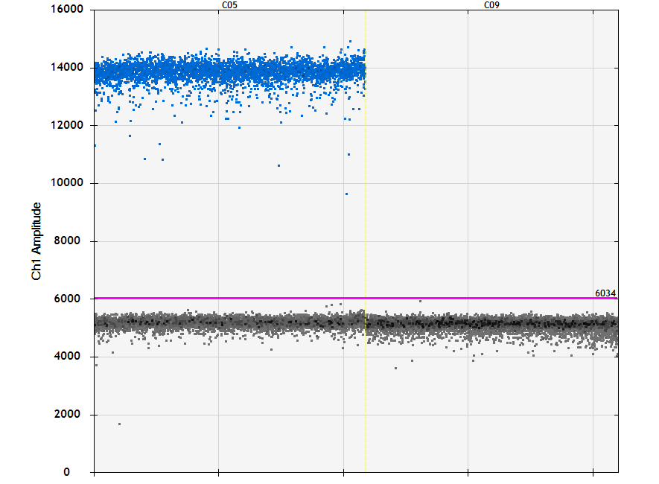
409002 Extraction blank
340066 Extraction blank

Supplemental Figure 2: Linearity of CDC N2 RT-dPCR assay.
Results of three independent experiments using purified RNA template are shown.

Supplemental Figure 3: Between laboratory variation
The consistency of the between-laboratory variation was assessed using interaction plots. Figure S3 shows that different samples within a single round vary between laboratories in the same manner, but the laboratory variation between the 3 NMIs is not the same in different rounds. This suggests that there may be an interaction between laboratory and round (meaning that the two are not independent of each other). The variability within samples is consistent, indicating that the standard deviation is approximately proportional to the mean.

Figure S3: Interaction plot showing the between-laboratory variation for each sample in the seven rounds. Each line represents the laboratory means for each sample.

Supplemental Figure 4: Same material in different rounds
Results obtained for sample G21125. Solid red lines represent the three estimates for the mean, dotted lines are ±1 standard error. The interaction effect between laboratory and round is clearly visible.
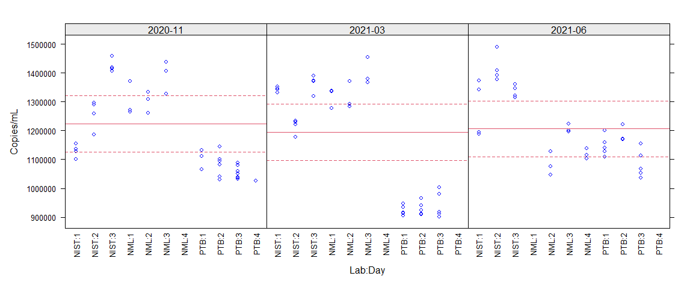

Supplemental Table 7: dMIQE checklist for authors, reviewers and editors

ITEM TO CHECK | PROVIDED | COMMENT
ITEM TO CHECK | Y/N
1. SPECIMEN
Detailed description of specimen type and numbers | Y | Inactivated and lyophilized whole virus SARS-CoV-2 materials of different dilutions from two EQA schemes “Virus Genome Detection of Coronaviruses incl. SARS-CoV-2” between June/July and November 2020 (INSTAND code 340) and in four EQA schemes “Virus Genome Detection of SARS-CoV-2” (INSTAND code 409) between March, June, September and November 2021
Sampling procedure (including time to storage) | N
Sample aliquotation, storage conditions and duration | Y | Lyophilised samples were stored in refrigerators (+ 2 °C to + 8 °C) until analysis
2. NUCLEIC ACID EXTRACTION
Description of extraction method including amount of sample processed | Y | Manual extraction using QIAamp viral RNA mini kit (Qiagen), 140 µL (NIST) or 200 µL (NML and PTB) was used as input. Extraction was performed as per manufacturer’s instructions.
Volume of solvent used to elute/resuspend extract | Y | 60 µL (NML and NIST) or 62 µL (PTB)
Number of extraction replicates | Y | Single extraction replicates performed for each unit.
Extraction blanks included? | Y | NML: An extraction blank of 200 µL nuclease free water (Ambion) was included as input for the method.  NIST: An extraction blank of 140 µL nuclease free water (ThermoFisher, catalog # AM9937) was included during each set of extractions
3. NUCLEIC ACID ASSESSMENT AND STORAGE
Method to evaluate quality of nucleic acids | N
Method to evaluate quantity of nucleic acids (including molecular weight and calculations when using mass) | N
Storage conditions: temperature, concentration, duration, buffer, aliquots | Y | Extracted RNA stored at -80°C
Clear description of dilution steps used to prepare working DNA solution | N
4. NUCLEIC ACID MODIFICATION
Template modification (digestion, sonication, pre-amplification, bisulphite etc.) | N
Details of repurification following modification if performed | N
5. REVERSE TRANSCRIPTION
cDNA priming method and concentration | Y | PCR primers used
One or two step protocol (include reaction details for two step) | Y | One step Reverse Transcription protocol
Amount of RNA added per reaction | Y | Template RNA of 5-10 µL was added to final reaction volume of 20-22 µL.
Detailed reaction components and conditions | Y | Reactions were set up using the One-Step RT-ddPCR Advanced Kit for Probes (Cat no. 1864021, Bio-Rad). Total reaction volumes of 20-22 µL were prepared containing 1X Supermix, 20 U/µL reverse transcriptase, 15 mM DTT, primers and probes concentration (400 nM and 200 nM – PTB and 1000 nM and 250 nM – NIST and 900 nM and 250 nM - NML) respectively, nuclease-free water and 5-10 µL RNA template. The reactions were performed in triplicates using 96-well plate. Nuclease-free water (NTCs) was used as negative control. Thermocycling conditions were as follows: Reverse transcription at 47.5 °C (NML) or 50°C (NIST and PTB) for 15 minutes, 5 minutes at 95 °C, 45 cycles of 95 °C for 30 s, and 55 °C for 30 sec, followed by 98°C for 5 min and a 4 °C hold. The ramp rate for each step was 2°C/s.
Estimated copies measured with and without addition of RT* | Y | Without addition of RT, no positive droplets were observed
Manufacturer of reagents used with catalogue and lot numbers | N
Storage of cDNA: temperature, concentration, duration, buffer and aliquots | N
6. dPCR OLIGONUCLEOTIDES DESIGN AND TARGET INFORMATION
Sequence accession number or official gene symbol | Y | Nucleocapsid gene of SARS-CoV-2 RNA (N) (NC_045512.2)
Method (software) used for design and in silico verification | N
Location of amplicon | Y | Table S2
Amplicon length | Y | 67 bp (CDC N2) & 99 bp (China CDC N)
Primer and probe sequences (or amplicon context sequence)** | Y | Published previously see [1, 2]
Location and identity of any modifications | N
Manufacturer of oligonucleotides | Y | Eurofins Genomics (PTB NIST and NML) Biosearch (NML), and Thermofisher (NIST).
7. dPCR PROTOCOL
Manufacturer of dPCR instrument and instrument model | Y | BioRad, QX200 Digital droplet PCR system
Buffer/kit manufacturer with catalogue and lot number | Y | One-Step RT-ddPCR Advanced Kit for Probes (1864022) (Bio-Rad Laboratories, USA). Lot numbers available upon request.
Primer and probe concentration | Y | Concentrations of primers and probes are: 400 nM and 200 nM (PTB), 900 nM and 250 nM (NML), and 1000 nM and 250 nM (NIST), respectively.
Pre-reaction volume and composition (incl. amount of template and if restriction enzyme added) | Y | 20-22 µL reactions were prepared containing 5-10 µL template RNA
Template treatment (initial heating or chemical denaturation) | N | RNA templates were denatured by heating to 65°C for 5 minutes before immediately chilling on ice for at least 1 minute (NML). PTB and NIST did not heat denature RNA templates.
Polymerase identity and concentration, Mg++ and dNTP concentrations*** | Y | The exact composition of the mastermix is not provided by the manufacturer.
Complete thermocycling parameters | Y | Thermocycling conditions were as follows: Reverse transcription at 47.5 °C (NML) or 50°C (NIST and PTB) for 15 minutes, 5 minutes at 95 °C, 45 cycles (PTB, NML) or 60 cycles (NIST) of 95 °C for 30 s, and 55 °C for 30 sec, followed by 98°C for 5 min and a 4 °C hold. The ramp rate for each step was 2°C/s.
8. ASSAY VALIDATION
Details of optimisation performed | N
Analytical specificity (vs. related sequences) and limit of blank (LOB) | Y | See Analytical assessment of SARS-CoV-2 RT-dPCR assay section.
Analytical sensitivity/LOD and how this was evaluated | Y | See Analytical assessment of SARS-CoV-2 RT-dPCR assay section.
Testing for inhibitors (from biological matrix/extraction) | N
9. DATA ANALYSIS
Description of dPCR experimental design | Y | Three units analysed of each material were analyzed on separate days. Replication was performed in the dPCR format with each sample being analysed in at least two replicates.
Comprehensive details negative and positive of controls (whether applied for QC or for estimation of error) | Y | Negative controls consisted of an extraction blank performed in each extraction round, carrier only controls and water NTC’s containing water in the place of template in the dPCR experiments. Each of these controls was analysed in triplicate in every dPCR experiment.
Partition classification method (thresholding) | Y | All thresholds were manually set up to allow the distinction between positive and negative partitions (PTB).  All thresholds were set using the ‘Autoanalyze - combined wells’ function to classify positive and negative partition (NML).  All thresholds were manually set up to allow the distinction between positive and negative partitions (NIST).
Examples of positive and negative experimental results (including fluorescence plots in supplemental material) | Y | Supplemental Figure 3
Description of technical replication | Y | For each sample, at least three technical replicates were performed.
Repeatability (intra-experiment variation) | N
Reproducibility (inter-experiment/user/lab etc. variation ) | N
Number of partitions measured (average and standard deviation ) | Y | Reporting the numbers from June 2020 and March 2021 EQA rounds as examples:  PTB  NML  15265 ± 1284 (June 2020)  14553 ± 1718 (March 2021)  NIST  12350 ± 2056 (June 2020)  10894 ± 1672 (March 2021)
Partition volume | Y | 0.850 nL (PTB)  0.776 nL (NML)  0.7472 nL (NIST)
Copies per partition (λ or equivalent ) (average and standard deviation) | N
dPCR analysis program (source, version) | Y | Bio-Rad QuantaSoft version 1.0.596 (PTB)  Bio-Rad QuantaSoft version 1.7.4.0917 (NML and NIST)
Description of normalisation method | N
Statistical methods used for analysis | Y | See Statistical analysis
Data transparency | N | Raw data available on request

* Assessing the absence of DNA using a no RT assay (or where RT has been inactivated) is essential when first extracting RNA. Once the sample has been validated as DNA-free, inclusion of a no-RT control is desirable, but no longer essential.
** Disclosure of the primer and probe sequence is highly desirable and strongly encouraged. However, since not all commercial pre-designed assay vendors provide this information when it is not available assay context sequences must be submitted (Bustin et al. Primer sequence disclosure: A clarification of the miqe guidelines. Clin Chem 2011;57:919-21.)
*** Details of reaction components are highly desirable, they are not always possible for commercial disclosure reasons. Inclusion of catalogue number is essential where component reagent details are not available.

3. References
[1] Centers for Disease Control and Prevention (CDC). Research Use Only 2019-Novel Coronavirus (2019-nCoV) Real-time RT-PCR Primers and Probes 2020 [updated 6th June 2020]. Available from: https://www.cdc.gov/coronavirus/2019-ncov/lab/rt-pcr-panel-primer-probes.html.

[2] WHO. China N assay Specific primers and probes for detection of 2019 novel coronavirus. 2020. https://www.who.int/emergencies/diseases/novel-coronavirus-2019/technical-guidance/laboratory-guidance

[3] Vierbaum L, Wojtalewicz N, Grunert H-P, Lindig V, Duehring U, Drosten C, et al. (2022) RNA reference materials with defined viral RNA loads of SARS-CoV-2—A useful tool towards a better PCR assay harmonization. PLoS ONE 17(1): e0262656. https://doi.org/10.1371/journal.pone.0262656

[4] ISO 20395:2019. Biotechnology — Requirements for evaluating the performance of quantification methods for nucleic acid target sequences — qPCR and dPCR.

[5] CLSI EP17. Evaluation of Detection Capability for Clinical Laboratory Measurement Procedures, 2nd Edition.

[6] Cleveland MH, Romsos EL, Steffen CR, Olson ND, Servetas SL, Valiant WG, Vallone PM (2023). Rapid production and free distribution of a synthetic RNA material to support SARS-CoV-2 molecular diagnostic testing. Biologicals 82: 101680. https://doi.org/10.1016/j.biologicals.2023.101680.

[7] Dagata JA, Farkas N, Kramar JA (2016) Method for Measuring the Volume of Nominally 100 μm Diameter Spherical Water-in-Oil Emulsion Droplets. NIST Special Publication 260-184. https://nvlpubs.nist.gov/nistpubs/SpecialPublications/NIST.SP.260-184.pdf [Accessed 28/04/2024].

[8] Kosir, A. B., et al. (2017), 'Droplet volume variability as a critical factor for accuracy of absolute quantification using droplet digital PCR', Anal Bioanal Chem, 409 (28), 6689-97. doi: 10.1007/s00216-017-0625-y.

[9] Pinheiro, L. B., et al. (2017), 'Interlaboratory Reproducibility of Droplet Digital Polymerase Chain Reaction Using a New DNA Reference Material Format', Anal Chem. 89(21):11243-11251. doi: 10.1021/acs.analchem.6b05032.

