Supplementary Material

Cold plasma within a stable supercavitation bubble - a breakthrough technology for efficient inactivation of viruses in water

Arijana Filipićª, David Dobnikª, Ion Gutiérrez-Aguirreª, Maja Ravnikarª, Tamara Koširª, Špela Baeblerª, Alja Štern^{b}, Bojana Žegura^{b}, Martin Petkovšek^{c}, Matevž Dular^{c}, Miran Mozetič^{d}, Rok Zaplotnik^{d}, Gregor Primc^{d,*}

ªDepartment of Biotechnology and Systems Biology, National Institute of Biology, Ljubljana, Slovenia
^{b}Department of Genetic Toxicology and Cancer Biology, National Institute of Biology, Ljubljana, Slovenia
^{c}University of Ljubljana, Faculty of Mechanical Engineering, Ljubljana, Slovenia
^{d}Department of Surface Engineering, Jožef Stefan Institute, Ljubljana, Slovenia

*Corresponding author. Email: gregor.primc@ijs.si

Supplementary Table 1. Production of H₂O₂ directly after the treatment.
Experiment | H₂O₂ concentration (mg/L)
Experiment | Treatment time (min)
Experiment | 0 | 1 | 2 | 3 | 4 | 5 | 10 | 15
1ª | 0 | - | - | - | - | 5 | 10 | 10–25e
2ª | 0 | 0.5–2 | - | 2–5 | - | 5 | 10 | 10–25e
3 | 0 | 0.5–2 | - | >2 | - | 5 | 10 | 10–25e
4ª | 0 | 0.5–2 | - | 2–5 | - | 5 | 10 | 10–25e
5 | 0 | 0.5–2 | - | 2–5 | - | 5 | 10 | 10–25e
6 | 0 | 0.5–2 | - | 2–5 | - | 5 | - | -
7 | 0 | - | 2 | - | <5 | - | - | -
8 | 0 | - | <2 | - | <5 | - | - | -
9 | 0 | - | 2 | - | 5 | - | - | -
Supercavitation | 0 | - | - | - | - | - | 0 | 0
PAW | 0 | - | - | - | - | 5 | 10–25e | 10–25
Cytotoxicity^{b} | 0 | - | - | - | - | 5–10^{d} | 10–25e | 10–25
Plant physiology^{c} | 0 | - | - | - | - | 5–10^{d} | - | -
Experiments 1–9 represent direct plasma treatments.
ªExperiment in which concentration was also measured after 60 min incubation. In all experiments, concentration remained the same.
^{b}It represents the range of six plasma treatments for determining the cytotoxicity of plasma-activated water (PAW).
^{c}It represents the range of 12 plasma treatments for determining the effects of PAW on plant physiology.
^{d}Measured concentrations were closer to 5 than 10.
^{e}Measured concentrations were closer to 10 than 25.

Supplementary Table 2. Primers used in RT-PCR.
Primer  set | Length of amplified product (bp) | Position in genome | Primer sequence 5'→3'
1 | 1696 | 19-40  1714-1693 | Fw: GGTCCTGCTCAACTTCCTGTCG  R: GAGTTTGCTGCGATTGCTGAGG
2 | 1567 | 1693-1714  3259-3240 | Fw: CCTCAGCAATCGCAGCAAACTC  R: TAGCGACCACTGTCGTGCTT

Gene | Gene description | Gene ID | Functional group | Forward primer sequence 5'→3' | Reverse primer sequence 5'→3' | Probe sequence 5'→3' | Efficiency (%) | Reference
GBSS1 | Granule-bound starch synthase 1 | Sotub08g026990 | Primary metabolism | CCAAGAAATGGGAGACATTGCTATTGGG | TGATCTTATTGTTGAAACAAGGATAACCAAAGCTC | NA | 90 | (Kogovšek et al., 2010)
CAT1 | Catalase 1 | Sotub12g027890 | ROS signaling | ANCAAATGGGTTGAGTCTCTATCC | AGGACTTGTCAGCCTGAGACAAGTAT | FAM-CTCATGAGATTCGCAGCAT-MGB | 93 | (Pompe-Novak et al., 2006)
HSP70 | Heat shock protein 70 | Sotub09g009340 | Heat stress | CCCTAGGGCACTTAGAAGGTTGA | GTGGTCTGAGCAGTGGATGAAA | NA | 93 | (Lukan et al., 2020)
ACO2 | 1-aminocyclopropane-1-carboxylate oxidase | Sotub07g018820 | Ethylene biosynthesis | AAGGGACTCCGCGCTCATA | CAAGTTGGTCACCAAGGTTAACC | FAM-TCGATGTTCCTCCCATGCGCC-MGB | 97 | (Chersicola et al., 2017)
RD29 | Responsive to desiccation 29B | Sotub03g014340 | Abscisic acid signaling | AATTGCTGATAAGGCGGTTG | GCTGTTGCCTGAGTTTCCTC |  | 90 | provided by Prof Sophia Sonnevald (FAU)
13-LOX | 13-lipoxygenase | Sotub03g034620 | Jasmonic acid biosynthesis | GTACCGGACTCAACACAACCT | CCCATCTGCAGCATAAGGATAGTC | FAM-CATGGGCTGAAACTTC-MGB | 100 | (Petek et al., 2014)
COX | Cytochrome oxidase | Sotub04g015050 | Reference genes | CGTCGCATTCCAGATTATCCA | CAACTACGGATATATAAGRRCCRRAACTG | FAM-TGCTTACGCTGGATGGAATGCCCT-TAMRA | 100 | (Weller et al., 2000)
EF-1 | Potato elongation factor 1α | Sotub06g010680 | Reference genes | GGAAGCTGCTGAGATGAACAAGA | CTCACGTTCAGCCTTAAGTTTGTC | FAM-TCATTCAAGTATGCCTGGGTGCT-TAMRA | 100 | (Baebler et al., 2009)
Supplementary Table 3. Primer and probe information for genes used for determining the effects of plasma-activated water on plant physiology. For each assay, gene short name, description, gene identifier, functional group, primer and probe sequences, assay efficiency and reference are shown. Probes were labelled with either TAMRA or RGB.

Supplementary Table 4. Pressure in the combined plasma-supercavitation device. The first number represents the pressure at the beginning of the experiment, and the second represents the pressure at the end.
Exp. | Pressure (kPA)
1 | 5.1–6.1
2 | 5.0–5.8
3 | 5.0–6.5
4 | 5.0–5.9
5 | 5.5–5.9
6 | 4.9–5.1
7 | 4.7–4.9
8 | 4.5–4.8
9 | 4.9–5.2
Supercavitation | 4.9–5.2
PAW | 4.9–5.1
Cytotoxicityª | 4.1–5.5
Plant physiology^{b} | 4.7–4.5
Experiments 1–9 represent direct plasma treatments.
ªIt represents the range of six plasma treatments for determining cytotoxicity of plasma-activated water (PAW).
^{b}It represents the range of 12 plasma treatments for determining the effects of PAW on plant physiology.

Supplementary Table 5. The measured temperature.
Exp. | Temperature (°C)
Exp. | Treatment time (min)
Exp. | 0 | 1 | 2 | 3 | 4 | 5 | 10 | 15
1 | 20.2 | - | - | - | - | 23.9 | 25.1 | 26.5
2 | 22.3 | 22.9 | - | 23.5 | - | 24.3 | 25.3 | 26.4
3ª | - | - |  | - | - | - | - | -
4 | 21.4 | 22.3 | - | 22.8 | - | 23.2 | 24.1 | 25.1
5 | 21.3 | 22 | - | 22.7 | - | 23.5 | 24.8 | 25.9
6 | 20.9 | 21.7 | - | 22.6 | - | 23.6 | - | -
7 | 22.2 | - | 23.4 | - | 24.1 | - | - | -
8 | 20.9 | - | 21.9 | - | 22.9 | - | - | -
9 | 21.4 | - | 22.4 | - | 23.1 | - | - | -
Supercavitation | 20.5 | - | - | - | - | - | 21.4 | 23.1
PAW | 20.2 | - | - | - | - | 22.5 | 24.3 | -*
Cytotoxicity^{b} | 18.6 ± 2.6 | - | - | - | - | 21.1 ± 2.1 | 23.0 ± 1.5 | 24.5 ± 1.0
Experiments 1–9 represent direct plasma treatments.
ªMeasurement was not taken due to technical issues.
^{b}It represents values of six plasma treatments for determining the cytotoxicity of plasma-activated water (PAW).

Supplementary Table 6. Virus inactivation (log) for each experiment after direct plasma treatment.
Experiment | Incubation (min) | Treatment time (min)
Experiment | Incubation (min) | 1 | 2 | 3 | 4 | 5 | 10 | 15
1 | 0 | - | - | - | - | 6.16 | 6.16 | 6.16
1 | 60 | - | - | - | - | 5.63 | 5.63 | 5.63
2 | 0 | 0.53 | - | 3.55 | - | 5.84 | 5.84 | 5.84
2 | 60 | 0.89 | - | 5.62 | - | 5.62 | 5.62 | 5.62
3 | 0 | 0.21 | - | 4.53 | - | 5.53 | 5.53 | 5.53
3 | 60 | 0.86 | - | 5.30 | - | 5.60 | 5.60 | 5.60
4 | 0 | 0.14 | - | 4.75 | - | 5.52 | 5.22ª | 5.52
4 | 60 | 0.96 | - | 5.56 | - | 5.26ª | 5.26ª | 5.56
5 | 0 | 0.29 | - | 3.61 | - | 5.96 | 5.96 | 5.96
6 | 0 | 0.08 | - | 3.63 | - | 5.52 | - | -
6 | 60 | 0.33 | - | 5.50 | - | 5.50 | - | -
7 | 0 | - | 1.72 | - | 5.83 | - | - | -
7 | 60 | - | 3.22 | - | 5.60 | - | - | -
8 | 0 | - | 2.63 | - | 5.54 | - | - | -
8 | 60 | - | 5.19 | - | 5.88 | - | - | -
9 | 0 | - | 4.92 | - | 5.92 | - | - | -
9 | 60 | - | 5.81 | - | 5.81 | - | - | -
ªOnly one plaque was present on all plates; this was probably a result of cross-contamination due to time-sensitive experiments as in 5-min treated samples without incubation, or 3-min treated samples with incubation, no viruses were present.

Supplementary Table 7. Virus inactivation (log) after the control treatments.
Treatment type | Incubation (min) | Treatment time (min)
Treatment type | Incubation (min) | 5 | 10 | 15
Supercavitation | 0 | - | 0.22 | 0.19
PAW | 15 | 0.15 | 0.72 | 1.93
PAW | 60 | 0.61 | 1.42 | 3.29
 | Concentration (mg/L)
 |  | 5 | 12.5 | 25
H₂O₂ | 15 | 0.10 | 0.85 | 3.52
H₂O₂ | 60 | 0.48 | 2.47 | 5.30

Supplementary Table 8. Reduction of the intensity of the volume of a band (%) on the agarose gel after direct plasma treatments (experiments 1–9) without incubation and after supercavitation control treatment compared to a positive control band. When no bands were observed, the result was 100%.
Reduction of the intensity of the band compared to the positive control (%)
Exp. | Primer set | Treatment time (min)
Exp. | Primer set | 1 | 2 | 3 | 4 | 5 | 10 | 15
1 | 1 | - | - | - | - | 100 | 100 | 100
1 | 2 | - | - | - | - | 100 | 100 | 100
2 | 1 | 80 | - | 100 | - | 100 | 100 | 100
2 | 2 | 92 | - | 100 | - | 100 | 100 | 100
3 | 1 | 1 | - | 100 | - | 100 | 100 | 100
3 | 2 | 18 | - | 100 | - | 100 | 100 | 100
4 | 1 | 5 | - | 100 | - | 100 | 100 | 100
4 | 2 | 22 | - | 100 | - | 100 | 100 | 100
5 | 1 | 24 | - | 100 | - | 100 | 100 | 100
5 | 2 | 74 | - | 100 | - | 100 | 100 | 100
6 | 1 | 0 | - | 100 | - | 100 | 100 | 100
6 | 2 | 0 | - | 100 | - | 100 | 100 | 100
7 | 1 | - | 89 | - | 100 | - | - | -
7 | 2 | - | 95 | - | 100 | - | - | -
8 | 1 | - | 87 | - | 100 | - | - | -
8 | 2 | - | 87 | - | 100 | - | - | -
9 | 1 | - | 100 | - | 100 | - | - | -
9 | 2 | - | 100 | - | 100 | - | - | -
Supercavitation | - | - | - | - | - | - | - | -
Supercavitation | - | - | - | - | - | - | 0 | 0

Supplementary Table 9. The results of gene expression assays used for determining the effects of plasma-activated water on plant physiology. Relative gene expression values of target genes, normalized to the expression of two validated reference genes, COX and EF-1 are shown for all analyzed plants. PAW, plasma-activated water.
Sampling time (days) | Sample | Relative gene expression
Sampling time (days) | Sample | CAT1 | 13-LOX | ACO2 | RD29 | HSP70 | GBSS1
17 | Control | 0.886 | 0.584 | 0.347 | 1.710 | 0.737 | 0.446
 |  | 0.625 | 0.959 | 0.731 | 3.516 | 0.851 | 0.536
 |  | 0.284 | 0.946 | 0.886 | 0.428 | 0.914 | 0.769
 |  | 0.290 | 0.911 | 0.556 | 0.444 | 0.849 | 1.169
 | PAW | 0.150 | 0.931 | 0.581 | 0.769 | 1.151 | 1.206
 |  | 0.212 | 1.124 | 0.393 | 10.180 | 0.988 | 0.490
 |  | 0.800 | 0.671 | 0.737 | 0.750 | 0.846 | 0.768
 |  | 0.311 | 0.982 | 0.485 | 5.031 | 0.892 | 0.669
24 | Control | 0.760 | 0.859 | 0.652 | 0.067 | 0.791 | 0.901
 |  | 0.707 | 0.968 | 0.695 | 0.085 | 0.848 | 0.974
 |  | 0.811 | 0.656 | 0.827 | 0.048 | 0.708 | 0.683
 |  | 1.767 | 1.138 | 1.075 | 0.128 | 0.699 | 2.189
 | PAW | 1.130 | 1.388 | 2.390 | 0.013 | 0.840 | 1.408
 |  | 0.962 | 1.224 | 0.954 | 0.138 | 0.911 | 1.218
 |  | 0.738 | 0.925 | 1.054 | 0.077 | 0.835 | 0.968
 |  | 0.968 | 1.328 | 1.497 | 0.117 | 0.845 | 1.460
43 | Control | 1.175 | 0.832 | 1.241 | 0.067 | 0.898 | 0.838
 |  | 1.303 | 0.604 | 1.108 | 0.043 | 0.951 | 1.009
 |  | 1.177 | 0.582 | 0.786 | 0.024 | 1.049 | 0.834
 |  | 1.022 | 0.778 | 1.379 | 0.043 | 0.885 | 0.976
 | PAW | 1.774 | 0.890 | 1.773 | 0.013 | 1.147 | 0.802
 |  | 1.232 | 0.758 | 1.503 | 0.029 | 0.950 | 0.864
 |  | 1.120 | 0.713 | 1.136 | 0.029 | 1.024 | 0.830
 |  | 1.288 | 0.594 | 1.448 | 0.029 | 0.851 | 0.859

Supplementary Table 10. P values for the expression of six genes in the plants irrigated with plasma-activated water, compared with the control group.
Sampling time (days) | Genes
Sampling time (days) | CAT1 | 13-LOX | ACO2 | RD29 | HSP70 | GBSS1
17 | 0.487835 | 0.576292 | 0.577941 | 0.301992 | 0.138272 | 0.817935
24 | 0.823586 | 0.074281 | 0.100391 | 0.899542 | 0.0516 | 0.837347
43 | 0.281633 | 0.666176 | 0.114253 | 0.096676 | 0.540608 | 0.166912

Supplementary Figure 1. Virus concentrations in each experiment after direct plasma treatments.
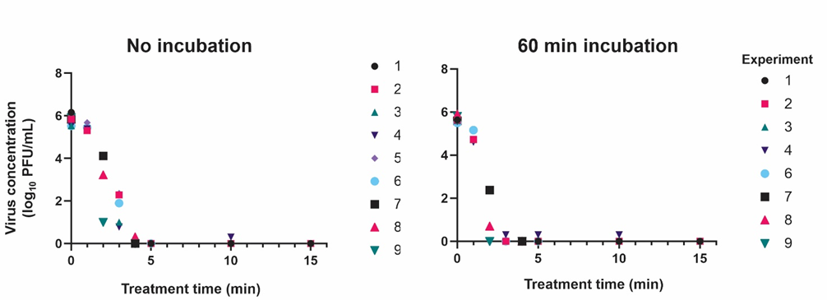

Supplementary Figure 2. Comparison of 5-min direct plasma treatment (0- and 60-min incubation), 5-min plasma-activated water (PAW) (15- and 60-min incubation), and 5 mg/L H₂O₂ (15- and 60-min incubation).
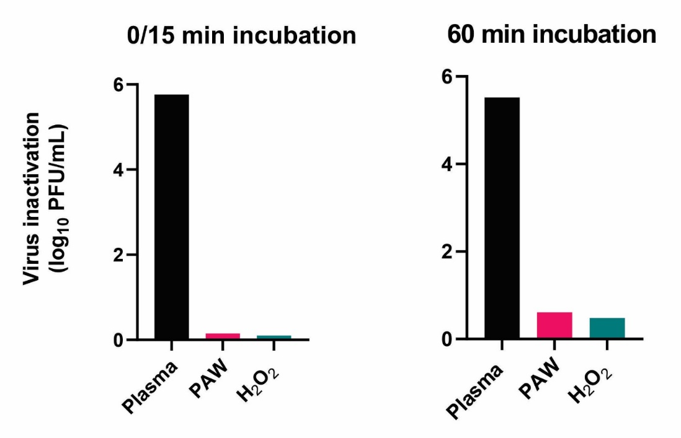

Supplementary Information 1. Treatment of wastewater
To evaluate the inactivation potential of the combined device for contaminated water, we used the influent from a wastewater treatment plant. The influent was autoclaved and filtered with filter paper to remove suspended solids. Water samples were then prepared as described in the manuscript, i.e., 0.43 L of water was spiked with bacteriophage MS2 at a concentration of >10⁵ PFU/mL. The prepared water was treated with plasma for up to 30 minutes. In each experiment, samples were taken after 0, 5, 10, 15, 20, and 30 min and processed immediately after treatment. The pressure ranged from 4.1 to 5.7 kPa and always increased during the experiments. Production of H₂O₂ also increased with treatment time (up to 25 mg/L after 30 min), whereas pH remained the same. The flow rate was maintained at 1.05 ± 0.15 L/min. Virus concentration and virus inactivation were determined in the same way as described in the main text. Virus inactivation is shown in Supplementary Table 11.
Supplementary Table 11. Virus inactivation (log and %) in influent of wastewater.
Experiment | Virus inactivation
Experiment | log |  |  |  |  | %
Experiment | Treatment time (min)
Experiment | 5 | 10 | 15 | 20 | 30 | 5 | 10 | 15 | 20 | 30
1 | 0.73 | 4.03 | 5.17 | 5.17 | 5.17 | 90 | 99.993 | 100 | 100 | 100
2 | 0.98 | 4.18 | 5.86 | 5.86 | 5.86 | 81 | 99.991 | 100 | 100 | 100

References:
Baebler, Š., Krečič-Stres, H., Rotter, A., Kogovšek, P., Cankar, K., Kok, E.J., Gruden, K., Kovač, M., Žel, J., Pompe-Novak, M., Ravnikar, M., 2009. PVY NTN elicits a diverse gene expression response in different potato genotypes in the first 12 h after inoculation. Mol Plant Pathol 10, 263–275. https://doi.org/10.1111/j.1364-3703.2008.00530.x
Chersicola, M., Kladnik, A., Žnidarič, M.T., Mrak, T., Gruden, K., Dermastia, M., 2017. 1-Aminocyclopropane-1-Carboxylate Oxidase Induction in Tomato Flower Pedicel Phloem and Abscission Related Processes Are Differentially Sensitive To Ethylene. Front Plant Sci. https://doi.org/10.3389/fpls.2017.00464
Kogovšek, P., Pompe-Novak, M., Baebler, Š., Rotter, A., Gow, L., Gruden, K., Foster, G.D., Boonham, N., Ravnikar, M., 2010. Aggressive and mild Potato virus Y isolates trigger different specific responses in susceptible potato plants. Plant Pathol 59, 1121–1132. https://doi.org/10.1111/j.1365-3059.2010.02340.x
Lukan, T., Pompe‐Novak, M., Baebler, Š., Tušek‐Žnidarič, M., Kladnik, A., Križnik, M., Blejec, A., Zagorščak, M., Stare, K., Dušak, B., Coll, A., Pollmann, S., Morgiewicz, K., Hennig, J., Gruden, K., 2020. Precision transcriptomics of viral foci reveals the spatial regulation of immune‐signaling genes and identifies RBOHD as an important player in the incompatible interaction between potato virus Y and potato. The Plant Journal 104, 645–661. https://doi.org/10.1111/tpj.14953
Petek, M., Rotter, A., Kogovšek, P., Baebler, Š., Mithöfer, A., Gruden, K., 2014. Potato virus Y infection hinders potato defence response and renders plants more vulnerable to Colorado potato beetle attack. Mol Ecol 23, 5378–5391. https://doi.org/10.1111/mec.12932
Pompe-Novak, M., Gruden, K., Baebler, Š., Krečič-Stres, H., Kovač, M., Jongsma, M., Ravnikar, M., 2006. Potato virus Y induced changes in the gene expression of potato (Solanum tuberosum L.). Physiol Mol Plant Pathol 67, 237–247. https://doi.org/10.1016/j.pmpp.2006.02.005
Weller, S.A., Elphinstone, J.G., Smith, N.C., Boonham, N., Stead, D.E., 2000. Detection of Ralstonia solanacearum Strains with a Quantitative, Multiplex, Real-Time, Fluorogenic PCR (TaqMan) Assay. Applied and Environmental Microbiology 66, 2853–2858. https://doi.org/10.1128/AEM.66.7.2853-2858.2000

