Supplementary files: 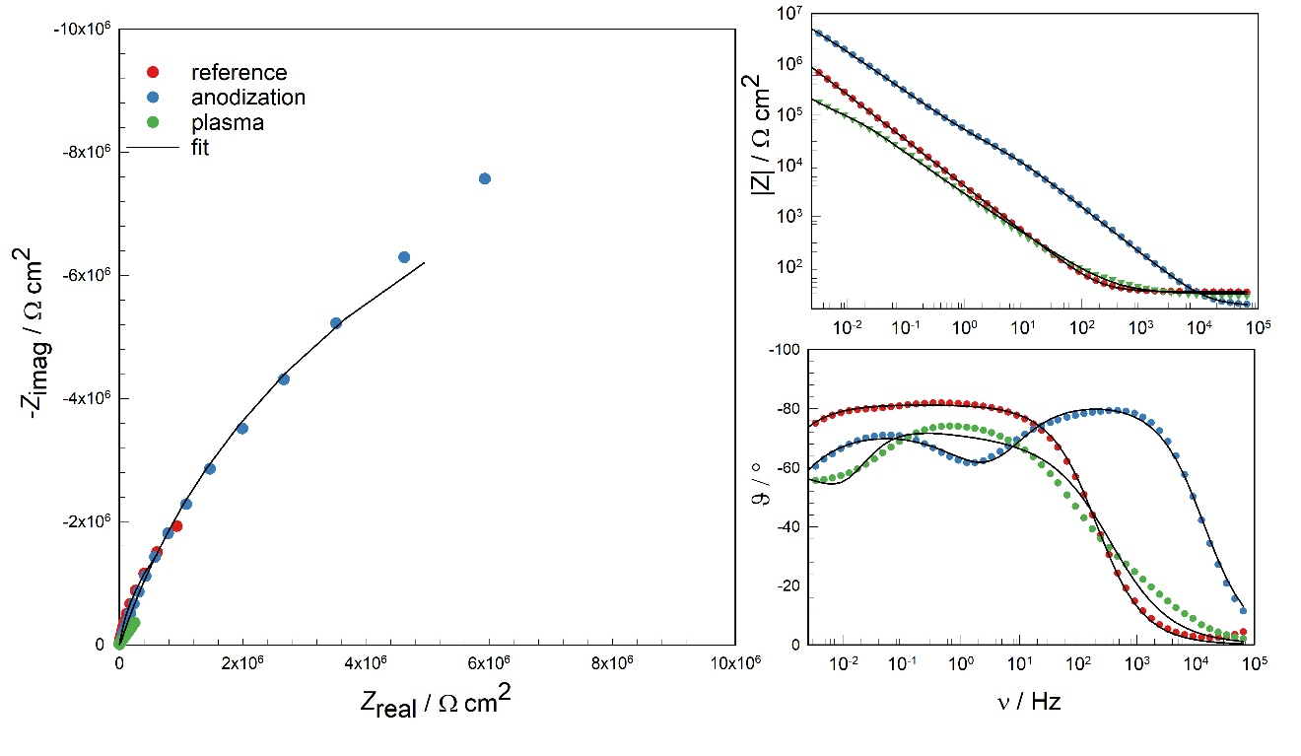Figure S1: Electrochemical impedance spectroscopy (EIS) evaluation in 0.9% NaCl solution of reference, anodized and plasma treated Ti6Al4V alloy: a) Nyquist plot, b and c) Bode plots and d) equivalent circuits

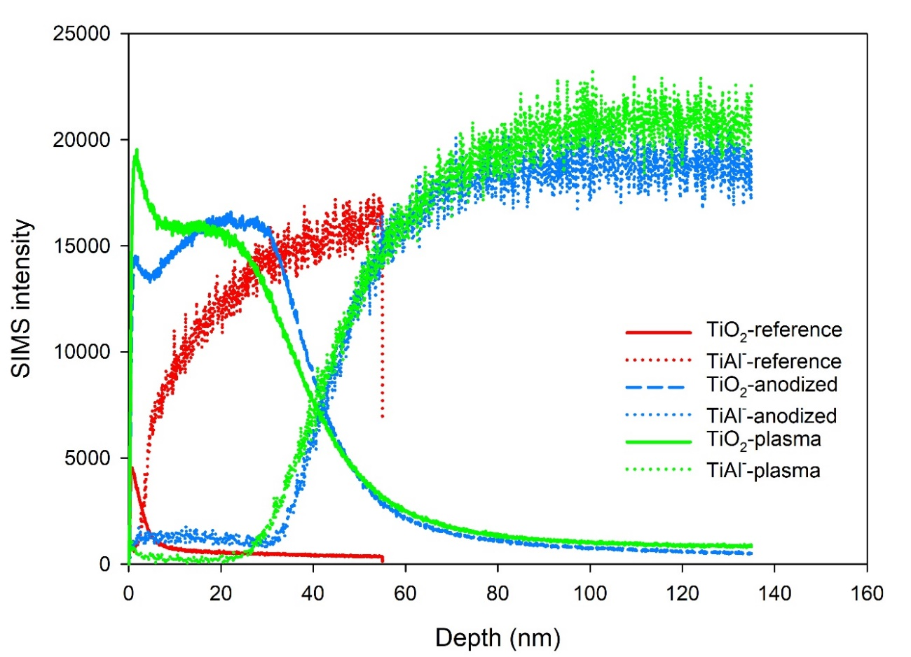
Figure S2: Intensities of the SIMS signals of titanium oxide (TiO₂⁻) and metallic alloy (TiAl⁻) from which cross section of curves the depth of oxides was determined
Table S1: Values of fitted parameters of the equivalent circuit at 1 h immersion time, R_{e}- electrolyte resistance, CPE₁- capacitive behavior of barrier layer, R₁- charge transfer resistance, CPE₂- capacitive behavior of defective outer layer, R₂- pore resistance, Units: R [Ω cm²], CPE [Ω^{–1} cm^{–2}s^{n}]
 | R_{e} | CPE₁ | n₁ | R₁ | CPE₂ | n₂ | R₂ | Chi²
Ti6Al4V reference | 32.4 | 4.72·10⁻⁵ | 0.905 | 6.49·10⁶ | / | / | / | 0.00021
Ti6Al4V anodization | 17.2 | 1.81·10⁻⁶ | 0.913 | 38879 | 3.35·10⁻⁶ | 0.764 | 2.20·10⁷ | 0.00039
Ti6Al4V plasma | 29.0 | 2.65·10⁻⁴ | 0.99 | 35654 | 1.14·10⁻⁴ | 0.742 | 3.63·10⁶ | 0.0037

Table S2: Micro-hardness measurements below the oxidized surfaces of Ti6Al4V alloy
 | HV 0.01
reference Ti6Al4V | 351 ± 22.0
Anodized Ti6Al4V | 324 ± 17.0
Plasma treated Ti6Al4V | 527 ± 59.6

