SUPPLEMENTARY INFORMATION

COMPARING THE EFFECTS OF PRISTINE AND UV-VIS AGED MICROPLASTICS: BEHAVIOURAL RESPONSE OF MODEL TERRESTRIAL AND FRESHWATER CRUSTACEANS

Primož Zidar¹, Dana Kühnel², Andrijana Sever Škapin^{3,4}, Tina Skalar⁵, Damjana Drobne¹, Luka Škrlep³, Branka Mušič³, Anita Jemec Kokalj^{1,}*

¹University of Ljubljana, Biotechnical Faculty, Department of Biology, Jamnikarjeva 101, SI-1000 Ljubljana, Slovenia
²Helmholtz Centre for Environmental Research – UFZ, Permoserstr. 15, 03418 Leipzig, Germany
³Slovenian National Building and Civil Engineering Institute; Dimičeva ulica 12; SI-1000 Ljubljana, Slovenia
⁴Faculty of Polymer Technology—FTPO, Ozare 19, SI-2380 Slovenj Gradec, Slovenia
⁵University of Ljubljana, Faculty of Chemistry and Chemical Technology, Večna pot 113, SI-1000 Ljubljana, Slovenia

*corresponding author, anita.jemec@bf.uni-lj.si

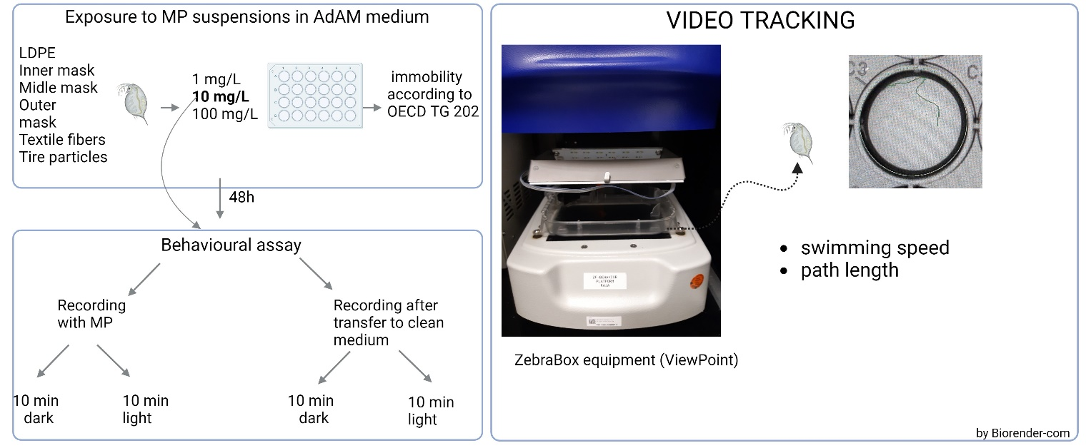
Figure S1. Experimental set-up with Daphnia magna

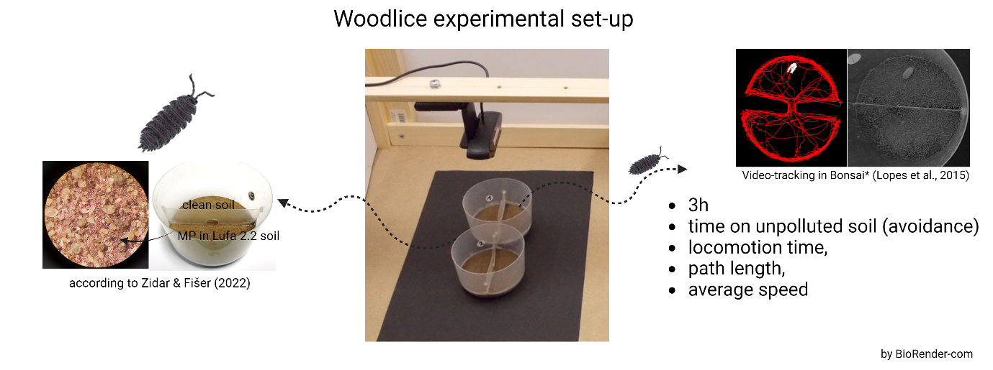
Figure S2: Experimental set-up with woodlice Porcellio scaber.

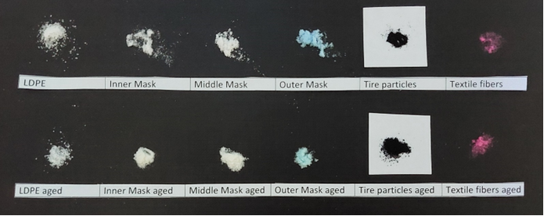

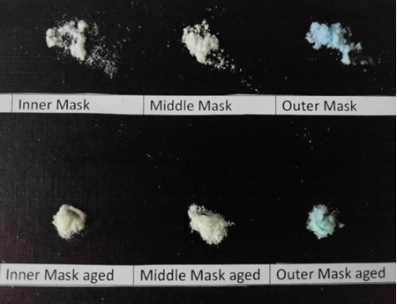
Figure S3. Photos of particles before and after UV-VIS induced ageing. Significant changes of colour were observed for all medical mask-derived polypropylene microplastics.

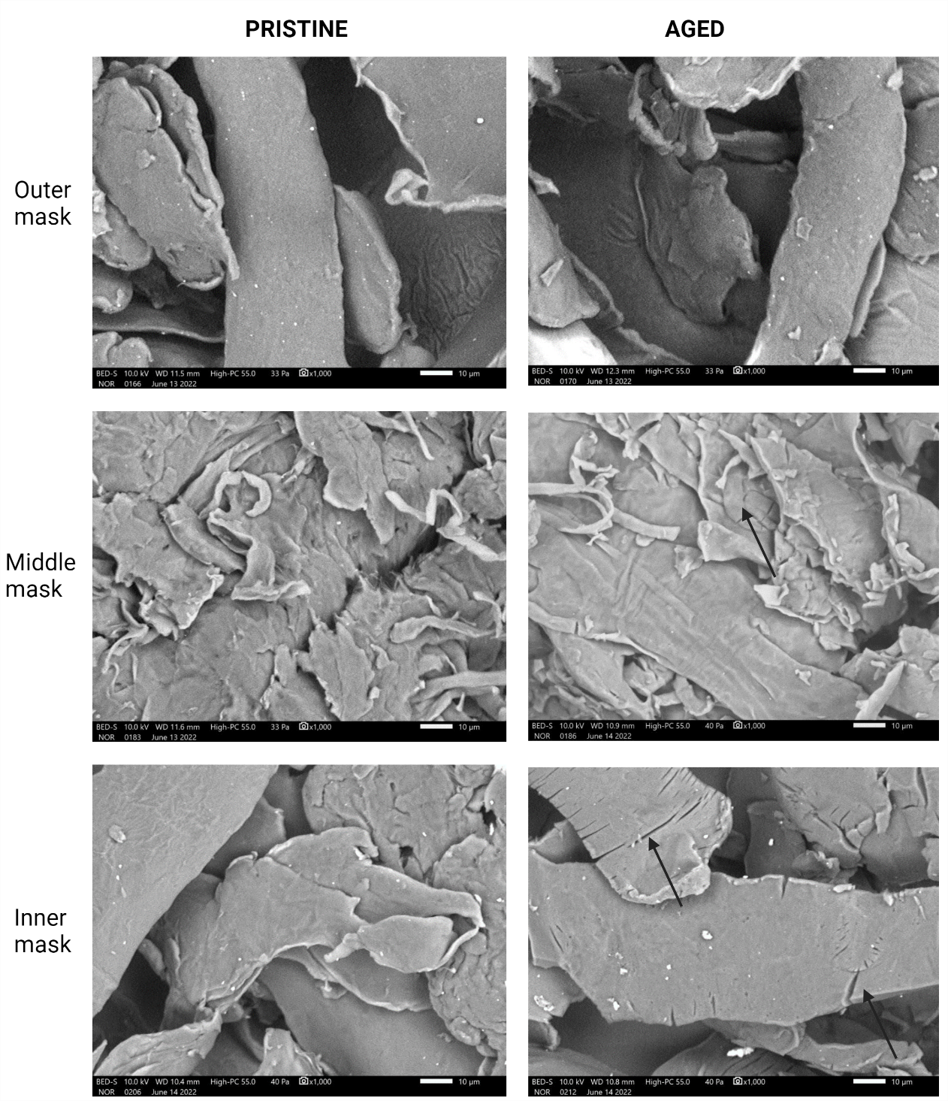
Figure S4: Scanning electron microscopy images of aged and pristine microplastics from polypropylene medical mask: a-b) outer mask; c-d) middle mask, and e-f) inner mask. Black arrows point to the cracks. Images taken by Scanning electron microscope (LV-SEM) JSM-IT500LV (Jeol, Japan).

A  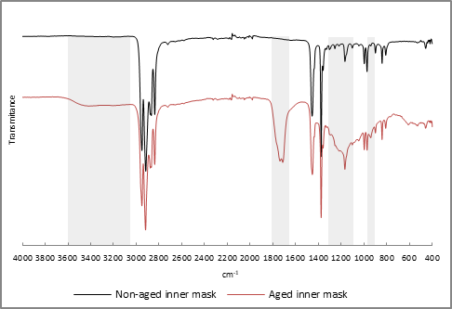 | B  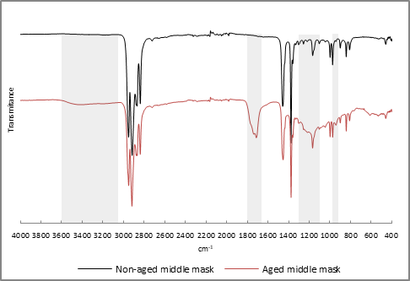
C  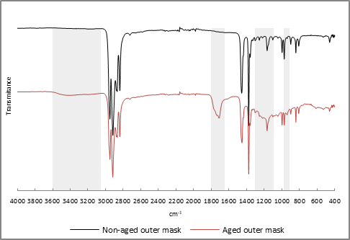 | D  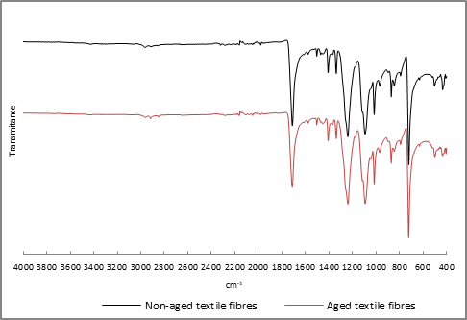
E  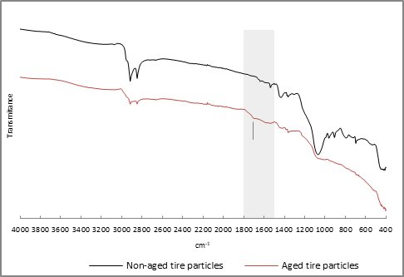 | F  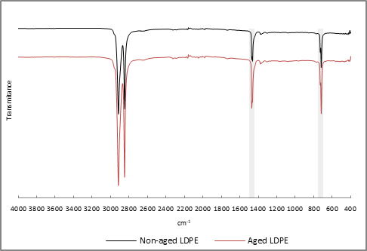
Figure S5: Fourier transform infrared-attenuated total reflectance (FTIR) spectra of aged and pristine (non-aged) samples: a) inner mask, b) middle mask and c) outer mask, d) tire particles, e) LDPE, and f) textile fibres. The regions containing bands discussed in the article are highlighted in grey.
Table S1. The specified area under band (SAUB) for C=O and CH₂ (obtained by ATR-IR) used to calculate carbonyl index (CI) (Table 1).

MP designation | SAUB C=O | SAUB CH₂ | CI
Inner mask | 6,98 | 3,07 | 2,24
Middle mask | 3,97 | 2,45 | 1,62
Outer mask | 2,53 | 2,21 | 1,30
Tire particles | 1,33 | 1,75 | 0,75
LDPE | 0,51 | 2,55 | 0,20

