This Author Accepted Manuscript (AAM) is published in:
Wear, vol. 532/533, 15 November 2023, p. 1-15
DOI: 10.1016/j.wear.2023.205107


Sliding wear behaviour of conventional and cryotreated PM Cr-V (Vanadis 6) ledeburitic tool steel
ªVenu Yarasu*, ªPeter Jurci, ªPeter Gogola, ^{b}Bojan Podgornik, ^{b}Marko Sedlaček
ªFaculty of Materials Technology based in Trnava, Slovak University of Technology based in Bratislava, Trnava, 917 24, Slovakia, EU.
^{b}Institute of Metals and Technology, Lepi pot 11, 1000 Ljubljana, Slovenia, EU.

Corresponding author: Venu Yarasu, E-mail: venu.yarasu@gmail.com

Abstract

Cryogenic treatment is a widely accepted method for extending the tool life of tool steels. This study focuses on investigating the tribological properties of PM Cr-V cold work tool steel subjected to conventional and cryogenic treatments. The aim of the study is to compare the reciprocal sliding wear performance of Cr-V cold work tool steel under different treatment conditions. The Cr-V tool steel specimens were cryotreated at temperatures of −75 °C, −140 °C, or −196 °C, followed by double tempering at 170 °C or 530 °C for 2 hours. Cryotreated specimens exhibited a 10 % increase in hardness compared to conventionally treated specimens after tempering at 170 °C. However, specimens cryotreated and tempered at 530 °C showed a 7 % drop in hardness. Reciprocating sliding wear tests were conducted at room temperature using an Al₂O₃ ball as the counter-body to simulate abrasive wear. The results indicate that the friction coefficient is primarily influenced by the applied load and sliding velocity rather than the material treatment. Cryogenic treatment at 170 °C improved the wear performance by approximately 24 % compared to conventionally treated specimens, while cryotreated specimens tempered at 530 °C did not exhibit any improvement in wear performance compared to conventionally treated specimens.

Keywords: Cold work tool steel, Conventional treatment, Cryogenic treatment, Hardness, Reciprocal sliding, Wear

Introduction

Cold work tool steels play a crucial role in the manufacturing industry, particularly in fine blanking, stamping, and punching applications. These applications subject the steels to harsh operating conditions, including high loads, contact stresses, contact temperatures, and severe wear. The failure mode and mechanism depend on factors such as tool design, manufacturing method, working conditions, and the tool material [1]. Cr-V ledeburitic tool steels are well-suited for cold forming operations that require excellent wear resistance. Ledeburitic steels are high-carbon high-alloyed steels. These steels are characterized by the appearance of ledeburite in their as-solidified microstructures [2]. Enhancing tool life is a critical parameter in sustainable manufacturing, which emphasizes non-polluting, energy-conserving, and environmentally friendly production methods that are economically viable and safe for employees.

Cryogenic treatment (CT) is a technique aimed at improving the properties of tool steels, including hot-work [3-10], high-speed [11-18], cold-work [19-27], and others [28, 29]. CT is a supplementary heat treatment process performed between quenching and tempering. This treatment, carried out at temperatures below zero degrees, modifies the microstructure of the targeted material. These microstructural changes can significantly influence the tool life and productivity of cryogenically treated cold work tool steels. The benefits of CT on tool steels are well-documented in the literature. Researchers have observed significant improvements in hardness, wear resistance, and tool life in cryogenically treated cold work tool steels. These improvements have led to important advancements in tool wear, tool life, and the recovery of cutting conditions in machining applications [30]. The progress achieved through CT is mainly attributed to the more efficient reduction of retained austenite compared to conventional heat treatment (CHT). Additionally, CT results in a more refined microstructure with a homogeneous distribution of carbides and the precipitation of nano-sized carbides [3, 5, 10, 11, 13, 17, 20, 21].

Das et al. established a correlation between microstructural parameters, mechanical properties, and wear performance of AISI D2 steel. Their findings indicated that CT reduces the amount of retained austenite, increases the amount and population density of “secondary” carbides, and consequently improves hardness and wear resistance [31]. In a study conducted by Kara et al. [32], CT caused a decrease in the amount of retained austenite in the microstructure of Sleipner cold-work tool steel. The study also found that CT increased the hardness of the material and resulted in a more homogeneous structure with an increase in the population of small secondary carbides. Furthermore, the martensite formed during CT differs from that formed during CHT. For instance, in a study on Vanadis 6 steel by Durica et al., the martensite after CT exhibited a high dislocation density within the martensitic domains, and the martensitic laths showed internal twinning with twin widths not exceeding 10 nm [33]. The improvements achieved through CT have not only resulted in higher hardness and wear resistance but have also led to improvements in other properties such as fatigue resistance, dimensional stability, ductility, toughness, strength, and corrosion resistance [12, 34, 35, 36].

In forming applications, abrasive or mixed abrasive/adhesive wear are common types of failures. Understanding the wear performance of different tool steels is crucial in addressing these challenges. Therefore, many researchers have studied the wear performance of different tool steels. For instance, Mohan Lal et al. [37] investigated the wear performance of AISI M2 and D3 tool steels. Their study focused on the wear resistance when tested in a pin-on-disk configuration against a grinding wheel. They reported a significant improvement in wear resistance, with AISI M2 exhibiting a 135 % improvement and D3 tool steel showing an even greater improvement of 174 % [37]. In another study, Molinari [18] examined the wear performance of AISI M2 steel in a pin-on-disk configuration using hardened 100Cr6 steel as a counterpart. The results showed a notable improvement of approximately 68 % in wear resistance for AISI M2 steel. Furthermore, da Silva reported no significant changes in wear resistance of AISI M2 steel when tested against alumina abrasive paper [38].

The majority of experimental studies were focused on the effect of CTs on the wear resistance of AISI D2 steel. For instance, Das et al. [39] found that there is a critical duration of CT that achieves the best wear resistance, and they determined that the best wear resistance is obtained for specimens deep cryogenically processed at -196 °C for 36 hours. In another study by Das et al. [40] it was observed that CT improves the wear resistance of AISI D2 steel, with the degree of improvement varying in the following order: cold treatment at -75 °C, shallow cryogenic treatment at -125 °C (for 5 min. only both), and deep cryogenic treatment at -196 °C (DCT). For instance, the estimated improvement in wear resistance for DCT varies between 158 % and 63 % in comparison to cold treatment and between 138 % and 51 % in comparison to shallow cryogenic treatment. These reported improvements in wear resistance decreased with increasing severity of wear test conditions [40].

Additionally, a study conducted by Kara et al. [32] investigated the effect of CT on the wear behavior of Sleipner cold work tool steel. They conducted dry sliding wear tests and found that DCT for 36 hours resulted in lower wear rates compared to the other treatments. These findings highlight the potential of CT as a viable method for enhancing the wear resistance of cold work tool steel. In another study by the same researchers, the focus was on the effects of DCT-36 and DCTT-36 on the machinability of AISI D2 cold work tool steel. Three groups of test samples were employed: CHT, DCT-36, and deep cryogenic treatment with tempering (DCTT-36). The study revealed that DCT improves the workability of the materials and enhances wear resistance by an average of 121 % and 145 %, respectively [41].

Furthermore, Silvio José Gobbi et al. [42] studied the effects of ultra-low temperature processes, in other words, DCT, on the microscale abrasion resistance of tool steel AISI D2 using silicon dioxide particles. They found that DCT specimens demonstrated increased wear resistance due to the transformation of retained austenite and the increase in the amount of precipitated carbides. In another study, the influence of DCT at -185 °C for 24 hours on the dry sliding wear performance of AISI H21 tool steel was examined by Dileep Korade et al. [35]. They reported a reduction in wear rate of DCT specimens by about 24 % compared to CHT.

In particular, with respect to PM tool steels, various tribological performances have been reported in the literature when tested against hard alumina counterparts. For example, when S390 PM high-speed steel (after 24-h cryogenic treatment at -196 °C) was tested against an alumina counterpart using 10 mm balls in reciprocal sliding, only a 10 % improvement in abrasive wear performance was reported [16]. Similarly, when different cold work tool steels designated as A1, A2, and B1 were tested against a WC counterpart using 32 mm balls, a 15 % improvement in wear resistance was observed in reciprocal sliding [34]. Furthermore, Yarasu et al. found no substantial changes in wear resistance against an alumina counterpart when Vanadis 6 steel was treated at -90 or -196 °C for durations of 4 or 10 hours, followed by tempering at 530 °C [43]. In another study by the same researchers, the mixed wear characteristics of Vanadis 6 steel were studied at different CT temperatures (-75, -140, or -196 °C) after tempering treatments at 170 and 530 °C, by using a 100Cr6 steel counterpart. They found that CT at -140 °C, in combination with tempering treatment at 170 °C, provided the optimum conditions to achieve the best adhesive/abrasive wear performance [19]. The previous statement highlights the need for a more systematic investigation into the effect of CTs and tempering treatments on tribological performance. The statement also acknowledges that the reported changes in wear performance are influenced by incomparable process and tribological test conditions. Furthermore, it mentions that the use of CT generally improves wear performance, but the extent of improvement depends on various factors such as experimental alloy composition, CT temperature, tempering temperature, and tribological test conditions.

However, it is important to note that the majority of previous research has primarily focused on examining cast and wrought AISI D2 steel and high-speed steels. Moreover, despite the great number of scientific articles published on this topic, there were inconsistencies in the cryogenic treatment parameters used. This concerned mainly the use of cryogenic temperatures and durations; while the temperature of -196 °C was used in combination with a variety of durations, up to 132 h, for AISI D2 grade, only a 5-minute duration was used to treat the same steel at either -75 or -125 °C, e.g. [31, 39, 40]. Moreover, the tempering regime was kept constant; the investigators tempered their specimens at 210 °C for 2 hours in all of their trials. In other works, e.g. [16, 32, 34, 42], the cryogenic treatments and tempering regimes were kept less or more constant, and the effect of only one particular CT regime on wear behaviour has been studied. The only more comprehensive study on the adhesive and abrasive behaviour of cryogenically treated Vanadis 6 steel was conducted by the authors of the present paper but using a 100Cr6 ball bearing steel as a counterpart. These authors have used three CT temperatures (-75, -140, or -196 °C) combined with two tempering regimes (170 or 530 °C). On the other hand, no such study exists on the pure abrasive wear performance of the same or similar steel grade to date. Therefore, the objective of the present study is to fill this research gap by examining the impact of different CTs and tempering treatments on the tribological behavior of Cr-V ledeburitic PM tool steel. Our focus is specifically on evaluating the abrasive wear resistance under reciprocal dry sliding conditions, which may provide a more practical and relevant perspective for tool steel applications.

2. experimental procedure

2.1. Material

The cold work tool steel examined in this study was a commercially available PM Cr-V tool steel commonly used in blanking and die applications within the forming industry. The steel belongs to the class of high-carbon high-chromium ledeburitic cold work tool steels. Although ledeburitic steels are often characterized by higher chromium content, the specific composition of the steel used in our research, with its elevated vanadium content, still falls within the class of ledeburitic steel. The composition of the steel, expressed in weight percentages (wt.%), is presented in Table 1.

Table 1. Chemical composition of the tested sample in weight %.
Sample | C | Si | Mn | P | S | Cr | Mo | Ni | Co | V | W | Fe
Vanadis 6 | 1.98 | 1.05 | 0.42 | 0.02 | 0.01 | 6.82 | 1.47 | 0.14 | 0.03 | 5.02 | 0.05 | 83.2

2.2. Heat treatment

Square-shaped specimens measuring 25 mm × 25 mm × 12 mm were initially ground to a roughness of 0.05 μm. They were then vacuum austenitized at 1050 °C for 30 minutes. Subsequently, they were quenched to room temperature using nitrogen gas at a pressure of 5 bar. Vacuum-hardened samples were then double tempered at 170 °C (CHT170) or 530 °C (CHT530), each for two hours, followed by air cooling. In the CT process, the samples were quenched to room temperature and then cooled using cold nitrogen gas to predetermined cryogenic temperatures, specifically -75 °C, -140 °C, or -196 °C. It is important to note that the temperatures of -75 °C or -140 °C were achieved solely through the use of cold nitrogen gas, whereas the temperature of -196 °C was maintained by introducing liquid nitrogen into the cryogenic chamber. The specimens were held at these temperatures for 17 hours and then re-heated to room temperature. Following CT, double tempering was carried out at either 170 °C or 530 °C, each for 2 hours. The specimens treated in this manner were labeled as CT75170, CT140170, CT196170, CT75530, CT140530, and CT196530, respectively. Both the cooling and heating rates were set at 1 °C/min. Figure 1 depicts the schematic representation of the heat treatment cycles utilized in this study.

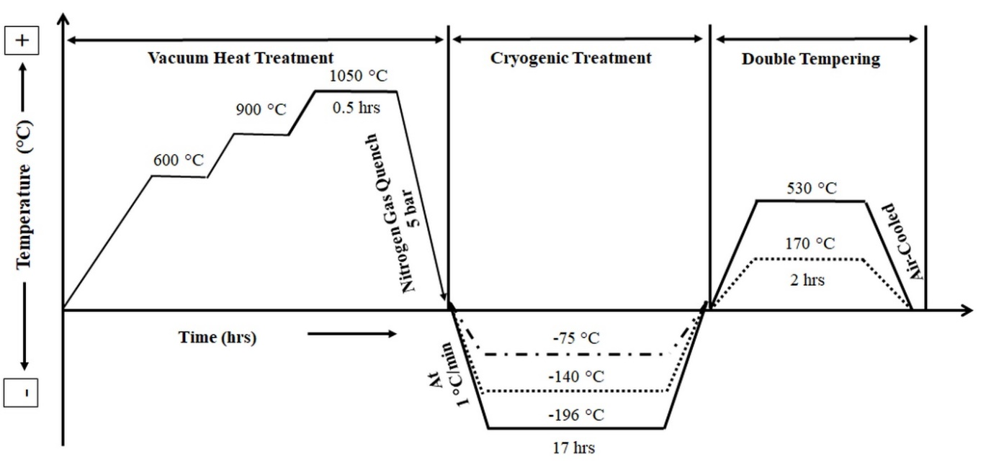

Figure 1. Schematic representation of heat treatment cycles.
The austenitizing process parameters [44] and cryogenic process parameters [33, 45, 46] were selected based on the optimal behavior observed in recent studies that extensively investigated the behavior of materials during CTs. These studies specifically examined the effect of varying holding times on the transformation and mechanical characteristics of Vanadis 6 tool steel. In these investigations, it was observed that shorter holding times did not achieve the desired transformation and mechanical properties, while excessively long durations resulted in diminishing returns or potential adverse effects. Based on the collective findings of these studies, a 17-hour holding time emerged as a critical duration for our material composition to ensure optimal results and the desired mechanical characteristics.

2.3. Hardness
The hardness of the specimens, which were subjected to various heat treatments, was measured using a Vickers hardness tester with a 10 kg load (HV10), in accordance with the ASTM E384 standard. The bulk hardness of the specimens was determined using a Rockwell hardness tester under a 150 kg load, following the ISO 6508-1 standard procedure. At least three measurements were performed for each test specimen, and the average value was reported.

2.4. Wear testing

To evaluate wear resistance, the heat-treated samples were initially mirror polished using diamond suspension media of varying sizes (9, 6, and 3 µm; Ra = 0.01 µm). This step was taken to minimize the influence of surface roughness. Subsequently, the samples were subjected to reciprocating sliding wear tests under atmospheric dry sliding conditions, utilizing the ball-on-flat contact configuration, following the ASTM-G133 standard test method. The experimental setup used in reciprocal sliding wear tests is summarized in Figure 2.

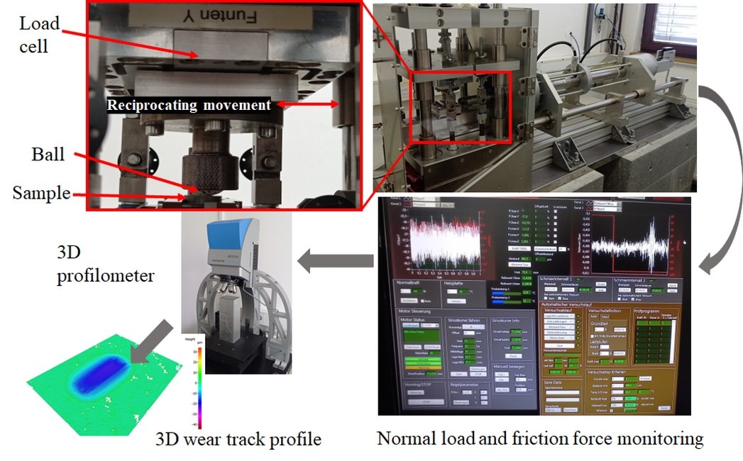

Figure 2. Experimental setup used in reciprocal sliding tests.

All tests were performed at room temperature with a relative humidity of 50-55 %. 20 mm diameter Al₂O₃ balls were used as oscillating counter-bodies to simulate abrasive wear. Al₂O₃ was chosen as the counter-body due to its overall hardness being much higher than that of the investigated cold work tool steel. The abrasive wear itself should mainly concentrate on the tested cold work tool steel. The applied load of 30 N for low load and 100 N for high load was selected to ensure that the Hertz initial contact pressure does not exceed 1600 MPa. All the test parameters for reciprocating sliding wear tests, performed in four configurations (low load-low sliding speed, low load-high sliding speed, high load-low sliding speed, high load-high sliding speed) with a total sliding distance of 200 m, are presented in Table 2. At least 3 parallel tests were conducted for all combinations, and average values were reported. The wear volume of the specimens was measured using an Alicona Infinite Focus G4 3D microscope. This high-resolution 3D optical device is based on a variation of focus intended for topography and form measurements. The wear resistance was plotted in terms of wear volume. The wear volume of the ceramic counter ball was not calculated since the wear on the harder alumina counter-body was negligible.

Table 2. Reciprocating sliding test configurations.
Condition | Value
Load [N] | 30, 100
Hertz contact pressure [MPa] | 1055, 1576
Sliding speed [m/s] | 0.04, 0.2
Stoke length [mm] | 2
Frequency [Hz] | 10, 50
Test time [s] | 1000, 5000
Sliding distance [m] | 200

2.5. Microstructure

The samples for microstructural examination were prepared following established procedures. Polished specimens were etched using Villela-Bain reagent (1 g picric acid, 5 mL hydrochloric acid, 100 mL ethanol) for 30 seconds. Microstructural features were investigated using a JSM-7500F field emission scanning electron microscope equipped with an energy dispersive X-ray detector. An accelerating voltage of 15 kV was used, and the micrographs were captured in the secondary electron (SE) and backscattered imaging mode (BSE). The determination of population densities followed a well-established methodology based on scanning electron microscopy (SEM) coupled with energy-dispersive X-ray spectroscopy (EDS) analysis. A minimum of thirty SEM micrographs were randomly selected from the samples at a standard magnification of 3000x to ensure statistical reliability in the investigations. Manual counting was performed on the acquired micrographs to determine the population densities of different carbides. The particles belonging to each carbide type were identified and counted. This approach facilitated the calculation of the mean population density per square millimeter for each carbide type. A more detailed description of how the carbides were differentiated is in [33].

Furthermore, XRD analysis was performed on solid samples of CHT and CT specimens after tempering at various temperatures, using the PANalytical Empyrean X-ray diffractometer (Malvern Panalytical Ltd., Malvern, UK). The measurements were conducted in Bragg-Brentano geometry, with a Theta-2Theta angle range of 30° to 130° 2Theta. However, for better interpretation of the diffraction peaks, a Thera-2 Theta angle range of 40° to 125° was presented in the data. The XRD source was set to 40 kV and 40 mA. The phase quality was analyzed using the PANalytical Xpert High Score program (HighScore Plus version 3.0.5) with the ICSD FIZ Karlsruhe database. Quantitative results were obtained from XRD patterns using the Rietveld refinement-based program MAUD version 2.84 [47]. Since there is a high probability that some characteristic peaks of carbide may overlap with those of either martensite or austenite, a Rietveld refinement of the obtained XRD spectra has been adopted to distinguish between these peaks.

3. results and discussion

3.1. Microstructure

Figure 3 shows the BSE microstructures of CHT and CT specimens after tempering at 170 °C, along with the corresponding EDS maps for carbides. Since the qualitative features of the microstructure are the same for any given treatment, only the microstructures after tempering at 170 °C are presented. The BSE images as well as the EDS mapping provide clear differentiation between smaller eutectic (vanadium-rich) and coarser secondary (chromium-rich) carbides in the examined steel.

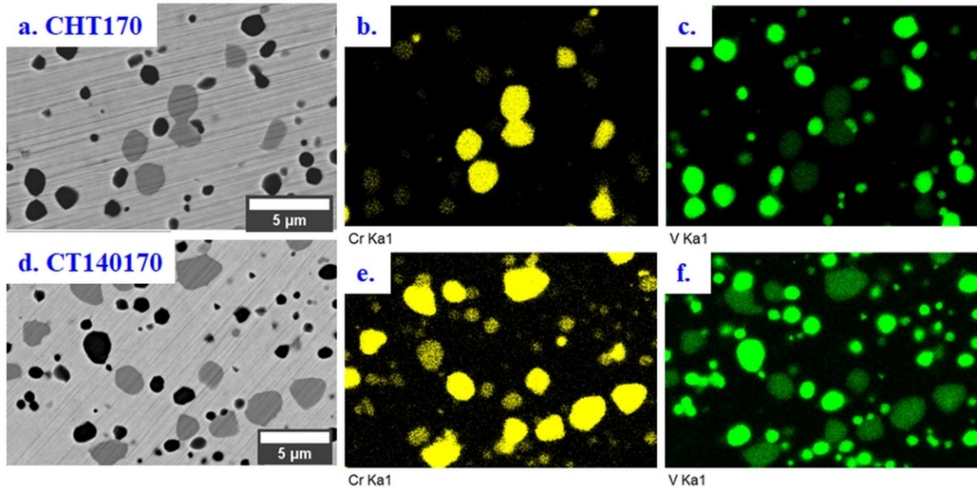

Figure 3. Electron image and corresponding EDS maps: a. CHT170, b), Chromium carbides (SCs), c) Vanadium carbides (ECs), d) CT140170, e) SCs, and f) ECs.

In addition, Figure 4 displays the SE microstructures of CHT and CT specimens after tempering at 170 °C and 530 °C. Both treatments exhibit a typical martensitic microstructure with various types of carbides. The microstructure consists of martensite, a certain amount of retained austenite, and carbides of different types. These carbides, which are uniformly distributed throughout the matrix, include vanadium-rich eutectic carbides (ECs, MC-type), chromium-rich secondary carbides (SCs, M₇C₃), and alloyed cementite small globular carbides (SGCs, M₃C).

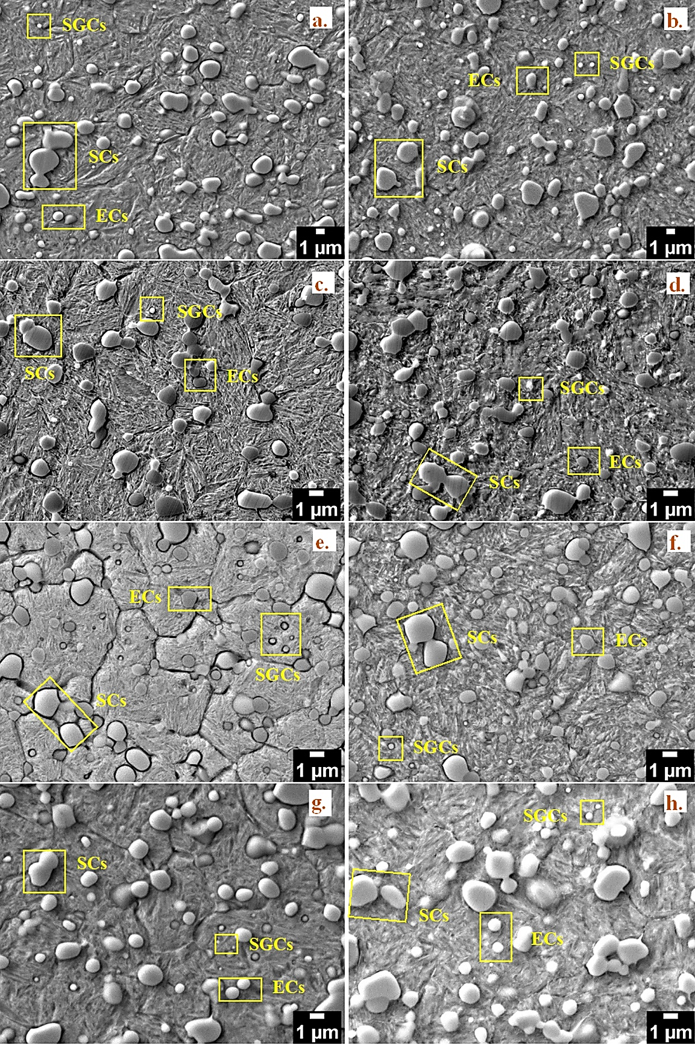

Figure 4. SEM micrographs of CHT and CT specimens: a) CHT170, b) CHT530, c) CT75170, d) CT75530, e) CT140170, f) CT140530, g) CT196170, h) CT196530 showing different carbides.

The X-ray diffraction profiles of CHT and CT specimens are shown in Figure 5. The characteristic peaks of martensite, retained austenite, and two major carbides are visible in the profiles. In the case of retained austenite, the intensity of the diffraction peak for CT specimens shows a significant reduction, suggesting a considerable reduction of the retained austenite phase. The estimation of the retained austenite amount showed 19.8 vol.% of this phase in CHT steel, while for CT specimens, it reduced to 4.8, 3.6, and 2.8 vol.%, respectively, for CT75170, CT140170, and CT196170.

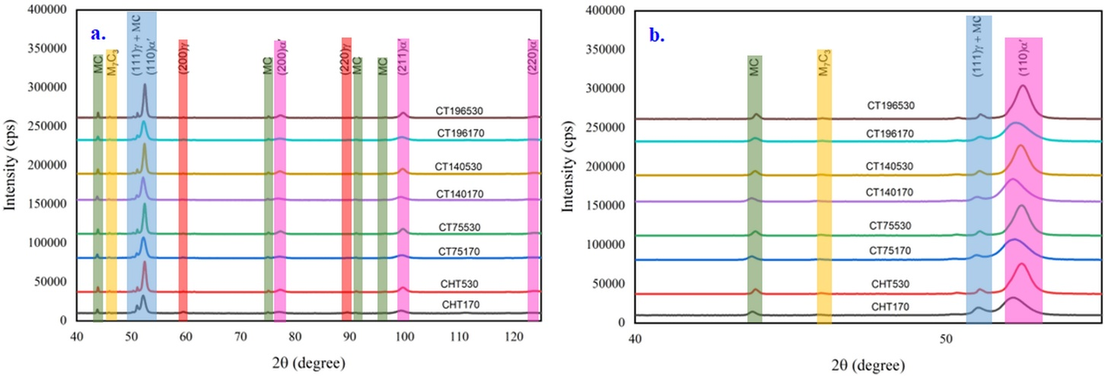

Figure 5. X-ray diffraction profiles of the samples after CHT and CT treatments after tempering at different temperatures: a) 40-125 2Theta degree, b) 40-55 2Theta degree.

Generally, the finding of a more complete martensitic transformation is in excellent agreement with recently published results obtained for different Cr and Cr-V ledeburitic steels [20, 33, 36, 45, 46]. For instance, Das et al. studied the effect of different CTs on the retained austenite amount in AISI D2 steel. They reported that the retained austenite amount in the CT (-75 °C) specimen is 4.6 vol.% compared to 9.8 vol.% in the CHT specimen, and other CTs at -125 or -196 °C almost completely eliminate the retained austenite reduction [48, 49].

On the other hand, among the CTs studied, the CT196170 specimens show the least amount of retained austenite. The temperature effect on the reduction of retained austenite is merely attributed to the difference between the characteristic martensite finish temperature and the CT temperature, which serves as the main driving force for the retained austenite to martensite transformation. For Cr-V ledeburitic tool steel, the martensite finish temperature was estimated to be -69 °C [33]. Consequently, treatment at -196 °C should result in less retained austenite than other cryogenic temperatures. In contrast, tempering at 530 °C almost eliminates the amount of retained austenite in both CHT and CT specimens (see Figure 5). The main contributor to this phenomenon is the decomposition of retained austenite, and at high tempering temperatures, the decomposition is much faster, while the stress relief induced by tempering favors the complete decomposition of retained austenite after tempering at 530 °C [46].

Another significant difference between CHT and CT specimens is the amount of small globular carbides (SGCs). It can be understood that the applied heat treatment schedules have no effect on the population densities of eutectic carbides or secondary carbides since the hardening parameters are the same for all the specimens [20, 33, 36, 45, 46]. However, the population density of small globular carbides differs for each treatment schedule used. The population densities of small globular carbides derived with reference to different heat treatment schedules are shown in Figure 6.

When compared to other treatments, CT140T170-treated specimens resulted in the highest population density of small globular carbides (SGCs) in both tempered conditions. The observed increase in the density of small carbides can be attributed to the reduction of retained austenite and the concurrent development of compressive stresses within the retained austenite phase [33]. However, from the graph, it can also be noticed that the population densities of small globular carbides decrease with an increase in tempering temperature (530 °C). The possible explanation for this phenomenon is the partial stress relief that occurs during high-temperature tempering treatment. As a consequence, the number and population density of SGCs decrease with an increase in tempering temperature. The detailed explanatory features of the microstructure and carbides in relation to different process conditions will not be covered here because they are already available in several other recently published publications [20, 33, 36, 45, 46].

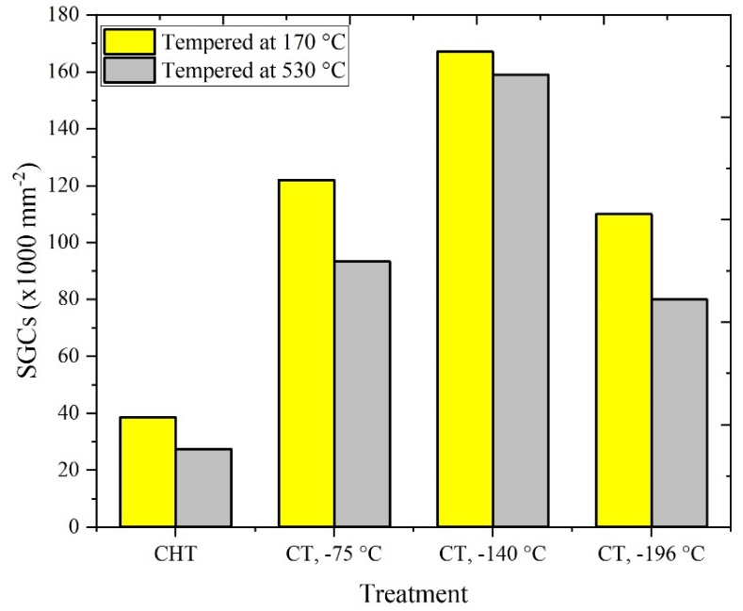

Figure 6. Population densities of small globular carbides for different treatment specimens [20, 33, 36, 45, 46].

3.2. Hardness

Figure 7 shows the mean Vickers (HV 10) and Rockwell (HRC) hardness values of CHT and CT specimens. The maximum standard deviation of 5.8 HV was found in the Vickers hardness measurements, and a standard deviation of 0.7 HRC was observed in the Rockwell readings. Generally, the specimens can be divided into two groups based on the obtained hardness values. First, the hardness of CT specimens is higher than that of CHT specimens in both hardness scales when tempered at 170 °C (see Figure 7a). For instance, the hardness of the CHT specimen was found to be 791 HV, whereas the hardness of the CT specimens was over 850 HV, resulting in an increase in hardness of approximately 10 %. These results are in excellent agreement with those reported for cryotreated AISI D2 [49-51] and AISI D3 steel [52, 53]. Second, the hardness trend was reversed when the samples were tempered at 530 °C (see Figure 7b). In this case, the hardness of the CHT specimen (764 HV) was higher than that of the cryotreated specimens, and the decrease in hardness in CT specimens was around 7 %. To explain these changes at high-temperature tempering, the following factors can be considered:

First, the CHT specimen shows secondary hardening due to the extensive secondary austenite to martensite transformation and precipitation of M₇C₃ carbides. Secondary hardening in tool steels refers to the increase in hardness and strength observed after tempering, resulting from the precipitation of fine carbide particles within the steel matrix. On the other hand, the CT specimens do not show secondary hardening due to clear differences in the initial microstructural characteristics [46]. It is evident that the role of secondary austenite to martensite transformation is much more important in the CHT specimen, as they contain 19.8 vol% of retained austenite, while the CT specimens show a reduction in retained austenite of almost 75 %. Therefore, the loss of secondary hardening in CT specimens can be attributed to a much lower contribution of retained austenite transformation, a decrease in the population densities of SGCs and suppressed precipitation of alloy carbides [46]. Furthermore, the hardness changes within the CT specimens were found to be insignificant in any tempered condition, and almost similar hardness values were observed.

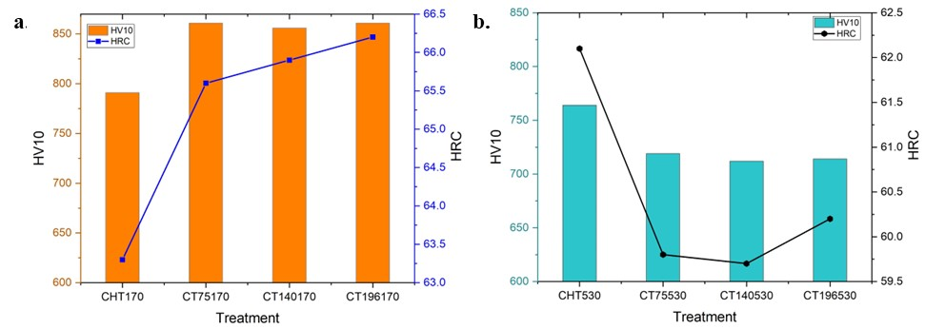

Figure 7. Mean hardness of CHT and Cryotreated specimens: a) after tempering at 170 °C, b) after tempering at 530 °C.

The primary explanation for the increase in hardness observed in CT over CHT when tempered at 170 °C is mainly due to the more complete transformation of martensite. A certain, but limited, contribution from additional carbides can also be expected; however, their impact on bulk hardness is anticipated to be lower. For instance, the CT196170 specimen contains the lowest amount of retained austenite, while the CT140170 specimens have the highest carbide count. Various authors [39, 46, 54] have experimentally demonstrated that the reduction of retained austenite has a more favourable effect on hardness increase compared to an increase in carbide count. However, at certain low levels of retained austenite, the effect of additional carbides may counterbalance the differences in retained austenite; this could be why the hardness values of different CT specimens are almost the same after low-temperature tempering.

The differences in hardness levels of high-temperature tempered samples can be explained as follows: Prior to tempering, the steel contains martensite, a small amount of retained austenite, and varying carbide quantities. The small hardness increase (presence of a weak secondary hardness peak) after high-temperature tempering at 530 °C (Figure 8) can be attributed to the extensive transformation of retained austenite to martensite and the precipitation of M₇C₃ carbides in the case of CHT specimens. Cryogenically treated specimens contain less retained austenite; hence, the contribution of retained austenite-to-martensite transformation to the overall hardness is minimal. In addition, tempering reduces the count of additional carbides (SGCs). And finally, various authors have reported suppressed precipitation of stable M₇C₃ carbides in AISI D2 steel [55, 56] or Vanadis 6 steel [33, 46]. Therefore, the contribution of this phenomenon is also minimal in the case of samples after tempering at 530 °C. In Figure 8, the tempering curves for both CHT and CT specimens are presented. From the tempering chart, it is evident that CHT steel exhibits a weak secondary hardness peak, while this peak is completely absent in differently cryogenically treated steel. This distinction indicates that similar tempering conditions, where both steels demonstrate comparable secondary hardness behaviour, do not actually exist due to the unique influence of cryogenic treatment.

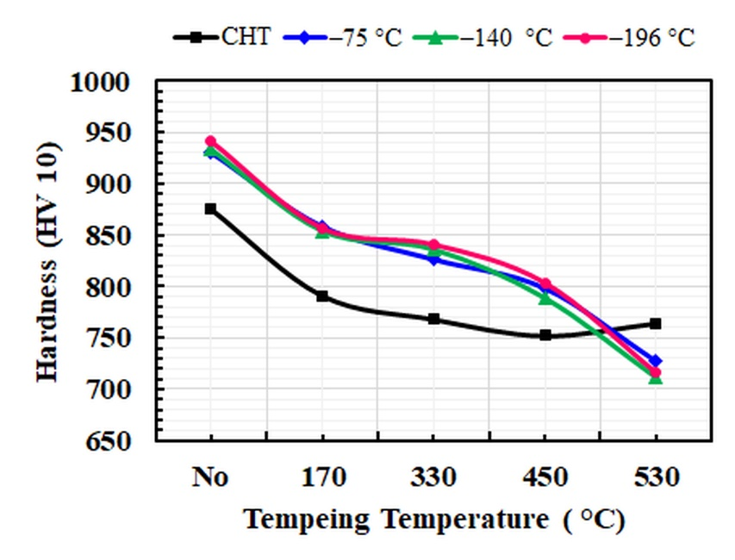

Figure 8. Tempering charts of Vanadis 6 steel after CHT and CT treatments.

3.3. Tribological properties

3.3.1. Coefficient of Friction (COF)

The effects of different heat treatments and testing conditions on the mean coefficient of friction (COF) are shown in Figure 9. The COF ranged from 0.65 to 0.88 for specimens tempered at 170 °C, and from 0.61 to 0.82 for samples tempered at 530 °C. When the specimens were tempered at 170 °C under a 30 N load and a sliding speed of 0.2 m/s, CHT170 exhibited the highest friction coefficient of 0.88, followed by CT75170 with 0.75, and CT140170 and CT196170 with 0.76 and 0.79, respectively. However, under other conditions, such as a 30 N load and a sliding speed of 0.04 m/s, all treatments (CHT170, CT75170, CT140170, and CT196170) showed similar friction coefficients ranging from 0.65 to 0.66. Similarly, under a 100 N load and a sliding speed of 0.2 m/s, all treatments (CHT170, CT75170, CT140170, and CT196170) exhibited similar COF values of approximately 0.6.
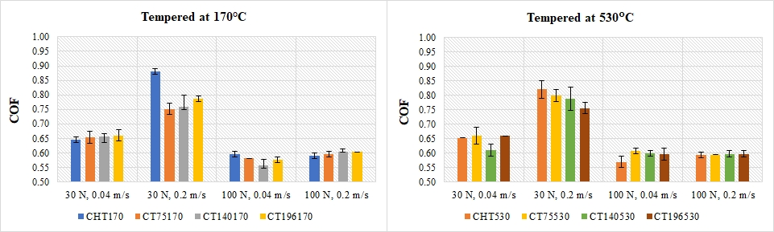

Figure 9. Mean friction coefficient of CHT and CT specimens at different loads and speeds.

When comparing the friction coefficients among specimens treated at 530 °C, no consistent relationship between the treatment and the friction coefficient was observed. For example, under a 30 N load and a sliding speed of 0.04 m/s, the friction coefficients ranged from 0.61 to 0.66 for the different treatments (CT140530, CT196530, CHT530, and CT75530). Similarly, under a 30 N load and a sliding speed of 0.2 m/s, the friction coefficients varied from 0.76 to 0.82. The range of friction coefficients remained relatively consistent across the different treatments for both load and sliding speed conditions. These numerical facts suggest that the treatment of the sample, as represented by the various treatments, does not exhibit a clear and consistent influence on the friction coefficient in the provided dataset.

However, two major tendencies can be observed from the mean COF diagrams. Firstly, the COF is primarily dependent on the load. For instance, the COF values obtained at a load of 30 N are higher than those for specimens tested at 100 N. Secondly, the COF exhibits a dependency on sliding speed at 30 N. For example, the specimens display lower COF at lower sliding speeds and vice versa, higher COF at higher sliding speeds. However, this tendency was not observed when specimens were tested at 100 N. These observations remain consistent even when the samples are tempered at 530 °C. This behaviour of COF can be attributed to the initial contact stresses. The initial contact stresses at 30 N and 100 N were measured as 1055 MPa and 1577 MPa, respectively. Micro-asperities, which are small surface irregularities or projections, play a significant role in the behaviour of the COF. At higher contact stresses, plastic deformation of micro-asperities can easily occur. Additionally, during repeated sliding, the surface can smoothen, resulting in lower COF values. In the current study, it is observed that COF is primarily dependent on the load and sliding speed at lower loads, while the treatment of the material did not show any significant impact on the COF.

These findings align closely with previous research conducted by Jovičevič-Klug and Podgornik [12]. The researchers investigated the impact of loading severity on the COF for two high-speed steels, namely M2 and M3:2, after CTs against alumina counterparts. The study revealed a consistent decrease in COF with increasing load, and the CTs had minimal impact on the COF. It is important to note that both the specimen and the counterpart surfaces were not perfectly flat initially. Although mirror polished, they exhibited microscale roughness, with only the highest peaks of imperfections making actual contact. Consequently, this roughness may result in a higher COF, particularly under low loading conditions. However, as the applied load increases, the surface imperfections gradually eliminated during a shorter testing period, resulting in a smoother surface and a lower COF [57].

3.3.2 Wear resistance (volume loss)

Figure 10 illustrates the volume loss of material in mm³ under different process and testing conditions. It is evident from Figure 10 that the volume loss of specimens generally increases with higher loads and sliding speeds. Specifically, the CT specimens show lower volume loss (indicating better wear resistance) compared to CHT specimens after tempering at 170 °C. However, when tempered at 530 °C, no significant improvement in wear resistance is observed in CT specimens over CHT specimens; instead, higher volume loss is observed. These differences can be attributed to the final microstructure of the steel, which will be discussed in subsequent sections.

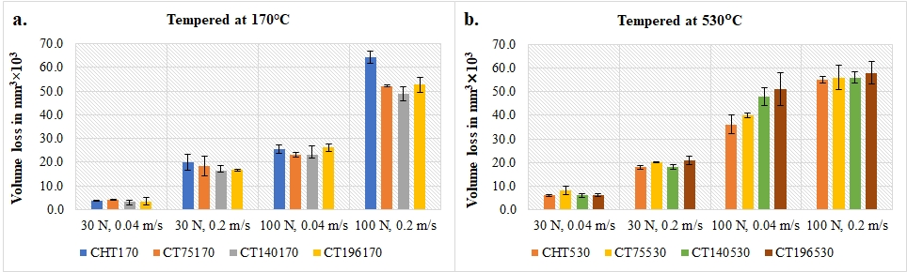

Figure 10. Wear volume loss of CHT and CT specimens at different test conditions, a) tempered at 170 °C, b) tempered at 530 °C.

The volume loss of CHT and CT specimens changes with the severity of contact conditions. Moreover, it is evident that the highest volume losses occur under high load-high speed (100N, 0.2 m/s) testing conditions, regardless of the material treatment. Nevertheless, CT specimens exhibit better wear resistance than CHT specimens after tempering at 170 °C. The degree of wear resistance increases with the severity of the testing conditions. For example, at 30 N and a lower sliding speed (0.04 m/s), the volume loss of the CHT specimen was 3.7×10³ mm³, whereas the CT specimen (-140 °C) had a volume loss of 3.5×10³ mm³, which is approximately 5 % lower. However, under 100 N and high sliding speed, the volume loss of the CHT specimen was 64.2×10³ mm³, while the CT specimen (-140 °C) had a volume loss of 48.8×10³ mm³, representing a significant 24 % reduction. Therefore, improved wear resistance is observed in the CT specimen at -140 °C compared to other specimens. The variations in wear resistance can be attributed to the increased hardness of the CT specimens, as shown in Figure 7. Additionally, the specimen evaluated at -140 °C demonstrates superior performance relative to other CT temperatures, likely due to a synergistic effect resulting from higher hardness and an increased population density of small globular carbides, as depicted in Figure 6.

The volume loss of the material gradually increases as the applied load increases from 30 N to 100 N (refer to Figure 10). This trend follows the Archard equation for sliding wear, which states that the volume loss of the material is directly proportional to the normal load and inversely proportional to the hardness of the softer material [58]. Several studies conducted by Das and colleagues [38, 47, 48], Akhbarizadeh et al. [50, 59-61], as well as other investigators, have reported a significant increase in the number of extra carbides and a reduction in retained austenite for D-class ledeburitic steels after CTs. These microstructural changes have resulted in substantial improvements in wear resistance.

In our current experiments, the maximum number of extra carbides was observed after CT at -140 °C, which logically corresponds to the best wear performance of the examined steel after this treatment. Previous literature [39, 48, 49, 51, 59, 62] has also shown that increased carbide counts and reduced retained austenite lead to an increase in hardness after low-temperature tempering. However, there is no observed benefit in hardness when D-class steels are high-temperature tempered after CTs [63]. In these microstructures, no austenite is present, and although the number of extra carbides is reduced compared to the pre-tempered states, it remains higher than that in CHT steels [45, 46, 64]. When comparing CT and CHT specimens after tempering at 530 °C, the increased SGCs count is insufficient to compensate for the lower bulk hardness, which can be attributed to the delayed and suppressed precipitation of nano-sized alloy carbides. This is the main reason for the higher volume losses observed in CT specimens compared to CHT specimens when tempered at 530 °C. Nonetheless, the matrix of CT steels undergoes more significant softening compared to CHT steels due to microstructural changes caused by CT, as demonstrated in references [46, 64].

In our initial study on the wear resistance of Vanadis 6 steel after different CTs combined with high-temperature tempering, no practical effect on wear resistance against an alumina counterpart was reported [43]. However, this study only utilized treatments at -196 °C or -90 °C. The results obtained in the current work indicate that treatment at -140 °C may lead to a certain and undeniable improvement in wear resistance compared to the state after treatment at -196 °C. Therefore, the influence of CT on the wear resistance of Vanadis 6 steel can be considered very limited after high-temperature tempering, although a slight improvement can be expected at 30 N compared to the state after CHT.

3.4. Worn surfaces characterization

Figure 11 displays the wear tracks of the CHT specimens under various test conditions. It is important to note that the wear track characteristics observed in the CHT specimens were similar to those in all other specimens. Therefore, only the wear tracks of the CHT specimens are referenced here. Generally, the width of the wear track increases with higher loads and sliding speeds. Additionally, at lower sliding speeds, the worn tracks are covered with fused wear debris. This effect is more pronounced at 100 N due to increased plastic deformation and wear debris generation. In contrast, at higher sliding speeds, no wear debris is retained on the wear track.
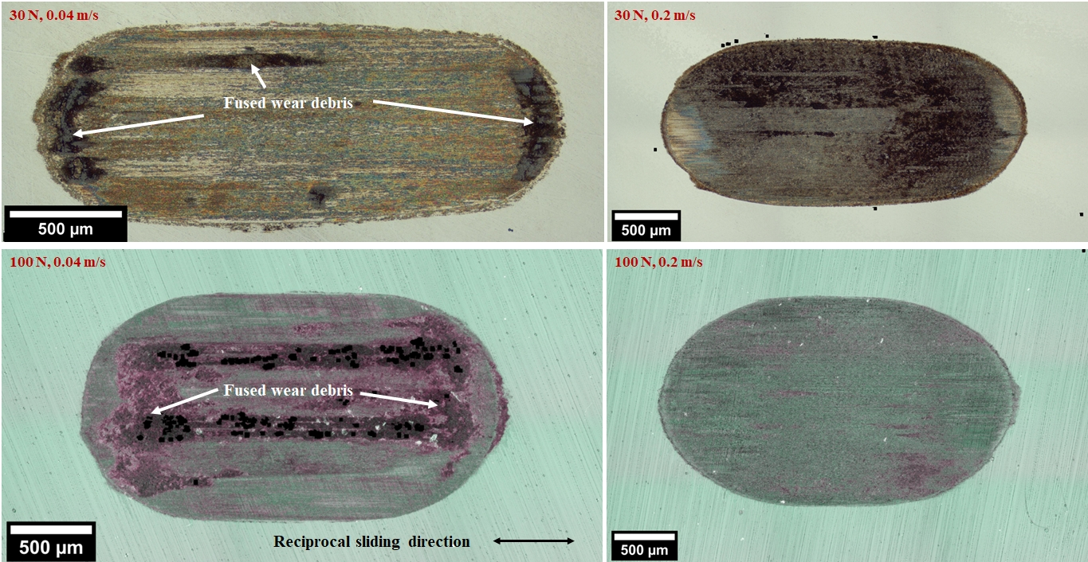

Figure 11. Reciprocal sliding wear tracks of CHT specimens at different test conditions.
Figure 12a-h illustrates SEM images of the wear tracks of CHT170 and CT140170 specimens under different test conditions. The main feature observed is the abrasive wear mechanism, which becomes more pronounced with the generation of severe grooves at higher loads and sliding speeds. At a load of 30 N (Figure 12a), the worn surface of the CHT170 specimen appears smooth at lower sliding speeds. However, Figure 12b shows a rough worn surface with the presence of wear debris at higher sliding speeds. On the other hand, much deeper abrasive grooves are formed on the worn surfaces of the CHT170 specimen after testing at 100 N (Figure 12c-d). Figure 12e-h presents a visual comparison that effectively illustrates the notable difference in surface smoothness between the CT140170 and CHT specimens. These images corroborate the findings presented in Figure 10a, which clearly demonstrate a reduction in volume loss resulting from CT. It is worth emphasizing that similar wear characteristics have been observed in other CT specimens. However, the CT140170 specimens exhibit the smoothest worn surfaces among other samples, providing evidence for the better wear resistance of the steel subjected to this specific treatment.
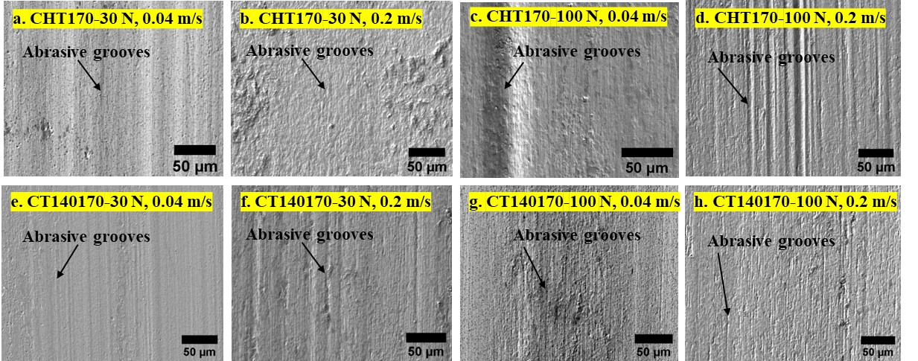

Figure 12. SEM images of wear tracks at different test conditions after tempering at 170 °C: a-d) CHT170, e-h) CT140170.
Figure 13 displays the 3D topography, while Figure 14 shows the corresponding 2D wear track profiles of the CHT170 and CT140170 specimens under a load of 30 N and a sliding speed of 0.04 m/s. Analysis of the topographic and profile data reveals that the wear track depth for the CHT specimens measures -5.9 μm, whereas for the CT140170 specimens, it measures -4.1 μm. Additionally, the CT140170 specimens demonstrate a smoother profile compared to the CHT170 specimens. This improved smoothness can be attributed to the synergistic effect of their increased hardness resulting from a higher occurrence of martensitic transformation and a greater population density of small carbides. These factors contribute to enhanced resistance against abrasive wear.
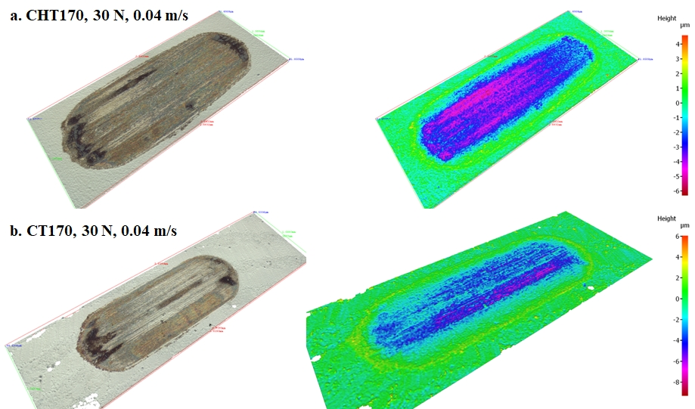

Figure 13. 3D topography of wear track profiles for CHT170 and CT140170 specimens after testing at 30 N and sliding speed of 0.04 ms⁻¹
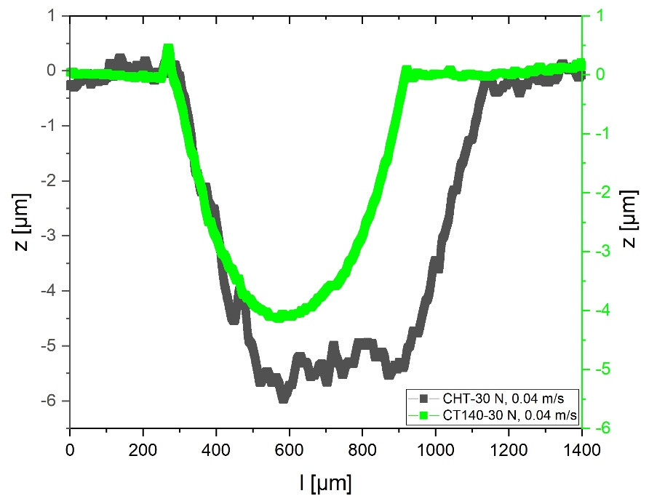

Figure 14. 2D wear track surface profiles for CHT170 and CT140170 specimens after testing at 30 N and sliding speed of 0.04 ms⁻¹.
The worn surfaces of the CHT and CT specimens after tempering at 530 °C are shown in Figure 15a-h. The worn tracks of high-temperature tempered specimens show deeper and wider abrasive grooves, generating higher volume loss than those tempered at 170 °C, see Figure 10b. But, by visual inspection of the micrographs of the worn surfaces in Figure 15 it is seen that CHT530 specimens manifest larger and deeper abrasive grooves than what is visible on surfaces of CT140530 specimens. This finding, however, contradicts the results in Figure 10b where lower volume losses were determined for conventionally treated steel specimens.
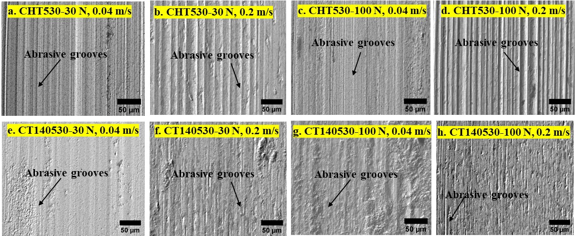

Figure 15. SEM images of wear tracks at different test conditions after tempering at 530 °C: a-d) CHT530, e-h) CT140530.
Figure 16 illustrates the 3D topography profiles of the CHT530 and CT140530 specimens after testing under a load of 100 N and a sliding speed of 0.04 m/s. On the other hand, Figure 17 displays the 2D wear track profiles of the CHT530 and CT140530 specimens under the same testing conditions.
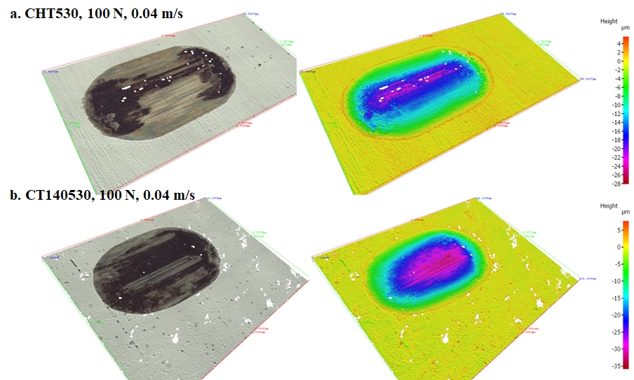

Figure 16. 3D wear track topography profiles for CHT and CT specimens after tempering at 530 °C.
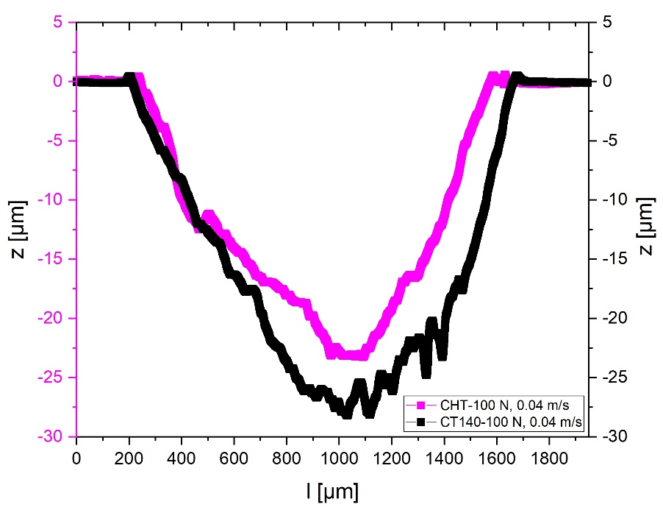

Figure 17. 2D wear track surface profile for CHT and CT specimens after tempering at 530 °C.
In terms of the maximum depth of the wear track, the CHT530 specimens exhibit a depth of -22.9 μm, whereas the CT140530 specimens show a depth of -28.0 μm. This difference can be attributed to the higher hardness of the CHT530 specimens, resulting from the secondary hardening effect. On the contrary, the CT specimens suffer from a loss of the secondary hardening effect, a softening of the matrix, and the coarsening of the carbides, all of which contribute to a lower hardness and consequently lead to higher volume losses.
The resulting wear behavior is influenced by the competition between the different roughness levels and depths of the worn surfaces in the differently treated specimens. In simpler terms, wear tracks for CT specimens exhibit lower surface roughness, while CHT steel has a shallower wear track. To evaluate the wear track roughness, it is important to consider the carbide content in the differently treated specimens. CT specimens contains a higher amount of carbides compared to CHT specimens (see Figure 6). Carbides, being hard phases, may effectively protect the surface against grooving. This may explain the lower roughness observed in CT specimens. However, it is worth noting that CT specimens exhibit lower hardness after high-temperature tempering (see Figure 7b). Hardness plays a crucial role in determining the resistance of metallic materials to abrasive wear. Therefore, it is logical to expect a higher volume loss in CT and high-temperature tempered specimens compared to CHT specimens. This is despite the fact that the worn surfaces of CT specimens may appear smoother due to the beneficial effect of an increased number of carbides. It is also worth noting that Bergman et al. [65] have reported that an increased amount of carbides may not inevitably lead to a notable improvement in abrasive wear resistance (although a limited improvement can be expected) when the material of the counterpart exhibits very high hardness. In the case of Vanadis 6 steel, the SGCs present are cementite [33]. Cementite has a hardness of around 1300 HV, which is much lower than that of sintered alumina (around 2500 HV). Therefore, while an increased amount of SGCs can partially contribute to better wear performance of low-temperature tempered specimens, it cannot completely counterbalance the lower hardness of cryogenically treated and high-temperature tempered specimens.
Furthermore, the phenomenon of tribo-oxidation was observed under severe contact conditions, irrespective of the heat treatment condition. When subjected to higher loads, specifically 100 N, all specimens displayed significant tribo-oxidation due to the presence of fused wear debris on the wear track. This effect was particularly pronounced at lower sliding speeds. In Figure 18, the electron image and corresponding iron and oxygen maps of the CHT specimen under the conditions of 100 N and a low sliding speed of 0.04 m/s provide confirmation of significant tribo-oxidation occurring at low sliding speeds.
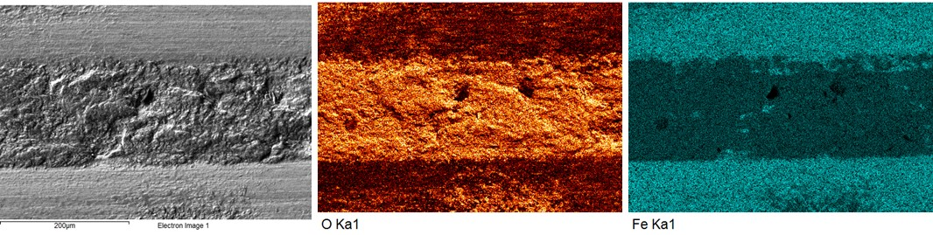

Figure 18. EDS map of worn surface at 100 N (low sliding speed) showing significant tribo-oxidation.
It should be noted, however, that at higher sliding speeds, the wear debris tends to be ejected from the tracks, which prevents the significant formation of fused debris and subsequent tribo-oxidation. In Figure 19, the electron image and corresponding elemental maps of the CT specimen under conditions of 100 N and a high sliding speed of 0.2 m/s confirm that there is no significant tribo-oxidation taking place.
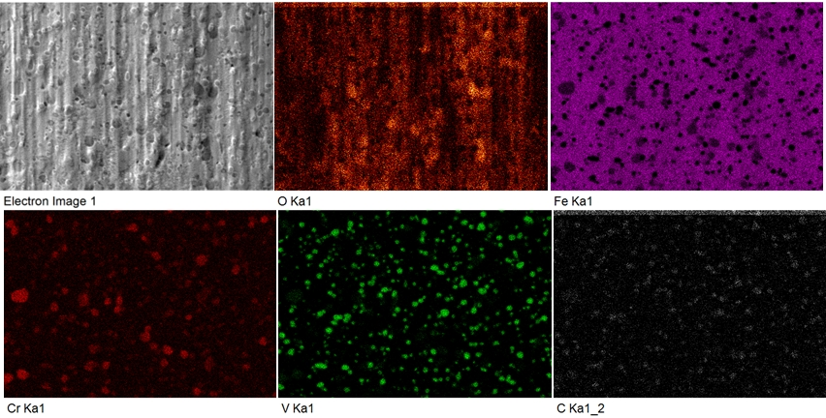

Figure 19. EDS map of worn surface at 100 N (high sliding speed) showing no significant tribo-oxidation.

3.5. Subsurface characterization
SEM micrographs of the worn surfaces for the CHT170 and CT140170 specimens under high load and high speed contact conditions (100 N, 0.2 m/s) are shown in Figure 20. In the subsurface micrographs, the CHT specimen exhibits the formation of a white layer on the worn surface, which measures approximately 1 μm in thickness. In contrast, the CT specimen shows no indication of white layer formation.
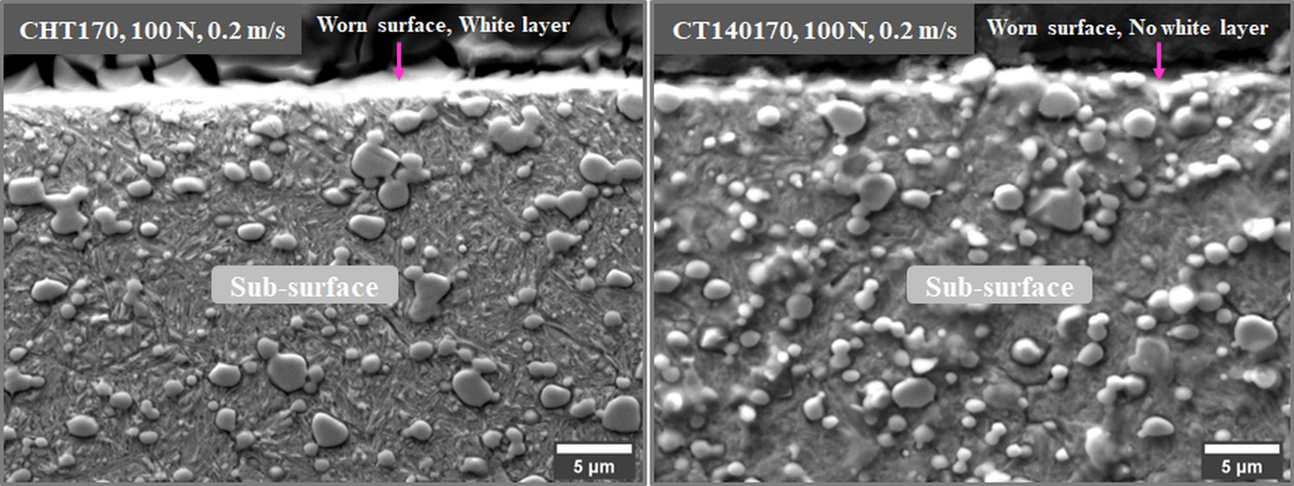

Figure 20. SEM microstructure of subsurface of worn surfaces for CHT and CT specimens.

The formation of a white layer in ferrous materials during wear is attributed to three phenomena: severe plastic deformation, frictional heat-induced phase transformations, and reactions with carbon and/or nitrogen [66]. In our study, wear tests were conducted without lubrication, ruling out the possibility of chemical hardening through carbon/nitrogen enrichment [67]. Therefore, the white layer in our investigation resulted from plastic deformation or a combination of plastic deformation and phase transformation. Formation of a white layer through phase transformations or melting requires very high temperatures, which are typically achieved at higher loads or sliding speeds [68]. Considering our wear conditions, plastic deformation alone likely caused the white layer.

These findings align with other studies on white layer formation. For example, Das et al. [40, 68] examined DCT AISI D2 steel wear performance at different loads and reported white layer formation due to severe plastic deformation. They also observed that CHT specimens were more susceptible to plastic deformation than DCT specimens due to microstructural differences. In our study, the improved wear performance of CT specimens tempered at 170 °C can be attributed to a favorable microstructure, characterized by lower retained austenite and higher population densities of SGCs compared to CHT specimens.

4. conclusion

The influence of CHT and various CTs (at -75, -140, or -196 °C) in combination with tempering temperature (low/high) on the reciprocal wear behavior of Vanadis 6 cold work tool steel against a hard ceramic counterpart has been thoroughly investigated. The wear characteristics obtained have been analyzed in correlation with the microstructures and hardness values of the materials. The key findings can be summarized as follows:

CTs lead to a reduction of retained austenite over 75 % and a significant increase in the number of small globular carbides in the material microstructures when compared to CHT. The number of carbides was found to be the highest after CT at -140 °C in combination with tempering at 170 °C. On the other hand, high-temperature tempering leads to a reduction in the number and population density of carbides. These findings suggest that CT can be an effective method for improving the microstructure of tool steels.

After tempering at 170 °C, the CT specimens exhibited a 10 % increase in hardness compared to the CHT specimens. However, CT specimens tempered at 530 °C experienced a 7 % decrease in hardness. These results show that CT can be an effective method for improving the hardness and consequently the abrasive wear resistance of ledeburitic tool steels. However, an appropriate tempering temperature must be selected, not necessarily being the same as for conventional heat treatment.
- The study determined that the friction behavior of ledeburitic tool steel is primarily influenced by the applied load and sliding speed, rather than the material heat treatment. The COF values for CHT specimens ranged from 0.57 to 0.88, while CT specimens showed a variation ranging from 0.56 to 0.82, depending on the contact conditions.
- The wear behavior of the ledeburitic tool steel is influenced by the applied load and sliding speed. As the applied load increased from 30 N to 100 N, the volume loss of the material gradually increased. Additionally, higher sliding speeds resulted in higher volume losses.
- Under severe contact conditions, the CHT specimens showed the highest volume loss of 64.2×10³, whereas the lowest volume loss of 48.8×10³ was achieved by subjecting the steel to CT at -140 °C followed with low-temperature tempering. Conversely, for high-temperature tempering the highest volume loss was observed in specimens subjected to CT at -196 °C.
- The wear mechanism identified was abrasive wear under any given heat treatment condition, accompanied by tribo-oxidation under severe contact conditions.
- The results demonstrated that CT specimens exhibited improved wear resistance with low-temperature tempering, while high-temperature tempered samples showed a decline in wear performance.
- CT at -140 °C combined with low-temperature tempering at 170 °C yielded the optimal process condition for improving the wear performance of Cr-V ledeburitic tool steel under severe abrasive wear conditions. This specific combination resulted in a significant 24 % improvement in abrasive wear performance compared to the CHT specimens.

Funding

The authors acknowledge that the paper is a result of experiments realized within the project VEGA 1/0112/20. In addition, this publication is the result of the project implementation “Centre for Development and Application of Advanced Diagnostic Methods in Processing of Metallic and Non-Metallic Materials – APRODIMET”, ITMS: 26220120014, supported by the Research & Development Operational Programme funded by the ERDF.

CRedit authorship contribution statement

Venu Yarasu: Investigation, Data management, Validation, Formal analysis, Visualization, Methodology, Writing – original draft. Peter Jurci: Conceptualization, Resources, Supervision, Methodology, Funding acquisition, Project administration, Writing – review and editing. Bojan Podgornik: Conceptualization, Resources, Supervision, Methodology, Writing – review and editing. Marko Sedlaček: Supervision. Peter Gogola: Additional SEM analysis.

Declaration of competing interest

The authors declare that they have no known competing financial interests or personal relationships that could have appeared to influence the work reported in this article.

references
[1] R. Ebner, H. Leitner, F. Jeglitsch, D. Caliskanoglu, Methods of property oriented tool steel design, in: Proceeding of 5th International Conference on Tooling, Leoben, Sept. 29th to October 1st, 1999: pp. 3–24.
[2] G.E. Totten, ed., Steel heat treatment handbook, CRC, Taylor & Francis, Boca Raton, 2007: p.832.
[3] N.B. Dhokey, S.S. Maske, P. Ghosh, Effect of tempering and cryogenic treatment on wear and mechanical properties of hot work tool steel (H13), Materials Today: Proceedings. 43 (2021) 3006–3013.
[4] E. Nas, N. Altan Özbek, Optimization of the machining parameters in turning of hardened hot work tool steel using cryogenically treated tools, Surface Review and Letters. 27 (2020) 1950177.
[5] J. Soleimany, H. Ghayour, K. Amini, F. Gharavi, The effect of deep cryogenic treatment on microstructure and wear behavior of H11 tool steel, Physics of Metals and Metallography. 120 (2019) 888–897.
[6] P. Suchmann, D. Jandova, J. Niznanska, Deep cryogenic treatment of H11 hot working tool steel, Mater Tech. 49 (2015) 37–42.
[7] A. Çiçek, F. Kara, T. Kıvak, E. Ekici, I. Uygur, Effects of deep cryogenic treatment on the wear resistance and mechanical properties of AISI H13 hot-work tool steel, Journal of Materials Engineering and Performance. 24 (2015) 4431–4439.
[8] M. Perez, C. Rodriguez, F.J. Belzunce, The use of cryogenic thermal treatments to increase the fracture toughness of a hot work tool steel used to make forging dies, Procedia Materials Science. 3 (2014) 604–609.
[9] A. Çiçek, F. Kara, T. Kivak, E. Ekici, Evaluation of machinability of hardened and cryo-treated AISI H13 hot work tool steel with ceramic inserts, International Journal of Refractory Metals and Hard Materials. 41 (2013) 461–469.
[10] M. Koneshlou, K.M. Asl, F. Khomamizadeh, Effect of cryogenic treatment on microstructure, mechanical and wear behaviors of AISI H13 hot work tool steel, Cryogenics. 51 (2011) 55–61.
[11] P. Jovičević-Klug, G. Puš, M. Jovičević-Klug, B. Žužek, B. Podgornik, Influence of heat treatment parameters on effectiveness of deep cryogenic treatment on properties of high-speed steels, Materials Science and Engineering: A. 829 (2022) 142157.
[12] P. Jovičević-Klug, B. Podgornik, Comparative study of conventional and deep cryogenic treatment of AISI M3: 2 (EN 1.3395) high-speed steel, Journal of Materials Research and Technology. 9 (2020) 13118–13127.
[13] S.S. Gill, J. Singh, R. Singh, H. Singh, Effect of cryogenic treatment on AISI M2 high speed steel: metallurgical and mechanical characterization, Journal of Materials Engineering and Performance. 21 (2012) 1320–1326.
[14] L.P. Singh, J. Singh, Effects of cryogenic treatment on high-speed steel tools, J Eng Technol. 1 (2011) 88–93.
[15] F. Cajner, V. Leskovšek, D. Landek, H. CaJner, Effect of deep-cryogenic treatment on high speed steel properties, Materials and Manufacturing Processes. 24 (2009) 743–746.
[16] B. Podgornik, V. Leskovšek, J. Vižintin, Influence of deep-cryogenic treatment on tribological properties of P/M high-speed steel, Materials and Manufacturing Processes. 24 (2009) 734–738.
[17] M. Pellizzari, Influence of deep cryogenic treatment on the properties of conventional and PM high speed steels, La Metallurgia Italiana. (2008).
[18] A. Molinari, M. Pellizzari, S. Gialanella, G. Straffelini, K.H. Stiasny, Effect of deep cryogenic treatment on the mechanical properties of tool steels, Journal of Materials Processing Technology. 118 (2001) 350–355.
[19] V. Yarasu, P. Jurci, J. Hornik, S. Krum, Optimization of cryogenic treatment to improve the tribological behavior of Vanadis 6 steel using the Taguchi and grey relation approach, Journal of Materials Research and Technology. 18 (2022) 2945–2962.
[20] J. Ďurica, J. Ptačinová, M. Hudáková, M. Kusý, P. Jurči, Microstructure and Hardness of Cold Work Vanadis 6 Steel after Subzero Treatment at −140°C, Advances in Materials Science and Engineering. 2018 (2018) 1–7.
[21] P. Jurči, J. Ptačinová, M. Sahul, M. Dománková, I. Dlouhy, Metallurgical principles of microstructure formation in sub-zero treated cold-work tool steels – a review, Matériaux & Techniques. 106 (2018) 104.
[22] P. Jurči, Sub-Zero Treatment of Cold Work Tool Steels – Metallurgical Background and the Effect on Microstructure and Properties, HTM Journal of Heat Treatment and Materials. 72 (2017) 62–68.
[23] J. Sobotová, M. Kuřík, Z. Kolář, P. Priknerová, Effect of Conditions of Cryogenic Treatment on the Properties of Selected Cold Work Tool Steels, HTM Journal of Heat Treatment and Materials. 72 (2017) 99–103.
[24] D. Toboła, W. Brostow, K. Czechowski, P. Rusek, Improvement of wear resistance of some cold working tool steels, Wear. 382–383 (2017) 29–39.
[25] I. Gunes, M. Uzun, A. Cetin, K. Aslantas, A. Cicek, Evaluation of wear performance of cryogenically treated Vanadis 4 Extra tool steel, Km. 54 (2016) 195–204.
[26] J. Sobotova, P. Jurci, I. Dlouhy, The effect of subzero treatment on microstructure, fracture toughness, and wear resistance of Vanadis 6 tool steel, Materials Science and Engineering: A 652 (2016) 192–204.
[27] F.K. Arslan, I. Altinsoy, A. Hatman, M. Ipek, S. Zeytin, C. Bindal, Characterization of cryogenic heat treated Vanadis 4 PM cold work tool steel, Vacuum. 86 (2011) 370–373.
[28] G. Prieto, J.E.P. Ipiña, W.R. Tuckart, Cryogenic treatments on AISI 420 stainless steel: Microstructure and mechanical properties, Materials Science and Engineering: A. 605 (2014) 236–243.
[29] P. Baldissera, Deep cryogenic treatment of AISI 302 stainless steel: Part I – Hardness and tensile properties, Materials & Design. 31 (2010) 4725–4730.
[30] T. Kivak, U. Şeker, Effect of cryogenic treatment applied to M42 HSS drills on the machinability of Ti-6Al-4V alloy, Mater. Tehnol. 49 (2015) 949–956.
[31] D. Das, K.K. Ray, Structure–property correlation of sub-zero treated AISI D2 steel, Materials Science and Engineering: A. 541 (2012) 45–60.
[32] F. Kara, Y. Küçük, O. Özbek, N.A. Özbek, M.S. Gök, E. Altaş, İ. Uygur, Effect of cryogenic treatment on wear behavior of Sleipner cold work tool steel, Tribology International. 180 (2023) 108301.
[33] J. Ďurica, J. Ptačinová, M. Dománková, L. Čaplovič, M. Čaplovičová, L. Hrušovská, V. Malovcová, P. Jurči, Changes in microstructure of ledeburitic tool steel due to vacuum austenitizing and quenching, sub-zero treatments at −140°C and tempering, Vacuum. 170 (2019) 108977.
[34] B. Podgornik, I. Paulin, B. Zajec, S. Jacobson, V. Leskovšek, Deep cryogenic treatment of tool steels, Journal of Materials Processing Technology. 229 (2016) 398–406.
[35] D. Korade, K.V. Ramana, K. Jagtap, Wear and Fatigue Behaviour of Deep Cryogenically Treated H21 Tool Steel, Trans Indian Inst Met. 73 (2020) 843–851.
[36] P. Jurči, A. Bartkowska, M. Hudáková, M. Dománková, M. Čaplovičová, D. Bartkowski, Effect of Sub-Zero Treatments and Tempering on Corrosion Behaviour of Vanadis 6 Tool Steel, Materials. 14 (2021) 3759.
[37] D. Mohan Lal, S. Renganarayanan, A. Kalanidhi, Cryogenic treatment to augment wear resistance of tool and die steels, Cryogenics. 41 (2001) 149–155.
[38] F.J. Da Silva, S.D. Franco, Á.R. Machado, E.O. Ezugwu, A.M. Souza, Performance of cryogenically treated HSS tools, Wear. 261 (2006) 674–685.
[39] D. Das, A.K. Dutta, K.K. Ray, Optimization of the duration of cryogenic processing to maximize wear resistance of AISI D2 steel, Cryogenics. 49 (2009) 176–184.
[40] D. Das, A.K. Dutta, K.K. Ray, Sub-zero treatments of AISI D2 steel: Part II. Wear behavior, Materials Science and Engineering: A. 527 (2010) 2194–2206.
[41] F. Kara, M. Karabatak, M. Ayyıldız, E. Nas, Effect of machinability, microstructure and hardness of deep cryogenic treatment in hard turning of AISI D2 steel with ceramic cutting, Journal of Materials Research and Technology. 9 (2020) 969–983.
[42] S.J. Gobbi, V.J. Gobbi, G. Reinke, P.V. Muterlle, D.M. Rosa, Ultra-low-temperature process effects on microscale abrasion of tool steel AISI D2, Materials Science and Technology. 35 (2019) 1355–1364.
[43] V. Yarasu, L. Janka, P. Jurčia, Dry sliding wear behaviour of sub-zero processed Cr–V ledeburitic steel Vanadis 6 against three counterpart types, International Journal of Materials Research. 111 (2020) 894–907.
[44] P. Jurci, Cr-V Ledeburitic Cold-Work Tool Steels, Materiali in Tehnologije. 45 (2011) 383–394.
[45] Kusý, Rízeková-Trnková, Krajčovič, Dlouhý, Jurči, Can Sub-zero Treatment at −75 °C Bring Any Benefits to Tools Manufacturing, Materials. 12 (2019) 3827.
[46] P. Jurči, M. Dománková, M. Hudáková, J. Ptačinová, M. Pašák, P. Palček, Characterization of microstructure and tempering response of conventionally quenched, short- and long-time sub-zero treated PM Vanadis 6 ledeburitic tool steel, Materials Characterization. 134 (2017) 398–415.
[47] L. Lutterotti, S. Matthies, H.-R. Wenk, MAUD (material analysis using diffraction): a user friendly Java program for Rietveld texture analysis and more, in: Proceeding of the Twelfth International Conference on Textures of Materials (ICOTOM-12), McGill University, Montreal, Canada, 1999.
[48] D. Das, A.K. Dutta, K.K. Ray, On the enhancement of wear resistance of tool steels by cryogenic treatment, Philosophical Magazine Letters. 88 (2008) 801–811.
[49] D. Das, K.K. Ray, On the mechanism of wear resistance enhancement of tool steels by deep cryogenic treatment, Philosophical Magazine Letters. 92 (2012) 295–303.
[50] K. Amini, A. Akhbarizadeh, S. Javadpour, Effect of deep cryogenic treatment on the formation of nano-sized carbides and the wear behavior of D2 tool steel, Int J Miner Metall Mater. 19 (2012) 795–799.
[51] D.N. Korade, K.V. Ramana, K.R. Jagtap, N.B. Dhokey, Effect of Deep Cryogenic Treatment on Tribological Behaviour of D2 Tool Steel - An Experimental Investigation, Materials Today: Proceedings. 4 (2017) 7665–7673.
[52] N.W. Khun, E. Liu, A.W.Y. Tan, D. Senthilkumar, B. Albert, D. Mohan Lal, Effects of deep cryogenic treatment on mechanical and tribological properties of AISI D3 tool steel, Friction. 3 (2015) 234–242.
[53] S. Kumar, M. Nagaraj, A. Bongale, N.K. Khedkar, Effect of deep cryogenic treatment on the mechanical properties of AISI D3 tool steel, IJMATEI. 10 (2019) 98–113.
[54] R. Thornton, T. Slatter, H. Ghadbeigi, Effects of deep cryogenic treatment on the dry sliding wear performance of ferrous alloys, Wear. 305 (2013) 177–191.
[55] V.G. Gavriljuk, V.V. Sirosh, Yu.N. Petrov, A.I. Tyshchenko, W. Theisen, A. Kortmann, Carbide Precipitation During Tempering of a Tool Steel Subjected to Deep Cryogenic Treatment, Metall. Mater. Trans. 45A (2014) 2453–2465.
[56] V.G. Gavriljuk, W. Theisen, V.V. Sirosh, E.V. Polshin, A. Kortmann, G.S. Mogilny, Yu.N. Petrov, Y.V. Tarusiny, Low-temperature martensitic transformation in tool steels in relation to their deep cryogenic treatment, Acta Mater. 61 (2013) 1705–1715.
[57] E.J. Abbott, Specifying surface quality, Mech Eng. 59 (1933) 569–572.
[58] B. Bhushan, P.L. Ko, Introduction to tribology, Appl. Mech. Rev. 56 (2003) B6–B7.
[59] A. Akhbarizadeh, K. Amini, S. Javadpour, Effects of applying an external magnetic field during the deep cryogenic heat treatment on the corrosion resistance and wear behavior of 1.2080 tool steel, Materials & Design. 41 (2012) 114–123.
[60] A. Akhbarizadeh, S. Javadpour, K. Amini, Investigating the effect of electric current flow on the wear behavior of 1.2080 tool steel during the deep cryogenic heat treatment, Materials & Design. 45 (2013) 103–109.
[61] A. Akhbarizadeh, M.A. Golozar, A. Shafeie, M. Kholghy, Effects of austenizing time on wear behavior of D6 tool steel after deep cryogenic treatment, J. Iron Steel Res. Int. 16 (2009) 29–32.
[62] N.B. Dhokey, S. Nirbhavne, Dry sliding wear of cryotreated multiple tempered D-3 tool steel, Journal of Materials Processing Technology. 209 (2009) 1484–1490.
[63] A. Schulz, C. Cui, M. Steinbacher, T. Ümit, M. Wunde, I. Jung, S. Acar, F. Nürnberger, G. Gerstein, S. Herbst, H.J. Maier, Effects of Cryogenic Treatment on the Microstructure and Mechanical Properties of High-alloyed Tool Steels: Auswirkungen der Kryobehandlung auf die Mikrostruktur und die mechanischen Eigenschaften hochlegierter Werkzeugstähle, HTM Journal of Heat Treatment and Materials. 75 (2020) 73–93.
[64] P. Jurči, J. Ďurica, I. Dlouhý, J. Horník, R. Planieta, D. Kralovič, Application of −140 °C Sub-Zero Treatment For Cr-V Ledeburitic Steel Service Performance Improvement, Metall Mater Trans A. 50 (2019) 2413–2434.
[65] F. Bergman, P. Hedenqvist, S. Hogmark, The influence of primary carbides and test parameters on abrasive and erosive wear of selected PM high speed steels, Tribology International. 30 (1997) 183–191.
[66] A.A. Torrance, A. Cameron, Surface transformations in scuffing, Wear. 28 (1974) 299–311.
[67] J. Schöfer, P. Rehbein, U. Stolz, D. Löhe, K.-H. Zum Gahr, Formation of tribochemical films and white layers on self-mated bearing steel surfaces in boundary lubricated sliding contact, Wear. 248 (2001) 7–15.
[68] D. Das, A.K. Dutta, K.K. Ray, Correlation of microstructure with wear behaviour of deep cryogenically treated AISI D2 steel, Wear. 267 (2009) 1371–1380

