Photocatalytic CO₂ reduction over mesoporous TiO₂ photocatalysts

Reli Martin,1 Nadrah Peter,2 Filip Edelmannová Miroslava,1 Ricka Rudolf,1 Sever Škapin Andrijana,2, 3 Lavrenčič Štangar Urška,4 Kočí Kamila1,*
(1) Institute of Environmental Technology, CEET, VŠB-Technical University of Ostrava,
17. listopadu 15/2172, Ostrava-Poruba, 708 00, Czech Republic.
(2) Slovenian National Building and Civil Engineering Institute, Dimičeva ulica 12, 1000 Ljubljana, Slovenia.
(3) Faculty of Polymer Technology - FTPO, Ozare 19, 2380 Slovenj Gradec, Slovenia
(4) University of Ljubljana, Faculty of Chemistry and Chemical Technology, Večna pot 113, 1000 Ljubljana, Slovenia.
*E-mail: kamila.koci@vsb.cz, Phone: +420 596 997 354

*Corresponding author:
E-mail : kamila.koci@vsb.cz

S1. Experimental

S1.1 Characterisation of photocatalysts
Structural characterization of the samples was done by X-ray powder diffraction (XRD) the result of which are the diffractograms of the samples. The diffractogram used was a θ/θ (PANalytical Empyrean, The Netherlands) equipped with real time multi strip (RTMS) detector (PIXcel 1D, PANalytical, The Netherlands). The radiation was the Cu Kα radiation at 45 kV and 40 mA. 2θ angles were between 20 and 80° with a step size of 0.02° 2θ and 250 s virtual time per step. On the incident beam side, 0.25° divergence slit and 0.5° anti-scattering slit was used as well as a 0.04 radian Soller slit and 10 mm copper mask. The diffracted beam side had the programmable fixed anti-scatter slit of 0.25° and 0.04 radian Soller slit. The diffractograms were used for semi-quantitative phase analysis in the Highscore plus diffraction software. The calculation method was the default Rietveld with several iterations so that the R_{wp} was minimized. With it, we quantified the crystal phase content, but did not account for the presence of amorphous phase.
Specific surface area and porosity of the samples were determined by nitrogen sorption method using ASAP 2020 sorber (Micromeritics, USA) at 77 K. Specific surface area was calculated according to the Brunauer–Emmett–Teller (BET) theory and pore volume and pore diameter according to the Barrett–Joyner–Halenda (BJH) model.
Diffuse reflectance measurements were performed on PerkinElmer Lambda 1050 UV-Vis-NIR spectrophotometer with 150 mm integrating sphere. The samples were prepared as 1% mixture of the corresponding sample powder in BaSO₄. Reference spectrum was collected with BaSO₄ alone. The measurements were performed with opened specular exclusion port to minimize the specular component of the reflection. Where a significant absorption of light was present at lower energies, the baseline was adjusted to the linear fit in that region.
X-ray photoelectron spectroscopy (XPS) measurements were performed using a PHI VersaProbe III (Version AD) (PHI, Chanhassen, MI, USA) equipped with a hemispherical analyzer and a monochromatic Al Kα X-ray source. Survey spectra were measured using a pass energy of 224 eV and step of 0.8 eV, while Ti 2p and O 1s core-level spectra were measured at a pass energy of 27 eV and step of 0.1 eV. The data were acquired using the CasaXPS 2.3.24PR software. Fitting of the high-resolution XPS spectra was performed with Shirley background subtraction using 30–70% Gaussian−Lorentzian peak shapes. The binding energy was corrected using the C-C/C-H peak in the C 1s spectra at 284.8 eV. The fitting of Ti 2p [1] and O 1s [2] spectra was performed accordingly to the literature.
FE-SEM images were recorded on a field emission scanning electron microscope (Zeiss ULTRA plus) at 2.0 kV.
Photocurrent measurements were conducted on photoelectric spectrometer (Instytut Fotonowy, Krakow, Poland) equipped with 150 W xenon lamp, potentiostat, integration sphere and light intensity calibrator. The three-electrode electrochemical cell was used for the measurement itself. Saturated Ag/AgCl and Pt wire were used as reference and counter electrodes, respectively. Working electrode was prepared by depositing the photocatalyst on the conductive side of ITO-coated (indium tin oxide) transparent PET foil (60 Ω/sq resistance, Sigma Aldrich) foil. The photocatalyst was suspended in small amount of ethanol and the suspension was used for creating thin layer on the ITO foil using Elcometer Micrometric film applicator (Elcometer 3570/1, Great Britain). The ITO foil with a thin layer of photocatalyst served as working electrode. 0.1 mol · l⁻¹ KNO₃ solution was used as electrolyte. The irradiated area (0.785 cm²) of the working electrode was determined by the diameter of window in electrochemical cell, which is 1 cm. The measurements were conducted in two settings. The first one was a scan through wavelengths from 250 to 450 nm (step 10 nm) and with applied potential from -0.2 to 1 V (step 0.1 V), the shutter was opened for 5 s and closed for 5 s. The second measurement was conducted at wavelength 350 nm and potential 1 V, the shutter was opened for 30 s and closed for 30 s.

S1.2 Photocatalytic experiment

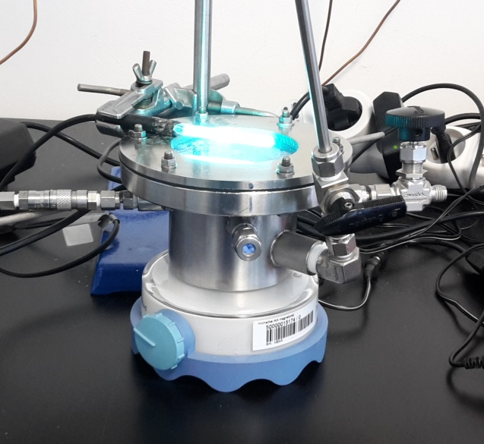
Figure S1: The batch reactor used for the photocatalytic reduction of CO₂ with a 254 nm pen-ray lamp.

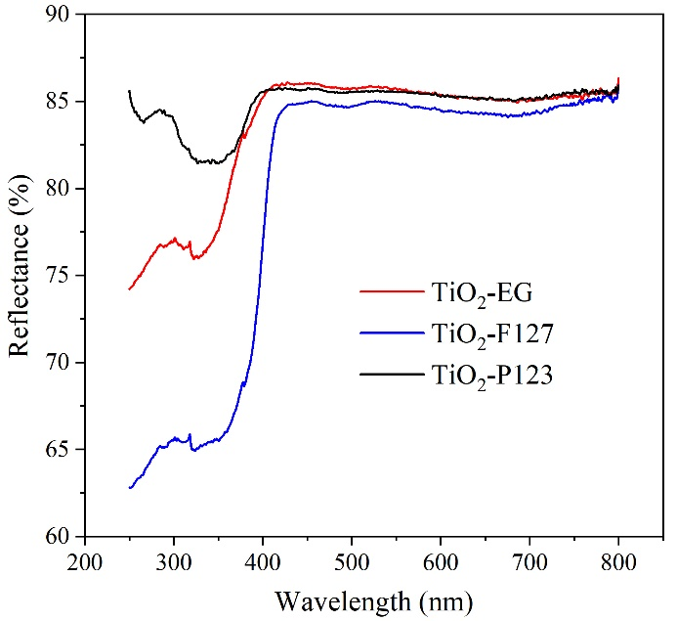
Figure S2: Reflectance spectra of investigated photocatalysts.

Calculation of apparent quantum yield:
Nomenclature
$A$ (m²) incident area
$c$ (m s⁻¹) speed of light
$d$ (m) light path
$E_{f}$ (J) energy of a photon quantum
$E_{S}$ (W) energy of the photon flux
$h$ (J s) Planck constant
$I_{0}$ (W m⁻²) incident light intensity
$N_{A}$ (mol⁻¹) Avogadro number
${\dot{n}}_{e}$ (mol s⁻¹) molar flux of electrons used for the formation of one mole
of product
${\dot{n}}_{f}$ (mol s⁻¹) molar flux of incident photons
${\dot{n}}_{P}$ (mol s⁻¹) molar flux of product
$z_{P}$ (-) number of electrons required for the formation of one product
molecule

Greek letters
$λ$ (m) wavelength
$Φ_{λ,A}$ (-) apparent quantum yield

The apparent quantum yield is finally determined:
$$Φ_{λ,A}=\frac{{\dot{n}}_{e}}{{\dot{n}}_{f}}=\frac{z_{P}{\dot{n}}_{P}}{{\dot{n}}_{f}}∙100$$
The molar flux of incident photons is given by:
${\dot{n}}_{f}=\frac{E_{S}}{E_{f}N_{A}}=\frac{I_{0}A}{E_{f}N_{A}}$

The energy of a photon quantum is calculated according to:
$$E_{f}=\frac{h c}{λ}$$

Table S1: Parameters for the calculation of the apparent quantum yields in the case of UVP lamp (λ = 254 nm)
UVP lamp (λ = 254 nm)
where I₀ is from measurement
h | 6.63 × 10⁻³⁴ J s
c | 3 × 10⁸ m s⁻¹
λ | 3.65 × 10⁻⁷ m
N_{A} | 6.02 × 10²³ mol⁻¹
A | 4.42 × 10⁻³ m²
I₀ | 6.38 W m⁻²
E_{S} | 28.203 × 10⁻³ W
$${\dot{n}}_{f}$$ | 8.55 × 10⁻⁸ mol s⁻¹
$${\dot{n}}_{P }$$ | 2.83 μmol/8 h = 9.826 × 10⁻¹¹ mol s⁻¹
z_{P} | 12
$$Φ_{λ,A}$$ | 1.38 %

Example of calculation for TiO₂-P123:
The energy of a photon quantum is calculated according to
$$E_{f}=\frac{h c}{λ}= \frac{6.63 {10}^{-34} 3.00 {10}^{8}}{3.65 {10}^{-7}} =5.44 {10}^{-19} J$$
The molar flux of incident photons is given by
${\dot{n}}_{f}=\frac{E_{S}}{E_{f}N_{A}}=\frac{I_{0}A}{E_{f}N_{A}}$ = $\frac{6.38 4.42 {10}^{-3}}{5.44 {10}^{-19} 6.02 { 10}^{23}}=8.55 { 10}^{-8} mol s^{-1}$

The apparent quantum yield is finally determined
$$Φ_{λ,A}=\frac{{\dot{n}}_{e}}{{\dot{n}}_{f}}=\frac{z_{P}{\dot{n}}_{P}}{{\dot{n}}_{f}}100= \frac{12 9.826 10^{-11} }{8.55 {10}^{-8} }∙100=1.38 \%$$

Table S2: Yields of products and apparent quantum yields after 8 hours of irradiation.
Sample | Yields  of CH₄  (μmol/g_{cat.}) | Yields  of CO  (μmol/g _{cat.}) | Yields  of H₂  (μmol/g _{cat.}) | Yields  of all products  (μmol/g _{cat.}) | $Φ_{λ,A}$  (%)
TiO₂-EG | 2.3 | 0.1 | 14.1 | 16.5 | 0.80
TiO₂-F127 | 4.4 | 0.2 | 22.2 | 26.8 | 1.31
TiO₂-P123 | 12.3 | 0.3 | 15.7 | 28.3 | 1.38

Supporting information references

[1] A.V. Naumkin, A. Kraut-Vass, S.W. Gaarenstroom, C.J. Powell, NIST X-ray Photoelectron Spectroscopy Database, National Institute of Standards and Technology, Gaithersburg MD, 2000.
[2] M.C. Biesinger, L.W.M. Lau, A.R. Gerson, R.S.C. Smart, Resolving surface chemical states in XPS analysis of first row transition metals, oxides and hydroxides: Sc, Ti, V, Cu and Zn, Appl. Surf. Sci., 257 (2010) 887-898.

