Electronic Supplementary Material for:

Experimental study and thermodynamic modelling of the temperature effect on the hydration of belite-ye’elimite-ferrite cements

Maruša Mrak^{1, 2}, Frank Winnefeld³, Barbara Lothenbach^{3,4}, Andraž Legat¹, Sabina Dolenec^{1,*}
¹ Slovenian National Building and Civil Engineering Institute, Dimičeva ulica 12, 1000 Ljubljana, Slovenia
² Jožef Stefan International Postgraduate School, Jamova cesta 39, 1000 Ljubljana, Slovenia
³ Empa, Swiss Laboratories for Materials Science and Technology, Überlandstrasse 129, 8600 Dübendorf, Switzerland
⁴ Norwegian University of Science and Technology (NTNU), Department of Structural Engineering, Trondheim, Norway
* Corresponding author. Tel.: +386 40 693 125. E-mail address: sabina.dolenec@zag.si

In the following Figures S1–S3, the data reported in this study are summarized, as they are already discussed in detail in the paper.

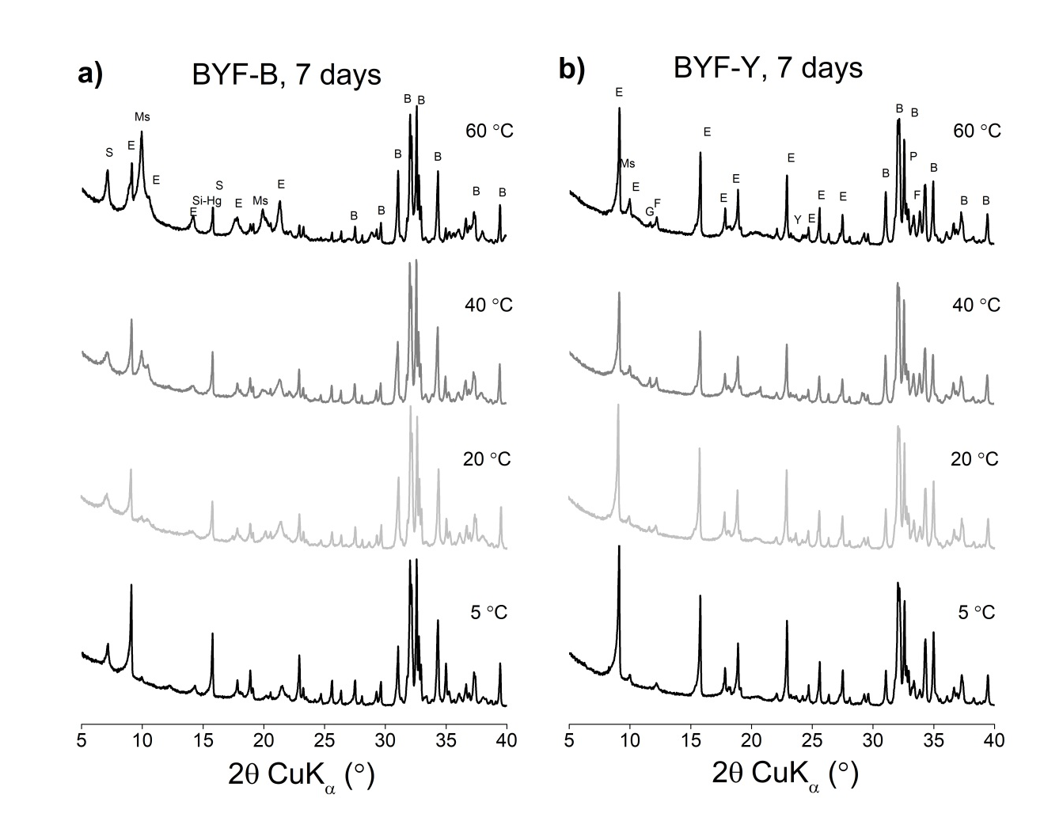
Fig. S1 X-ray diffraction patterns of cement mixtures BYF-B (a) and BYF-Y (b) at 7 days of hydration at different curing temperatures. B = belite, E = ettringite, F = ferrite, G = gypsum, Ms = monosulfate, P = perovskite, S = strätlingite, Si-Hg = siliceous hydrogarnet

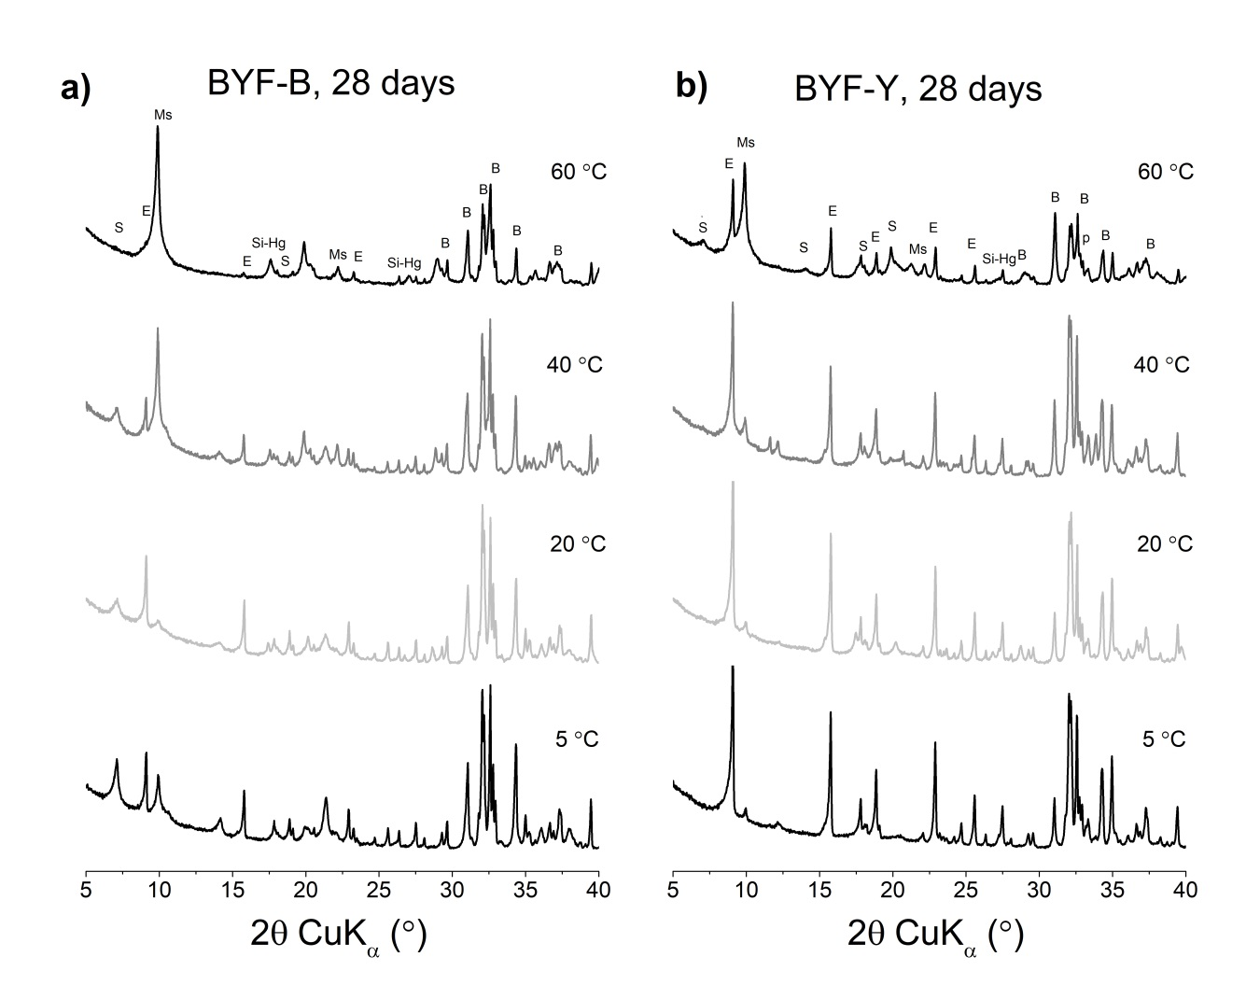
Fig. S2 X-ray diffraction patterns of cement mixtures BYF-B (a) and BYF-Y (b) at 28 days of hydration at different curing temperatures. B = belite, E = ettringite, Ms = monosulfate, P = perovskite, S = strätlingite, Si-Hg = siliceous hydrogarnet

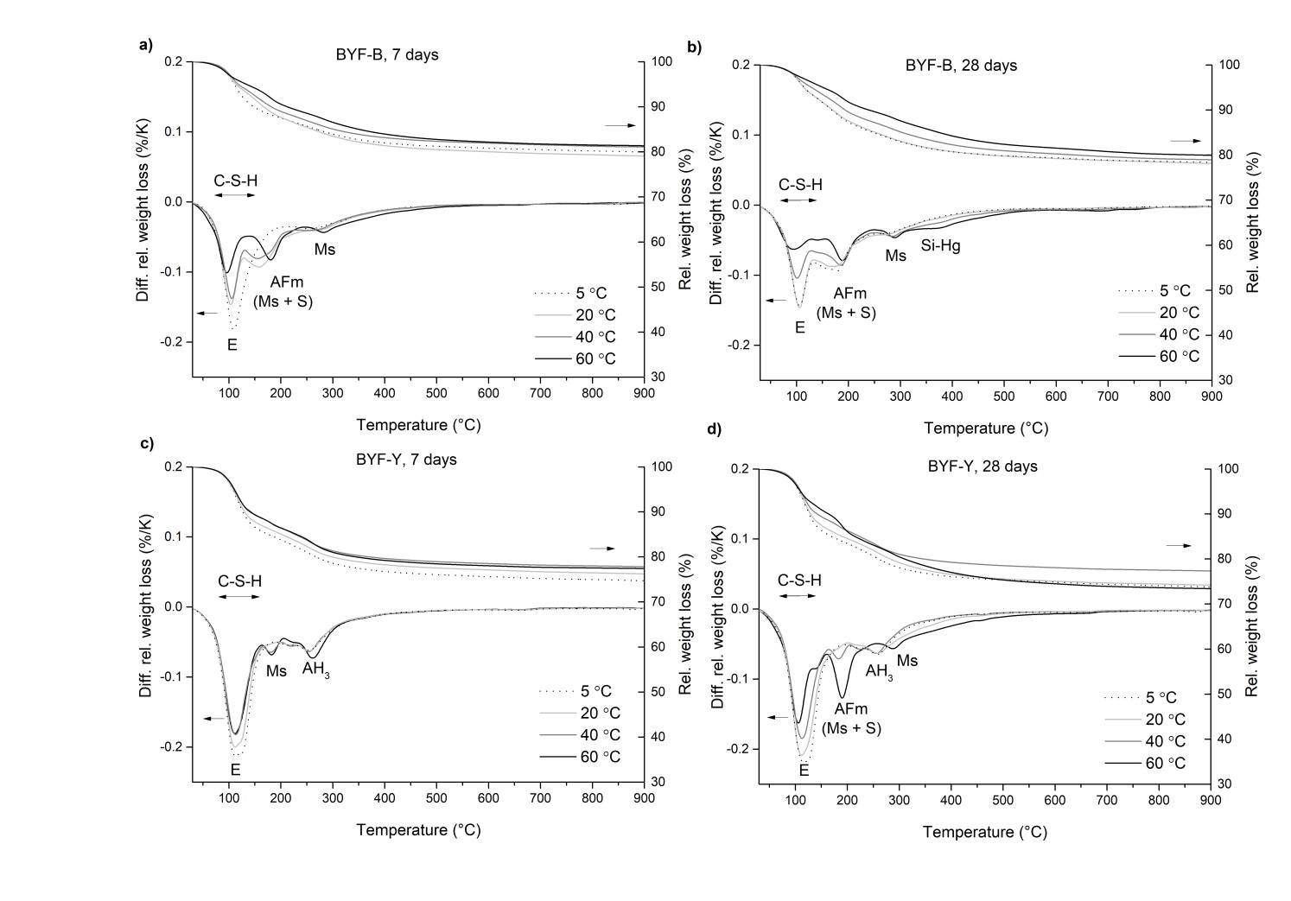
Fig. S3 Thermogravimetric analysis of cement paste BYF-B at 7 and 28 days (a and b) of hydration and cement paste BYF-Y at 7 and 28 days (c and d) of hydration. AH₃ = aluminium hydroxide, C-S-H = calcium silicate hydrate, E = ettringite, G = gypsum, Ms = monosulfate, S = strätlingite, Si-Hg = siliceous hydrogarnet

