Evolution of surface functional groups and aromatic ring degradation upon treatment of polystyrene with hydroxyl radicals

Alenka Vesel^{a*}, Rok Zaplotnikª, Gregor Primcª and Miran Mozetičª
ª Jozef Stefan Institute, Jamova cesta 39, 1000 Ljubljana, Slovenia. E-mail addresses: alenka.vesel@ijs.si, rok.zaplotnik@ijs.si, gregor.primc@ijs.si, miran.mozetic@ijs.si
* Corresponding author, e-mail address: alenka.vesel@guest.arnes.si

Abstract
The surface properties of hydrocarbon polymers are inadequate for numerous applications. Hence, they require alteration via functionalisation with desired functional groups. Hydroxyl groups are often preferred, since they enable appropriate polarity for the irreversible grafting of desired molecules. In this study, the surface kinetics resulting from the treatment of polystyrene with hydroxyl (OH) radicals from the gas phase was fundamentally investigated through a precisely-designed experiment. Polystyrene samples were exposed to various known fluences of OH radicals, and the evolution of surface functional groups versus the OH fluence was monitored using high-resolution X-ray photoelectron spectroscopy (XPS). The fluences of OH radicals varied between 1×10¹⁸ and 4×10²³ m⁻² in the process of finding a threshold fluence for the formation of specific groups. The surface concentration of carbonyl (C=O) groups could be measured using XPS at a fluence of approximately 5×10²⁰ m⁻². The C=O groups became measurable at a fluence of approximately 1.5×10²¹ m⁻², and carboxyl (COOH)/ester groups at approximately 4×10²¹ m⁻². As deduced from the XPS, a concentration of C=O groups at approximately 5% occurred before the degradation of the aromatic ring. The formation of other oxygen-functional groups required opening of the aromatic ring. The results have been explained using a two-step process, considering available theories vis-a-vis initial stages in the functionalisation of PS with polar functional groups.

Keywords: polystyrene, surface functionalisation kinetics, OH radicals, radicals fluence dependence, time evolution, XPS

1. Introduction
The surface properties of hydrocarbon polymers have been a subject of scientific interest for decades. Hydrocarbons consist of carbon and hydrogen atoms; so, any surface modification with functional groups containing other atoms is relatively easy to trace and evaluate. Experimenters especially prefer polystyrene (PS), because it has an aromatic ring that can be detected using surface-sensitive techniques like X-ray photoelectron spectroscopy (XPS). PS is a biocompatible polymer; so, it is often used in biomedical applications ^{[1-5]}. Another important application is in packaging, that is, food packaging materials ^{[6-9]}. Various methods could be used to perform surface modification of polymers, such as gamma irradiation ^{[10]}, ozone ^{[11]}, ion implantation ^{[12]}, laser radiation ^{[13]}, chemical agents ^{[14]} and gaseous plasma ^{[15]}. Non-equilibrium gaseous plasma is ecologically benign, and its use in research and industry is steadily increasing ^{[15]}. Plasmas sustained within different gases are used to functionalise the surface using the desired functional groups. For example, fluorine-containing plasma is applied when the desired surface finish is hydrophobisation ^{[16, 17]}; nitrogen or ammonia plasma is used for grafting amino groups onto the PS surface ^{[18-20]}; whereas the oxygen-containing plasmas are employed for hydrophilisation, that is, grafting with oxygen-containing functional groups ^{[21]}.
Numerous authors have used oxygen plasmas to hydrophilise PS samples ^{[15, 22-25]}. Oxygen plasma contains reactive species such as neutral atoms in the ground and metastable states, molecular metastables, and positively charged molecular ions. The evolution of surface functional groups should depend on reactive species’ doses (fluences), the polymer temperature, and other parameters. Low-pressure oxygen plasma is also a source of vacuum ultraviolet (VUV) radiation ^{[26, 27]}, which breaks bonds within the surface films of polymers and thus contributes to surface modifications ^{[28]}.
An excellent theoretical study on the surface kinetics of PS treatment using oxygen atoms in the ground state was conducted by Ventzek’s group ^{[29]}, whereas Kushner’s group offered a flawless theory vis-a-vis various functional groups formed on the PS surface upon treatment with atmospheric pressure plasma rich in oxygen (O) atoms and hydroxyl (OH) radicals ^{[30]}. While Ventzek’s group reported the formation of various functional groups on the PS surface, Kushner’s group reported the formation of only alcoholic groups. Kushner’s group also reported saturation of the oxygen concentration on the PS surface, when the O-atom fluences approached 10²¹ m⁻² ^{[30]}. Hori’s and Ventzek’s groups joined forces and performed experiments in a plasma reactor powered by an inductively-coupled radiofrequency (RF) generator to provide illustrations of the interaction kinetics ^{[31]}. The authors ^{[31]} reported the O-atom density in plasma to be as large as 1×10²¹ m⁻³, at a pressure of 5 Pa; however, the PS samples were placed in the flowing afterglow where the density should have been much lower. They reported the appearance of various functional groups, whose concentrations reached saturation point post treatment for half an hour. Unfortunately, it is impossible to quantify the fluence needed for surface saturation, because the authors did not report the O-atom flux onto the PS surface ^{[31]}. Nevertheless, the authors found carbon-carbon (C−C) bond scission necessary for the formation of C=O or O−C=O groups. Specifically, only OH (C−OH) groups would form on the PS surface without degrading the aromatic ring or breaking polymer chains, upon treatment with oxygen atoms, according to ^{[31]}.
An experimental study of surface kinetics, upon treatment of PS with neutral O atoms at low pressure and precisely controlled O-atom flux, was first reported by ^{[32]} and later elaborated on small fluencies ^{[33]}. Here, the authors clearly showed that the initial stage in surface functionalisation of PS was the substitution of hydrogen from carbon-hydrogen (C−H) groups with OH groups, whereas other functional groups appeared simultaneously with the degradation of the phenyl ring. The experimental results obtained by Vesel et al. correspond to the theory of Ventzek’s group ^{[29]}. The saturation with OH groups was observed after receiving the O-atom fluence of approximately 1×10²¹ m⁻², which is very similar to the one reported by Kushner’s group ^{[30]}. It seems that the O-atom fluence is the decisive parameter governing the kinetics of PS functionalisation. Apart from the above-mentioned publications, we did not find any other publication describing the evolution of surface functional groups on the PS surface versus the fluence of O atoms.
The above literature survey indicates a scarcity of experimental data and/or a relatively incomplete theoretical explanation of PS surface functionalisation with oxygen-containing functional groups. Even lesser knowledge is available regarding the interaction of OH radicals with the PS surface. Kushner’s group included the effect of OH radicals on the surface functionalisation of PS. They calculated the density of various radicals in plasma, sustained in a mixture of helium (98 vol.%), oxygen (2 vol.%) and water vapour (10 ppm) by an atmospheric pressure RF discharge ^{[30]}. The OH density was found to be approximately 10¹⁸ m⁻³, that is, over 100 times smaller than the O-atom density. Still, the contribution of the OH radicals to the surface functionalisation of PS was found to be significant, because the authors considered the reaction probability for OH radicals to be 2 or 3 orders of magnitude larger than for O atoms ^{[30]}. In their model, they took into account several assumptions, for example, negligible etching of the PS surface upon treatment with either OH or O radicals. This assumption does not correspond with another model proposed by Bruggeman’s group, who reported the etching probability for OH radicals to be as large as 0.01, that is, roughly 100 times larger than that for O atoms at similar conditions ^{[34]}. In another paper, the same group reported an etching rate as large as 0.02 ^{[35]}. Unfortunately, Bruggeman’s group did not report on the functionalisation of the PS surface ^{[34]}.
Kushner’s group reported a variety of surface reactions upon treatment of PS surface with both O and OH radicals ^{[30]}. According to their model, the first effect is the formation of a dangling bond on the PS surface:
O + R−H → OH + R (1) and
OH + R−H → H₂O + R (2).
Here, R is a PS radical. The dangling bond is then either occupied by another radical arriving from the gas phase or by cross-linkage. This model is different from Ventzek’s, who assumed the substitution of surface hydrogen (H) atoms with appropriate oxygen-containing radicals ^{[29]}. Kushner also provided a feasible explanation for preferential functionalisation with alcohol groups: scavenging of oxygen-rich functional groups by OH radicals arriving from the gas phase:
OH + R−OO → O₂ + R−OH. (3)
However, existing instruments for surface characterisation do not enable experimental verification of these proposed models.
The functionalisation of PS surface with polar oxygen-containing groups leads to increased hydrophilicity. Arinda et al. ^{[36]} treated thin PS films deposited on quartz crystals with oxygen plasma at a pressure of 40 Pa, sustained by an RF discharge operating at the frequency of 2 MHz. The reported discharge voltage was as low as 50 – 80 V and the treatment time was 120 s. A gradual decrease in the static water contact angle (WCA) was observed with an increase in discharge voltage, and an almost super-hydrophilic surface finish (WCA approximately 10°) was observed at a voltage of 80 V. No significant hydrophobic recovery was observed for plasma-treated samples stored in the air, but a significant increase in the WCA was observed post storage in water.
Islam et al. ^{[37]} treated thin PS films deposited on silicon substrates, with plasmas sustained in several gases mixed with argon via a symmetric, capacitively-coupled RF discharge operating at a power of 20 W. The samples were placed on the grounded electrode, and the vacuum flange served as the powered electrode. The plasma treatment time was 300 s and the samples were characterised using XPS. The oxygen concentration, as deduced from the XPS survey spectra, was as large as 45 at.% after treatment of the PS sample in oxygen plasma, and 35% post treatment with ammonia plasma. The WCA dropped to 17° and 37°, respectively. The plasma treatments were found useful for adhesion of gold nanoparticles.
The ionisation potential of OH radicals is higher than those of O atoms in the ground state. Hence, one may expect quicker saturation of the polymer surface with OH groups when OH radicals are used for the treatment of the PS samples. The kinetics of other oxygen-containing functional groups on the PS surface, upon treatment with OH radicals in the ground state, has never been tackled experimentally and formed the subject of this study.
The proposed hypothesis was that the surface interaction of OH radicals with PS would cause the subtraction of H atoms from the C−H bonds at low fluences of OH radicals, a saturation of the surface with densely distributed hydroxyl (−C−OH) groups at moderate fluences, and degradation of the phenyl ring at large fluences. The formation of other oxygen-containing functional groups excluding OH would be feasible only when there exist large fluences of OH radicals, because the probability for OH radicals to cause C−C or C=C bond scission on a virgin PS surface is minimal. The chain scission will only occur when the PS surface is already functionalised with hydroxyl groups.
2. Materials and methods
The surface kinetics post treatment of PS with OH radicals in the ground state and at room temperature of both gas and polymer was studied experimentally. The source of OH radicals was non-equilibrium gaseous plasma sustained in water vapour.
2.1. PS samples
Biaxially-oriented and additive-free PS foil with a thickness of 0.05 mm was purchased from Goodfellow Limited (Huntingdon, UK). Prior to the experiment, the foil was cut into small pieces of dimensions 8 mm × 8 mm. To avoid any contamination, the samples were vacuum packed, until they were placed in the experimental vacuum system.
2.2. Experimental system
An experimental system for precise dosing of OH radicals is shown schematically in Figure 1. The system was high-vacuum compatible, with all elements made of either stainless steel or borosilicate glass. Viton gaskets were used for combining vacuum elements. Non-equilibrium gaseous plasma was sustained in a glass discharge tube with an inner diameter of 36 mm and a length of 400 mm. A water-cooled coil was mounted onto the discharge tube and connected to a radio frequency (RF) generator, operating at a standard industrial frequency of 13.56 MHz and adjustable discharge power of up to 1,000 W (Cesar 1310, Advanced Energy, USA). A matching network was used (VarioMatch 1500 W-ICP, Advanced Energy, USA) to match the plasma impedance with the impedance of the RF generator. All experiments were performed using a low discharge power of 6 W. In this context, it must be noted that, a substantial dissociation fraction of molecules in electrodeless, inductively-coupled plasma, sustained in the E-mode, was found to be achievable at a low power absorbed by gaseous plasma ^{[38]}. The discharge tube was connected to the processing tube through a 70-mm long narrow tube with an inner diameter of 8 mm, as shown in Figure 1. The processing tube was made of borosilicate glass, with an inner diameter of 36 mm and a length of 340 mm. Samples were placed inside the processing tube, at a distance of 200 mm from the exhaust of the narrow tube, as shown in Figure 1. The processing tube was connected to metallic vacuum elements and pumped using a turbomolecular vacuum pump (HiPace300, Pfeiffer Vacuum, Germany), with a nominal pumping speed of 260 l/s for N₂ and nominal ultimate pressure below 10⁻⁵ Pa. The turbomolecular pump was backed by a two-stage rotary pump (Duo 5M, Pfeiffer Vacuum, Germany), with a nominal pumping speed of 5 m³/h and nominal ultimate pressure below 0.1 Pa. At the end of the processing tube, a Pirani/Bayard-Alpert pressure gauge (PBR 260, Pfeiffer Vacuum, Germany) was mounted, and an absolute capacitive pressure gauge (Baratron 722A, MKS Instruments, USA) was connected to the discharge tube as shown in Figure 1. The processing tube was also equipped with a catalytic probe (Plasmadis Ltd., Slovenia), whose tip was mounted at the position of the PS sample. The catalytic probe was calibrated for OH radicals, and its absolute accuracy was found to be approximately 30%, whereas its relative accuracy was 5% or better.
The discharge tube was also equipped with a dosing valve, which delivered water vapour into the discharge tube. The source of water vapour was a flask filled with Milli-Q water. The rotary pump was turned on in the absence of the polymer sample, and the dosing valve was fully open to evacuate the flask filled with water. The liquid water started boiling soon after evacuation of the flask, due to the vacuum conditions. The dosing valve was fully open for a few minutes during the boiling of water, to ensure removal of residual atmosphere from the flask. Next, the dosing valve was closed, so that the water-vapour saturated pressure was established within the flask filled with liquid water. When a polymer sample was placed in the processing tube, the dosing valve was kept partially open to ensure appropriate flow of water vapour from the flask to the discharge tube. The flow was low, so the water in the flask remained at room temperature regardless of evaporation during treatment of PS samples. Plasma in the discharge tube was characterised via optical emission spectroscopy (OES). We used the spectrometer Ava Spec 3648 (Avantes, the Netherlands), with a 0.5 nm resolution in the wavelength range from 200 to 1,100 nm. The spectrometer was previously calibrated for spectral response with AvaLight-DH-CAL (Avantes, the Netherlands).
The pumping speed of the vacuum pumps was much higher than the conductance of vacuum elements in Figure 1. As a result, pressure gradients appeared along the vacuum elements, including the processing tube and the narrow tube between the processing and discharge tubes. The pressure gradients caused a gas drift from higher to lower pressures, that is, from the dosing valve through the discharge and processing tubes towards the turbomolecular pump. Considering perfect vacuum tightness and negligible desorption of gases from the inner walls of the vacuum elements, the mass flow through the system was constant. Since mass flow was a product of volume flow and gas density (which, in turn, is proportional to the pressure at constant temperature), the gas pressure behaved semi-quantitatively, as shown in Figure 2. The exact quantification of the curve between the Pirani/Bayard-Alpert and absolute capacitive pressure gauges in Figure 2 is beyond the scope of this paper and difficult to evaluate because of the complex behaviour of vacuum elements’ conductivity for water vapour in the range of pressures involved.
2.3. Surface modification of PS with OH radicals
The experiments were performed as follows: a pristine PS sample was mounted in the processing tube at the position shown in Figure 1. The system was evacuated down to the ultimate pressure, which was below 1 Pa at the position of the absolute capacitive pressure gauge (marked as “baratron” in Figure 1), and below 0.02 Pa at the position of the Bayard-Alpert gauge. After achieving these pressures, the dosing valve was opened and adjusted to the conductance that enabled a pressure of 2.5 Pa at the position of the baratron gauge and 0.07 Pa at the position of the Bayard-Alpert gauge. The pressures are indicated in Figure 2. The plasma was sustained for a fixed time period, and the polymer sample was subjected to the flux of OH radicals. Post completion of treatment time, the plasma was turned off, the dosing valve was closed, the system was vented, and the sample was transferred to the on-site XPS instrument for characterisation. This procedure was repeated for new and pristine PS samples for different treatment times, until the treatment time was long enough to observe the saturation of the polymer surface with oxygen-containing functional groups.
2.4. XPS characterisation
The surface chemical composition and evolution of specific functional groups on the samples’ surfaces was characterised using an XPS instrument (TFA XPS from Physical Electronics, Munich, Germany). As mentioned before, to avoid the ageing of treated samples and possible contamination, only one sample was treated using OH radicals under selected conditions and then immediately transferred to XPS. Post characterisation, another sample was treated under varying conditions and characterised. The samples were excited with monochromatic Al Kα_{1,2} radiation at 1,486.6 eV, over an area of 400 µm². The base pressure in the XPS chamber was approximately 6 × 10⁻⁸ Pa. Photoelectrons were detected using a hemispherical analyser at a take-off angle of 45° with respect to the normal of the sample surface. XPS survey spectra were measured at a pass energy of 187 eV, using an energy step of 0.4 eV. High-resolution XPS spectra of carbon C1s were measured at a pass energy of 29.35 eV, using an energy step of 0.125 eV. An additional electron source was used for surface charge neutralisation. The main peak in the C1s spectrum corresponding to the C−C/C−H bonds was set to the binding energy of 284.8 eV.
The measured XPS spectra were analysed using CasaXPS software (supplied by Casa Software Limited, Devon, PA, USA). The C1s spectra were fitted with the Gauss-Lorentzian functions. Briggs-Grant-Tougaard background subtraction was used for the proper inclusion of the shake-up satellite π*-π. All other models for the background subtraction (including Tougaard Universal Polymer background) failed due to detachment of a part of the shake-up peak. The widths and positions of the peaks were fixed during the fitting procedure. The peak fitting was performed after considering the peculiarities of the C1s peak of PS, which could be subjected to appearance of some peak asymmetry due to the vibrational fine structure and chemical shift difference between aliphatic and aromatic carbon, as explained in ^{[39]}. This was also observed in our case for the untreated sample, because the peak was not fully symmetric. Therefore, the C1s peak of the untreated sample or C−C/C−H was fitted with two peaks, with a ratio of 6:2 corresponding to aromatic and aliphatic carbon at 284.8 eV and 285.1 eV ^{[39]}. In case of oxidised PS samples, other subpeaks were included, corresponding to various carbon-oxygen functionalities: C−O, C=O, O=C−O and O−CO−O, appearing at approximately 286.1, 287.3, 288.6 and 289.6 eV, respectively (±0.1 eV), and the satellite peak appearing at 291.6 eV. The width of the peaks was fixed between 1.1–1.3 eV.
2.5. Atomic force microscopy characterisation
The samples were characterised using atomic force microscopy (AFM). The A100-AFM microscope (A.P.E. Research, Trieste, Italy) was used to characterise the topology of the plasma-treated samples. All measurements were performed in a tapping mode using NT-MDT silicon tips, with a recording frequency of 1 Hz. The surface roughness was calculated based on AFM images taken over an area of 20×20, 10×10, 5×5 and 2×2 μm². Surface roughness was expressed in terms of average roughness (Ra).
2.6. Wettability
Post plasma treatment, some samples were also probed for wettability. We used an the DSA100 instrument from Kruss GmbH (Hamburg, Germany). We deposited a liquid droplet with a volume of 1 μL. MiliQ water. The water contact angle (WCA) was measured simultaneously using a sessile drop method. Five droplets were deposited for each of the treatment conditions.
3. Results
3.1. Characterisation of water-vapour plasma
Figure 3 shows the OES spectrum of plasma sustained in water vapour. The dominant spectral features are Balmer-series hydrogen atom emission lines (H_{α} and H_{β} at 656 and 486 nm, respectively). The intensity of the OH transition at a bandhead of 309 nm is weaker, but the integral emission (considering the broadness of this spectral feature) is superior to the integral emission from the hydrogen atoms. The intensive integral emission from the OH radicals is explained by the fact that the excitation level of the OH radicals is at much lower energy than the levels from which the Balmer series radiate. The rich radiation from both OH radicals and H atoms indicates the extensive dissociation of water molecules to OH radicals and H atoms. The OH radicals were partially dissociated to O and H atoms upon plasma conditions, which explains the presence of weak O atom lines (at 777 and 845 nm), in the spectrum shown in Figure 3. The water vapour, therefore, effectively dissociates to form OH radicals upon plasma conditions. Due to the pressure gradients (Figure 2), the OH radicals (together with H atoms and some O atoms) formed in the discharge tube, drift to the processing chamber, where they are readily available for any chemical interaction with PS samples. Any other reactive plasma species, such as charged particles, do not survive on the way from the plasma to the position of the PS sample, because their lifetime is much lower than the lifetime of neutral radicals. The reason for this is the neutralisation of charged particles on plasma-facing surfaces. Also, any radiation from plasma could not influence the polymer surface kinetics, because the polymer samples were placed in the shaded part of the processing tube, as shown in Figure 1.
OES is a quantitative technique for plasma characterisation, because the spectra only reveal radiation intensity and not the radicals’ density in the ground state. Simultaneously, along with plasma characterisation through OES (Figure 3), the density of radicals was also measured using a catalytic probe inserted into the processing chamber. A detailed description of the catalytic probe and measurement principle can be found in ^{[40]}. The probe tip was always placed at the position of the sample, as shown in Figure 1. The density of OH radicals was found to be (7.0 ± 0.5)×10¹⁷ m⁻³. Once the density is known, the flux of OH radicals on the sample surface can be calculated using the standard equation:
j = ¼ n <v>, (4)
where j is the flux, n is the density of OH radicals as determined using the catalytic probe, and <v> is the average thermal velocity of OH radicals. At s temperature of 300 K, the <v> was found to be 610 m/s. The fluence ($Φ$) of radicals impinging on PS samples is simply a product of the flux and the treatment time:
$Φ=j∙t$, (5)
because the OH density in the processing tube remained constant at (7.0 ± 0.5)×10¹⁷ m⁻³ throughout the treatment of PS samples.
3.2. Characterisation of PS surfaces treated using various OH fluences
The influence of the OH radicals on the functionalisation kinetics of PS samples was investigated using XPS. Figure 4 shows the XPS survey spectrum of the untreated PS sample; it reveals the presence of carbon atoms only and indicates a high purity surface.
Oxygen, which was absent on the surface of an untreated PS, was observed after exposing the PS to OH radicals from plasma. The evolution of oxygen concentration, as determined from the XPS survey spectra versus the treatment time, is shown in Figure 5. In addition, Figure 5 also shows surface oxygen concentration versus the fluence of OH radicals (top axis). At low OH fluences, that is, below approximately 1×10²⁰ m⁻², some oxygen (approximately 1 at.%) is detected on the PS surface. However, no observable changes were observed in carbon C1s spectra (or these changes were below the XPS sensitivity), as shown in Figure 6. When the OH fluence exceeded 4×10²⁰ OH radicals per m⁻², the oxygen concentration became clearly detectable and began to increase with increasing fluence. At the highest OH fluence, there was still no indication of surface saturation with oxygen, which would be reflected in the change of the slope of the curve. As the highest OH fluence corresponded to the treatment time of one hour, further increase in treatment time was not considered rational.
Figure 5 reveals surface oxidation, but it does not provide much information about surface kinetics. To get an insight into the formation of various functional groups, high-resolution C1s XPS spectra were examined. The evolution of C1s spectra with treatment time and OH fluence is shown in Figure 7. The first signs of a change in the shape of the spectra begin to appear at an OH fluence of 6×10²⁰ m⁻², as further shown in Figure 8.
C1s spectra were fitted with several subpeaks corresponding to different functional groups, in order to reveal the initial kinetics of functionalisation with OH radicals. The results are presented in Figure 9 for the broad range of OH fluences, and in Figure 10 for the most interesting range, that is, between 1×10²⁰ and 1×10²² m⁻³.
3.3. Surface morphology
The surface morphology was deduced from AFM imaging. We acquired the AFM images of several spots in both untreated and treated samples. There were some variations in the calculated roughness, but the average roughness R_{a} remained within the range of 3.0 ± 1.5 nm. Figure 11 shows typical AFM images on a 5×5 µm² area for the untreated PS sample, for the sample after receiving the intermediate OH fluence of 1×10²² m⁻² , and for the sample after receiving the highest OH fluence of 3.6×10²³ m⁻². Despite such a high OH fluence, no noticeable changes in the surface morphology were detected for this sample, in comparison to the untreated one.
4. Discussion
The results of the polymer functionalisation versus the fluence of OH radicals reveal the surface kinetics post treatment, which is worth discussing. The first impression one gets after examining Figures 9 and 10 is a predominant functionalisation with −C−O functional groups (or OH), but it could also be ether groups as it is difficult to distinguish among these groups when using XPS as the probing technique. The concentration of OH groups is always larger than the concentration of any other functional groups, even for fluences above 10²³ m⁻³ where etching is supposed to be significant ^{[41]}.
When the OH fluence was below approximately 4×10²⁰, the concentration of any oxygen-functional groups fell below the detection limit of the XPS (Figure 8). Further, the intensity of the satellite peak (characteristic of the aromatic ring) also remained intact. Following such fluence, the curve on the high-binding energy side of the main C1s peak rose, thereby indicating the initiation of changes in the chemical environment of carbon atoms (Figure 8). This modification is related to appearance of C−OH groups. The number of OH groups soon stabilised at approximately 5 at.%, and then remained constant within a range of fluences between 6×10²⁰ m⁻² and 1.5×10²¹ m⁻², as evident from Figure 10. The aromatic ring was found to be practically intact at this range of fluences. This observation is in very good agreement with the theoretical predictions of Kushner’s group ^{[30]}, who actually observed PS surface saturation after achieving a fluence of approximately 5×10²⁰ m⁻² while modelling the interaction of O and OH radicals with pristine PS. Polito et al. ^{[30]} reported a factor of two larger concentration of oxygen on the PS surface; however, this discrepancy is explained by peculiarities of the XPS technique. It is worth stressing that the XPS, though one of the most surface-sensitive techniques for polymer characterisation, has a finite depth-resolution. As a rule of thumb, one monolayer of foreign atoms on a pristine material corresponds to approximately 5–10 at.% of the concentration, as revealed by XPS at standard conditions used in our experiments ^{[24]}. The saturation with C−OH groups in the range of fluences between 6×10²⁰ m⁻² and 1.5×10²¹ m⁻² is also in agreement with Ventzek’s theory ^{[29]}, which reported the adsorption energy of O atoms being as large as −2 eV/nm for pristine (not functionalised) PS. The OH radicals probably interacted with the PS surface, causing the subtraction of the H atom, and thus forming a dangling bond on the polymer surface and a water molecule desorbed in vacuum conditions. This reaction can be presented as follows:
OH + R−H → H₂O + R− (6),
according to Kushner’s model ^{[30]}. The dangling bond was almost immediately occupied by another OH radical, which formed a C−OH functional group on the PS surface, that is,
R− + OH → R−OH. (7)
The substitution of the C−H bond on the aromatic ring with the C−OH bond was probably not a single-step reaction. Such a substitution:
OH + R−H → H + R−OH (8)
would release an H atom, which is not feasible at room temperature, because of the rather large binding energy of H atoms on C atoms in the aromatic structure. It should be stressed that the aromatic ring remained practically intact up to an OH fluence of 2×10²¹ m⁻² (Figures 9 and 10). Hence, no breakage of the C−C or C=C bonds in the phenyl ring occurred at low OH fluences.
The measurable degradation of the aromatic ring after receiving OH fluences above 2×10²¹ m⁻² is depicted in Figures 9 and 10. This degradation was accompanied by an abrupt increase in the concentration of OH bonds. The moderate fluence of the OH radicals caused a noticeable opening of the aromatic ring and an occupation of the dangling bonds by OH radicals.
At larger OH fluences above 2×10²¹ m⁻², the concentration of OH groups kept increasing with increasing fluence, and other functional groups begin to appear upon treatment with OH radicals (Figures 9 and 10). As mentioned earlier, a monolayer of a certain functional group, as detected by XPS at standard conditions on a perfectly smooth polymer, corresponds to approximately 5–10 at.%. The concentration of OH groups in Figure 9 is double, which is explained by the increased specific surface area due to polymer etching at large OH fluences. Etching provides nanostructured surfaces and thus, a rich morphology, so that the real surface is much larger than the geometrical ^{[34, 42]}. This is a feasible explanation for the observation of a large concentration of oxygen-containing groups at large OH fluences.
While the etching probability reported for PS upon treatment with OH radicals was rather large at roughly 0.01, it is only approximately 10⁻⁴ upon treatment with O atoms ^{[34]}. These values were measured at atmospheric pressure, when the plasma was sustained in argon with an admixture of oxygen or water vapour of approximately 1 vol.%. The values may be lower at low-pressure conditions, especially because we placed polymer samples far from the plasma source, so any synergies with other plasma species (charged particles, metastables, radiation) are negligible. Vesel et al. ^{[41]} reported the etching probability for O atoms interacting with polyethylene terephthalate. In a carefully designed experiment, the authors measured the mass of a polymer film with a quartz crystal microbalance and reported the probability of 1.4×10⁻⁶. This value is roughly 100 times lower than that reported in ^{[34]} for the RF-driven plasma jet sustained in argon with an admixture of reactive gases. This discrepancy is yet to be explained. In any case, etching causes the breaking of bonds between C atoms, thus releasing carbon monoxide (CO) and/or carbon dioxide (CO₂) molecules, and thereby contributing to the richness in surface morphology and increase in surface roughness ^{[25]}.
The proposed interaction between OH radicals and the PS surface is illustrated in a simplified manner in Figure 12. At a fluence of up to a few 10²⁰ m⁻² [Figure 12 (a)], samples treated with OH radicals do not exhibit a measurable number of OH groups. Such a small fluence is therefore insufficient for the functionalisation of PS with oxygen-containing functional groups. The aromatic ring was still intact post treatment at this fluence. At a fluence of approximately 2×10²¹ m⁻², the aromatic ring was partially functionalised with OH groups, as shown in Figure 12 (b), but the ring was not degraded. At a fluence above 2×10²¹ m⁻², the aromatic ring started opening, thus providing more binding sites. A measurable number of C=O groups appeared on the PS samples, as illustrated in Figure 12 (c). The concentration of C=O groups increased steeply with the rising fluence of OH radicals, and it finally stabilised at approximately 9% after receiving a fluence of 1×10²² m⁻² (Figure 9). A concentration of COOH and/or ester groups (O=C−O) at 3% was observed after receiving an OH fluence of approximately 1×10²² m⁻² (Figures 9 and 10). The concentration of these groups saturated at roughly 4% at large OH fluences. The functionalisation at a fluence of 2×10²² m⁻² is illustrated in Figure 12 (d).
Measurable quantities of carbonate (CO₃) groups were detected at a fluence of approximately 3×10²² m⁻² (Figures 9 and 10). The concentration of CO₃ groups kept increasing, even for the largest fluence probed in these experiments: 4×10²³ m⁻².
The persistence of the satellite peak in the high-resolution C1s spectra was evident for all OH fluences, despite extensive etching occurring at large fluences ^{[34]}. The measurable quantity of the aromatic component is explained by the poor migration of oxygen groups into the subsurface film of thickness, as reported following XPS under standard conditions. If the OH radicals or O-containing functional groups had migrated into the surface film with over approximately 10 nm thickness, the satellite peak would have disappeared completely from the high-resolution XPS C1s spectra.
Incorporation of O-containing functional groups into the polymer surface also strongly influences the wettability of the polymer material. Therefore, we also measured the wettability versus the OH fluence. The result of the measured water contact angle is shown in Fig. 13. This figure is in perfect agreement with Figure 5 and follows a similar trend. As soon as it was noticed that the oxygen concentration had started rising (Figure 5), the water contact angle in Figure 13 started decreasing from its initial value of 88° to less than 10°. The surface thus became almost superhydrophilic.
Finally, it is worth emphasising that the PS samples were kept close to room temperature during treatment with the OH radicals. Heating of polymer samples upon interaction with molecular radicals such as OH, O and H was a consequence of the heterogeneous surface recombination of radicals into parent molecules. The recombination coefficients were reported by Zaplotnik et al. ^{[43]} and were approximately 2×10⁻³ for PS. The heating power per surface area was as follows:
$\frac{P}{S}=j∙W_{o}∙γ$, (9)
where j refers to the flux of radicals on the polymer surface, W₀ is the energy dissipated on the polymer surface due to association between a radical and parent molecule, and γ is the probability for surface association, that is, the number of radicals associated on the surface divided with the total number of radicals impinging the surface in a unit time. Considering the numerical values, that is, j = 10²⁰ m⁻²s⁻¹, W₀ = 5×10⁻¹⁹ J and γ = 2×10⁻³, the heating power per surface area was found to be P/S = 1×10⁻¹ Wm⁻². This value is marginal.
The dissipated power, as calculated based on equation (9), is expected to cause increasing polymer temperature at the rate of
$\frac{dT}{dt}=\frac{P/S}{ρ∙d∙c_{p}}$. (10)
Here, ρ is the polymer density, d is the thickness of the polymer foil, and c_{p} is the PS heat capacity. The numerical values are P/S = 1×10⁻¹ Wm⁻², ρ = 10³ kgm⁻³, d = 5×10⁻⁵ m and c_{p} = 1.4×10³ J/kg K. Neglecting cooling due to thermal conductivity of water vapour, the samples heat up at a rate of dT/dt = 1.5×10⁻³ K/s. The heating due to surface association of radicals, is therefore, marginal.
Equations (9) and (10) could be also used for estimation of heating, due to the etching of the polymer sample upon exposure to OH (or any other) radical, provided the etching probability is known. In equation (9), the W₀ should be replaced with the value of the energy released upon oxidation with an impinging radical, and γ is the etching probability. As already mentioned, Bruggeman’s group studied the etching of PS upon treatment with atmospheric pressure plasma and reported an etching probability of approximately 10⁻² ^{[34]}. This value is definitely smaller in the afterglow, wherein synergy with ions and radiation is absent. Unfortunately, the etching probability for PS is yet to be measured. However, as with the polymer named polyethylene terephthalate, the etching probability upon treatment with O atoms in the absence of ions and radiation should be approximately two orders of magnitude lower in the afterglow than in glowing plasma ^{[41, 44]}. Still, the over-estimated heating rate using the probability γ = 10⁻² would be approximately five times larger than heating due to surface association of radicals, that is, dT/dt = 1.5×10⁻³ K/s. The real value is probably at least an order of magnitude smaller, but cannot be calculated because of the unknown etching coefficient in the afterglow.
5. Conclusions
The carefully-designed experiments in this study enabled the determination of the surface kinetics upon treatment of PS with OH radicals. The OH radicals were found to be less reactive than the O atoms, whose kinetics has been discussed in previous studies. The surface functionalisation upon treatment with OH radicals became measurable using XPS, only after receiving fluences of 5×10²⁰ OH radicals per m². The concentration of OH groups, as determined via XPS, was approximately 5% at such a low fluence. A two-stage process was suggested to explain the experimental observations. In the first stage, an impinging OH radical interacted with an H atom, which was bonded to carbon to form a water molecule and a dangling bond on a C atom in the aromatic ring. The probability for this reaction is rather low, definitely much lower than the probability of substituting the C−H bond on the aromatic ring with an OH group when treated with O atoms. In the next step, the dangling bond was occupied with an OH radical from the gas phase, thus forming the OH group. More significant concentrations of OH groups simultaneously appeared on the PS surface with the opening of the aromatic ring. The aromatic rings within the PS surface layer, with a thickness equal to the probing depth of XPS, were significantly (but not fully) opened after receiving an OH radical fluence of approximately 5×10²¹ m⁻². At this fluence, the C=O groups appeared on the PS surface. Other oxygen-containing functional groups appeared at larger fluences of OH radicals. The concentration of COOH groups became measurable at the fluence of just above 10²¹ m⁻³, whereas a significant concentration of the CO3 group appeared only after a fluence of several 10²² m⁻². At such large fluences, the polymer was etched because of treatment with OH radicals. The atomic oxygen-to-carbon (O/C) ratio value reached approximately 0.35 at the largest fluence of OH radicals used in this study, that is, 4×10²³ OH radicals per m² of the geometrical area.

Credit and authorship contribution statement
Conceptualisation: A.V. and M.M; Investigation: R.Z. and G.P; Methodology: M.M.; Formal analysis: R.Z. and A.V.; Writing – original draft: A.V.; Visualisation: G.P.; Methodology: M.M. and R.Z.; Supervision M.M.; Writing – review and editing: M.M and A.V.; Funding acquisition: M.M.

Declaration of competing interests
The authors declare that they have no known competing financial interests or personal relationships that could have influenced the work reported in this paper.

Data availability
The data will be made available on request.

Acknowledgements
This work was supported by the Slovenian Research Agency Core Funding (P2-0082 Thin-film structures and plasma surface engineering), the Research Project (L2-2616 “Selected area functionalisation of polymeric components by gaseous plasma”), and the research infrastructure of the Centre for Characterisation of Surfaces and Nanoparticles.

References
[1] S. Mattioli, S. Martino, F. D'Angelo, C. Emiliani, J.M. Kenny, I. Armentano, J. Appl. Polym. Sci. 2014, 131. https://doi.org/10.1002/app.40427
[2] Q.-N. Xu, H.-L. Wang, X.-F. Zhou, J.-P. Liang, H. Yuan, Y. Xu, D.-Z. Yang, Sep. Purif. Technol. 2022, 301, 121829. https://doi.org/10.1016/j.seppur.2022.121829
[3] W.-K. Lee, C.J. Engel, M.D. Huntington, J. Hu, T.W. Odom, Nano Lett. 2015, 15, 5624. 10.1021/acs.nanolett.5b02394
[4] K.J. Cha, M.-H. Na, H.W. Kim, D.S. Kim, J. Micromech. Microeng. 2014, 24, 055002. https://dx.doi.org/10.1088/0960-1317/24/5/055002
[5] H. Rosado-Galindo, M. Domenech, Stem. Cell Res. Ther. 2023, 14, 208. https://dx.doi.org/10.1186/s13287-023-03450-0
[6] R. Abhijith, A. Ashok, C.R. Rejeesh, Mater. Today: Proc. 2018, 5, 2139. https://doi.org/10.1016/j.matpr.2017.09.211
[7] Z. Pilevar, A. Bahrami, S. Beikzadeh, H. Hosseini, S.M. Jafari, Trends Food Sci. Technol. 2019, 91, 248. https://doi.org/10.1016/j.tifs.2019.07.020
[8] V. Guazzotti, V. Hendrich, A. Gruner, D. Fiedler, A. Störmer, F. Welle, Foods 2022, 11. https://doi.org/10.3390/foods11142120
[9] F. Welle, Recycling 2023, 8, 26. https://doi.org/10.3390/recycling8010026
[10] E.C. Onyiriuka, L.S. Hersh, W. Hertl, Appl. Spectrosc. 1990, 44, 808. https://dx.doi.org/10.1366/0003702904086975
[11] R. Yang, Q. He, C. Wang, S. Sun, Ferroelectrics 2018, 530, 130. https://doi.org/10.1080/00150193.2018.1453200
[12] C.H. Jung, H.J. Kwon, D.K. Kim, Y.M. Lim, H.K. Kim, Y.C. Nho, J.H. Choi, J. Korean Phys. Soc. 2008, 52, 884. https://dx.doi.org/10.3938/jkps.52.884
[13] P. Rytlewski, M. Żenkiewicz, Appl. Surf. Sci. 2009, 256, 857. https://doi.org/10.1016/j.apsusc.2009.08.075
[14] V.D. Dolzhikova, Y.G. Bogdanova, V.G. Sergeyev, Russ. Chem. Bull. 2023, 72, 1396. https://dx.doi.org/10.1007/s11172-023-3914-y
[15] S. Guruvenket, G.M. Rao, M. Komath, A.M. Raichur, Appl. Surf. Sci. 2004, 236, 278. https://doi.org/10.1016/j.apsusc.2004.04.033
[16] K. Matsubara, M. Danno, M. Inoue, H. Nishizawa, Y. Honda, T. Abe, Surf. Coat. Technol. 2013, 236, 269. https://doi.org/10.1016/j.surfcoat.2013.09.058
[17] M. Minařík, E. Wrzecionko, A. Minařík, O. Grulich, P. Smolka, L. Musilová, I. Junkar, G. Primc, B. Ptošková, M. Mozetič, A. Mráček, Coatings 2019, 9, 201. https://doi.org/10.3390/coatings9030201
[18] A. Boulares-Pender, A. Prager-Duschke, C. Elsner, M.R. Buchmeiser, J. Appl. Polym. Sci. 2009, 112, 2701. https://doi.org/10.1002/app.29849
[19] B. Finke, K. Schröder, A. Ohl, Plasma Process. Polym. 2008, 5, 386. https://doi.org/10.1002/ppap.200700134
[20] C. Kleinhans, J. Barz, S. Wurster, M. Willig, C. Oehr, M. Müller, H. Walles, T. Hirth, P.J. Kluger, Biotechnol. J. 2013, 8, 327. https://doi.org/10.1002/biot.201200210
[21] Y.T. Lau, O.H. Chin, H.C. Lee, W.S. Chiu, H.J. Woo, Appl. Surf. Sci. 2022, 578, 151963. https://doi.org/10.1016/j.apsusc.2021.151963
[22] F. Clément, B. Held, N. Soulem, H. Martinez, Eur. Phys. J. Appl. Phys. 2003, 21, 59. https://doi.org/10.1051/epjap:2002102
[23] R. Günther, W.R. Caseri, C. Brändli, J. Appl. Polym. Sci. 2022, 139, 51753. https://doi.org/10.1002/app.51753
[24] M. Haïdopoulos, M. Horgnies, F. Mirabella, J.-J. Pireaux, Plasma Process. Polym. 2008, 5, 67. https://doi.org/10.1002/ppap.200700067
[25] A. Vesel, Surf. Coat. Technol. 2010, 205, 490. https://doi.org/10.1016/j.surfcoat.2010.07.016
[26] E.J. Iglesias, F. Mitschker, M. Fiebrandt, N. Bibinov, P. Awakowicz, Meas. Sci. Technol. 2017, 28, 085501. https://dx.doi.org/10.1088/1361-6501/aa7816
[27] J. Lee, D.B. Graves, J. Phys. D: Appl. Phys. 2011, 44, 325203. https://dx.doi.org/10.1088/0022-3727/44/32/325203
[28] M. Dhayal, M.R. Alexander, J.W. Bradley, Appl. Surf. Sci. 2006, 252, 7957. https://doi.org/10.1016/j.apsusc.2005.10.005
[29] R.C. Longo, A. Ranjan, P.L.G. Ventzek, ACS Appl. Nano Mater. 2020, 3, 5189. https://dx.doi.org/10.1021/acsanm.0c00618
[30] J. Polito, M. Denning, R. Stewart, D. Frost, M.J. Kushner, J. Vac. Sci. Technol. 2022, 40. https://dx.doi.org/10.1116/6.0001850
[31] Y. Fukunaga, R.C. Longo, P.L.G. Ventzek, B. Lane, A. Ranjan, G.S. Hwang, G. Hartmann, T. Tsutsumi, K. Ishikawa, H. Kondo, M. Sekine, M. Hori, J. Appl. Phys. 2020, 127. https://doi.org/10.1063/1.5127863
[32] A. Vesel, R. Zaplotnik, J. Kovac, M. Mozetic, Plasma Sources Sci. Technol. 2018, 27, 094005. https://dx.doi.org/10.1088/1361-6595/aad486
[33] A. Vesel, R. Zaplotnik, M. Mozetič, G. Primc, Appl. Surf. Sci. 2021, 561, 150058. https://doi.org/10.1016/j.apsusc.2021.150058
[34] V.S.S.K. Kondeti, Y. Zheng, P. Luan, G.S. Oehrlein, P.J. Bruggeman, J. Vac. Sci. Technol. 2020, 38. https://dx.doi.org/10.1116/6.0000123
[35] P. Luan, V.S.S.K. Kondeti, A.J. Knoll, P.J. Bruggeman, G.S. Oehrlein, J. Vac. Sci. Technol. 2019, 37. https://dx.doi.org/10.1116/1.5092272
[36] P. Surya Arinda, D. Joseph Djoko Herry Santjojo, M. Masruroh, S. Purnomo Sakti, Mater. Today: Proc. 2019, 13, 24. https://doi.org/10.1016/j.matpr.2019.03.181
[37] M. Islam, Z. Matouk, N. Ouldhamadouche, J.-J. Pireaux, A. Achour, Plasma 2023, 6, 322.
[38] R. Zaplotnik, A. Vesel, M. Mozetic, EPL 2011, 95, 55001. https://dx.doi.org/10.1209/0295-5075/95/55001
[39] G. Beamson, D.T. Clark, J. Kendrick, D. Briggs, J. Electron Spectrosc. Relat. Phenom. 1991, 57, 79. https://doi.org/10.1016/0368-2048(91)85015-L
[40] I. Šorli, R. Ročak, J. Vac. Sci. Technol. 2000, 18, 338. https://dx.doi.org/10.1116/1.582189
[41] A. Vesel, M. Kolar, A. Doliska, K. Stana-Kleinschek, M. Mozetic, Surf. Interface Anal. 2012, 44, 1565. https://doi.org/10.1002/sia.5064
[42] E. Gogolides, M. Vlachopoulou, K. Tsougeni, N. Vourdas, A. Tserepi, Int. J. Nanomanufacturing 2010, 6, 152. https://dx.doi.org/10.1504/IJNM.2010.03478
[43] R. Zaplotnik, A. Vesel, M. Mozetič, Plasma Process. Polym. 2018, 15, 1800021. https://doi.org/10.1002/ppap.201800021
[44] A. Doliška, A. Vesel, M. Kolar, K. Stana-Kleinschek, M. Mozetič, Surf. Interface Anal. 2012, 44, 56. https://doi.org/10.1002/sia.3769

FIGURE CAPTIONS

Fig. 1. Schematic of the experimental setup (not to scale)

Fig. 2. Distribution of the gas pressure in the vacuum system of Fig. 1 when polymer samples were treated with OH radicals

Fig. 3: An optical spectrum of water vapour plasma

Fig. 4. XPS survey spectrum of the untreated PS shows carbon peak and very pure surface. The inset shows the position where the oxygen peak should appear (at approximately 532 eV), if present.

Fig. 5. The oxygen concentration on the PS surface, as calculated from the XPS survey spectra, versus the treatment time (bottom axis) and versus the fluence of OH radicals (top axis)

Fig. 6. Overlapping of carbon spectra of untreated PS and PS treated at low OH fluence

Fig. 7. Evolution of carbon C1s spectra with treatment time and OH fluence, respectively

Fig. 8. Overlapping of carbon spectra of the untreated PS and PS treated for 6 s where the first visual changes are noticeable

Fig. 9. The concentration of selected functional groups upon treatment of PS samples with OH radicals versus fluence of OH radicals in the range between 1×10¹⁸ and 4×10²³ m⁻³

Fig. 10. The concentration of selected functional groups upon treatment of PS samples with OH radicals versus the fluence of OH radicals in the range between 1×10²⁰ and 1×10²² m⁻³

Figure 11. AFM images of PS samples taken on a surface area of 10×10 µm²: (a) untreated, (b) treated with the OH fluence of 1×10²² m⁻² and (c) treated with the maximum OH fluence of 3.6×10²³ m⁻²

Fig. 12. A simplified illustration of the interaction between OH radicals and PS at room temperature; radicals’ fluences are listed at the top

Fig. 13. Evolution of surface wettability versus treatment time (bottom axis) and versus the fluence of OH radicals (top axis)

FIGURE 1

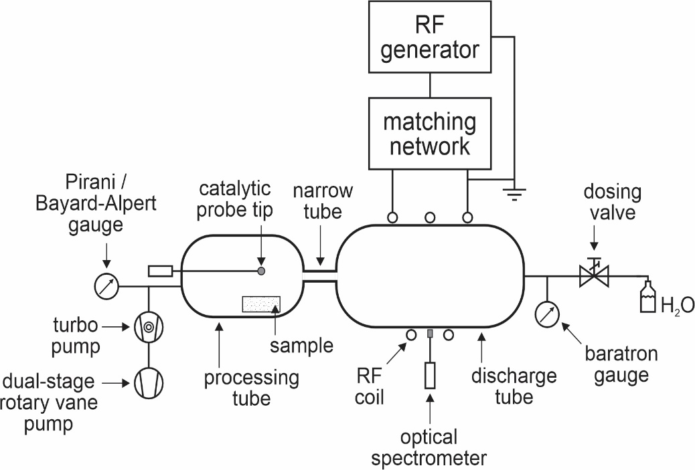

FIGURE 2

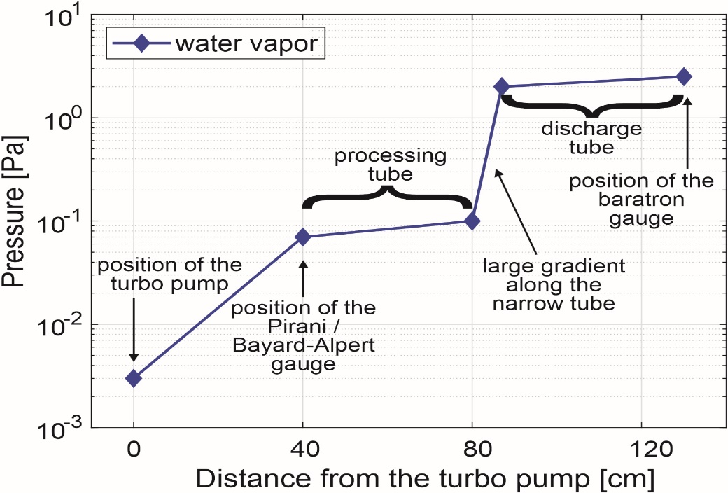

FIGURE 3

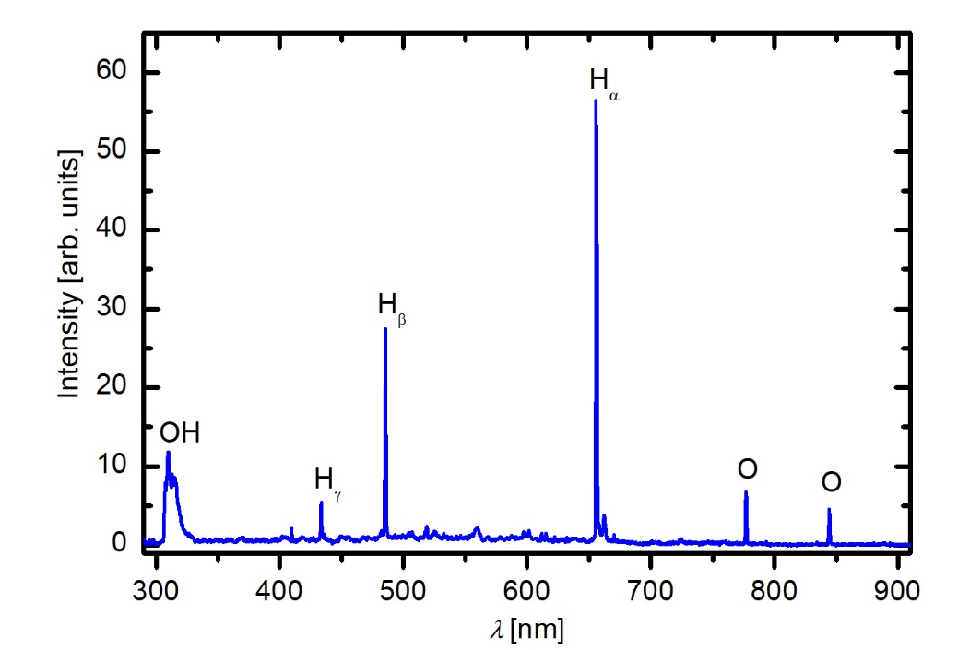

FIGURE 4

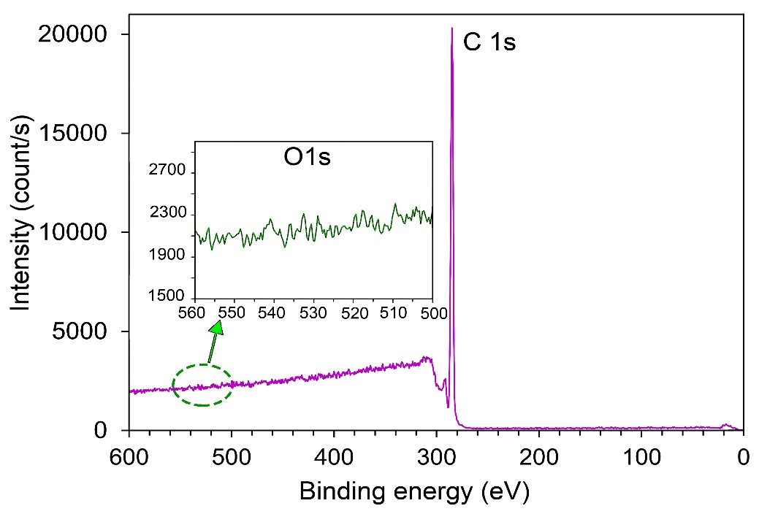

FIGURE 5

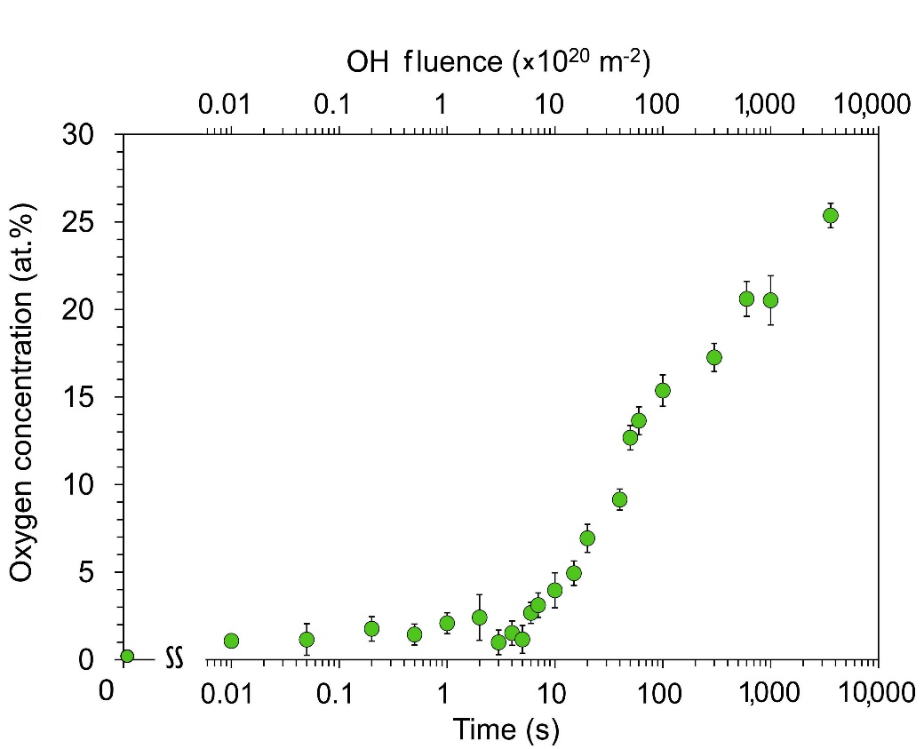

FIGURE 6

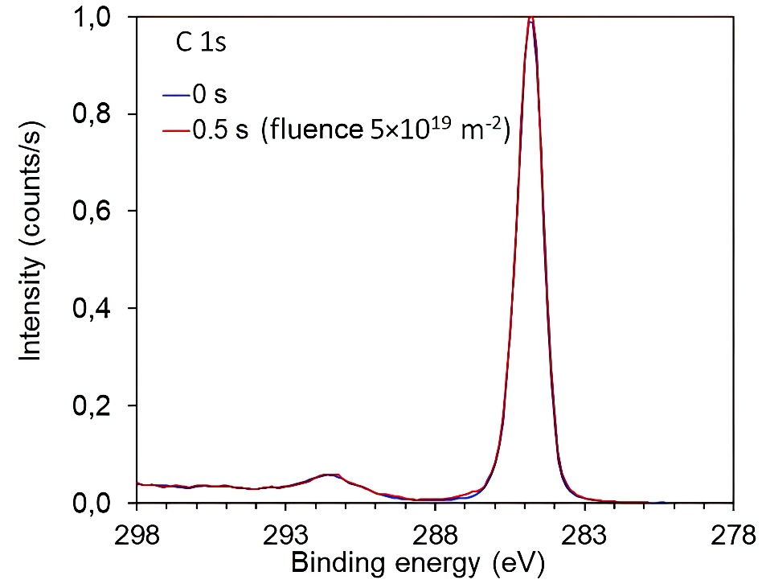

FIGURE 7

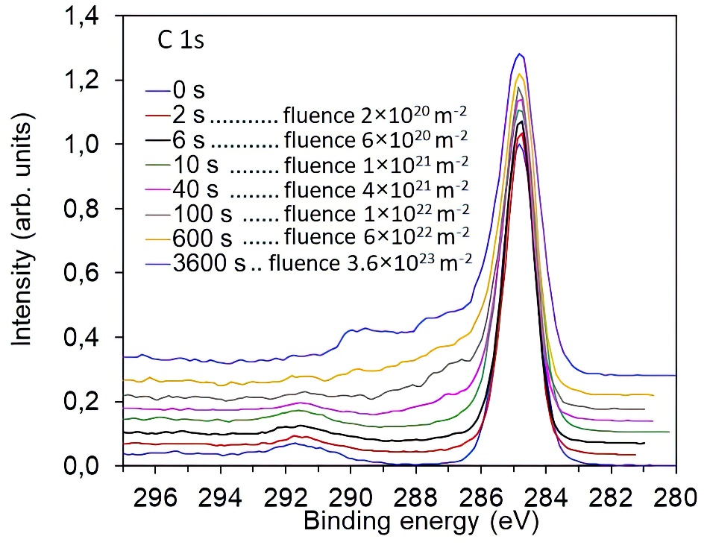

FIGURE 8

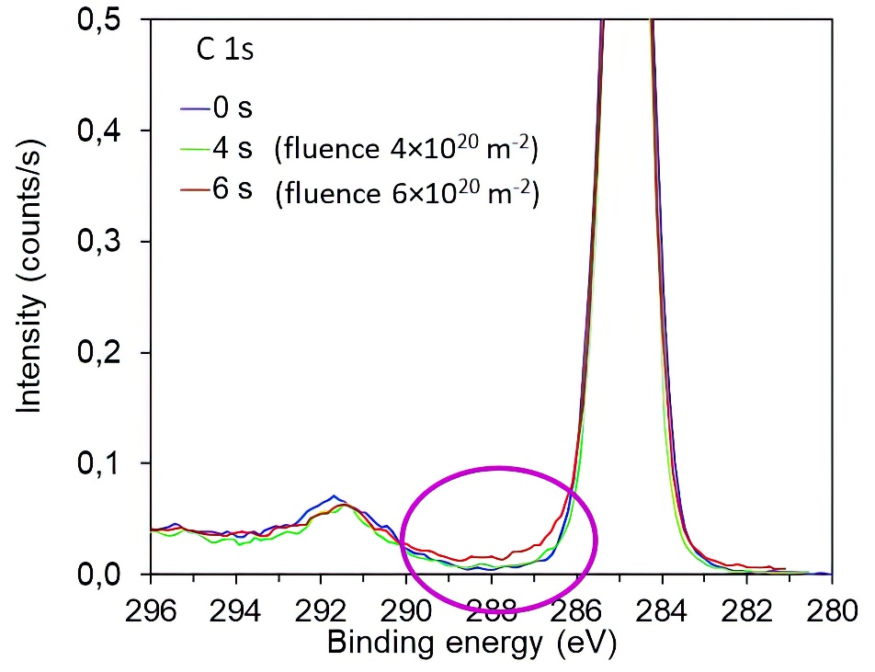

FIGURE 9

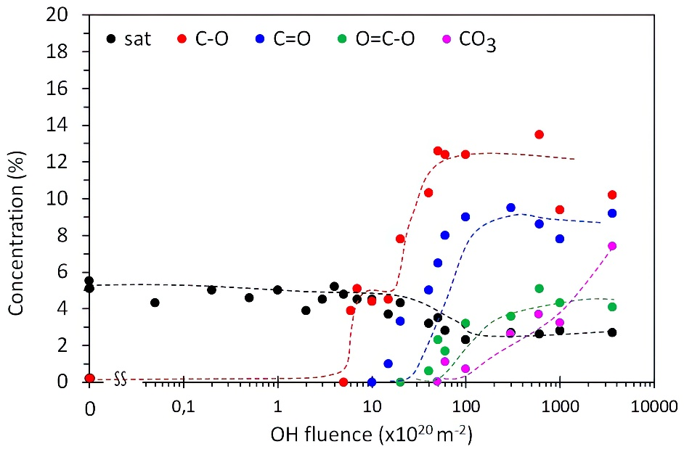

FIGURE 10

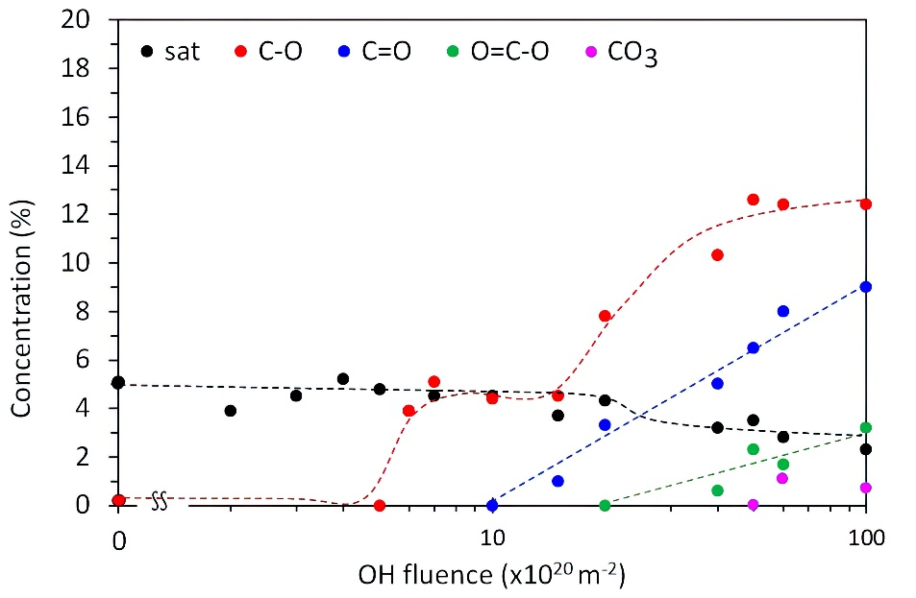

FIGURE 11

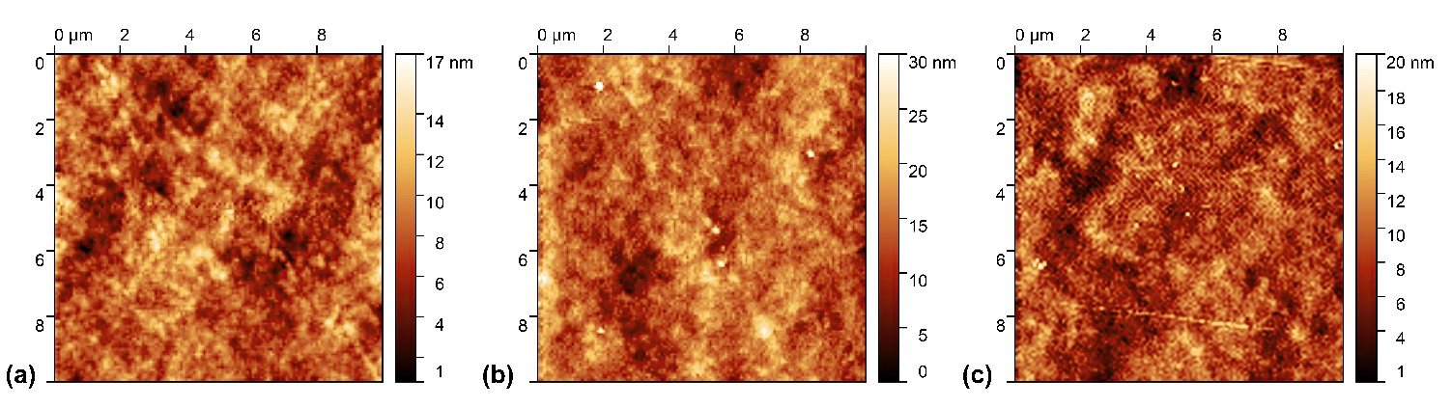

FIGURE 12

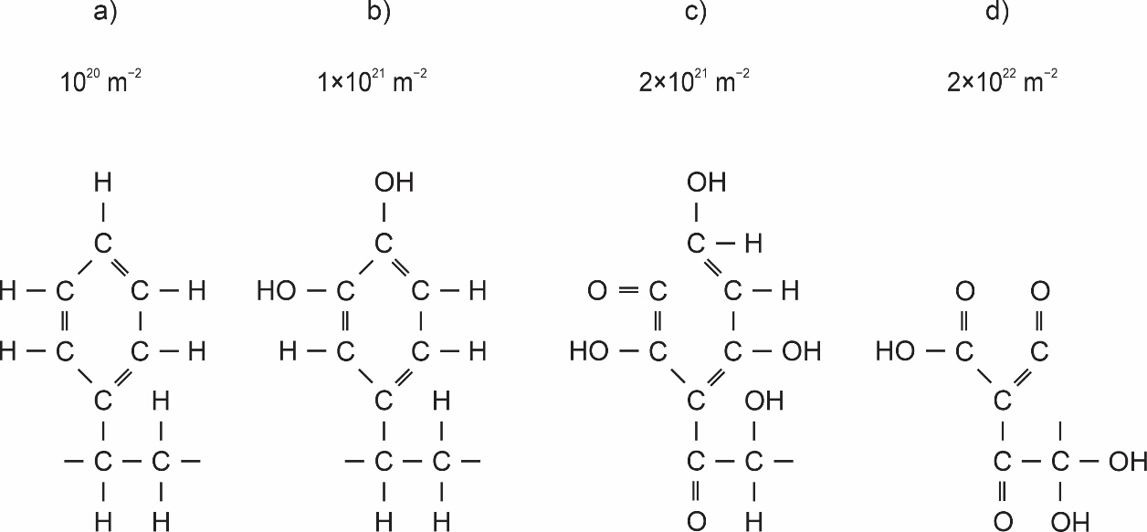
FIGURE 13

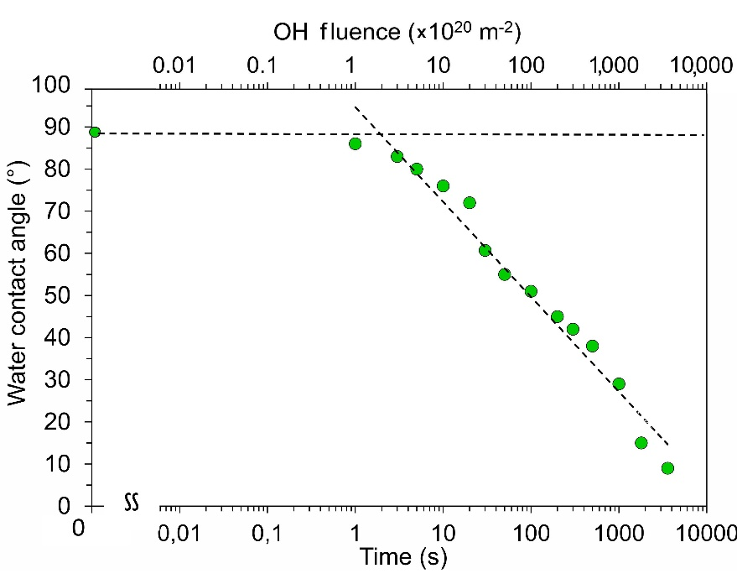

GRAPHICAL ABSTRACT


