Supplementary Figures
Fig. S1 Appearance of raw materials used for the preparation of the geotechnical composites – a) red mud, b) paper ash, and c) contaminated soil.

Fig. S2 Particle-size distribution of the red mud, the paper ash, and the contaminated soil.

Fig. S3 SEM micrograph of the RM, showing the results of the semi-quantitative EDS. The grain of cancrinite mineral phase upon which the EDS was performed is marked in red.

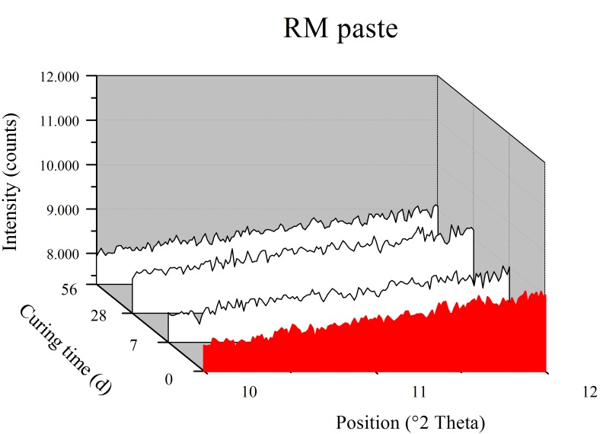
Fig. S4 Sections of XRD patterns of the RM paste after 7, 28, and 56 d of curing.

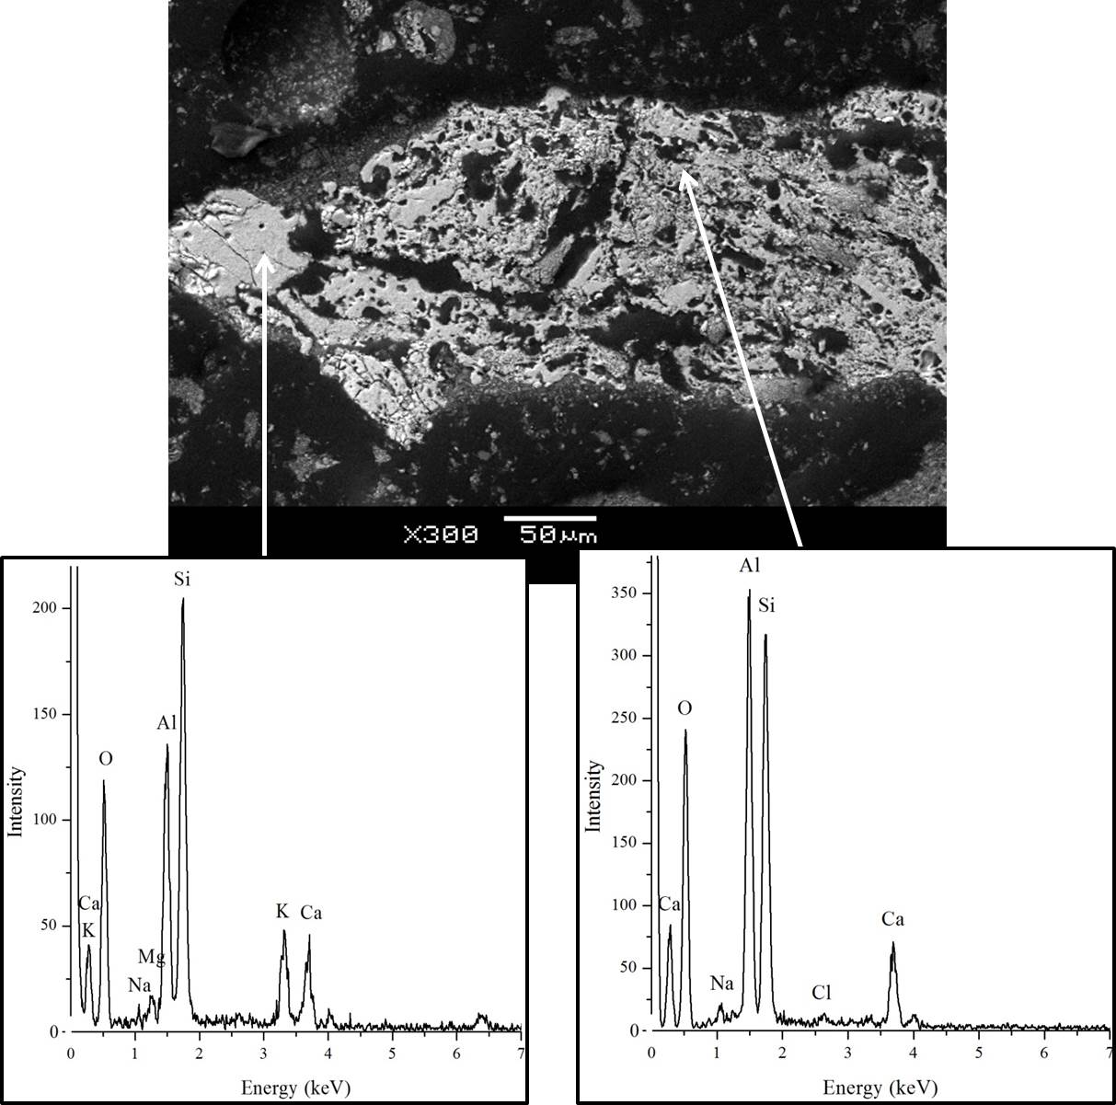

Fig. S5 SEM micrograph of the glassy phase of paper ash, showing the results of the semi-quantitative chemical analysis (EDS).

Fig. S6 SEM micrographs of the PA paste after 28 d of hydration.

(A) | (B)

Fig. S7 SEM micrograph of the RM/PA paste, showing the partially reacted PA grain with (a) the reaction rim on the edge of the grain and (b) unaltered fragments of RM.

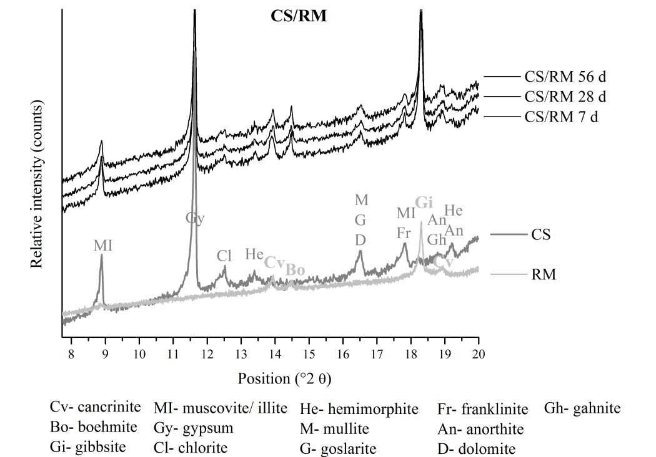

Fig. S8 Sections of XRD patterns of the composite with red mud (CS/RM) after 7, 28, and 56 d of curing, together with the XRD patterns of the raw materials used for the preparation of this composite.

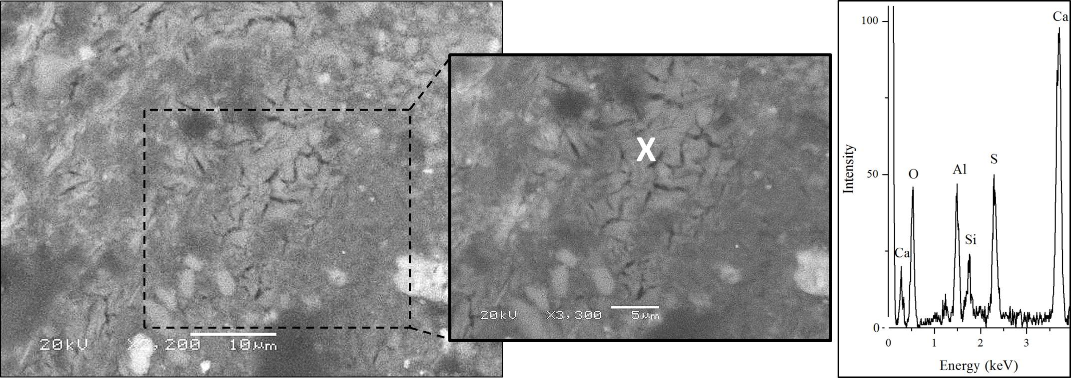

Fig. S9 SEM micrograph of a newly formed mineral phase in the red mud, and paper-sludge-ash-amended-contaminated soil (CS/RMPA) after 28 d of curing, showing the results of the semi-quantitative chemical analysis. The spot where the EDS was carried out is marked by “x”.

Fig. S10 Proctor compaction curves for the determination of maximum dry density and OWC for the composite with red mud (CS/RM), the composite with PA (CS/PA), and the composite with a mixture of RM and PA (CS/RMPA).
Supplementary Tables
Table S1 Summary of studies assessing the effect of the usage of red mud for the immobilization of PTEs in contaminated soil
Composite constituents | Scope | Composite preparation | Composite characterization | Reference
– Sediment dredged from the port  – Addition of 20% RM | To study the changes in mobility and the uptake of heavy metals by plants. | Soil taken from a a depth of 0–15 cm was intermixed with RM; pot trial (plastic pots). | Heavy metal content in the plants used in the pot trial. | Müller, I., Pluquet, E., 1998. Immobilization of heavy metals in sediment dredged from a  seaport by iron bearing materials. Water Sci. Technol. 37(6), 379–386. https://doi.org/10.1016/S0273-1223(98)00221-2.
– Contaminated soil – Addition of 2% RM with 0.25% CaCO₃ (beringite 5%) | To assess the efficiency of an RM to fix heavy metals in two soils (one contaminated by industrial activities and one by sewage sludge applications) | Pot trial, amendments were intermixed with soil. | Metal concentrations; sequential extraction procedure, different crop species were grown. | Lombi E., et al., 2002. In-situ fixation of metals in soils using bauxite residue: Chemical assessment. Environmental Pollution. 118, 435–443. https://doi.org/10.1016/S0269-7491(01)00294-9
– Severely contaminated soil  – Addition of 7.5% RM with 7.5% fly ash and 13% RM with 2% gypsum | To investigate the usage of different industrial byproducts for cleaning up severely contaminated soils with heavy metals. | Soil admixed with immobilizing agents was agglomerated and mixed. Experiments were performed in plexiglass columns. | Measurements of percolation and stabilizing ability for heavy metals. | Ciccu, R., et al., 2003. Heavy metal immobilization in the mining-contaminated soils using various industrial wastes. Miner. Eng. 16, 187–192. https://doi.org/10.1016/S0892-6875(03)00003-7.
– Contaminated soil from the vicinity of a former smelter  – Addition of 1% RM (2% zeolite, 0.3% CaCO₃) | To assess the effects of various soil amendments on the lability of metals in relation to the uptake by plants, dry-matter yield, pH, and bioavailability. | Amendments mixed with soil in concrete mixer; pot trial (specimens filled into plastic pots). | Seven-step sequential extraction procedure. | Friesl, W., et al., 2003. Immobilisation of heavy metals in soils using inorganic amendments in a greenhouse study. J. Plant Nutr. Soil Sci. 166(2), 191–196. https://doi.org/10.1002/jpln.200390028.
– Soil from a site near the mining area  – Addition of 2.5% RM in combination with different types of agents (fertilizer, hydrated lime, zeolite, biosolids) | To examine the effects of several soil treatment methods on the normal growth of plant species. | Soil was admixed with amendments; pot trials were conducted in a greenhouse. | Monitoring of plant growth parameters. | Lin, C., Long, X., Xu, S., 2003. Amendment of minesite acid sulfate soils and the use of vetiver grass for re-vegetation in Dabaoshan Mine, Northern Guangdong, China. Conference on Vetiver and Exhibition: Proceedings of the Third International Vetiver Conference, pp. 6–9.
– artificially spiked soil and soil from industrially polluted sites  – Addition of 5% RM | To assess the effects of RM on metal lability and bioavailability in soil. | Soil intermixed with RM; samples filled into the plastic pots. | Measurements of lability and bioavailability. | Friesl, W., Horak, O., Wenzel, W.W. 2004. Immobilization of heavy metals in soils  by the application of bauxite residues: pot experiments under field conditions. J. Plant Nutr. Soil Sci. 167, 54–59. https://doi.org/10.1002/jpln.200320941.
– Contaminated soil collected near the mining site  – Addition of 2% RM (2% sludge, 2% red gypsum) | To assess the risk reduction caused by the use of various Fe-rich industrial byproducts to remediate contaminated soil. | Soil intermixed with amendments; pots trial, glasshouse. | Measurements of concentrations and bioavailability. | Lombi, E., et al., 2004. Assessment of the use of industrial by-products to remediate a copper- and arsenic-contaminated soil. J. Environ. Qual. 33(3), 902–910. https://doi.org/10.2134/jeq2004.0902
– Mine tailings dam  – Addition of 15% RM | To explore the possibility of using two waste materials (red mud and fly ash) for remediating sites contaminated with  heavy metals. | Tailings were admixed with amendments; tests were carried out using plexiglas leach columns. | Column tests; reactor tests to measure the heavy metals sorption  capacity. | Bertocchi, A.F., et al., 2006. Red mud and fly ash for remediation of mine sites contaminated with As, Cd Cu, Pb and Zn. J. Hazard. Mater. 134, 112–119. https://doi.org/10.1016/j.jhazmat.2005.10.043.
– Heavy-metal-contaminated soil  – Addition of 3% RM with lime; addition of 5% RM | To remediate a heavy-metal-contaminated soil and allow its re-vegetation under field conditions. | Field experiment—amendments were applied to the surface before being ploughed into the soil. | Measurements of metal availability in soil and uptake by plant species. | Gray, C.W., et al., 2006. Field evaluation  of in situ remediation of a heavy metal contaminated soil using lime and red-mud, Environ. Pollut. 142(3), 530–539. https://doi.org/10.1016/j.envpol.2005.10.017.
– Soil from contaminated site  – Addition of 4% RM with 0.3% CaCO₃ (zeolite 10%) | To explore the efficiency of different amendments to immobilize the heavy metals present in a polluted soil and to analyze the influence on several microbiological properties. | Amendments were intermixed with soil; preparation of substrates. | The sequential extraction procedure, standard  microbial counts, sequencing of the 16S rDNA. | Garau, G., et al., 2007. Influence of red mud,  zeolite and lime on heavy metal immobilization, culturable heterotrophic microbial populations and enzyme activities in a contaminated soil. Geoderma 142, 47–57. https://doi.org/10.1016/j.geoderma.2007.07.011
– Smelter-contaminated soil  – Addition of 1% RM and gravel sludge + RM = 2.5% + 0.5% (limestone 0.5%) | Optimization of a field experiment (for overcoming the gap between pot and field experiments) in order to look at the long-term efficiency of soil treatments. | Amendments were hand-scattered over the surface, the pots were tilled. | Field experiment; eco-toxicological measurements. | - Friesl-Hanl, W., et al., 2009. Immobilising of Cd, Pb, and Zn contaminated arable soils close to a former Pb/Zn smelter: a field study in Austria over 5 years. Environ. Geochem. Health 31(5), 581–594. https://doi.org/10.1007/s10653-009-9256-3.
– Two contaminated farmed soils  – Addition of 0.5% and 2% (w/w) RM | To explore the feasibility of remediation of smelter-contaminated soils (one by fly ash, the other by waste water from the smelter). | Amendment was applied to the contaminated soil. | Metal mobility; the concentrations of free metal ions and distributions of metals. | Yetang, Yi, L., Duojun, H., Yongxuan, Z.W., 2010. Effect of red mud on the mobility of heavy metals in mining-contaminated soils. Chin. J. Geochem. 29(2), 191–196. https://doi.org/10.1007/s11631-010-0191-x.
– Topsoil from the gold mining area  – Addition of 2% and 5% (w/w) RM; and mixtures of 2% RM + 2% limestone and 2% RM + 2% furnace slag) | To evaluate the usefulness of different amendments for in situ stabilization relative to different endpoints (microorganisms, plants, and humans). | Amendments were thoroughly  mixed with the soil, samples filled into plastic pots. | Microbial analysis, measurements of phytoavailabilty. | Lee, S.H., et al., 2011. In situ stabilization of arsenic and metal-contaminated agricultural soil using industrial by-products. Geoderma 161(1/2), 1–7. https://doi.org/10.1016/j.geoderma.2010.11.008.
– Toxic-metal-contaminated soils and mine wastes  – Addition of 2% and 5% (w/w)  RM | To describe the remediation of metal-contaminated soils using red mud for chemical stabilization/immobilization followed by phytostabilization. | Contaminated soil intermixed with RM; pot trial (plastic plant pots). | Biological and ecotoxicological measurements; leaching (lysimeter); bioavailability. | Feigl, V., et al., 2012. Red mud as a chemical  stabilizer for soil contaminated with toxic metals. Water Air Soil Pollut. 223(3), 1237–1247. https://doi.org/10.1007/s11270-011-0940-4.
– Soil polluted by heavy metals due to a tailing dam collapse  – Addition of 1, 2, and 5% RM | To study the effect of RM addition on the fractionation and bioaccessibility in soil from mining areas. | Contaminated soil intermixed with RM; samples placed into paper cups. | Measurements of fractionation and bioaccessibility. | Huang, Y.Z., Hao, X.W. 2012. Effect of red mud addition on the fractionation and bio-accessibility of Pb, Zn and As in combined contaminated soil. Chem. Ecol. 28(1), 37–48. https://doi.org/10.1080/02757540.2011.619528.
– Contaminated calcarosol (sandy soil)  – Addition of 5% and 10% (w/w) RM | To examine the efficiency of the addition of five waste materials as metal-immobilizing agents to a contaminated soil. | Amendments were thoroughly mixed with soil, samples placed in 2-L plastic containers | Measurement of extractable fractionation of heavy metals in samples; metal bioavailability. | Zhou, Y.-F., Haynes R.J., Naidu, R. 2012. Use of inorganic and organic wastes for in situ  immobilization of Pb and Zn in a contaminated alkaline soil. Environ. Sci. Pollut. Res. 19(4), 1260–1270. https://doi.org/10.1007/s11356-011-0648-4.
– Material from a sulfide-bearing waste pile  – Addition of 2.5% and 5% RM in combination with Fe powder and Fe hydroxides | To investigate the efficacy of amendments in reducing the release of contaminants from a complex waste. | Samples placed in plexiglass columns. | Leaching column experiments (mixing method, filtration method). | Ardau, C., et al., 2013. Treatment of mine wastes with Transformed Red Muds (TRM) and other iron compounds: leaching column tests. Proced. Earth Planet. Sci. 7, 467–470. https://doi.org/10.1016/j.proeps.2013.03.018
– Contaminated alluvial soil  – Addition of 0.5 and 1% RM | To investigate the effects of  four additives combined with two foliar fertilizers on the bio-availability of Cd in soils and on the accumulation of Cd in two varieties of contaminated alluvial soil. | Field experiment – the additives were evenly spread on the soil surface and then tilled into the soil by a rotary hoe and fully mixed. | Measurements of bioavailability of Cd in soils and of the accumulation of Cd in two varieties of plant species. | Feng, R., et al., 2013. Field evaluation of in situ  remediation of Cd-contaminated soil using four additives, two foliar fertilizers and two varieties of pakchoi, J. Environ. Manage. 124, 17–24.  https://doi.org/10.1016/j.jenvman.2013.03.037.
– Acidic sandy soil  – Addition of 0, 5, 10, 20, 30, 40, and 50% (w/w) RM | To reveal the beneficial effects of RM, as soil ameliorant, on a specific acidic sandy soil. | Soil was intermixed with RM; pots trial (microcosms) | Combining physical and chemical methods with biological and ecotoxicological measurements. | Ujaczki, É., et al., 2016. Red mud as acidic sandy soil ameliorant: a microcosm incubation study. J. Chem. Technol. Biotechnol. 91(6), 1596–1606. https://doi.org/10.1002/jctb.4898.
– Loess  – Addition of 0, 5, 10, 15, 20, 25, and 30% RM with 5% CEM II | To evaluate the feasibility of RM waste in loess roadbed treatment (subgrade filling) and to reveal the action  mechanism of RM from a microscopic perspective. | Compaction test | Mechanical and microstructural characterization of composite. | Chen, R., et al., 2019. Mechanical properties and micro-mechanism of loess roadbed filling using by-product red mud as a partial alternative. Constr. Build. Mater. 216(20), 188-201. https://doi.org/10.1016/j.conbuildmat.2019.04.254
– Soil fertilized with cow dung manure  – addition of 0, 5, 10 and 15% (w/w) RM | To evaluate the effects of RM additions in soil fertilized with cow dung manure on available metal contents, growth, performance, and metal accumulation in plants. | Soil mixtures (10 kg) filled  into plastic pots. | Measurements of total and phytoavailable metal contents. | Gautam, M., Agrawal, M., 2019. Effects of red mud addition in soil fertilized with cowdung manure on growth performance and metal accumulations in Brassica juncea cultivars kranti and pusa bold. Commun. Soil Sci. Plant Anal. 50(10), 1214–1231. https://doi.org/10.1080/00103624.2019.1614599.

Table S2 Concentrations of chlorides and sulfates in standard reference material Anions – Whole Volume (Merck KGaA, Darmstadt, Germany), determined by spectrophotometry. The results represent the mean concentration obtained from three parallel samples ± standard deviation

Anions | Anions – Whole Volume  Certified (mg L⁻¹) | Anions – Whole Volume  Determined (mg L⁻¹)
Cl⁻ | 95.0 ± 9.50 | 93.5 ± 4.5
SO₄²⁻ | 44.3 ± 4.43 | 42.0 ± 2.0

Table S3 Concentrations of elements in standard reference material SPS-SW1 (reference material for measurements of elements in surface waters), Spectrapure Standards, Oslo, Norway). Concentrations of elements were determined by ICP-MS. The results represent the mean concentration obtained from three parallel samples ± standard deviation

Element | SPS-SW1  Certified (µg L⁻¹) | SPS-SW1  Determined (µg L⁻¹)
As | 10.0 ± 0.1 | 10.2 ± 0.2
Ba | 50 ± 1 | 49 ± 1
Cd | 0.50 ± 0.01 | 0.51 ± 0.01
Cr | 2.00 ± 0.02 | 2.02 ± 0.04
Cu | 20 ± 1 | 19.7 ± 0.4
Mo | 10.0 ± 0.1 | 10.1 ± 0.2
Ni | 10.0 ± 0.1 | 10.1 ± 0.2
Pb | 5.0 ± 0.1 | 5.1 ± 0.1
Se | 2.00 ± 0.02 | 2.01 ± 0.04
Zn | 20* | 20.3 ± 0.4
* Informative value

Table S4 Maximum dry density of the composite with red mud (CS/RM), the composite with PA (CS/PA), and the composite with a mixture of RM and PA (CS/RMPA)

 | Composites
Parameter | CS/RM | CS/PA | CS/RM PA
Maximum dry density (mg/m³) | 1.67 | 1.55 | 1.61

Table S5 Results of XRF chemical composition (total concentrations) of RM, PA, and CS

Parameter  (mg/kg dry matter) | RM | PA | CS
As | 98.14 | 2.8 | 1,789.45
Ba | 370.47 | 408.18 | 17,666.93
Cd | 10.4 | 6.15 | 165.58
Cr | 394.6 | 31 | 78.61
Cu | 100.05 | 274.94 | 1,132.43
Hg | 13.01 | <0.01 | 215.18
Mo | 3.53 | 7.57 | 51.52
Ni | 236.28 | 108.48 | 213.35
Pb | 112.97 | 69.20 | 20,456.14
Sb | 42.01 | 1.59 | 150.23
Se | 4.49 | 0.73 | 21.12
Zn | 269.2 | 152.99 | 146,288.3
Al | 94,400 | 52,000 | 50,690
Ca | 149,000 | 378,700 | 53,275
Fe | 136,400 | 2,900 | 83,630
K | 2,700 | 2,600 | 6,050
Mg | 5,100 | 21,100 | 22,750
P | 1,400 | 800 | 22,040
S | 3,300 | 2,800 | 26,490
Si | 37,900 | 58,300 | 114,240
Ti | 18,464 | 1,268 | 9,532

Table S6 Concentrations of elements and the pH and electrical conductivity of the leachates from the composite with red mud (CS/RM), the composite with PA (CS/PA), and the composite with a mixture of RM and PA (CS/RMPA), after 7, 28, and 56 d of curing. The concentrations of elements were determined by ICP-MS
 |  |  |  |  |  |  | Composites
 | Parameter  (mg/kg  dry matter) | CS/RM |  |  |  |  | CS/PA |  |  |  |  |  | CS/RMPA
 | Parameter  (mg/kg  dry matter) | 7 d | 28 d | 56 d |  | 7 d |  | 28 d | 56 d |  |  | 7 d |  | 28 d | 56 d
 | SO₄²⁻ | 6150 | 2700 | 3250 |  | 275 |  | 385 | 300 |  |  | 600 |  | 550 | 550
 | Cl⁻ | 11.5 | 3 | 11.5 |  | 66 |  | 93.5 | 46 |  |  | 18.5 |  | 10.5 | 12
 | Cr | <0.01 | <0.01 | <0.01 |  | 0.02 |  | 0.03 | 0.02 |  |  | 0.02 |  | 0.01 | 0.012
 | Ni | <0.01 | <0.01 | <0.01 |  | <0.01 |  | <0.01 | <0.01 |  |  | <0.01 |  | <0.01 | <0.01
 | Cu | 0.03 | 0.02 | 0.07 |  | 0.20 |  | 0.60 | 0.60 |  |  | 0.13 |  | 0.17 | 0.18
 | Zn | 1.67 | 0.79 | 0.61 |  | 0.03 |  | 0.08 | <0.01 |  |  | 0.05 |  | 0.03 | 0.01
 | As | 0.073 | 0.075 | 0.08 |  | 0.01 |  | 0.01 | 0.01 |  |  | 0.01 |  | 0.04 | 0.04
 | Se | 0.01 | <0.01 | <0.01 |  | <0.01 |  | 0.01 | <0.01 |  |  | <0.01 |  | <0.01 | <0.01
 | Mo | 0.17 | 0.16 | 0.1 |  | 0.75 |  | 0.43 | 0.43 |  |  | 0.69 |  | 0.51 | 0.51
 | Cd | 0.09 | 0.01 | 0.01 |  | <0.01 |  | <0.01 | <0.01 |  |  | <0.01 |  | <0.01 | <0.01
 | Sb | 0.01 | <0.01 | 0.01 |  | <0.01 |  | <0.01 | <0.01 |  |  | <0.01 |  | 0.01 | 0.01
 | Ba | 0.19 | 0.24 | 0.241 |  | 1.50 |  | 2.56 | 0.82 |  |  | 0.46 |  | 0.461 | 0.48
 | Hg | <0.01 | <0.01 | <0.01 |  | <0.01 |  | <0.01 | <0.01 |  |  | <0.01 |  | <0.01 | <0.01
 | Pb | 0.037 | 0.03 | 0.01 |  | 0.77 |  | 0.23 | 0.01 |  |  | 0.03 |  | 0.03 | 0.01
 | pH | 8.21 | 8.39 | 8.48 |  | 11.65 |  | 11.72 | 11.01 |  |  | 10.73 |  | 10.43 | 10.18
Conductivity  (mS/cm) |  | 1.12 | 0.53 | 0.51 |  | 0.77 |  | 0.7 | 0.23 |  |  | 0.23 |  | 0.19 | 0.16

