Supporting information
Mechanical, microstructural and mineralogical evaluation of alkali-activated waste glass and stone wools
Majda Pavlin, Barbara Horvat, Ana Frankovič and Vilma Ducman*
Slovenian National Building and Civil Engineering Institute (ZAG Ljubljana), Dimičeva 12, 1000 Ljubljana, Slovenia, www.zag.si
*Corresponding author: Vilma Ducman, Slovenian National Building and Civil Engineering Institute, Dimiceva 12, 1000 Ljubljana, SLOVENIA

Content (1 figure and 2 tables):
- Figure S1: Organic binder in AAMs.
- Table S1: Mechanical properties, curing 3 days at 40 °C.
- Table S2: Mechanical properties, curing 90 days at room temperature.

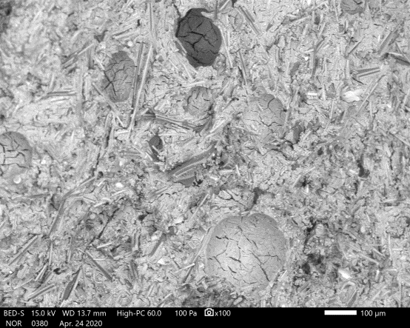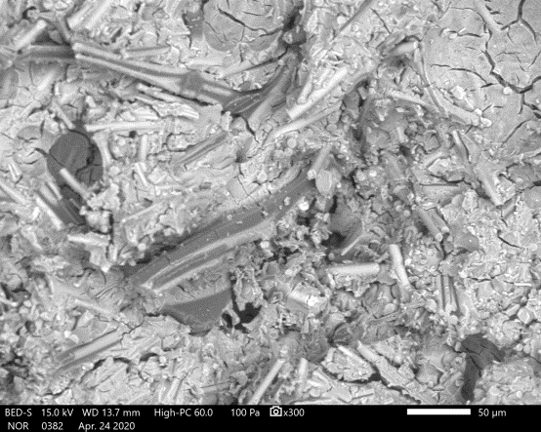
Drying process
Organic binder
Figure S1: Organic binder present in AAMs made of SW or GW. Two different types of pore are seen, one that are formed as a consequence of the drying process and pores present due to the organic binder by the reaction between alkaline activator and an organic binder.

Table S1: The results of compressive and flexural strengths different alkali-activated samples of glass (GW), stone wool (SW) after 3 days of curing at 40 °C.
Time (days) | Compressive strength (MPa) | Standard deviation (MPa) | Flexural strength (MPa) | Standard deviation (MPa)
GW1 | 11.1 | 1.41 | 3.81 | 0.19
GW2 | 53.1 | 4.61 | 15.8 | 2.37
GW3 | 38 | 0.37 | 12.7 | 1.59
GW4 | 36.9 | 4.33 | 12.0 | 0.63
GW5 | 38.4 | 1.5 | 10.7 | 1.01
SW1 | 24.5 | 0.72 | 9.32 | 1.72
SW2 | 40.6 | 1.03 | 8.28 | 0.67
SW3 | 27.2 | 1.45 | 7.79 | 0.09
SW4 | 30.57 | 1.94 | 6.47 | 1.32
SW5 | 31.6 | 0.65 | 9.81 | 0.39

Table S2: The compressive and flexural strengths of alkali-activated GW5 (a) and SW5 samples (b) measured after 1, 3, 7, 14, 28, 56 and 90 days, cured at room temperature.
- GW5
Time (days) | Compressive strength (MPa) | Standard deviation (MPa) | Flexural strength (MPa) | Standard deviation (MPa)
1 | 0 | 0 | 0 | 0
3 | 0 | 0 | 0 | 0
7 | 6.1 | 0.63 | 2.44 | 0.50
14 | 17.4 | 0.61 | 7.25 | 1.58
28 | 32.2 | 1.11 | 9.64 | 0.78
56 | 58.2 | 2.03 | 17.6 | 3.94
90 | 76.4 | 2.75 | 27.0 | 0.90

- SW5
Time (days) | Compressive strength (MPa) | Standard deviation (MPa) | Flexural strength (MPa) | Standard deviation (MPa)
1 | 0 | 0 | 0 | 0
3 | 0 | 0 | 0 | 0
7 | 9.61 | 0.2 | 2.86 | 0.0
14 | 25.5 | 1.92 | 7.82 | 2.07
28 | 34.1 | 1.62 | 8.68 | 0.14
56 | 49.7 | 2.03 | 13.3 | 0.43
90 | 55.8 | 1.61 | 13.5 | 1.00

