ELECTRONIC APPENDIX

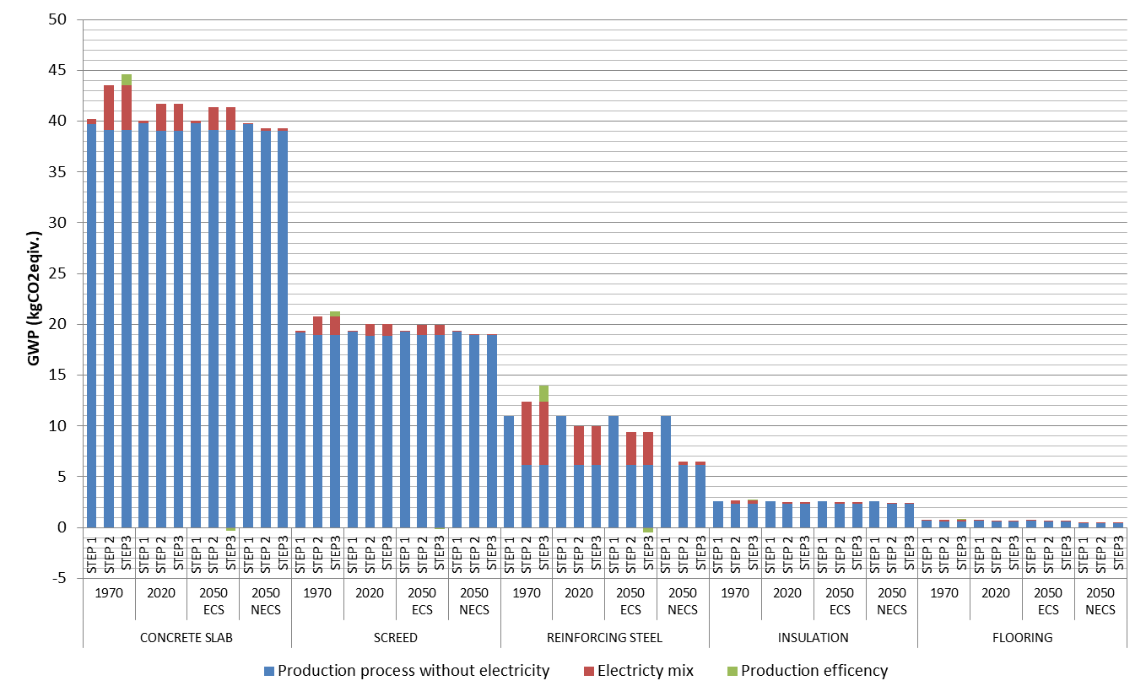
Figure S1 Calculated GHG emissions of the 1 m² of foundation by materials according to new remodeling approach

Table S1 Relative contribution of the electricity mix towards the total GHG emission of materials of the foundation calculated with electricity mixes for different periods and corresponding production efficiencies
 | 1970 |  |  | 2020 |  |  | 2050 ECS |  |  | 2050 NECP
 | STEP 1 | STEP 2 | STEP3 | STEP 1 | STEP 2 | STEP3 | STEP 1 | STEP 2 | STEP3 | STEP 1 | STEP 2 | STEP3
CONCRETE SLAB | 1,12% | 9,99% | 12,18% | 0,69% | 6,33% | 6,33% | 0,58% | 5,43% | 4,66% | 0,06% | 0,61% | 0,52%
SCEED | 0,78% | 8,84% | 10,81% | 0,48% | 5,60% | 5,60% | 0,41% | 4,72% | 4,04% | 0,04% | 0,53% | 0,45%
REINFORCING STEEL | 0,00% | 50,13% | 55,68% | 0,00% | 37,99% | 37,99% | 0,00% | 34,17% | 30,61% | 0,00% | 5,23% | 4,48%
INSULATION | 0,00% | 12,22% | 14,82% | 0,00% | 7,83% | 7,83% | 0,00% | 6,73% | 5,78% | 0,00% | 0,76% | 0,65%
FLOORING | 8,58% | 20,83% | 24,75% | 5,40% | 13,86% | 13,86% | 4,63% | 11,96% | 10,36% | 0,73% | 2,09% | 1,78%

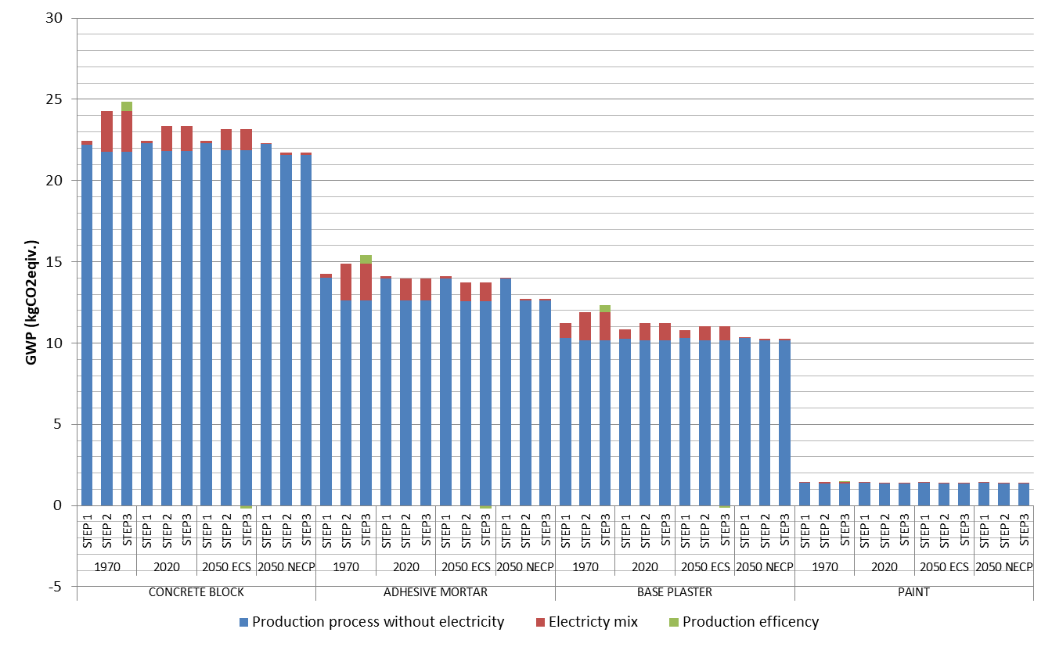
Figure S2 Calculated GHG emissions of the 1 m² of inner wall by materials according to new remodeling approach

Table S2 Relative contribution of the electricity mix towards the total GHG emission of materials of inner wall calculated with electricity mixes for different periods and corresponding production efficiencies
 | 1970 |  |  | 2020 |  |  | 2050 ECS |  |  | 2050 NECP
 | STEP 1 | STEP 2 | STEP3 | STEP 1 | STEP 2 | STEP3 | STEP 1 | STEP 2 | STEP3 | STEP 1 | STEP 2 | STEP3
CONCRETE BLOCK | 1,12% | 10,18% | 12,41% | 0,69% | 6,45% | 6,45% | 0,58% | 5,52% | 4,73% | 0,06% | 0,63% | 0,53%
ADHESIVE MORTAR | 1,70% | 15,11% | 18,20% | 1,04% | 9,80% | 9,80% | 0,89% | 8,46% | 7,28% | 0,09% | 0,97% | 0,82%
BASE PLASTER | 8,21% | 14,52% | 17,51% | 5,18% | 9,37% | 9,37% | 4,41% | 8,09% | 6,96% | 0,49% | 0,93% | 0,79%
PAINT | 1,75% | 7,53% | 9,24% | 1,07% | 4,74% | 4,74% | 0,91% | 3,92% | 3,35% | 0,10% | 0,44% | 0,38%

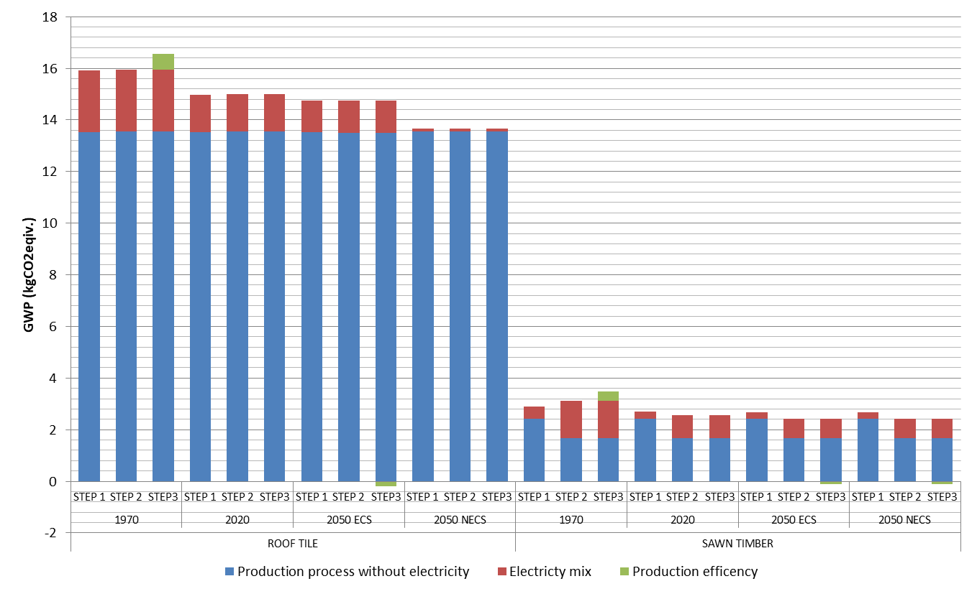
Figure S3 Calculated GHG emissions of the 1 m² of roof by materials according to new remodeling approach

Table S3 Relative contribution of the electricity mix towards the total GHG emission of materials of roof calculated with electricity mixes for different periods and corresponding production efficiencies
 | 1970 |  |  | 2020 |  |  | 2050 ECS |  |  | 2050 NECP
 | STEP 1 | STEP 2 | STEP3 | STEP 1 | STEP 2 | STEP3 | STEP 1 | STEP 2 | STEP3 | STEP 1 | STEP 2 | STEP3
ROOF TILE | 14,95% | 15,07% | 18,15% | 9,68% | 9,77% | 9,77% | 8,34% | 8,43% | 7,25% | 0,95% | 0,97% | 0,82%
SAWN TIMBER | 16,31% | 46,58% | 52,15% | 10,61% | 34,73% | 34,73% | 9,15% | 31,07% | 27,70% | 9,15% | 31,07% | 27,70%

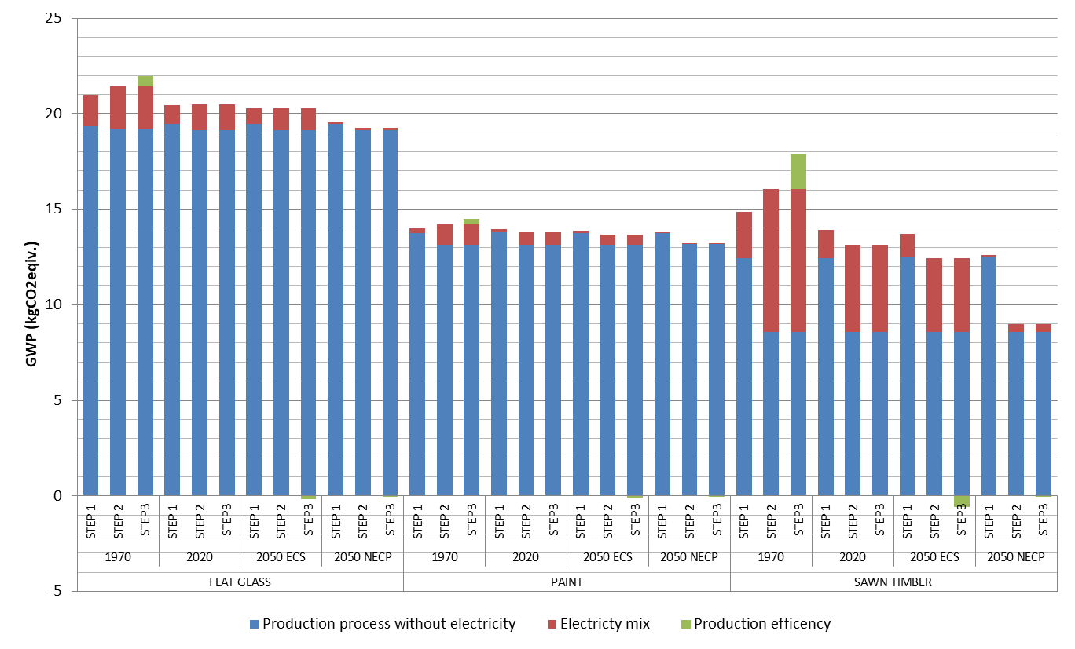
Figure S4 Calculated GHG emissions of the 1 m² of window by materials according to new remodeling approach

Table S4 Relative contribution of the electricity mix towards the total GHG emission of materials of window calculated with electricity mixes for different periods and corresponding production efficiencies
 | 1970 |  |  | 2020 |  |  | 2050 ECS |  |  | 2050 NECP
 | STEP 1 | STEP 2 | STEP3 | STEP 1 | STEP 2 | STEP3 | STEP 1 | STEP 2 | STEP3 | STEP 1 | STEP 2 | STEP3
FLAT GLASS | 7,67% | 10,39% | 12,66% | 4,81% | 6,64% | 6,64% | 4,11% | 5,68% | 4,87% | 0,45% | 0,64% | 0,54%
PAINT | 1,75% | 7,53% | 9,24% | 1,07% | 4,74% | 4,74% | 0,91% | 3,92% | 3,35% | 0,10% | 0,44% | 0,38%
SAWN TIMBER | 16,31% | 46,58% | 52,15% | 10,61% | 34,73% | 34,73% | 9,15% | 31,07% | 27,70% | 1,06% | 4,58% | 3,92%

