Electronic Supplementary Material for:

The influence of calcium sulfate content on the hydration of belite-calcium sulfoaluminate cements with different clinker phase compositions
Maruša Mrak^{1, 2}, Frank Winnefeld³, Barbara Lothenbach^{3,4}, Sabina Dolenec^{1,*}
¹ Slovenian National Building and Civil Engineering Institute, Dimičeva ulica 12, 1000 Ljubljana, Slovenia
² Jožef Stefan International Postgraduate School, Jamova cesta 39, 1000 Ljubljana, Slovenia
³ Empa, Swiss Laboratories for Materials Science and Technology, Überlandstrasse 129, 8600 Dübendorf, Switzerland
⁴ Norwegian University of Science and Technology (NTNU), Department

* Corresponding author. Tel.: +386 40 693 125. E-mail address: sabina.dolenec@zag.si

In the following Figures S1–S4, the data reported in this study are summarized, as they are already discussed in detail in the paper.

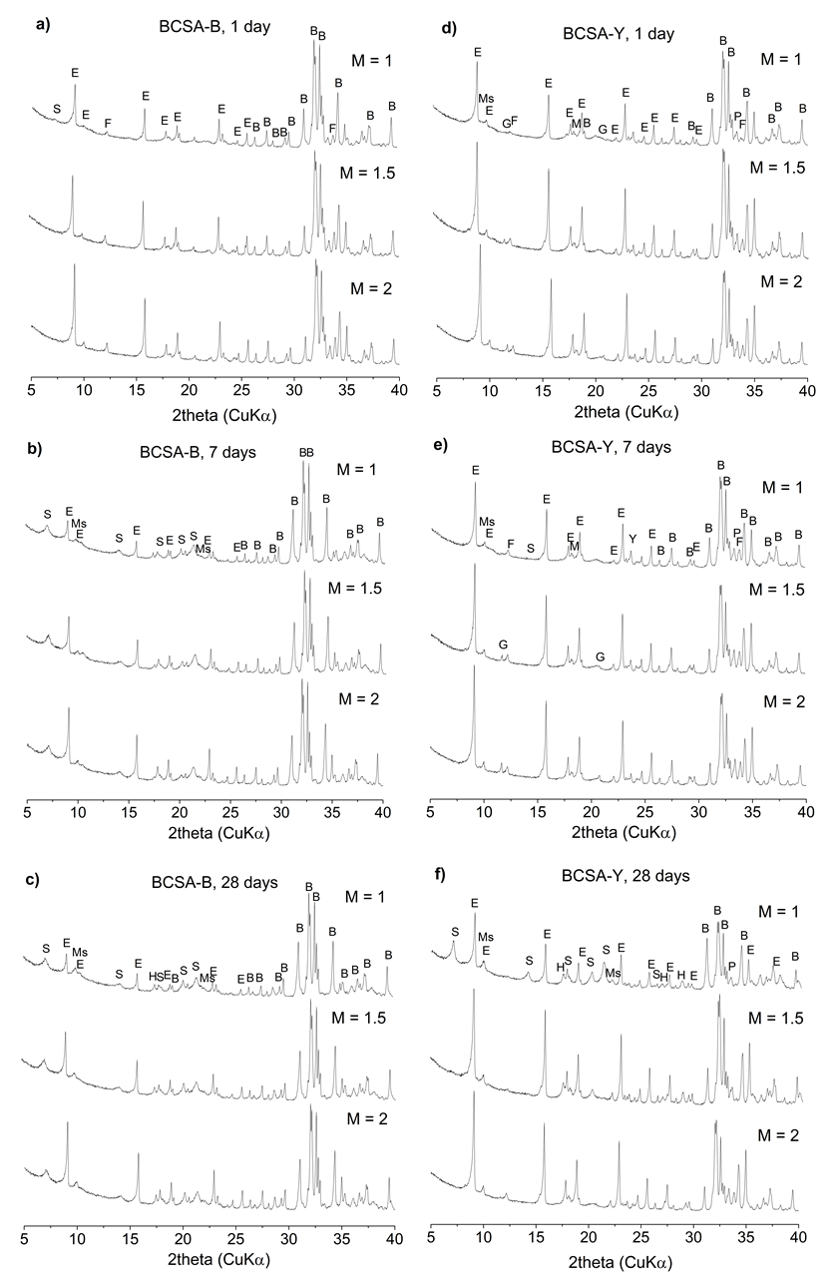
Fig. S1 X-ray diffraction patterns of BCSA-B at a) 1 day, b) 7 days and c) 28 days f hydration and BCSA-Y at d) 1 day, e) 7 days and f) 28 days of hydration. B = belite, Y = ye’elimite, F = ferrite, M = mayenite, P = perovskite, E = ettringite, Ms = monosulfate, S = strätlingite, H = siliceous hydrogarnet.

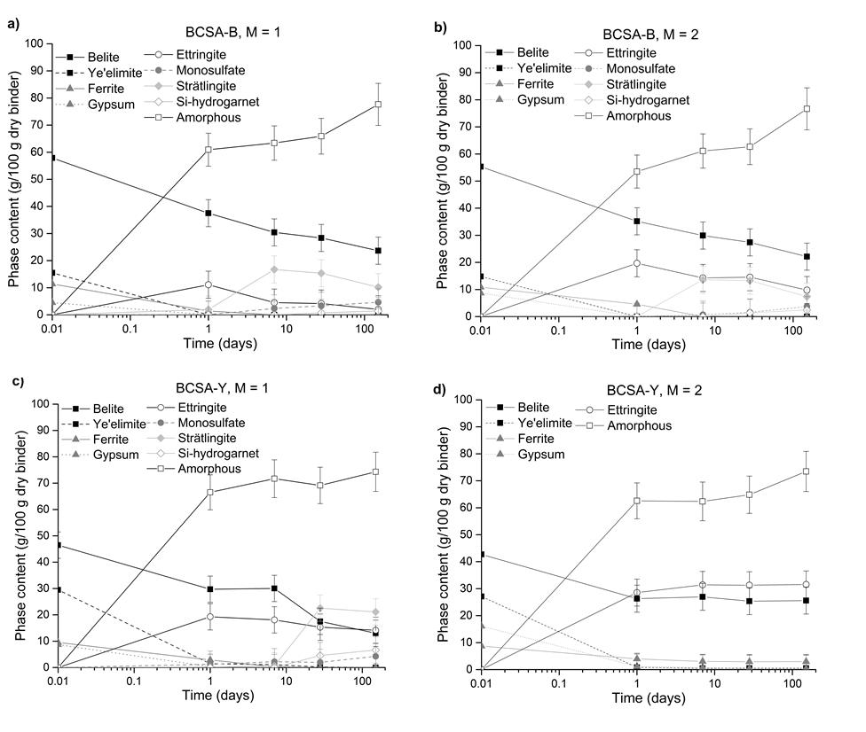
Fig. S2 X-ray powder diffraction quantification of the phase development in hydrating BCSA-B at a) M = 1 and b) M = 2 and BCSA-Y cement at c) M = 1 and d) M = 2.
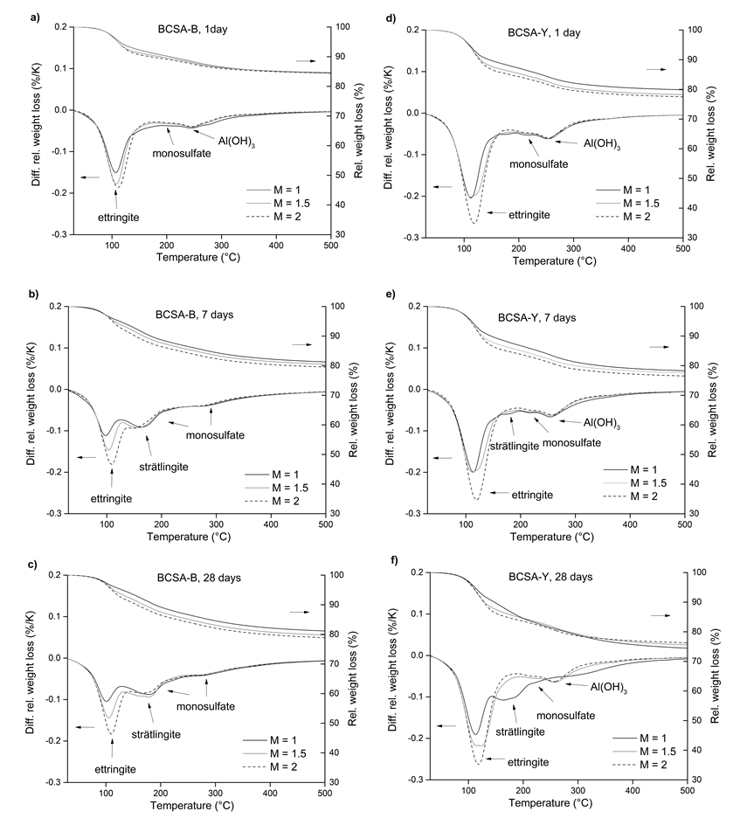
Fig. S3 Thermogravimetric analysis of cement paste BCSA-B at a) 1, b) 7 and c) 28 days of hydration and cement paste BCSA-Y at d) 1, e) 7 and f) 28 days of hydration.

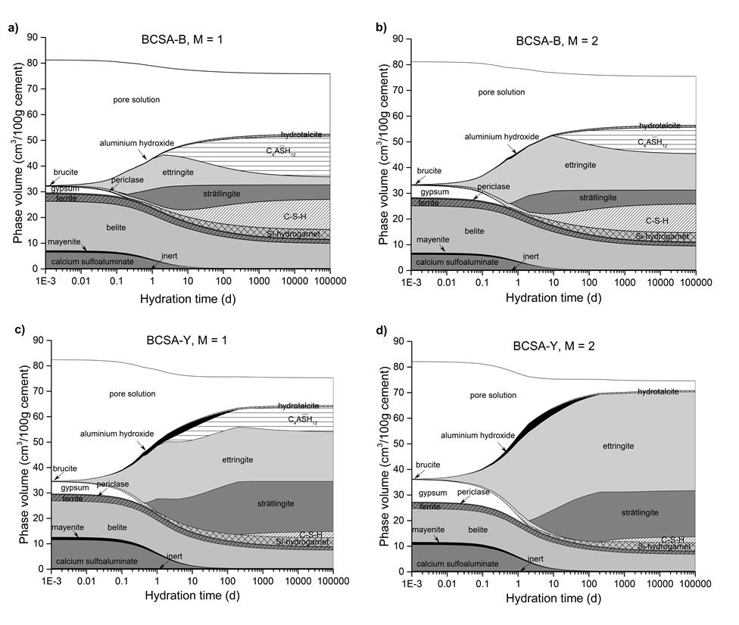
Fig. S4 Thermodynamic modelling of the phase assemblages depending on hydration time at M = 1 of a) BCSA-B cement and b) BCSA-Y cement and at M = 2 of c) BCSA-B cement and d) BCSA-Y cement.

