Supporting information
Influence of microwaves in the early stage of alkali-activation on the mechanical strength of alkali-activated materials
Barbara Horvat^{1,*}, Majda Pavlin¹, Vilma Ducman¹
¹Slovenian National Building and Civil Engineering Institute (ZAG Ljubljana), Dimičeva 12, 1000 Ljubljana, Slovenia, www.zag.si
*Corresponding author: Barbara Horvat, Slovenian National Building and Civil Engineering Institute, Dimičeva 12, 1000 Ljubljana, Slovenia, barbara.horvat@zag.si; Tel.: +386-40-394-270 (B.H.)

Content (3 figures and 1 table):
- Figure S1: XRD patterns of precursors.
- Figure S2: Rietveld refinement results of precursors and their long-term alkali-activated optimal mixtures.
- Figure S3: XRD patterns of precursors and their long-term alkali-activated optimal mixtures.
- Table S1: XRD mineral cards, and their chemical formulas, used for precursors and AAMs.

XRD patterns of precursors FA, SR and MK are presented in Figure S1 with an enlarged y-axis part containing an amorphous content and background (high quartz peak in MK squeezes/hides behaviour of base-line; figure S1 (b)). Peak identification is presented in Figure S3.
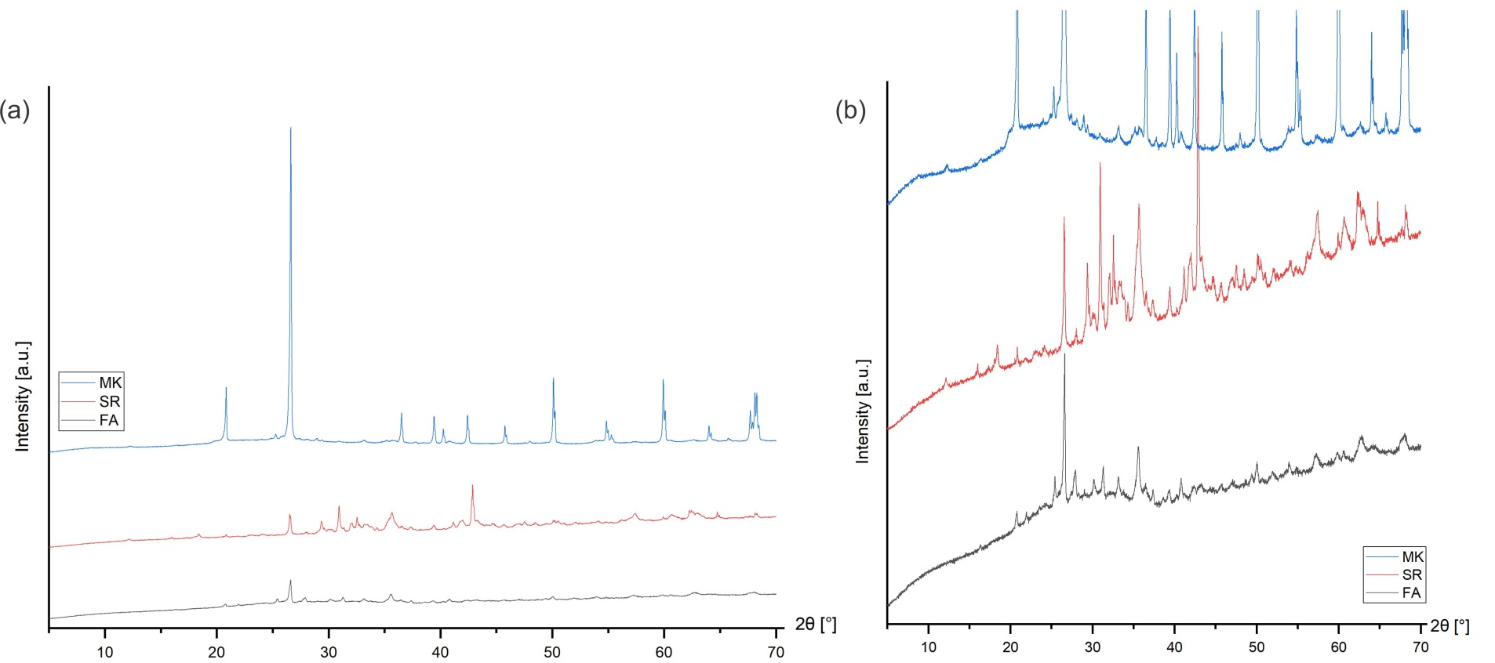Figure S1. (a) XRD patterns of precursors FA, SR and MK, and (b) enlarged part ascribed to amorphous content and background coming from the apparatus.

Rietveld refinement results and their XRD patterns of precursor SR, FA and MK, used for calculations of optimal mixture designs, with the optimally irradiated and non-irradiated limit results of AAMs, are presented in Figure S2 and Figure S3, respectively.

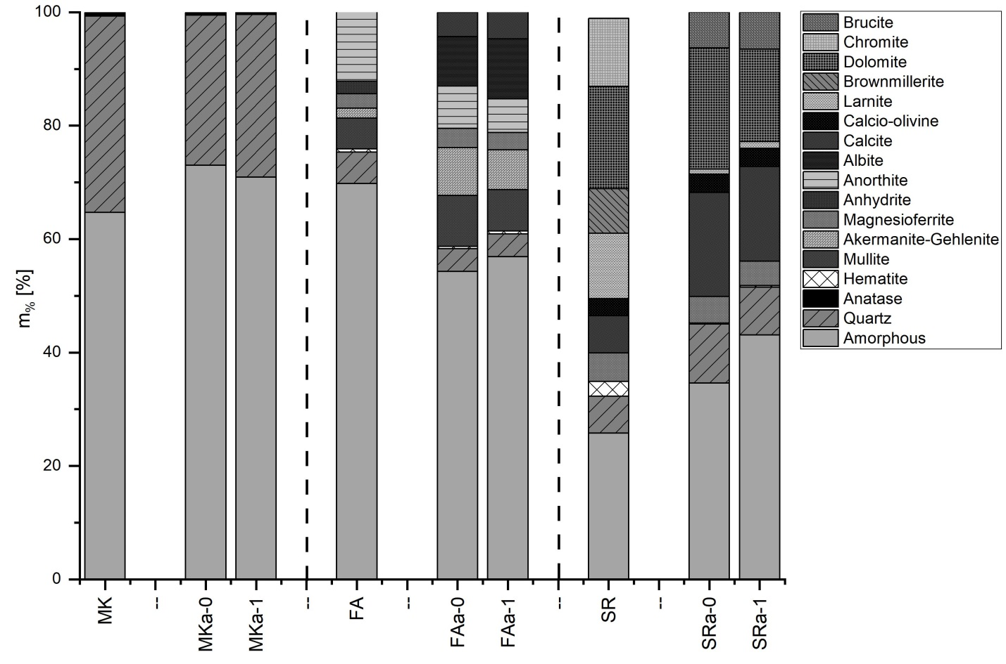
Figure S2. Rietveld refinement of precursor FA, SR and MK, and their long-term limit results of the most optimal AAM mixtures optimally irradiated and non-irradiated.

XRD patterns of 156-days-old irradiated (1) and non-irradiated (0) FAa (irradiation for 15 s at 40%), SRa (irradiation for 20 s at 60%) and MKa (irradiation for 5 s at 60%) with precursors. With dashed lines are marked minerals that form or disappear (except for MK). Mineral cards with their chemical formulas used for precursors and AAMs are listed in Table S1.

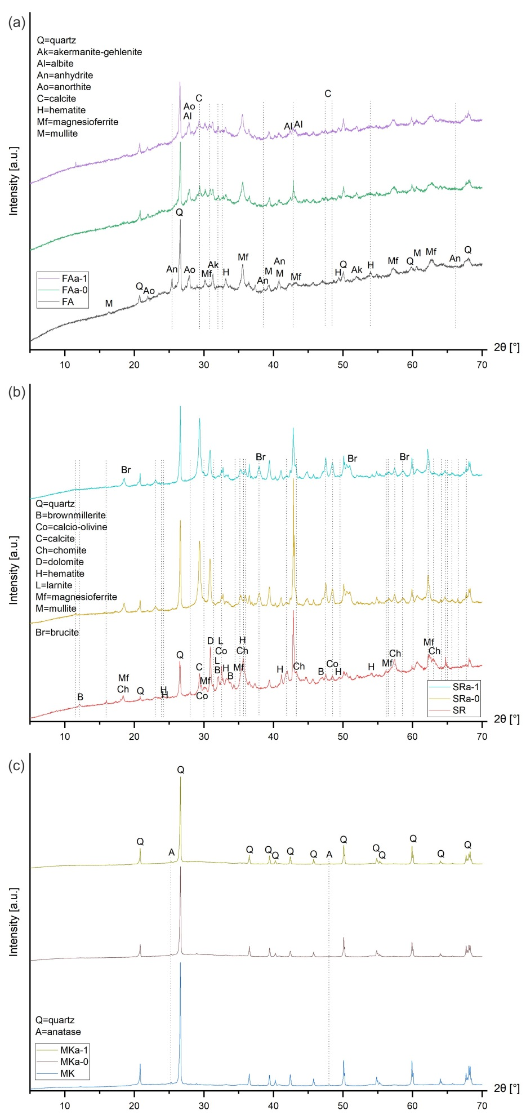
Figure S3. XRD patterns of a long-time limit of optimally irradiated and non-irradiated AAMs with precursors.

Table S1. XRD mineral cards and their chemical formulas, which were used for solving XRD patterns of precursors and AAMs.
Mineral name | Mineral card, reference code | Chemical formula
FA and AAM from FA
Quartz | ICSD 98-008-9278 | SiO₂
Hematite | ICSD 98-016-1291 | Fe₂O₃
Mullite | ICSD 98-004-3298 | Al_{1.83}Si_{1.08}O_{4.85}
Akermanite-Gehlenite | ICSD 98-016-0338 | Ca₂Mg_{0.35}Al_{1.3}Si_{1.35}O₇
Magnesioferrite | ICSD 98-024-0794 | Fe₂MgO₄
Anhydrite | ICSD 98-000-1956 | CaSO₄
Anorthite | ICSD 98-000-0654 | Ca(AlSiO₄)₂
Albite | ICSD 98-008-7660 | NaAlSi₃O₈
Calcite | ICSD 98-001-8166 | CaCO₃
SR and AAM from SR
Quartz | ICSD 98-015-6198 | SiO₂
Hematite | ICSD 98-041-5251 | Fe₂O₃
Magnesioferrite | ICSD 98-015-8433 | Fe₂MgO₄
Calcite | ICSD 98-002-0179 | CaCO₃
Calcio-olivine | ICSD 98-000-9095 | Ca₂SiO₄
Larnite | ICSD 98-003-9006 | Ca₂SiO₄
Brownmillerite | ICSD 98-024-5648 | Ca₂Mg_{0.1}Al_{0.9}FeO₅
Dolomite | ICSD 98-017-1521 | CaMg(CO₃)₂
Chromite | ICSD 98-017-1112 | Cr₂Fe_{0.32}Mg_{0.68}O₄
Brucite | ICSD 98-007-7086 | Mg(OH)₂
MK and AAM from MK
Quartz | ICSD 98-009-0145 | SiO₂
Anatase | ICSD 98-015-6838 | TiO₂

