APPENDIX A
This appendix contains additional analyses on the effect of flow velocity on shear forces in pier and abutments, foundation tip axial forces, and bending moments.
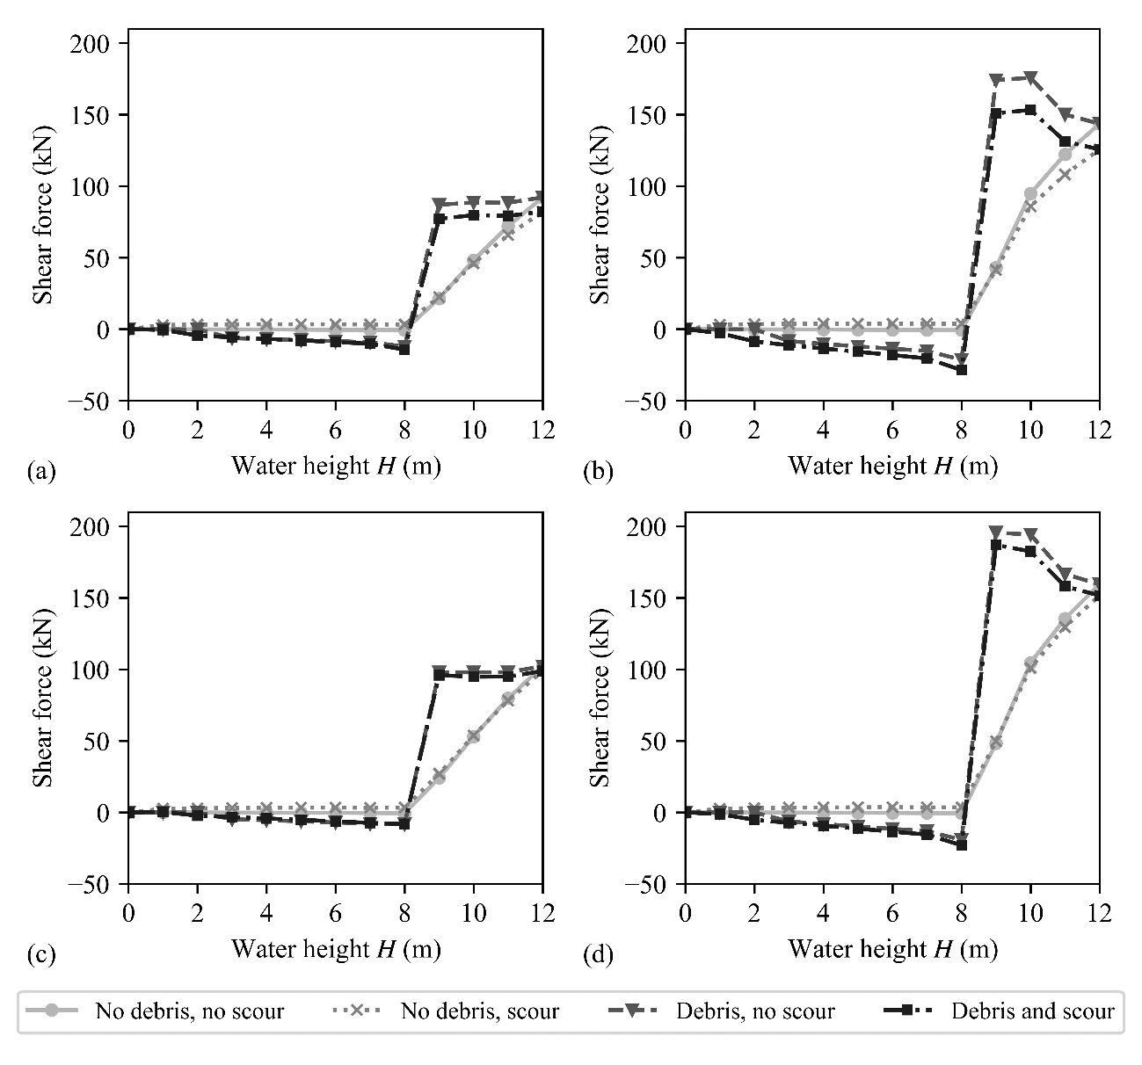
Figure A1:Shear force in bearings above the pier, (a) Lumped-spring SSI model with uniform flow distribution, (b) Lumped-spring SSI model with triangular flow distribution, (c) Winkler-spring SSI model with uniform flow distribution, and (d) Winkler-spring SSI model consideration with triangular flow distribution, for different flooding scenarios (v = 1.2 m/s).

It can be seen in Figure A1 that the shear force in the bearing above the pier change sign when the water reaches the deck, which is especially evident for the analyses with debris. This result was found to be a consequence of two distinct load transfer mechanisms, which are activated at different water heights. When water is below the deck, the flood loading is only applied to the pier and the deck provides elastic support at the top. Once the water reaches the deck, the mechanism of load transfer changes and the deck no longer supports the pier, but it actually pushes the pier in the direction of flow. This results in a change of the shear force in the bearing above the pier.
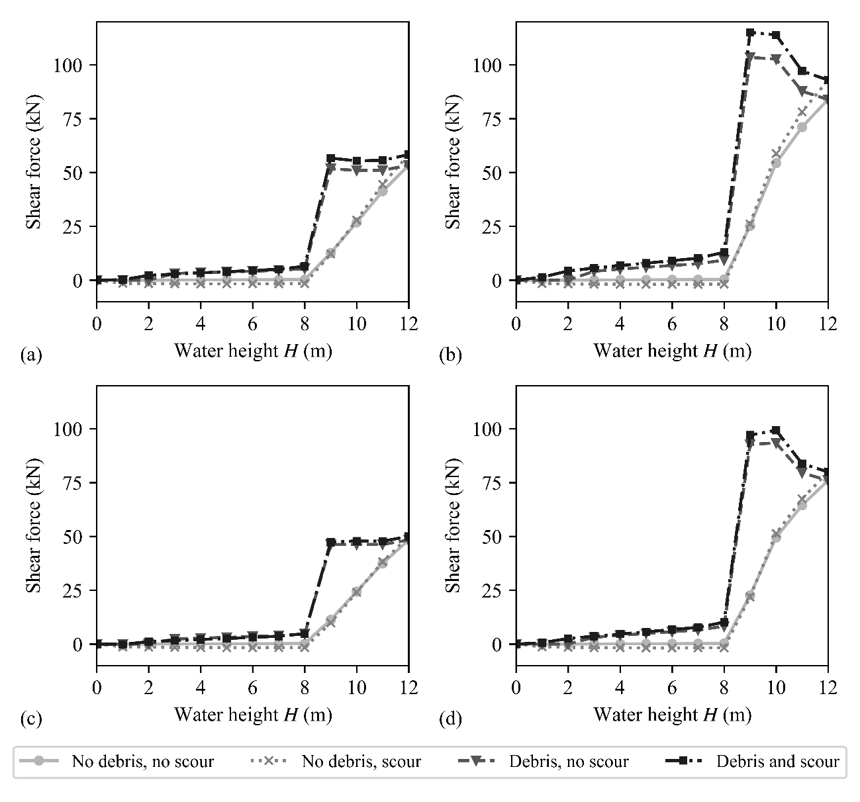
Figure A2: Shear force in bearings above the abutments, (a) Lumped-spring SSI model with uniform flow distribution, (b) Lumped-spring SSI model with triangular flow distribution, (c) Winkler-spring SSI model with uniform flow distribution, and (d) Winkler-spring SSI model consideration with triangular flow distribution, for different flooding scenarios (v = 1.2 m/s).

As can be seen in Figure A2, the change in the sign of the shear force in bearings above the abutment is less evident than for the pier in Figure A1. The effect of the debris is more pronounced that the effect of scour, for which two distinct trends can be seen as previously noted for the pier forces. In the case of the bearing above the pier, the influence of scour is consistent with the trend observed for the pier forces, i.e. scour increase the shear force when water is below the deck and vice versa (Figure 9). On the other hand, the effect of scour was observed to be the opposite in the case of the bearing above the abutment, for which scour decrease the shear force when water is below the deck, and increase the shear force when water reached the deck (Figure A2). This reversal for the effect of scour is expected because the reduction in the stiffness of the pier due to scour leads to redistribution of forces to the abutment bearings. In addition, triangular distribution of forces produces larger demand on the bearings. The results obtained with both modelling approaches are similar. The Winker SSI model produced slightly larger demand for the bearing above the pier and slightly lower demand for the bearing above the abutment compared to the Lumped SSI model. This is again a consequence of the local redistribution of forces between the bearings.

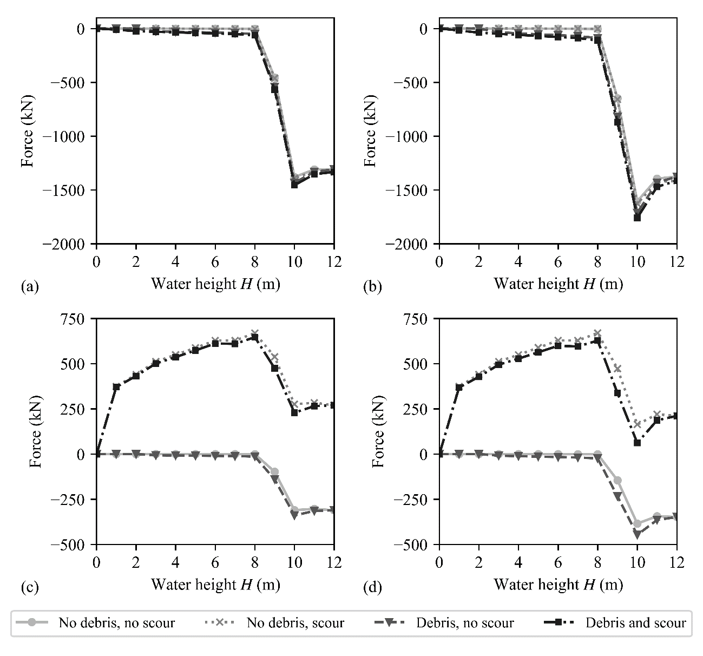
Figure A3: Foundation tip force, (a) Lumped-spring SSI model with uniform flow distribution, (b) Lumped-spring SSI model with triangular flow distribution, (c) Winkler-spring SSI model with uniform flow distribution, and (d) Winkler-spring SSI model consideration with triangular flow distribution, for different flooding scenarios (v = 1.2 m/s).

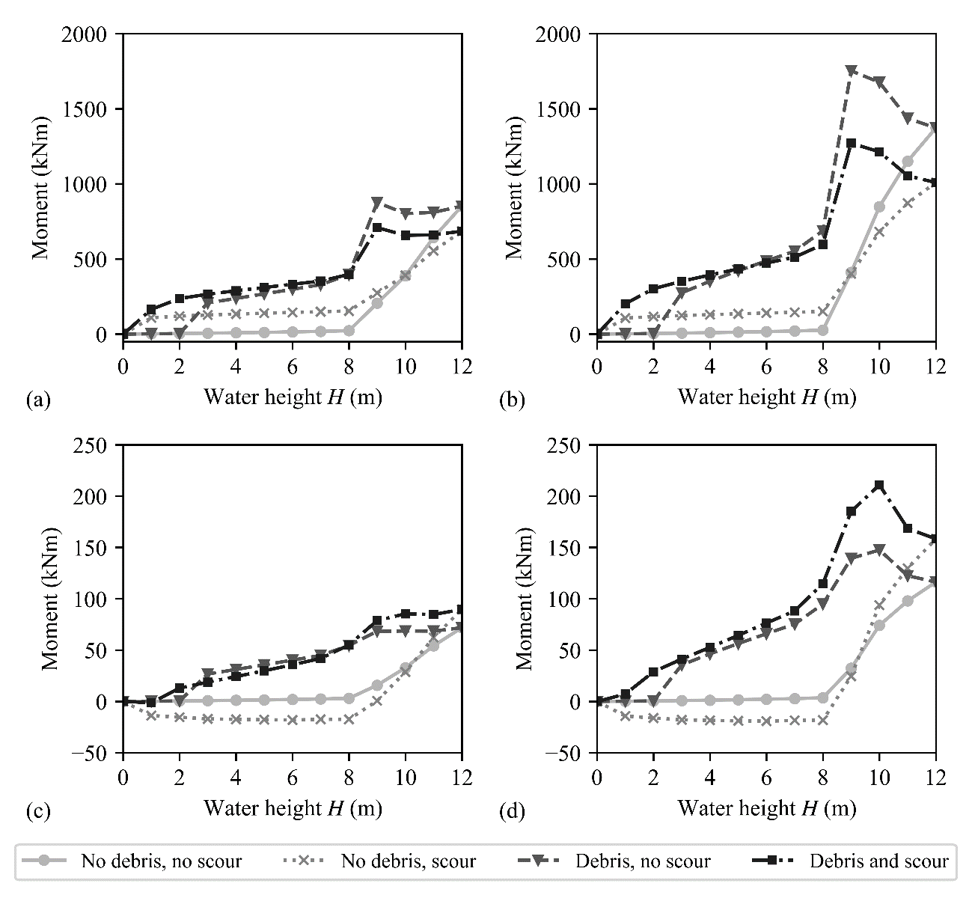
Figure A4: Foundation tip bending moment, (a) Lumped-spring SSI model with uniform flow distribution, (b) Lumped-spring SSI model with triangular flow distribution, (c) Winkler-spring SSI model with uniform flow distribution, and (d) Winkler-spring SSI model consideration with triangular flow distribution, for different flooding scenarios (v = 1.2 m/s).

Figure A3 and Figure A4 show that the two SSI modelling approaches produce quite different results for the foundation tip forces and bending moment. The difference is a consequence of the simplifying assumptions used in the Lumped SSI modelling, where it is assumed that the foundation loads are transferred entirely by the foundation base. It should be noted that such an approach neglects the contribution of the soil resistance over the shaft of the foundation, which results in overestimation of the foundation tip forces and bending moments. The Winker SSI modelling is in this context expected to provide more realistic modelling of the foundation forces. In Figure A3, foundation tip forces start to decrease when water reaches the deck as a result of hydrodynamic upward forces and buoyancy applied on the bridge deck (note that negative forces indicate uplift). Scour is observed to have a larger effect on the foundation tip forces in the case of the Winkler SSI model, whereas this effect is not observed for the Lumped SSI model. The results obtained for the Winkler model are a consequence of scour reducing the vertical force provided by the shaft (removal of soil springs), which results in an increase of the foundation tip force. This effect cannot be captured by the Lumped SSI because the contribution of the shaft is not modelled explicitly. Nevertheless, the Lumped SSI model is still able to reproduce globally the same effect as the Winkler SSI model with the vertical stiffness of the foundation becoming smaller due to the effect of scour. However, this is not sufficiently accurate for estimation of the foundation forces.
The difference in both modelling approaches can be also observed based on a comparison of the foundation tip bending moments (Figure A4). The two models exhibit the opposite trend regarding the influence of the scour on the foundation tip bending moment. Again, more realistic results are judged to be provided by the Winkler SSI model, which indicate that scour would increase the bending moment at the tip of the foundation (in absolute terms). The analyses with no debris and water height below the deck seem to produce an opposite rotation of the foundation, which produces a negative sign of the bending moment in the foundation. Nevertheless, scour also in this case increases in absolute terms the bending moment in the foundation.

