Supplementary Material

Freeze-casting of highly porous cellulose-nanofiber-reinforced γ˗Al2O3 monoliths
H. Hudelja^{1,2}*, T. Konegger³, B. Wicklein⁴, J. Čretnik⁵, F. Akhtar⁶, A. Kocjan^{1,2}
¹Department for Nanostructured Materials, Jožef Stefan Institute, Jamova 39, 1000 Ljubljana, Slovenia
²Jožef Stefan International Postgraduate School, Jamova 39, 1000 Ljubljana, Slovenia
³Institute of Chemical Technologies and Analytics, TU Wien, Getreidemarkt 9/164-CT, A-1060 Vienna, Austria
⁴Instituto de Ciencia de Materiales de Madrid (ICMM), Consejo Superior de Investigaciones Científicas (CSIC) Calle Sor Juana Inés de la Cruz, 3, Madrid 28049, Spain
⁵ Slovenian National Building and Civil Engineering Institute, Dimičeva ulica 12, 1000 Ljubljana, Slovenia
⁶ Division of Material Science, Luleå University of Technology, SE-97187 Luleå, Sweden

*Corresponding author:
Hermina Hudelja: hermina.hudelja@ijs.si, Tel.: +386 1 477 39 57

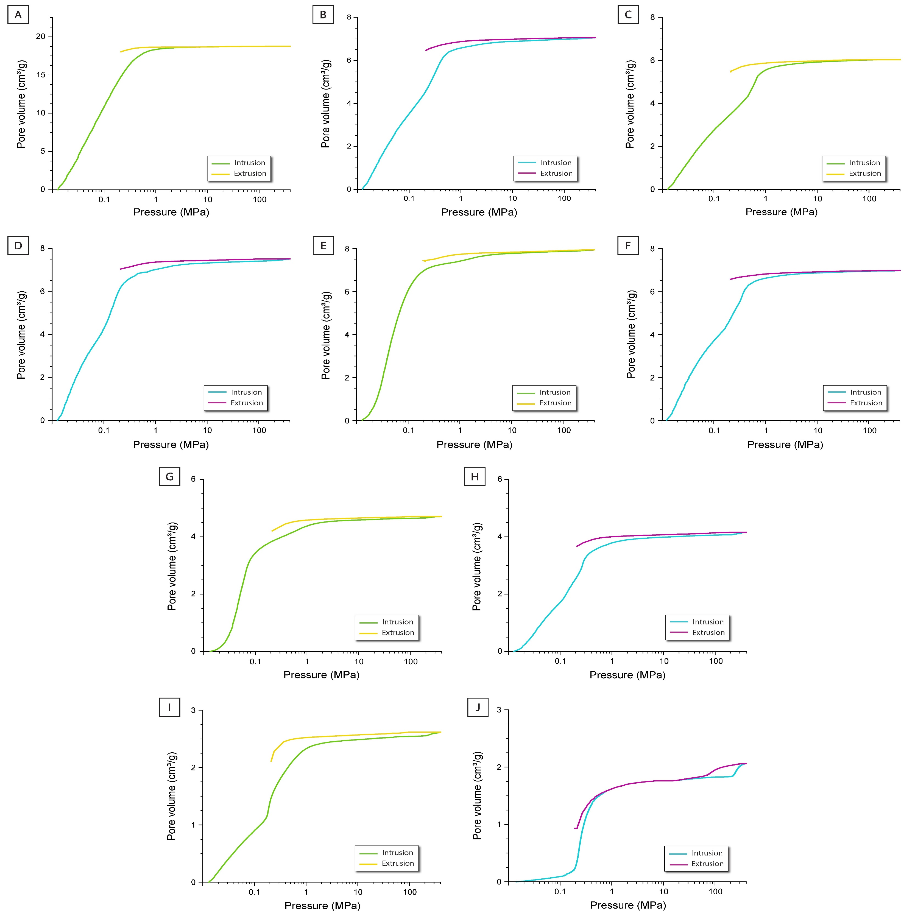

Figure S1: Intrusion and extrusion curves of A) monolith FZC‒1, B) monolith FZC‒2, C) monolith FZC‒3, D) monolith FZC‒4, E) monolith FZC‒5, F) monolith FZC‒6, G) monolith FZC‒7, H) F monolith ZC‒8, I) monolith FZC‒9, J) pure MA powder.

Supplementary Discussion 1: Influence of freezing rate on the evolution of porosity
The freezing rate had no relevant influence on the total porosity of HMMA monoliths. However, it had a considerable influence on pore size distribution (Fig. S2). In both cases a slower rate (1 °C/min) resulted in bigger pores sizes and narrower, monomodal pore size distribution with modal pore diameter of 40.5 and 29.7 μm for monoliths FZC‒5 and FZC‒7, respectively. When a faster freezing regime was used (6 °C/min) a broad, bimodal pore size distribution evolved. At fast cooling speeds smaller ice crystals are formed [1], since the crystallization process is controlled by nucleation and not by crystal growth. The size of ice-crystals determines macroporosity of final material, so the faster freezing rates result in finer pore sizes.
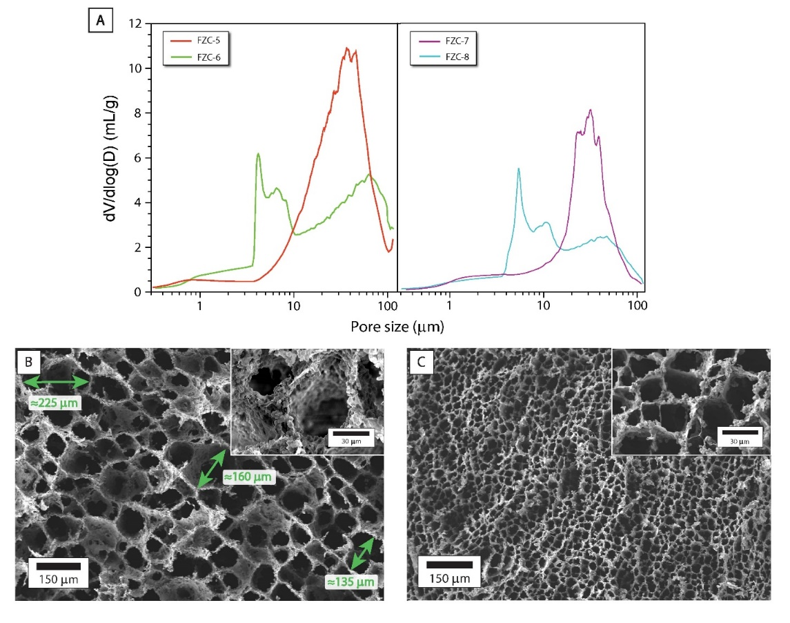
Figure S2: A) Influence of freezing rate on pore size distribution. B) SEM of monolith FZC‒5. Arrows indicate pores bigger than 115 μm. C) SEM of monolith FZC‒6.
The majority of macropores in monoliths FZC‒6 and FZC‒8 had a diameter of only few micrometres (between 3 and 11 μm), but some bigger pores with modal diameter at 48.4 μm (FZC‒8) and 62.9 μm (FZC‒6) were also formed. Prevailing finer pore structure of monoliths frozen at faster rates was additionally confirmed by SEM (Fig. S2B and S2C). Apparently the chosen freezing rate (6 °C/min) was not fast enough to completely prevent extensive ice-crystal growth, thus the evolved pore size distribution was bimodal.
While a freezing rate of 6 °C/min was apparently too fast to promote the growth of ice-columns with diameters exceeding 100 μm, which were present in FZC‒5, it was not fast enough to entirely prevent the formation of pores with diameter above 10 microns. The freezing rate also had an impact on the thickness of pore walls [2]. As can be seen from the magnified SEM images (Fig. S2B and S2C), the pore sizes were not only smaller at faster rates, but also thinner walls were formed.
Additionally, pore size distributions of both fast-frozen monoliths (FZC‒6 and FZC‒8) were very similar, with the only difference in the total volume of bigger pores (with diameters above 20 μm), i.e. the monolith FZC‒6 possessed higher volume of these pores. The latter was to be expected, since the same trend of decreasing number of bigger pores with increasing MA volume fraction was also observed at slow freezing rate (Fig. 4 in the manuscript).
Supplementary Discussion 2: Estimation of permeability
Permeability characteristics of monoliths FZC‒5 and FZC‒7 were determined by gas permeation experiments. Forchheimer’s equation (Eq. 1) for compressible fluids [3] was used to determine Darcian (k₁) and non-Darcian permeabilities (k₂):
$\frac{p_{i}^{2}−p_{0}^{2}}{2p_{0}∙L}=\frac{η}{k_{1}}\left(\frac{Q}{A}\right)+\frac{ρ}{k_{2}}{\left(\frac{Q}{A}\right)}^{2}$ (Eq.1)
Here, p_{i} and p_{o} are the absolute pressures on upstream and downstream side, respectively. Q is the volumetric air flow rate at the sample exit, A is the cross-sectional area normal to the flow and L is the sample thickness. An air viscosity of η = 1.84×10⁻⁵ Pa·s and an air density of ρ = 1.16 kg·m⁻³ were assumed (p_{o} = 1004 mbar and T = 22 °C). In order to determine k₁ and k₂, a quadratic function was fitted to (p_{i}²-p_{o}²/2p_{o}L) versus Q/A (Fig. S3), using the least-squares method.
The relationship between pressure drop and gas velocity Q/A was found to be indeed based on a quadratic relationship, indicating there are significant Non-Darcian contributions to the overall permeability characteristics.
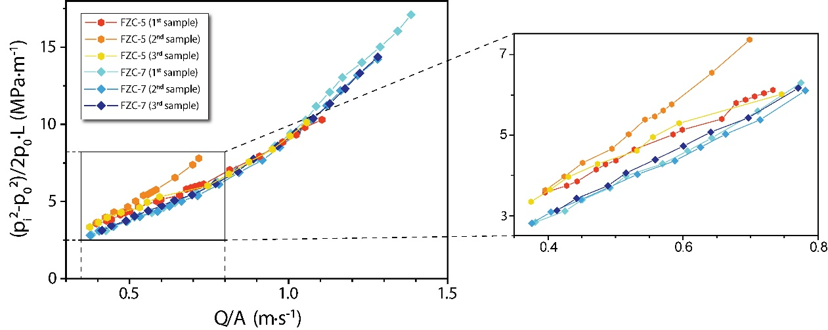
Figure S3: Specific air flow through specimens versus pressure differential, shown for monoliths FZC‒5 and FZC‒7 (n = 3 per batch).
Supplementary Discussion 3: Influence of freezing rate on compressive properties
The freezing rate had a considerable effect on compressive properties in axial direction (Fig. S4 and Table 4 in the manuscript). At lower MA volume fractions (φ_{A} < 0.054), higher yield points were measured for monoliths consolidated at slow freezing rate (1 °C/min). With increasing volume fraction (from 0.013 to 0.054), differences between yield points of slow and fast frozen monoliths decreased, reaching almost the same value at φ_{A} ≥ 0.054 (Fig. S4C). Better compressive properties of slowly frozen monoliths FZC‒2 and FZC‒5 can be readily explained by thickness of monolith pore walls. As already stated, at slower freezing rates, thicker walls were formed (Fig. S2B) that can withstand higher loads. At higher solid volume fractions, the compressive strengths, obtained in both directions, became similar. Since a well-defined columnar porosity could not evolve at as high volume fractions, pore structure was more random (Fig. 4D and 4E in the manuscript). As a consequence, differences in compressive properties in radial and axial direction disappeared. 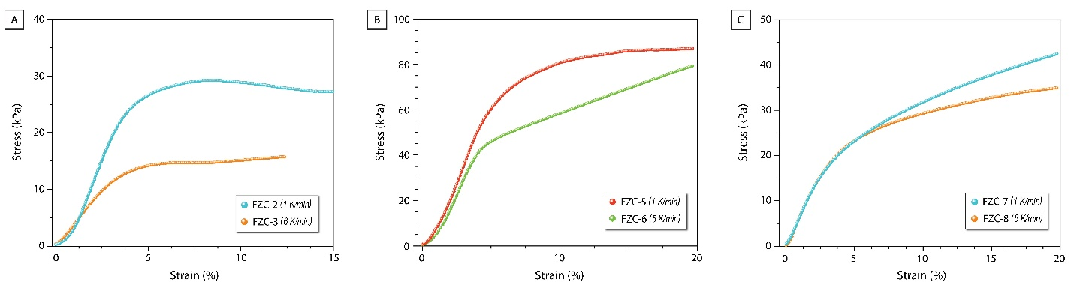
Figure S4: Influence of cooling speed on compressive stress of monoliths prepared from suspensions with different content of MA powder and CNF.
Supplementary Discussion 4: Determination of thermal properties
Cylindrical monoliths were used to determine thermal conductivity in axial direction (parallel to ice growth front), while cubes were used to measure thermal conductivity in radial direction (perpendicular to ice growth front), as illustrated on Fig. S5. Cylinders had a diameter of 25 mm and minimum height of 20 mm (12 mm in the case of monolith MA‒CIP200), while the cubes used had a side dimension of 20 mm.
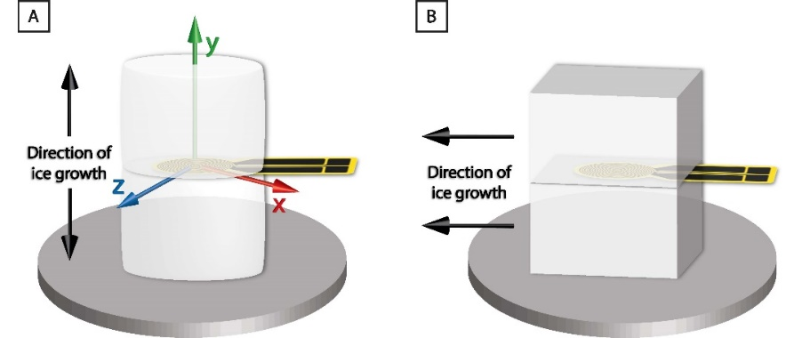
Figure S5: Illustration of measurement setup for the determination of thermal conductivity in axial (A) and radial (B) direction. The arrows indicate the in-plane (xy) and out-of-plane measuring direction (xz).

For the determination of specific heat capacity, a reference measurement was performed prior to an actual measurement. An empty cylinder, thermally insulated with polystyrene, was carefully heated with an applied power of 90 mW for 80 seconds. Under the conditions applied, the temperature inside the empty cylinder increased from 22.2 °C to 30.1 °C. Then the cylinder was left to cool down and a sample of known mass was placed inside it. The cylinder containing the sample was then again thermally insulated with polystyrene and heated. Electrical heating power was adjusted, so that the temperature increase was the same as in the reference measurement. Five independent measurements were performed, with a 2-hour conditioning time between measurements.
Hot disk enables simultaneous determination of thermal conductivity (λ) in-plane (axial) and through the plane (radial) of the sample. However, the as-determined radial λ is only valid if the sample has a homogeneous structure, i.e. evenly distributed and shaped pores along x- and z-axis as marked on Fig. S5A. As can be seen from SEM images (Fig. 4, A‒E in the manuscript) that is not the case for our monoliths, so the radial λ was determined in a separate measurement. The exception was the monolith MA‒CIP200 where due to its homogeneous pore shape axial and radial thermal conductivity could be determined with adequate certainty in a singular, anisotropic measurement.
References for Supplementary Material:
[1] S. Deville, Freeze-casting of porous ceramics: A review of current achievements and issues, Adv. Eng. Mater. 10 (2008) 155–169. doi:10.1002/adem.200700270.
[2] S.A. Barr, E. Luijten, Structural properties of materials created through freeze casting, Acta Mater. 58 (2010) 709–715. doi:10.1016/j.actamat.2009.09.050.
[3] M. Innocentini, P. Sepulveda, F. Ortega, Permeability, in: M. Scheffler, P. Colombo (Eds.), Cell. Ceram., Wiley, Weinheim, 2005: pp. 313–341. doi:10.1007/978-1-4614-7990-1.

