Supplementary Information

Environmental hazard of polypropylene microplastics from disposable medical masks: acute toxicity towards Daphnia magna and current knowledge on other polypropylene microplastics

Anita Jemec Kokalj^{1,}*, Andraž Dolar¹, Damjana Drobne¹, Marjan Marinšek², Matej Dolenec³, Luka Škrlep⁴, Gregor Strmljan⁴, Branka Mušič⁴, Andrijana Sever Škapin⁴

¹University of Ljubljana, Biotechnical Faculty, Department of Biology, Večna pot 111, SI-1000 Ljubljana, Slovenia
²University of Ljubljana, Faculty of Chemistry and Chemical Technology, Chair of Materials and Polymer Science, Večna pot 113, SI-1000 Ljubljana, Slovenia
³University of Ljubljana, Faculty of Natural Sciences and Engineering, Department of Geology, Aškerčeva 12, SI-1000 Ljubljana, Slovenia
⁴Slovenian National Building and Civil Engineering Institute; Dimičeva ulica 12; SI-1000 Ljubljana, Slovenia

*Corresponding author: Anita Jemec Kokalj
Department of Biology
Biotechnical Faculty
University of Ljubljana
Večna pot 111
SI-1000 Ljubljana, Slovenia
Email: anita.jemec@bf.uni-lj.si

Fourier-transform infrared spectroscopy
Figure S1

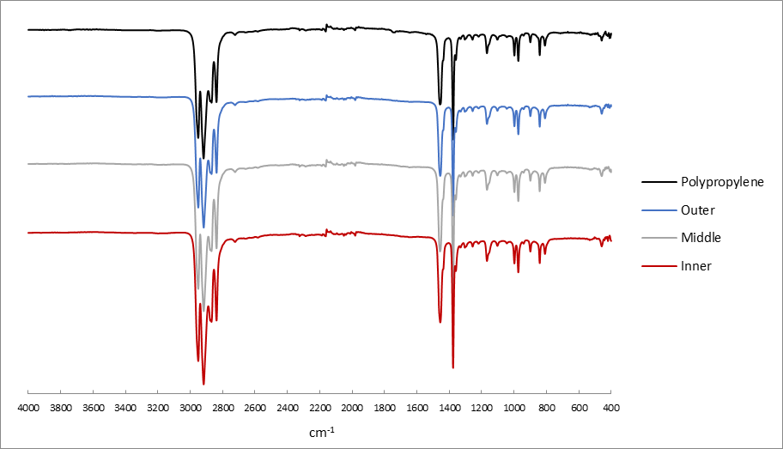
Figure S1. Attenuated total reflection–Fourier-transform infrared spectroscopy spectra for the polypropylene standard (from the internal Slovenian National Building and Civil Engineering Institute [ZAG] database) and for the inner frontal, middle filtering and outer layers of the milled medical mask.

Gas chromatography–mass spectrometry analysis
Figures S2-S6
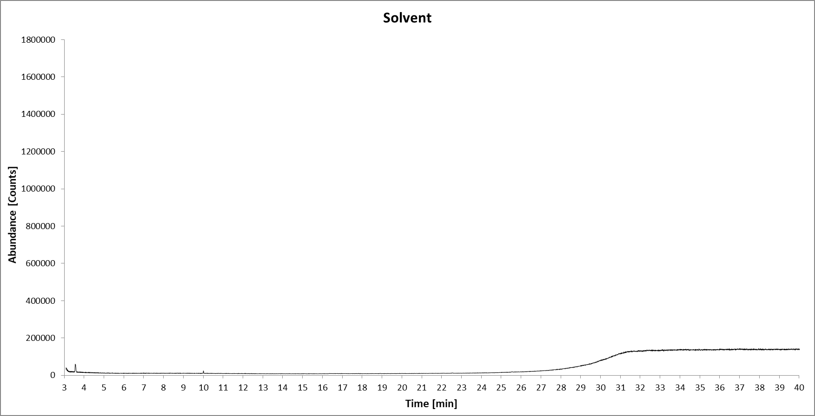
Figure S2. The GS-MS chromatogram of solvent (methanol).
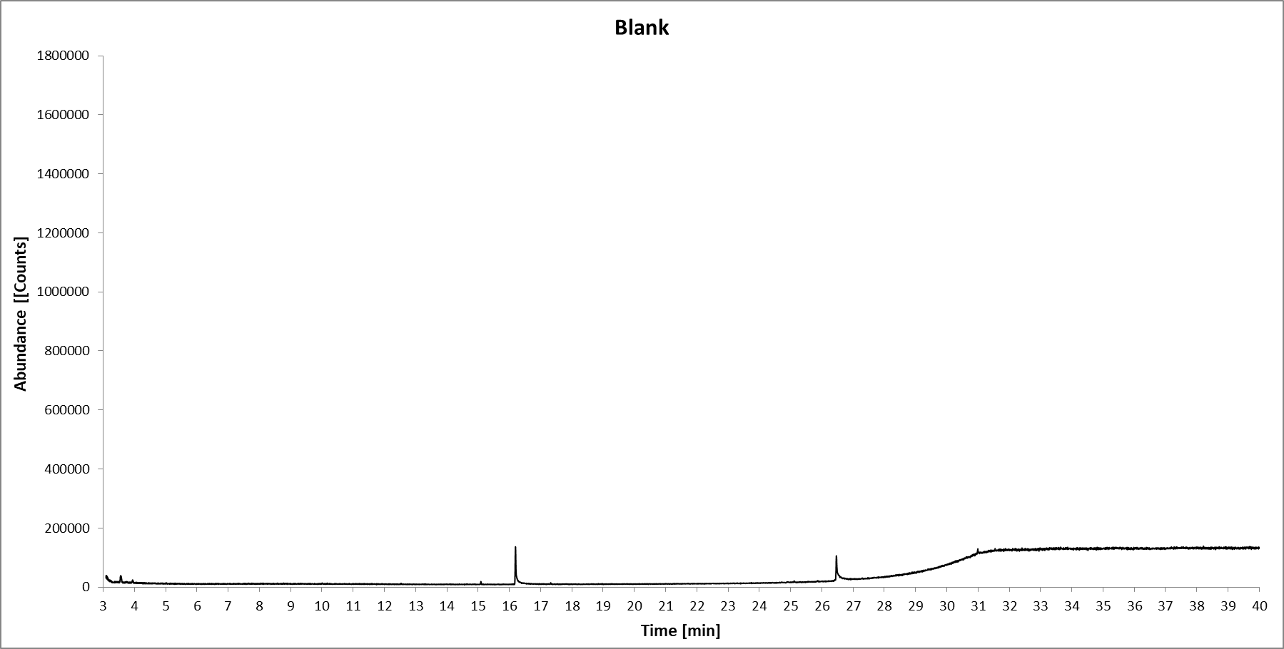 Figure S3. The GS-MS chromatogram of procedural blank.

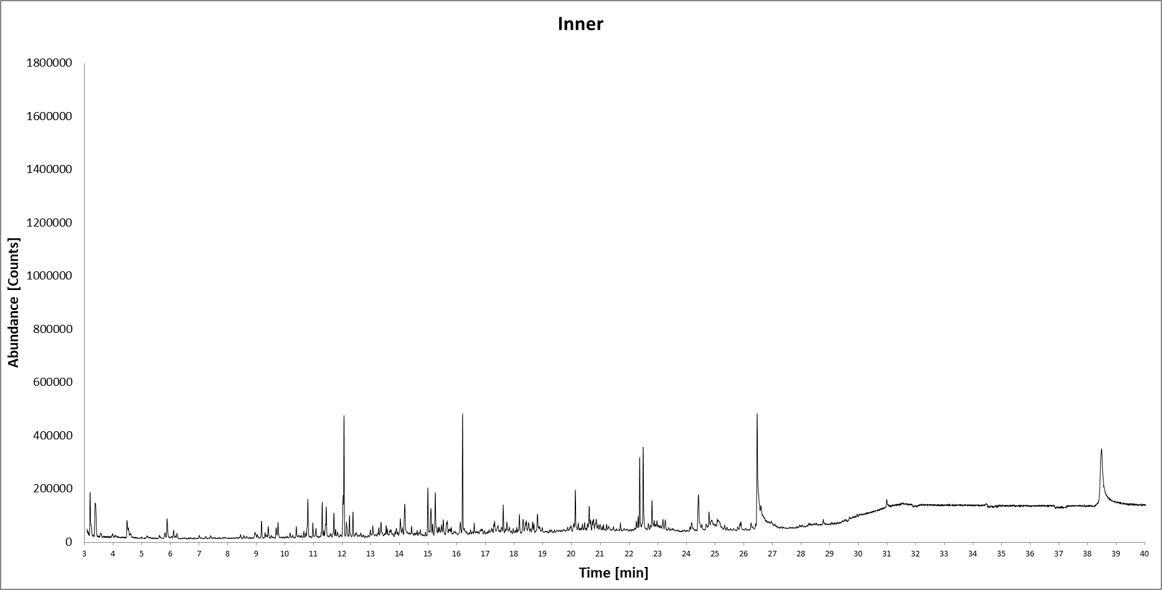
Figure S4. GC-MS chromatogram of the extract of the milled inner frontal layer of the face mask.

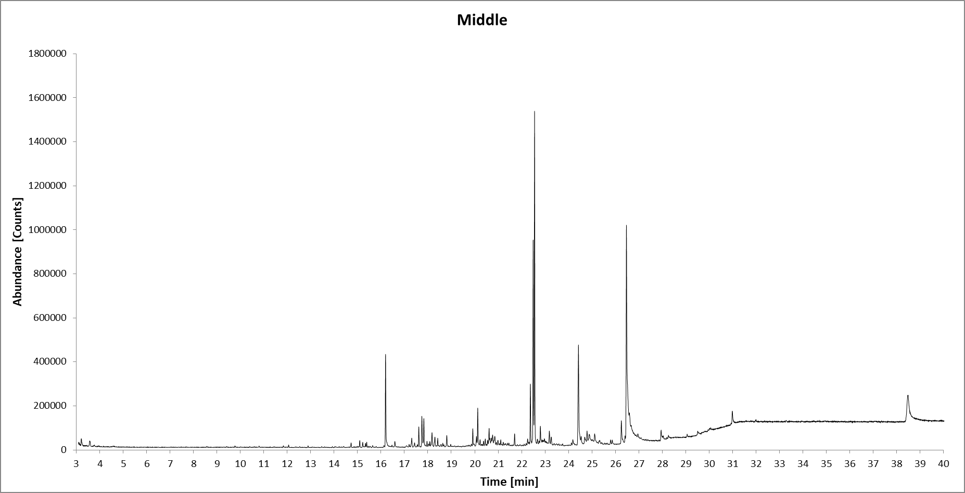
Figure S5. GC-MS chromatogram of extract of the milled middle filtering layer of the face mask.

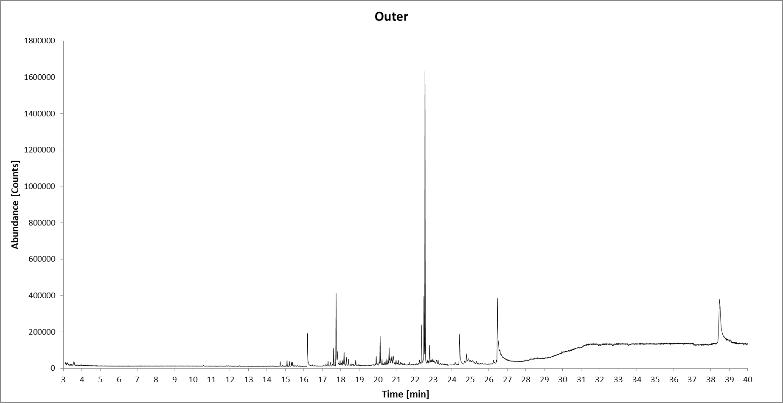
Figure S6. GC-MS chromatogram of the extract of the milled outer blue layer of the face mask.

A review of ecotoxicity data on polypropylene microplastics

Table S1. Search keywords and the number of results obtained. The number of relevant studies is also marked.
 | WoS  (advanced search: articles, category: Environmental Sciences | ScienceDirect  (advanced search: Research articles, subject area Environmental Sciences)
“Microplastics” and “polypropylene” | 688 (20 relevant) | 2003 (14 relevant)
“Microplastics” and “polypropylene” and “toxic” | 59 (7 relevant¹) | 1175 (13 relevant²)
¹all the same as for the “Microplastics” and “polypropylene” WoS search, ²12 of these are the same as for the “Microplastics” and “polypropylene” ScienceDirect search

