a | b

Fig S1. (a) CFC for all As data at Pan-European level. The P98 (BLC_{As}) correspond to 15 µg/L.
(b) CFC for all F⁻ data at Pan-European level. The P98 (BLC_{F}) correspond to 2.3 mg/L.

Table S1. Summary about the intersection of (A) [As] ≥15 µg/L (BLC_{As}) and (B) [F⁻] ≥2.3 mg/L (BLC_{F}) (b) with different litho-chronostratigraphic units: (1) European Crystalline Massifs, ECM (Precambrian, Paleozoic, Igneous and Metamorphic rocks); (2) Mesozoic-Triassic; (3) Mesozoic-Carbonated rocks (Mesozoic-Jurassic and Mesozoic-Cretaceous); and (4) Cenozoic.
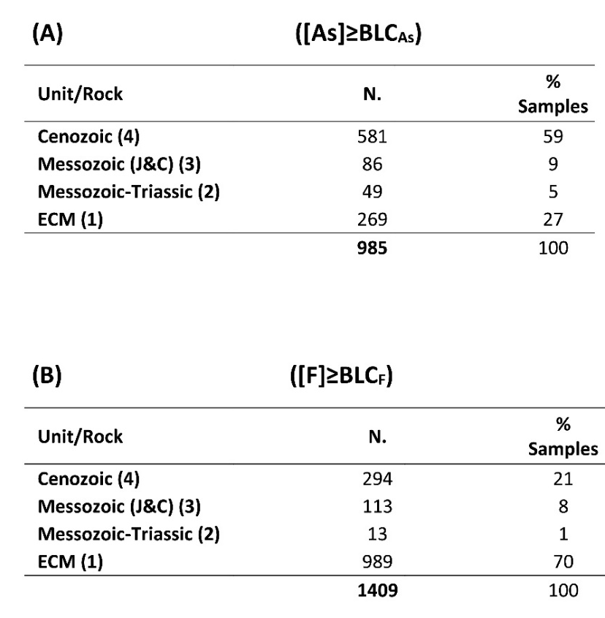
Table S2. Summary about the intersection of (A) [As]≥15 µg/L (BLC_{As}) and (B) [F⁻]≥2.3 mg/L (BLC_{F}) with mapped faults at different distances. The results are shown taking into account the main litho-chronostratigraphic units (1) European Crystalline Massifs, ECM (Precambrian, Paleozoic, Igneous and Metamorphic rocks); (2) Mesozoic-Triassic; (3) Mesozoic-Carbonated rocks (Mesozoic-Jurassic and Mesozoic-Cretaceous); and (4) Cenozoic.

