Linguistic Habitus, Different Capitals and the Identity of Bilingual Youth: The Case of Austrian Carinthia
Sabina Zorčič
ORCID ID: https://orcid.org/0000-0001-6647-1209
LinkedIn: https://www.linkedin.com/in/sabina-zor%C4%8Di%C4%8D-b6048966/
Inštitut za narodnostna vprašanja - Institute for Ethnic Studies
Erjavčeva ulica 26
SI-1000 Ljubljana
Slovenia
E-mail: sabina.zorcic@guest.arnes.si
Tel.: +386 31 88 00 99
The article summarises the results of pilot research about communicative practices among adolescents at bilingual schools in Austrian Carinthia. I present the findings by referencing Bourdieu's Theory of Practice, which I supplement when necessary with established concepts from sociolinguistics and social psychology. Bilingual schools are one of the last public spaces in the region where the use of Slovene is said to prevail, but even here it seems that Slovene is not the first choice of most pupils. We can conclude from what the young people say about their language practices that the decisive elements for the formation of an individual’s (language) identity are the habitus acquired during primary socialisation and the linguistic capital acquired during the phase of secondary socialisation or formal education. The current relative values of different languages in Austrian Carinthia as determined by their use are, of course, not set in stone, but it seems that that any change would require active language policies.
Keywords: linguistic habitus, linguistic capital, linguistic identity, minority language, Slovenian language, Austrian Carinthia.
Geolocation information: Austrian Carinthia
Funding details: This work was supported by the Slovenian Research Agency (research core funding No. 1000-17-0507).

Introduction
Sociolinguistic research that examines the language behaviour of the individual – in our case the selection of a language in formal and informal contexts at a bilingual school – should be based on notions linked to the individual’s identity. The development of locally intelligible subjectivities is a central theme in most language socialisation studies. Of course, the key terms are ethnic and linguistic identity, both of which are complex phenomena in the case of individuals from bilingual or multilingual areas. Studies conducted in bilingual settings demonstrate that the availability of two codes, however they may be distinguished locally and however the relationship between them may be conceptualised, constitutes an important resource that speakers can and do draw upon in “socialising culturally preferred subjectivities” (Garrett 2007, 236). In this article, (linguistic) socialisation is treated as the constituent (language) habitus of the individual. Bourdieu and Thompson (1991, 12) define habitus as a set of dispositions acquired during socialisation that incline agents to act and react in certain ways. Habitus provides individuals with a sense of how to act and respond in the course of their daily lives. It gives them “a feel of the game, a sense of what is appropriate in the circumstances and what is not, le sens pratique” (Ibid., 13). If you don’t feel like a “fish in water, the structuring of your habitus does not match that of the social context” (Maton 2012, 56). Linguistic capital is a sub-type of cultural capital (cf. Bourdieu 1986) and describes “the capacity to produce expressions à propos, for a particular market. Moreover, the distribution of linguistic capital is related in specific ways to the distribution of other forms of capital (economic capital, cultural capital, etc.) which define the location of an individual within the social space” (Bourdieu and Thompson 1991, 18). When dealing with language in a bilingual area two main aspects can be highlighted: (1) language(s) as a means of primary socialisation and the appearance of a linguistic habitus; and (2) language as a means of secondary socialisation (i.e. within educational institutions), a function through which it represents an opportunity to augment one's cultural (and consequently linguistic) capital. In the following analysis, I will show that an individual’s habitus and all the different forms of capital he or she possesses constitute his or her linguistic and national (or ethnic or regional) identities, and that these can be mutually exclusive.
I begin by briefly presenting the current state in Austrian Carinthia, that is, the bilingual habitus of Carinthian Slovenes and their bilingual education. After a brief presentation of the methodology used in the research results are presented and interpreted in chapters that shed light on linguistic habitus, the use of language in school and the relationship between the local dialect and standard Slovene. The theme of identity is central to discussions of bilingual youth and their communicative practices and language choices, and it therefore appears in various contexts throughout the paper. Identity is then addressed specifically in the last section, which focuses on respondents’ views on (their) different identities (ethnic, regional, national). The paper concludes with a synthesis of the discussion and my final thoughts on the subject.
- Bilingual Habitus and Bilingual Education in Austrian Carinthia
Primary socialisation usually takes place within the immediate and extended family, in the environment in which an individual lives and at educational institutions on the primary level, usually kindergarten and preschool. In bilingual or multilingual areas it is particularly interesting to observe the different forms individuals’ linguistic habitus takes, as these are the result of different circumstances and different inputs during primary socialisation. In Austrian Carinthia, a sharp decline in the use of Slovene over the past decade has largely been the result of the “privatization of Slovene” (Larcher 1991, 122) and negative demographic changes: the Carinthian Slovene ethnic group had 95,735 members in 1846, but just 12,586 in 2001 (Zupančič 1999, 2002). The results of the research confirm that German is the legitimate language, the first choice, and this is of course an internalised practice directed by the linguistic habitus. The term legitimate language is used in the Bourdieusian sense to mean the language with the greatest chance of success of being effective in discourse (cf. Bourdieu 1977, 650; Bourdieu and Thompson 1991, 70). In ethnically mixed areas, Slovene has the status of “an official language in addition to German”, and this applies particularly to juridical and official
contexts. But legal legitimacy does not guarantee actual use. And not insignificantly, the new provincial constitution passed in 2017 lists German as the sole official language (Art. 5 "Kärntner Landesverfassung") in spite of efforts by the Slovene minority. This could lead to even greater legitimacy in the Bourdieusian sense of the word.
Secondary socialisation in a bilingual area, that is, socialisation outside the family environment, takes place within educational institutions (primary and secondary schools). The task of bilingual schooling is of course to provide education on the individual, communal, regional and national levels. But language input and output are highly changeable. Whereas schooling in the minority language is a necessity, it is not decisive for language maintenance (cf. Hornberg (1988), cited in Baker 2001, 72). The formal legal and practical features of Slovene-language education in Austria have been described in depth elsewhere (e.g. "The Slovene Language in Education in Austria" 2005). Only those particular features relevant to the specific discussion will be discussed here.
The central role of the bilingual primary school (Volksschule) in the formation of a bilingual individual in Carinthia has been emphasised by authors whose work focuses on the psychological dimension of bilingualism in Carinthia, e.g. Larcher (1991) and Merkač (1986). Passive reception of the German language takes place much earlier. Through mass media, German even finds its way into homes where the only language of communication is Slovene (Busch 1999). For two decades now, practically no children have started primary school without a knowledge of German (Domej 1999, 132). A quarter of the children living in the bilingual area are registered for bilingual classes at primary school, while three quarters do not have any active contact with Slovene during their education (Ibid.). The consequences of enrolling minority children in a single-language school are predictable: they find themselves in a typical diglossic situation with the use of the Slovene dialect as a lower language type and German as a higher type (e.g. Interview 6TA: “Yes, my brother’s language conduct is similar, but he speaks only the dialect because he only went to the bilingual primary school [4 years, author’s note] and now has a job”). Prolonged attendance at a bilingual school should prevent a situation like this, but the results show that at best it only alleviates it. And in the case of pupils whose primary linguistic socialisation, i.e. the intergenerational transfer of the minority language, takes place to an even more limited extent, it is very difficult for educational institutions to make up for what childhood did not provide.
Today we are witness to two different tendencies in bilingual education in Austrian Carinthia. At the primary level (Volksschule), the increased enrolment of children with no prior knowledge of Slovene in bilingual classes is no longer a new phenomenon (cf. Domej 1999; Ogris 1995; Kern 2009; Ogris 2014). Yearly assessments by bilingual teachers revealed that of the 643 children enrolled in bilingual classes in the 2015/16 school year, only 15% showed good linguistic competence in Slovene; 22% had sufficient linguistic competence, while 62% had no linguistic competence in Slovene (Sandrieser, Vrbinc, and Weinfurter 2016, 65). For this reason some researchers are convinced that “bilingual schools have more and more assumed the function of dual language (immersion) schools or enrichment programmes for children belonging to the linguistic majority” (Doleschal 2011, 164). Ogris (2014, 98) arrived at a similar conclusion, noting that German-speaking parents' motivation for enrolling their children in bilingual classes is “linguistic education and has nothing with to do with the minority.”
Another tendency that has become apparent in recent years is the increased enrolment of pupils from Slovenia at bilingual secondary schools. This has served to balance out the ratio of Slovene to German native speakers on the secondary level, but due to the processes described above the pupils are very heterogeneous, and “Slovene has acquired a mixed status somewhere between a mother tongue, a second language and a foreign language learned more or less through formal instruction in the educational system” (Doleschal 2011, 165).
- Methodology
The paper presents several key findings from pilot research carried out in 2017 among secondary-school students at three bilingual schools in Austrian Carinthia – the Slovene Gimnazija (secondary school), the Commercial College in Klagenfurt and the College for Commercial Vocations in St. Peter. Twenty-four semi-structured interviews were carried out, and data was collected from 7 male and 16 female respondents ages 18 and 19 and from one underage female respondent (17) who obtained permission from her parents. All the respondents were Austrian citizens living in various parts of south Carinthia. Through the interviews, I obtained information about the respondents' habitus, the level of the various forms of capital they possessed and their communicative practices in different situations. The respondents were able to choose the language of the interviews, but only one female student chose German. The respondents also completed The Big Five Personality Test as part of the interview. The test, which is also known as the Big Five Inventory, measures the five main personality traits, O-openness, C-conscientiousness, E-extroversion, A-agreeableness and N-neuroticism (the “OCEAN” traits). Measurements of the Big Five personality dimensions were implemented with the help of a publicly accessible website (https://www.outofservice.com/bigfive/) that has been used in a wide variety of influential online studies on personality (for more see Srivastava et al. 2003). The test assigns a nominal value of 1 (the lowest possible value) to 100 (the highest) for every personal (OCEAN) trait. The students completed the Big Five test in German. Although the main aim of the pilot project was to get qualitative data on the speech behaviour of young people, it was possible to summarise some of the quantitative data obtained and to prepare a graphic presentation of select data using the open source Orange Data Mining Tool 3.8 (Demšar et al. 2013).
- Results and Interpretation

4.1 The Linguistic Habitus
Eight respondents (33.33%) grew up in families where only Slovene (one of Carinthian dialects of Slovene) was spoken and only became actively involved with German outside the family environment. Six (25%) respondents grew up in a completely German linguistic environment and encountered Slovene in one of the phases of their education, including two of them, whose first intensive contact with Slovene came in the last phase of their education, which means that they have had intensive contact with Slovene for just 4 years. Seven respondents (29.17%) use both Slovene and German for communication within the family, and three respondents (12.5%) grew up in a bilingual family where another language was present (Hungarian, Spanish, Bosnian). When describing their communication and language choices, respondents emphasise automatism, spontaneity and habit, all of which indicate a certain level of completeness of the linguistic habitus. One respondent offered a rare deviation from this general trend and seemed to possess a greater meta-sociolinguistic awareness that corresponds to “the traditionally rooted” or “politically engaged” identity types identified by Vavti (2009, 2010, 2011; 2013) and Priestly (1989): “In Pliberk [Bleiburg], I greet people in Slovene to see if they will answer in Slovene” (Interview 7G). In all other cases, even in bilingual areas, strangers are always greeted in German. “If you don’t know, of course, in German” (Interview 6VŠ). German is thus the legitimate language for most respondents – a first choice, an internalised practice directed by the linguistic habitus.
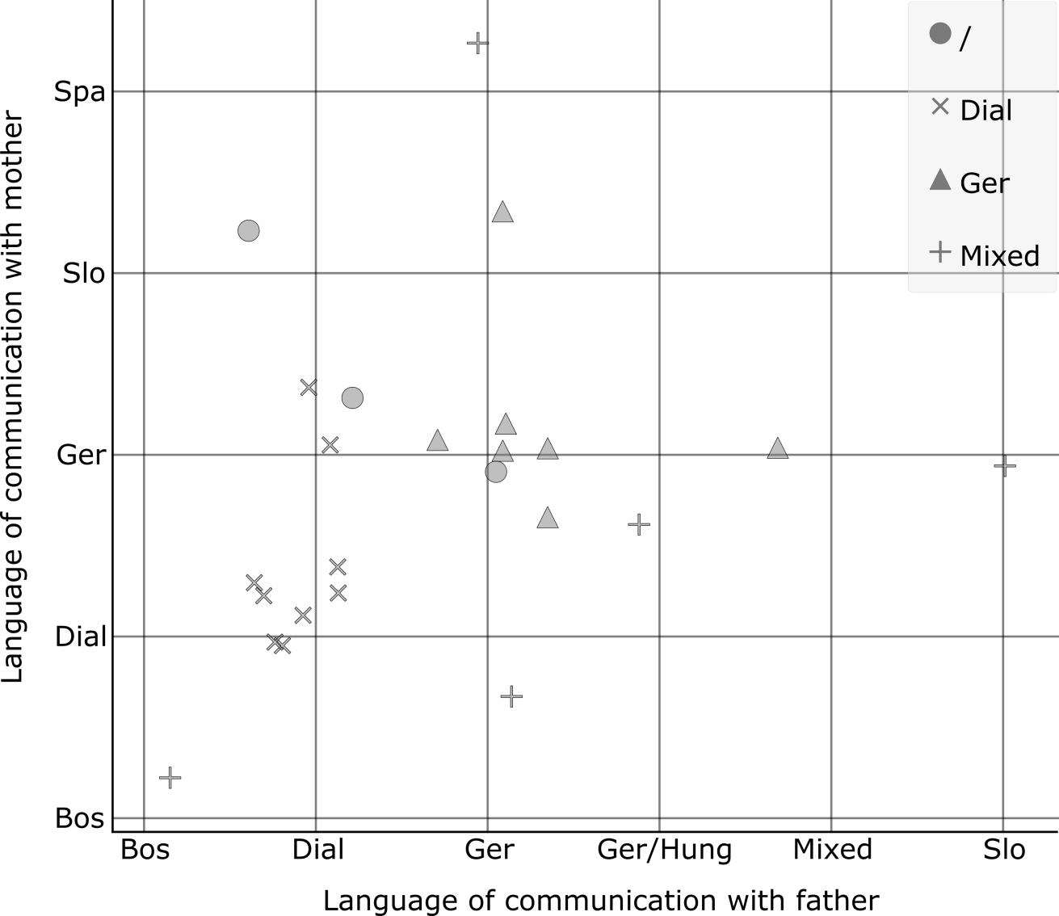
Figure 1. Respondents’ Primary Socialisation: language of communication with mother (y-axis) and father (x-axis), the shape shows the language of communication with siblings (legend). Explanation of terms used: Ger: German language or dialect, Dial: one of the Slovene Carinthian dialects, Slo: Slovenian language (closer to standard), Mixed: Slovene dialect and German (the term "mixed" was used by the respondents themselves and refers on the fact that they use both languages and also switch codes), Spa: Spanish, Bos: Bosnian, Hun: Hungarian, / - only child.

Figure 1 shows two condensed groups of respondents which represent those socialised in: (1) a Slovene dialect, (2) German. The homogeneity of the two groups that speak in the language of their primary socialisation with all members of their immediate family (siblings as shown in Figure 1, and grandparents, where the results are similar) is also apparent from members' declared ethnic identity (see Figure 4 below).
Use of Language in School
The respondents' statements indicate that the use of Slovene at bilingual schools is not automatic and spontaneous.

Slovene as the language of instruction
Provisions pertaining to the language of instruction and the way it is used differ from school to school: at the Commercial College in Klagenfurt and the College for Commercial Vocations in St. Peter, German and Slovene have equal status and alternate monthly as the language of instruction for all subjects, while at the Slovene Gimnazija Slovene is the only language of instruction for all subjects. As we will see, respondents’ replies show that these provisions are not binding. In her examination of the Slovene Gimnazija, Perenič (2006) showed that the status of Slovene as the language of instruction is very limited – even Slovene is not taught exclusively in Slovene (Ibid., 55). The number of Slovene-language lessons is now equal to that of lessons in other languages, which means that even “within the educational process itself, attention is gradually taken away from merely attempting to build awareness about the legal and political position of Slovene as a minority language” (Ibid., 51).
Students think about this issue to differing degrees, but they are all aware that it is an important factor in the communicative capacity of the language. Higher levels of communicative capacity require a greater commitment. The students themselves view the enrolment of bilingual children in single language secondary schools as a matter of convenience (another factor was the possible higher reputation of Austrian schools): “the bilingual baccalaureate requires much more effort” (Interview 3TA). They also observed the consequences of these decisions: “My friends who spoke Slovene but enrolled in the single language commercial academy simply think in German and no longer have the Slovene vocabulary for communication” (Interview 3TA). On the other hand, we can note a persistent rise in the enrolment of monolingual German speakers in bilingual educational institutions, a trend that, although generally positive, does have certain far-reaching consequences: heterogeneous Slovene language classes are very demanding from a didactic standpoint, and the very clear need (inherent, it is true, to all language instruction) to adapt lessons to the speakers' level poses a problem. In the words of one respondent, “the school does not impart the feeling of belonging to the minority and these children do not feel part of the minority” (Interview 7G).
As mentioned above Slovene is supposed to be the language of instruction at all three schools (it's supposed to be the only language of instruction at the Gimnazija, but that's only the case on paper (Perenič 2006, 51)). In the case of the other two schools, the respondents clearly showed that they were not required to adhere to the provision on the monthly use of a specific language (e.g. Interview 8TA, Interviews 2VŠ, 6VŠ): “no one sticks to this [the rule], instead they mix languages according to which language a question is asked in. In fact, the language is constantly adapted to the students” (Interview 6VŠ). The practice of accommodating students’ choice of language thus has a psychological component as well as an obvious practical one (due to weaker Slovene competence). With this in mind it is informative to look at students’ self-evaluation of their respective knowledge of Slovene and German: the average grade for the former is 6.5, while for the latter it is 9.5 (1 being the lowest mark, 10 being the highest).

Slovene outside lessons
I was very interested in respondents' communications with their peers during breaks. The first language choice of most students is German (66.67%). This was confirmed by Perenič (2006), who feels that the use of German among speakers of different dialects in spontaneous school communication is due to the lack of a regional colloquial language: “the Slovene standard language remains reserved for class communication between the teacher and the students (which is why it seems fake outside class), and students have a lower competence in it” (Ibid., 53).
Sometimes we make an effort in Slovene and speak in the dialect, but then we switch to German (Interview 7VŠ).
I always speak German, except in Slovene classes with the teacher. With my peers from Slovenia I speak German and they speak Slovene. If we don’t understand something, we try to explain it in the other language, but we generally stick to the pattern of each in our own language (Interview 8TA).

I talk in German with those who are from here, from Austria, Carinthia. [Even if they speak Slovene at home?] We didn’t know this at first, then we got used to speaking this way and now it’s difficult to [change] (Interview 5VŠ).
During my research I came across a class in which communication usually took place in German and English (the latter due to communication with class members from Slovenia). A separate study should be carried out to learn the reasons for this kind of linguistic conduct and how limited or extensive it is.
Six students (25%) assured us that they communicate in the dialect form of Slovene at school, but not surprisingly they were all from families with higher levels of economic (see Figure 3) as well as cultural and social capital where socialisation took place exclusively in Slovene. The two respondents who use the German language with their peers in spite of their socialisation in Slovene and the use of a Slovene dialect at home with parents and siblings attended the St. Peter’s school, and this could indicate the interpersonal conduct typical of that school. Scores for Neuroticism are also interesting in this regard (Neurotic individuals are prone to experience negative emotions, such as anxiety, depression, and irritation, rather than being emotionally resilient (Soto and Jackson 2013)). All of those whose first language choice in school is their dialect (home language) scored low in Neuroticism (the average for all six of them is 18), while the two students who use German language in school and a Slovene dialect at home scored very high (N₁ = 87 and N₂ = 71; the average score for Neuroticism among all respondents is 36.33, see Figure 2). The statistical significance of this finding would need to be checked on a larger sample in order to discard the possibility that this neuroticism is not caused by some other factor (lower levels of economic capital, for example).
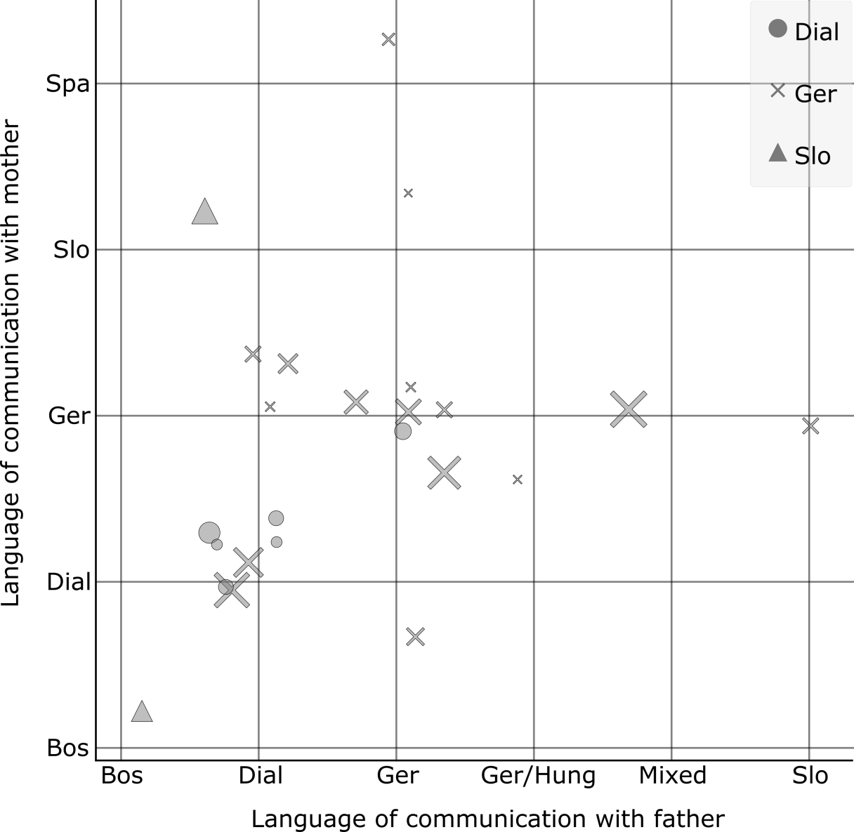
Figure 2. Respondents' Linguistic Habitus, Psychological Traits (Neuroticism) and Use of Language in School (shown with the help of the following variables: language of communication with mother (y-axis) and father (x-axis), the shape shows the language of communication in school with school friends, the size of the shapes corresponds to values for Neuroticism). See the notes to Figure 1 for an explanation of terms used.

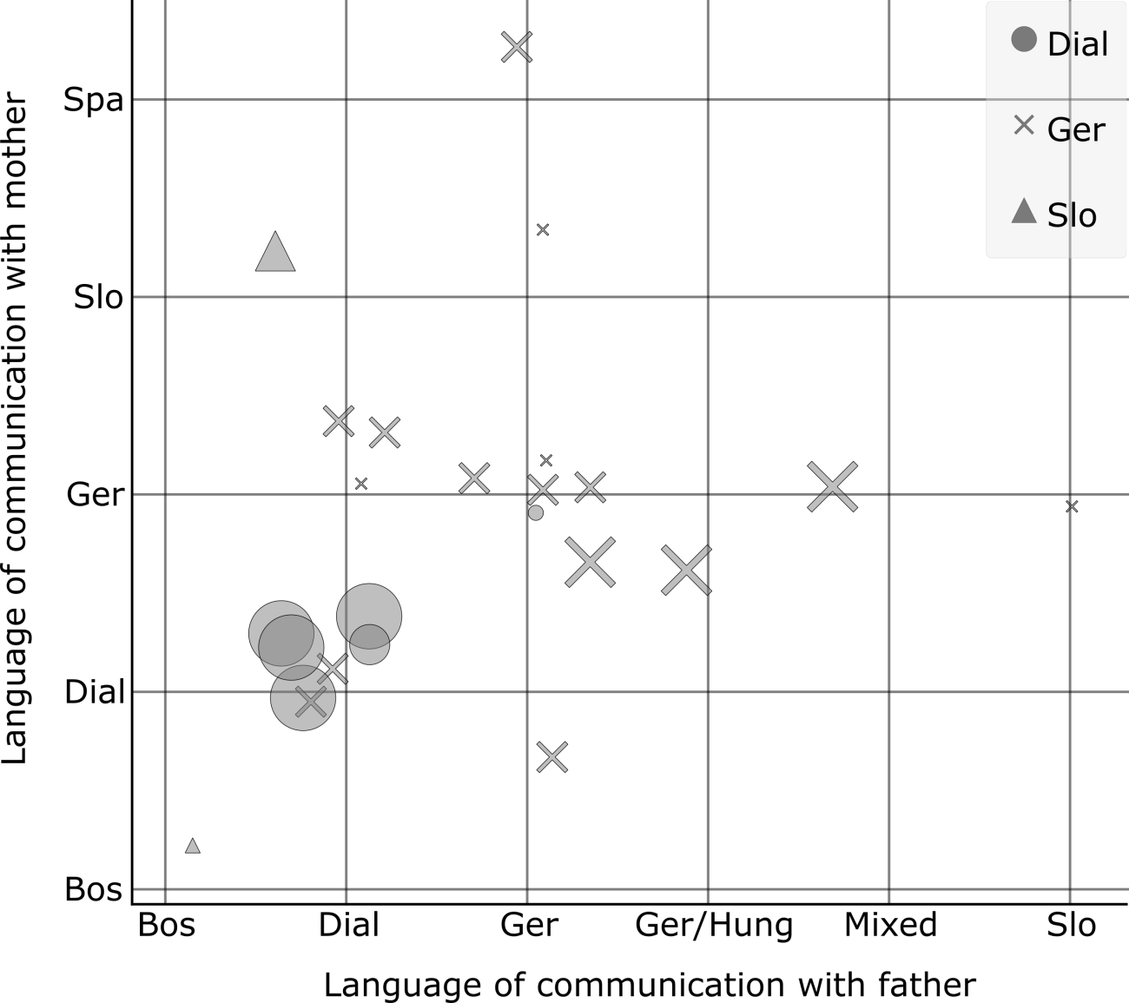
Figure 3. Respondents' Linguistic Habitus, Economic Capital and Use of Language in School (shown with the help of the following variables: language of communication with mother (y-axis) and father (x-axis), the shape shows the language of communication in school with school friends, and the size of the shapes corresponds to the level of economic capital). See the notes to Figure 1 for an explanation of terms used.

Two students chose a variant of Slovene closer to the standard language for communicating with their peers. One is weak in the Slovene Carinthian dialect, since his early socialisation took place in the Bosnian language. The other pupil has mastered the dialect (he uses it with this father), but puts more emphasis on colloquial Slovene, which he uses for communication with his mother, who moved to Austria from Slovenia. His case is discussed in detail below (see 4.4).
  - The Relationship between Dialects and Standard Slovene Language
When you start talking Slovene with Carinthian Slovenes it often happens that they think you know their local language, the one they speak, but when they see that you don’t know the dialect, they always switch to German (Interview 2VŠ).
The findings in this chapter are crucial to an analysis of the sociolinguistic situation in Austrian Carinthia: “Slovene is accepted as a foreign language, as the state language of Slovenia, but it is not considered to be a language of daily use in Carinthia” (Doleschal 2011, 166). Busch (2008, 60) already established that “the acknowledgement that someone speaks ‘only a dialect', allows for the interpretation that a distance has been created from the standard language and the national community [of Slovenes, author’s note].” For students who identify themselves as Carinthian Slovenes and who were fully or partly socialised in a Slovene dialect, the dialect represents a first language code, a mother tongue with an emotional connotation and symbolic capital. For most of them, standard Slovene is a higher language, i.e. the language they learn in school for formal communication and literacy. Slovene citizens also learn this language variant during their formal education. For specific inter-connected reasons, communication capacity in the standard Slovene language differs for speakers in Slovenia on the one hand and those in Austrian Carinthia on the other. The lower capacity of speakers in Austrian Carinthia results from the state and specifics of bilingual education, limited possibilities for formal use and emotional alienation. Schellander (1988) speaks of the “psychosocial alienation” of standard Slovene in most speakers of local dialects, noting that the “the lack of familiarity with it and its absence and strangeness” represent “an emotional obstacle that is a manifestation of a whole range of identity problems.” In his opinion, this is the result of the “emotionally, psychosocially and functionally distorted attitude to standard Slovene and the gradual mass transition to German,” that is, of the abandonment of local dialects and the concomitant “ethnic alienation” (Ibid.1988, 267).
In discussions of dialects and the standard language, the respondents always linked standard Slovene with school (as a language to be learned) or with the past, e.g.:
Young people talk in dialect even more than older people, who speak more standard Slovene … my grandparents spoke standard Slovene, but gradually they started speaking more in the dialect. The young have added to the dialect, when we speak it sounds similar to German, we introduced more German and it’s mixed now (Interview 9TA).

The consequences of more than a thousand years of language contact are evident in both the local Slovene and German dialects (because of the nature of the contact, standard Slovene was also influenced, but not standard German) (Reindl 2008). But the above quotation is very interesting because of the short amount of time and speed with which the language change was thought to take place, and because it hints at the possible development of a dialect form of Slovene in Carinthia. It should also be noted that the post-war period was a trying time for the minority, as it fought to preserve itself and especially its language, and that in this environment the dominant German language is able to name more of reality (especially modern reality) than Slovene (for preferred German lexical filling see Priestly 1989, 84). The question remains whether the interviewee’s description applies to the general language of communication in this area or only to the variant used by young people; in any case, further research is needed.
Encouraging [Slovene lessons for] children from the minority seems important, it would have been more useful to me if I’d learnt the cases in primary school, as in high school you’re expected to know them (Interview 7G).
A number of students stressed the effort required for mastering standard Slovene (e.g. Interview 3TA, 6VŠ, 7G). This student is one of the very few who are able to use Slovene at a high level, but she is aware of the input needed and expects her knowledge to pay dividends:
I’d like to teach (a school subject), maybe even at the Slovene Gimnazija. In fact all those who finish Slovene Gimnazija and go on to study pedagogy return. It’s easier to get a job, I think, because they’re always looking for people who know Slovene. (Interview 7G).
Those with access to this capital (be it via a transfer of the language from parents who come from Slovenia, or through their own effort, which is a product of investments made in their home environment, particularly in cultural and emotional capital) include standard Slovene in their future projections.
I will probably study Slovene and (name of the subject) in (city name). I’ve always been good at Slovene and have had good grades. At home, there’s an opportunity to talk to my mother in “real Slovene” [the mother is from Slovenia, is married in Carinthia and teaches Slovene, author’s note] (Interview 3TA).
In most cases, competences in standard Slovene deteriorate after the baccalaureate, while competences in German increase (either due to enrolment at an Austrian university or employment).
With my two sisters, I speak Slovene. [In the dialect?] Yes. My sisters also went to the bilingual school and are now studying in Klagenfurt. Now they only speak well in the dialect … they admit that they can’t write anymore (Interview 4VŠ).
These examples clearly show that young people do not feel comfortable speaking standard Slovene, or, to borrow Bourdieu’s expression, they do not feel like fish in water. Their answers show that limited language skills are the main reason for this, and this situation is itself the result of limited language use. Most come across standard Slovene only in Slovene lessons in bilingual school, while hardly any of them read Slovene literature (the interviews show that they only read the literature that is obligatory for school; family libraries contain fewer Slovene books than German ones, and the ones they do have are mostly children’s books). On the other hand, the Carinthian dialect constitutes the linguistic habitus of bilingual speakers, especially those who grew up in families in which communication is in one of the Carinthian Slovene dialects. Researchers have already discussed the presence/absence of a supradialect, a regional colloquial language (e.g. Schellander 1984). The fact is such a dialect is the only form that could replace standard Slovene in more demanding or formal speaking situations, i.e. those in which speakers these days opt for the other higher (regional) variant, German. Schellander cites the absence of speaking situations for the obligatory use of the standard language as a key reason for this markedly imbalanced bilingual situation, and notes that the “social principle of general optionality” (Schellander 1988, 269) applies to Slovene in general and standard Slovene in particular. In his view, the non-Slovene Carinthians, but also many Carinthian Slovenes, adhere to this principle:
[…] as parents who do not speak Slovene to their children and do not register them for bilingual classes; as teachers who are satisfied with a low level of required skills and neither speak nor convey the modern standard language; as citizens who do not speak Slovene with administrative officers; as heads and functionaries whose examples do not give standard Slovene a suitable social reputation and value [comparable to that] enjoyed by standard German in similar communication situations (Schellander 1988, 269).
Only a language variant that is established, i.e. used in the above cases, could attract the recognition of its value by its users and the other inhabitants in the area. Busch (2008, 61) has a similar observation: “Only with an increase in the regional [Slovene, author’s note] Carinthian colloquial language will the distance towards the standard language decrease.” Research on regional standards has already confirmed that speakers of regional standards “evoked the prestige and competence associated with standard dialects and – because of their local character – did not lose ground” (Edwards and Jacobsen, 1987, cited in Edwards 2009, 92). The Carinthian dialect is, of course, a form of (cultural) capital and is completely acceptable – it is even highly valued in certain situations, e.g. at home, when visiting relatives, at a local bar, at a cultural society event, in short, everywhere where bilingualism is socially recognised, established and accepted. This is why it can be suitably transformed into economic capital (local customers) and social capital (meeting people). But its highest value is, of course, symbolic, especially with regard to the speakers who constitute the “heart of the minority”, to quote a term used by one student. Various initiatives for the revitalisation of the Slovene dialect such as the Slovene in the Family initiative are certainly a welcome, important development and could provide a good foundation for building upon the dialect variant and turning it into standard Slovene. But a sobering realisation soon follows: the quality Slovene is low, and this is a consequence of the situation in bilingual education, which, as Doleschal claims, is now “largely used as a means for the acquisition of a second language by children from German-speaking families” (Doleschal 2017, 149). This is a multifaceted and complex topic that I will not go into at this point (but cf. Heller 1996, for a similar problem in Canada). The fact is all the students we interviewed are stronger in German (including those from Slovene families) and they will all continue their studies in Austria. In their lives, Slovene is mostly limited to local use. Only a few respondents find themselves in a situation in which the use of non-dialect Slovene would be socially desirable, while high-level knowledge of standard Slovene is unnecessary for functioning in different areas of life in this geographic area.
The responses of the students whose L1 is not Slovene but who attend bilingual schools at the secondary level are very interesting and informative. The reasons motivating these students (and their parents) for enrolment in a bilingual school vary (economic, cultural, social and symbolic), but it seems that the quality of their Slovene is closely connected to their motivation, which is the result of: (1) high cultural capital (e.g. parents are teachers or professors, see Figure 4, which also includes a visualisation of cultural capital), (2) emotional capital (e.g. acquired through family discussions), (3) interest in languages in general, (4) certain personal traits, as indicated, inter alia, by the results of the personality test completed by the respondents. The personal traits that seem to decisively shape both motivation to learn and communication practice are E-extroversion (highly extroverted individuals are assertive and sociable, rather than quiet and reserved (Soto and Jackson 2013)) and O-Openness (highly open individuals have a broad rather than narrow range of interests, are sensitive rather than indifferent to art and beauty, and prefer novelty to routine (Soto and Jackson 2013)). The respondent in Interview 4TA (values E83 and O59; average scores for Extroversion are 58.79 and 33.79 for Openness) and the respondent in Interview 2VŠ (E86, O95) had high marks for both traits; both speak excellent Slovene after only 4 years at a bilingual school. By comparison, the respondent in Interview 8TA had very low values for these traits (E18, O10) and was the only respondent who chose German as the interview language.
  - Multilingualism and Different Identities (Regional, Ethnic, National)
All the respondents mentioned the added value of multilingualism and treat it as a form of capital. Some view it more pragmatically (in terms of a competitive advantage or added value in the regional labour market and easier communication abroad) and focus on the more functional aspects, while others emphasise the cultural dimension. Older research obtained similar results (e.g. Nećak Lük, Jesih, and Wakounig 2002). Respondents in those studies also felt that knowledge of Slovene is a plus, and they agreed that even German-speaking children should learn it. Pragmatic arguments (communication ability) predominate among the reasons given for this view (see Diagram 2 in Novak Lukanovič 2002, 113), but respondents also mentioned integrative reasons (coexistence and tolerance), and German-speakers in particular cited the rationale “the more you know, the more you are worth” – a rather succinct description of the concept of cultural capital. The regional component should also be mentioned: regional identity, which, according to Paasi (1986 cited in Kosi 2013), consists of the identity of the region and regional awareness, was mentioned by all the respondents and appears in the very first sentence of the presentations on all the three schools' websites.
It’s good. It’s super that I can understand everything, someone speaking Slovene, German, Italian or English. This is a specific feature of this region. After the baccalaureate, I would like to go to the police school to become a Verbindunsoffizier. I think that because of my bilingualism I have more chances of getting a better position. I have an advantage over others who don’t speak so many languages (Interview 4TA).

The above comment serves to underline the pragmatic and economic aspect of multilingualism, while also expressing a very positive attitude towards this regional characteristic. Young people themselves speak of multiple identities: “You’re not just an Austrian, but have a number of identities” (Interview 4G). Identity as capital and its generation was described by Côté (1996), who was the first to use the phrase identity capital. He uses it to describe “what seems to be necessary for individuals to successfully negotiate the vagaries of life passages in late-modern society and a resource to secure social-class mobility or to reproduce one's class position” (Ibid., 424). In its most general sense, identity capital denotes what individuals “invest” in “who they are.”
So, I still feel like a Carinthian Slovene, I think that this coincides with the Austrian identity. I think it’s both, because I am from Austria, but I am a Carinthian Slovene … I don’t know how to explain this, but …. I’m both at the same time (Interview 4G).
Our research also confirms that the typical ethnic self-identification of
Carinthian Slovenes is oriented towards Austrian national identity: “I feel like a Carinthian Slovene and an Austrian. I’m not that [attached] to Slovenia” (Interview G5). “I feel I’m a Carinthian Slovene and an Austrian, more than a Slovene” (Interview G6). Carinthian Slovenes' clarifications of their responses to questions of ethnic or national identity show that both types of identity are present: ethnic identity, which is connected to the ethnic group and language, and national identity, which is connected to citizenship and the state. When asked about language use in school, the respondent in Interview 4VŠ said that they “speak Slovene only to Slovenes and German with Austrians.” It is important to note that the labels “Slovenes” and “Austrians” refer to citizenship. In this case (national) language is clearly connected to (national) identity. Regional identity is connected to the Slovene dialect, but since the use of the latter in public spaces is limited, it is acceptable to be a Carinthian Slovene who speaks German.
In cases of mixed marriages where one parent is from Slovenia, different types of capital and symbolic values come to the fore. “I feel more like an Austrian, I don’t have much to do with them [Carinthian Slovenes], they are different” (Interview 7TA). This respondent seems ambivalent. She connects Sloveneness with her mother, who came from Slovenia and possesses very little cultural and economic capital. On the other hand, a respondent whose mother moved to Austria from Slovenia and now teaches Slovene there described a very different situation; he even identifies as a Slovene (Interview 3TA). Ethnic and language appurtenance is even more evident in the case of mixed marriages with Carinthian Slovenes. Looking at Figure 4, we can assume that just one parent (mother or father) communicating with the children in the Slovene Carinthian dialect is enough for a local bilingual identity to take shape, i.e. for the children to express their identity as Carinthian Slovenes. Whether this awareness is characteristic only of youngsters who attend bilingual school still needs to be established. The fact is that those who do attend have a greater sense of involvement and experience bilingualism as their local reality.
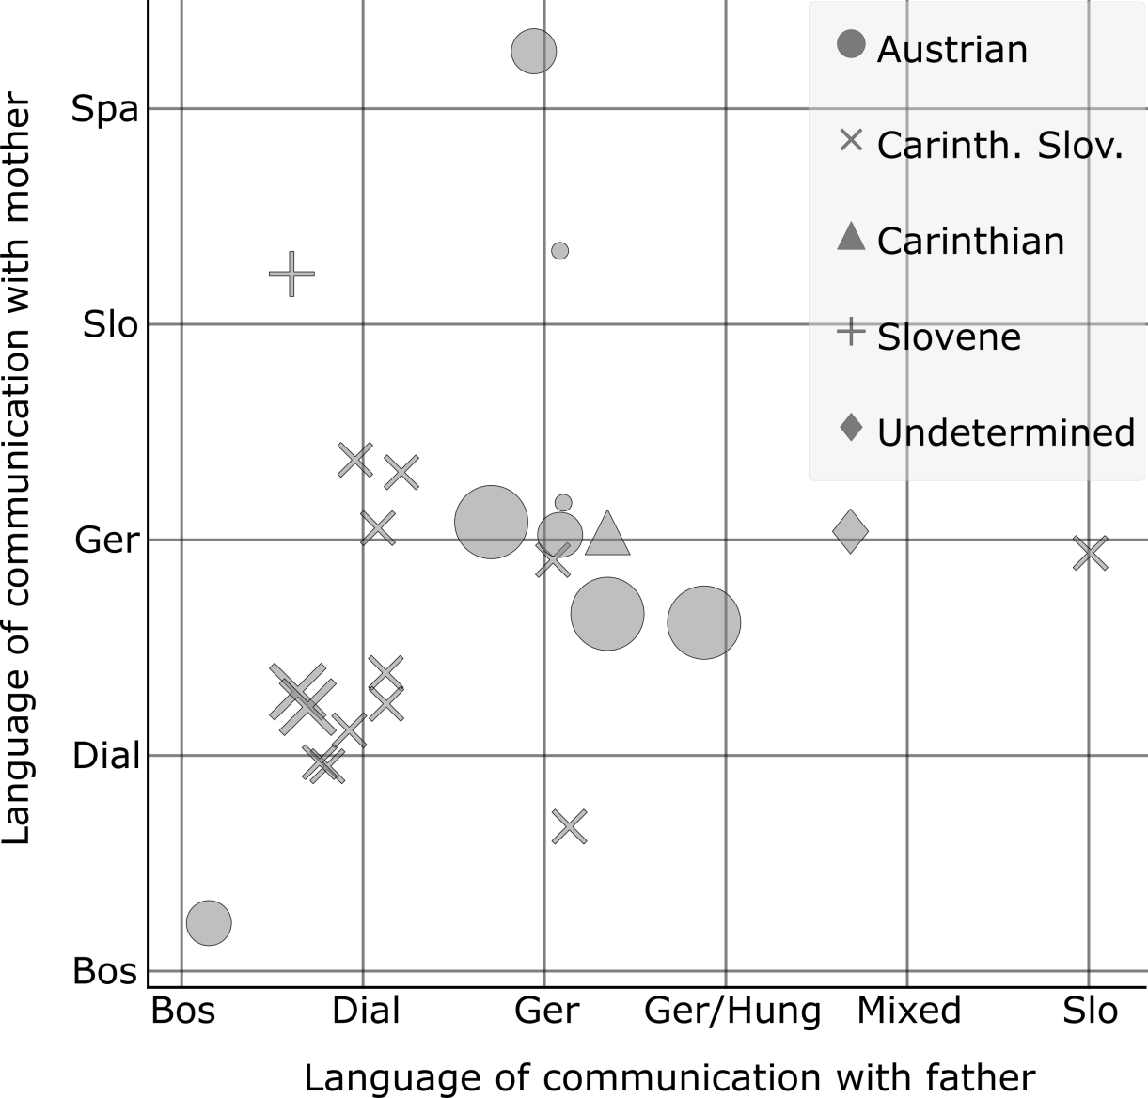
Figure 4. Habitus, Ethnic Identification and Cultural Capital (shown with the help of the following variables: language of communication with mother (y-axis) and father (x-axis), the shapes show the stated ethnic identity and the size of shapes corresponds to the level of cultural capital). See the notes to Figure 1 for an explanation of the terms used.
- Concluding Thoughts
Students’ responses about their communication practices reveal the effects of the linguistic habitus (which acts autonomously and subconsciously) as well as more engaged, conscious uses of language rooted in the view that language is capital. An important prerequisite of non-economic capital (i.e. capital without a nominal value) is that its users recognise it as capital, that is, as an entity that can be monetised or valorised. This is how the value (cultural, social or just symbolic) of these types of capital is acknowledged. The value of languages in Austrian Carinthia as determined by their use, is, of course, not set in stone, but it seems difficult to enhance without an active language policy. For those who declare themselves to be Carinthian Slovenes, the symbolic value of the dialect Slovene variant is very high, but because of the absence of an established and functional regional colloquial language variant, Slovene cannot compete with German as a potential language of choice in formal language situations. German is the legitimate choice and Slovene is reserved for those persons whom the speaker can identify as users of Slovene, that is, the dialect. But we did also identify some communicative practices that deviate from the norm, and these can be linked to capital (identity and emotional capital). As we have seen, individuals' personality traits (the big five in our case) can also play an important role and are worth examining.
The regional loyalty of the Carinthian Slovene ethnic minority is definitely not cause for concern. Carinthian Slovenes have become a strong economic, cultural and social regional entity. But the issue of language is much more complex. The consequences of inferior communication capacity in standard Slovene are already becoming evident, and the minority should direct its efforts towards language policy. The initiative for the revitalisation of the dialect within the family is the first step towards increasing the number of speakers socialised in a Slovene dialect; later, when they begin attending a bilingual school, they will have sound foundations for developing their dialect variant and turning it into standard Slovene. The latter, together with the dialect variant, is the best foundation for the establishment of a regional language of communication that could also be used in public to a greater extent, without prejudice. This in turn would enhance competence in the Slovene language. The example of the Carinthian Slovene writer Maja Haderlap is very telling. She wrote her first novel in German. In an interview for the Slovene newspaper Delo (October 25, 2011) she justified her decision with her “dual language identity” and the wider range of her novel due to the chosen language (both in Carinthia – due to the loss of Slovene literary public – and in a wider area). I think this is a good illustration of all aspects of the current situation with regard to the use of Slovene in Austrian Carinthia. The words of a rather observant student are a fitting conclusion to this paper: “the disappearance is happening and they can talk about a super political climate as much as they want, but what is needed is an active approach to the problems. The fact is they have simply put us in a coma.” Much needs to be done to promote the active use of Slovene in public and to achieve a “positively lived multilingualism in Carinthia” (Busch 2008, 63).
References
Baker, Colin. 2001. Foundations of Bilingual Education and Bilingualism. Vol. 3rd ed, Bilingual Education and Bilingualism. Clevedon [England]: Multilingual Matters.
Bourdieu, Pierre. 1977. "The Economics of Linguistic Exchanges." Social Science Information 16 (6):645-68.
———. 1986. "The Forms of Capital." In Handbook of Theory and Research for the Sociology of Education, edited by John Richardson. New York: Greenwood.
Bourdieu, Pierre, and John B. Thompson. 1991. Language and symbolic power the economy of linguistic exchanges.
Busch, Brigitta. 1999. Der virtuelle Dorfplatz: Minderheitenmedien, Globalisierung und kulturelle Identität. Klagenfurt/Celovec: Drava Verlag.
———. 2008. "Slovenščina na Koroškem: jezik manjšine, a ne le to." In Slovenščina med kulturami, edited by Miran Košuta, 55-63. Celovec, Pliberk: Slavistično društvo Slovenije.
Côté, James E. 1996. "Sociological perspectives on identity formation: The culture-identity link and identity capital." Journal of Adolescence 19 (5):417-28.
Demšar, J., T. Curk, A. Erjavec, C. Gorup, T. Hočevar, M. Milutinovič, M. Možina, et al. 2013. "Orange: Data mining toolbox in python." Journal of Machine Learning Research 14:2349-53.
Doleschal, Ursula. 2011. "Bilingual Education in Austria: The Case of Slovene in Carinthia." In Slovenski jezik v stiku - sodobne usmeritve večjezičnega in manjšinskega izobraževanja, edited by Sonja Novak Lukanovič and Vesna Mikolič, 158-75. Ljubljana: Slovene Association of Applied Linguistics.
———. 2017. "Multilingualism in Carinthia: The Case of Slovene and the Slovene Minority." In The Polyphony of English Studies: A Festschrift for Allan James, edited by Alexander Onysko, Eva-Maria Graf, Werner Delanoy, Nikola Dobric and Günther Sigott. Tübingen: Narr.
Domej, Teodor. 1999. Položaj manjšinskega jezika v izobraževanju na Koroškem, Materni jezik na pragu 21. stoletja = The mother tongue on the door of 21st century 1999. Portorož, 2. - 4. decembra 1999: Zavod Republike Slovenije za šolstvo.
Edwards, John. 2009. Language and identity : an introduction, Key topics in sociolinguistics. Cambridge (UK); New York: Cambridge University Press.
Garrett, Paul B. 2007. "Language Socialization and the (Re)Production of Bilingual Subjectivities." In Bilingualism: A Social Approach, edited by Monica Heller, 233-56. Basingstoke [England] ; New York: Palgrave Macmillan.
Heller, Monica. 1996. "Legitimate Language in a Multilingual School." In Linguistics and Education, 139-57.
Kern, Damjana. 2009. "Slovenski jezik v vzgojno-izobraževalnih ustanovah v manjšinskem prostoru." In Infrastruktura slovenščine in slovenistike, edited by Marko Stabej, 191-6. Ljubljana: Znanstvena založba Filozofske fakultete.
Kosi, Danilo. 2013. "Regionalna identiteta v Sloveniji." Dela 39:107-24.
"Kärntner Landesverfassung." In. LGBl. Nr. 25/2017.
Larcher, Dietmar. 1991. Fremde in der Nähe : Interkulturelle Bildung und Erziehung - im zweisprachigen Kärnten, im dreisprachingen Südtirol, im vielsprachigen Österreich, Disertacije in razprave 27/Dissertationen und Abhandlungen 27. Klagenfurt/Celovec: Drava.
Maton, Karl. 2012. "Habitus." In Pierre Bourdieu: Key Concepts, edited by Michael Grenfell, 48-64. Abingdon, New York: Routledge.
Merkač, Franc. 1986. Lebenswelten slowenischer Jugendlicher : Volksgruppenidentitätsfindung - Emanzipation in Kärnten. Klagenfurt/Celovec: Avtonomna delavnica.
Moritsch, Andreas. 2000/2001. "Nacionalne ideologije na Koroškem." In Koroški Slovenci 1900 - 2000. Bilanca 20. stoletja., edited by Andreas Moritsch, 9-24. Celovec-Ljubljana-Dunaj: Mohorjeva Založba.
Nećak Lük, Albina, Boris Jesih, and Vladimir Wakounig. 2002. "Medetnični odnosi v slovenskem etničnem prostoru." In Projekt Medetnični odnosi in etnična identiteta v slovenskem etničnem prostoru. Ljubljana: Inštitut za narodnostna vprašanja.
Novak Lukanovič, Sonja. 2002. "Pogled prebivalcev občine Železne Kaple - Bele na dvojezično izobraževanje." In Medetnični odnosi v slovenskem etničnem prostoru 3: občina Železna Kapla - Bela / Eisenkappel - Vellach, edited by Albina Nećak Lük, Boris Jesih and Vladimir Wakounig. Ljubljana: Inštitut za narodnostna vprašanja.
Ogris, Katharina. 2014. Schule = šola?: Zur Gleichwertigkeit der Unterrichtssprachen Deutsch und Slowenisch an Kärntner Volksschulen. Klagenfurt/Celovec: Drava Verlag/Založba Drava.
Ogris, Tomaž. 1995. "Slovenščina - dvojezični pouk v južnokoroških šolah." In Podoba našega otroka na Koroškem, edited by Danilo Sedmak, 27-38. Trst: SLORI.
Perenič, Urška. 2006. "Smernice za delo jezikovnega asistenta za slovenščino v okviru manjšinskega šolstva na avstrijskem Koroškem." Jezik in slovstvo 51 (5):47-57.
Priestly, Tom M. S. 1989. "Cultural Consciousness and Political Nationalism: Language Choice among Slovenes in Carinthia (Austria)." Canadian Review of Studies in Nationalism XVI (1-2):79-97.
Reindl, Donald F. 2008. Language Contact: German and Slovenian. Edited by Stolz Thomas. Vol. 20, Diversitas Linguarum. Bochum: Universitätsverlag Dr. N. Brockmeyer.
Sandrieser, Sabine, Michael Vrbinc, and Martina Weinfurter. 2016. "Jahresbericht über das Schuljahr 2015/16." In. Klagenfurt am Wörthersee: Landesschulrat für Kärnten, Ableitung VII, Minderheitenschulwesen.
Schellander, Anton. 1984. "K vprašanju slovenskega pogovornega jezika na Koroškem." Wiener Slawistischer Almanach 13:251-64.
———. 1988. "Sodobni slovenski jezik na Koroškem: Vprašanja govornega sporazumevanja, jezikovnega znanja in jezikovne rabe v dvojezični situaciji." In Sodobni slovenski jezik, književnost in kultura, edited by Boris Paternu and Franc Jakopin, 261-75. Ljubljana: Filozofska Fakulteta.
Soto, Christopher J., and Joshua J. Jackson. 2013. "Five-Factor Model of Personality." Psychology. doi: 10.1093/obo/9780199828340-0120.
Srivastava, S., O. P. John, S. D. Gosling, and J. Potter. 2003. "Development of Personality in Early and Middle Adulthood: Set Like Plaster or Persistent Change?" Journal of Personality and Social Psychology 84 (5):1041-53. doi: 10.1037/0022-3514.84.5.1041.
"The Slovene Language in Education in Austria." In. 2005. Regional Dossier, edited by Ramzie Krol-Hage and Marlous Visser. Mercator Research Centre on Multilingualism and Language Learning.
Vavti, Stefanie. 2013. 'Ich bin einfach ein Mensch' : Ethnische Selbstverortung und lokale Bezüge junger Slowenen in Kärnten (Österreich). Frankfurt am Main: Peter Lang AG.
Vavti, Štefka. 2009. "»Nisem 0815 Korošec ...« - Primeri etnične identifikacije pri slovensko govorečih (post)adolescentih na dvojezičnem avstrijskem Koroškem." Treatises and Documents, Journal of Ethnic Studies (60):40-61.
———. 2010. "»We prefer having fun and enjoying our life!« Slovene postadolescents in bilingual Carinthia -- between a zest for life and an enactment of the past?" Treatises and Documents, Journal of Ethnic Studies (62):50-73.
———. 2011. "Between Commitment and Out-migration. Identity Types of Young Slovenes in Bilingual Carinthia (Austria)." Treatises and Documents, Journal of Ethnic Studies (64):8-35.
"Verordnung der Bundesregierung vom 31. Mai 1977 über die Bestimmung der Gerichte, Verwaltungsbehörden und sonstigen Dienststellen, vor denen die slowenische Sprache zusätzlich zur deutschen Sprache als Amtssprache zugelassen wird." In. 1977. StF: BGBl. Nr. 307/1977. Bundesgesetzblatt für die Republik Österreich.
Weichselbraun, Anna. 2014. "‘People here speak five languages!’: The reindexicalization of minority language practice among Carinthian Slovenes in Vienna, Austria." Language in Society 43 (4):421.
Zupančič, Jernej. 1999. Slovenci v Avstriji. The Slovenes in Austria. Vol. 32, Geographica Slovenica. Ljubljana: Institute for Geography.
———. 2002. "Številčni razvoj koroških Slovencev v luči rezultatov ljudskega štetja leta 2001." Treatises and Documents, Journal of Ethnic Studies (40):72-105.

("Verordnung der Bundesregierung vom 31. Mai 1977 über die Bestimmung der Gerichte, Verwaltungsbehörden und sonstigen Dienststellen, vor denen die slowenische Sprache zusätzlich zur deutschen Sprache als Amtssprache zugelassen wird" 1977)
For more information on the Scatter plot visualisation widget, see https://docs.orange.biolab.si/3/visual-programming/widgets/visualize/scatterplot.html.
German was not broken down into sub-varieties in the research since this was not necessary for achieving the research goals. Slovene, on the other hand, needed to be broken down into dialect, regional colloquial language and standard language.
Graphs and data are available from the author.
The results are similar for cultural and social capital. Graphs and data are available from the author.
A study by Weichselbraun found that the reindexalization of minority language practice occurs among Carinthian Slovenes studying in Vienna: "[the Carinthian Slovenes] relish every opportunity to perform their multilingual competence and the cosmopolitan prestige that it indexes" (Weichselbraun 2014).
Cf. Moritsch (2000/2001, 24) for state-centered definitions of nationalities in Carinthia: »In Carinthia as well, the Austrian nation became the dominant group identity. The German became Austrian German and then German Austrian; similary, the Slovene became the Austrian Slovene and then the Slovene Austrian.«

